LEARNING AND DEVELOPMENT PROJECT FOR 200 CHILDREN IN PORTUGAL:
Promoting children’ autonomy, creativity and wellbeing by using a living environment as a platform to apply holistic alternative methodologies of art, equine-therapy, psychology and body-awareness techniques.

Introduction to Romi’s Way

Romi’s Way is a new professional non-profit organisation born to address the need of rebalancing the long term effects of human actions in relation to our all other forms of Life in our planet. Currently human needs, desires, habits and drive for economic growth is causing significant imbalance to the world causing harm to animals and environment at alarming rate.

Romi’s Way has a simple concept to promote balance between people, animals and environment – ensuring we invest on sustainable future and on quality of Life for all flora and fauna. With the current trend of mass production, mass farming, consumer driven approaches and lack of understanding of the global needs to sustain good quality Life on earth there is an urgent need to shift the focus to sustainability and balance. We want to believe it is not too late to invest on right people (= children as the next generation of decision makers), on right environmental knowledge and practises (= fact based and well researched methods and innovative approaches) and widened perspective to understand natural needs and potentials of animals (= removing the human manipulation to only use and acknowledge those aspects of animals seen useful for human consumption or need). There are ways to live in harmony and we believe this is to be done through: A) correct education, B) Re-connecting people back to natural world and c) understanding better how modern technology& innovations can support people to learn and connect back to Nature.

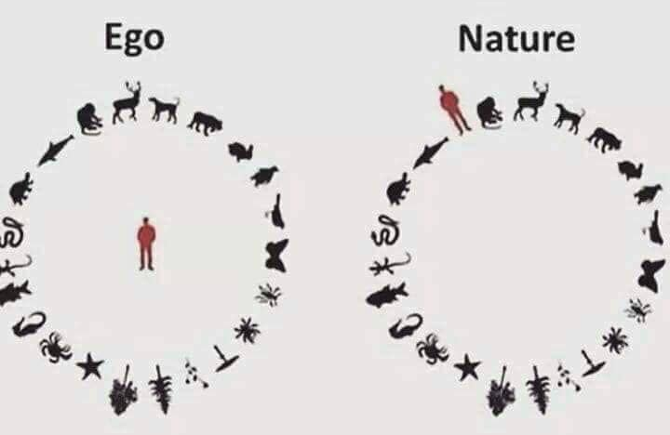Illustration from: Scotty Parks Facebook page

How the concept is manifested into project level and actions, can be seen as a Whereas ‘Do-No-Harm’ approach is commonly used by non-profit sector to validate project planning and minimise harm and risks to any direct or indirect project stakeholders, Romi’s Way approach for all projects starts from the “next level” from ‘Do-No-Harm’ – meaning we aim to “Do-Good” for 1) people 2) animals and 3) environment through all our actions. In practise this means, for each project targeting people we ensure at least one outcome is measuring the benefits for animals and another is measuring benefits for the environment.

We are a small international team of education sector, non-profit leadership, animal-therapy, social farming and environmental researchers team who refuse to give up on the vision of green and sustainable future and who wants to inspire world to take up on minor and major actions together.

Project Summary

Traditional education does not cover the needs of all learners, particularly those of vulnerable children having challenges outside the school hours. These needs are related to psychological, physical, social and emotional needs of the child/youth and they are key development elements to avoid behavioural issues and many obstacles and challenges during adulthood. Therefore Romi’s Way always promotes alternative or added educational components to traditional learning modalities, aiming to increase the overall wellbeing and healthy development needs of ALL learners. World does not need grade-A students, but balanced, respectful and compassionate human beings. We are here to provide this alternative support!

This small project is targeting vulnerable children in school communities in Portugal. By vulnerable, we mean those children and youth who are having learning difficulties due to neglect or abuse, bullying, substance abuse of parents or who have physical or mental disability.

Project Target | 200 vulnerable children (50% boys,50% girls) aged between 6-18 years  60 teachers/ educational staff and parents  10 trained new staff for Romi’s Way
Project duration | 1- year (extendable
Project location | Coimbra District, Portugal
Project cost | 48,000USD/ 43,217EUR year
Project cost allocations summary: | Direct staffing: 20,000USD  Trainings (incl. logistics, materials etc.): 10,000USD  Therapy horses maintenance: 10,000USD  Other operational and overheads: 8,000USD
Project activity summary: | - Baseline study – End-line study and report (impact evaluation)  - Training of teachers on alternative support and how to use natural environment as a learning, healing and developmental platform for learners  - Training of new Romi’s Way staff to become facilitators for project activities  - Art-therapy sessions  - Equine therapy (healing, mediation, body-awareness, integration to art-therapy)  - Nature meetings and gatherings (teacher meetings by walks, community gatherings in Nature i.e. day in social farm or planting trees where parents and children are doing activities together)  - School community meetings and consultations  - Youth Green Leadership sessions  - Training on differences between the past generations and the new generation -focusing on children as the future change makers  - Published report for general public on results

Project goals and outputs

Overall Project Goal is within a year to empower 200 vulnerable children in Portugal with learning difficulties to have the skills, knowledge, green-values and attitude needed to be balanced adults and leaders for green future.

Output 1 (OP1): 200 children from 6-18 years have participated on the project activities (50% girls/50% boys)

OP1 indicators:
# of children participating on activities (target 200)
% of children reporting wellbeing increased significantly after the project (target 70%)
% of children demonstrating improved skills, knowledge, values and attitude towards green-leadership (70%)
% of children demonstrating skills in green-leadership methods

OP1 Activities:
- Art therapy sessions
- Psychosocial support
- Animal assisted Equine therapy with meditations, relaxation sessions, body-awareness sessions, equine/art-therapy sessions etc.
- Nature gatherings
- Youth green-leadership sessions

Output 2 (OP2): 60 parents/ teachers/ educational staff trained on alternative support and techniques using Nature as a learning, healing and development platform

OP2 indicators:
# of teachers/ parents/ educational staff trained
% of trained participants demonstrating improved skills and understanding of alternative learning support and how to use Nature as a learning, healing and development platform

OP2 Activities:
- Community meetings and consultations at schools
- Practical learning in Nature
- Training sessions
- Development of Pedagogical Days (cycle of conferences and lectures, workshops, specific training and activities for the whole school community, including families), to reinvent co-operative education for the 21st century and strengthen relationships in the school and family community

Output 3(OP3): Animal welfare and value is increased and awareness raised for at least 400 public members
OP3 Indicators:
# animals (horses) trained to support human healing, learning and development (Target 3)
# of publications made promoting the alternative abuse-free use of animals as therapy and company (Target 4)
# of people reached by awareness raisings (target 400)
% of people participating on animal-assisted therapy/learning/ development sessions report significant benefits on their wellbeing (target 60%)

OP3 Activities:
- Providing home, care, love, healthcare for at least 3 horses
- training equine-therapy assistants/ facilitators
- conducting an impact assessment and publishing the results on the benefits of horse-assistance in relation to the wellbeing and development of vulnerable children

Output 4 (OP4): Environmental wellbeing and balance is increased in Coimbra district through school community actions

OP4 indicators:
# of volunteers taking part on nature gatherings (target 300)
# of Nature gathering for tree planting/ community gardening/ beach cleaning etc. arranged (target 4)
% of people feeling sense of accomplishment or feeling of ‘doing good’ after the events (target 80%)

OP4 Activities:
- Nature gathering (cleaning forests/ beaches, picking up berries together, social farming day, planting trees, office meetings as ‘walking meeting in the forest’ etc.)
- Community meetings where Nature gatherings are discussed and results reviewed
- Public postings reporting after Nature gatherings

