GREATER HANDS FOUNDATION (GHF)

2019
Organisation’s Profile

TABLE OF CONTENTS
PAGE
2. WHO WE ARE
2. OUR PASSION
2. VISION, MISSION, MOTTO AND CORE VALUES
3. LEADERSHIP STRUCTURE
3. OBJECTVES
4. AREAS/SCOPE OF OPERARIONS, WORK STRATEGIES
4. ACHIIEVEMENTS
6. PARTNERS AND SUPPORT GROUPS, TARGET GROUPS
6. CURRENT PROJECTS/SUPPORTS
6. STAFFING
7. NETWORKS/PARTNERSHIP/AFFILIATIONS
7. CORPORATE CONTACT.
8. PICTURES OF GREATER HANDS ACTIVITIES
10. ORGANOGRAM
11. REGISTRATION CERTIFICATE
12. CURRENT AUDITED ACCOUNTS REPORTS

Who we are:
Greater Hands Foundation (GHF) is a faith-based, Non-political, Non-sectional, Philanthropic, Non-Governmental Organization registered in 2007 with the Cross River State Ministry of Youth Development and Orientation, with subsequent renewals with Cross River State Department of Civil Society and NGOs (Dept. of CSO/NGOs). It has her office currently located at No.22 Ediba Street, off Rigbu-Amba Street by State Housing Estate, Four Corners, Ikom. The office was formerly located at Suite D35, Shopping Complex, (Opposite Zenith Bank), Obudu road, Four Corners, Ikom, Cross River State.
Our Passion:
Women and Children have continued to bear the burdens of the existent inequality in the spread of access to wealth and socio-economic activities that benefits them. Greater Hands Foundation (GHF) was born out of Passion to bridge the gap existed between the under privileged and vulnerable groups especially women and children in our society with right information; and create access to quality health care services, portable water, sound environment, Good governance and quality education, as well as fight injustices meted to these target groups in order to entrenched equal rights and privileges to all irrespective of age, sex, education, tribe and economic status etc.

Vision
A community where equal sustainable economic growth and quality health care is accessed by all.
Mission:
Greater Hands Foundation (GHF) mission is to achieve sustainable economic empowerment, better health, good governance and gender mainstreaming through capacity building initiatives and advocacy by deploying the appropriate (right) strategic approaches for the development of our communities.
Motto: “Except we care, they perish”.
Strategic Goal: GHF strategic goal is striving towards Sustainable Development, Health and Economic Empowerment – (Building Lives and giving hope).
GHF Core Values:
The realization of GHF Vision and Mission is precipitated on our Core Values of;
- Transparency and Accountability:
- Mutual respect
- Teamwork
- Passion
- Commitment
- Equity and justice

Leadership Structure:Greater Hands Foundation has a Board of Advisers and a Management Team. The management team is led by Programme/Project Director;others include Project Officer, Assistant Project Officer, Finance/Administrative Officer, Monitoring and Evaluation (M&E) Officer and M&E Assistant.
Other Objectives include:
- To build networking activities with organization relevant to the programmed of GREATER HANDS FOUNDATION to exchange information, provide campaign support and enhance capacity building with a view to maintaining close link on matters of common interest.
- To encourage, promote and create awareness on reproductive health issues. e.g female genital mutilation (FGM).
- To improve the life of those living with HIV/AIDS, MALARIA and other tropical diseases.
- To enhance and encourage livelihood activities and education development of individuals towards the promotion of sustainable development and empowerment.
- To build respect for the right and privilege of others and the debased in the society including orphans and vulnerable children.
- To enhance understanding of community, national and international affairs with a view to solving the problems associated therewith.
- To defend, promote and encourage youth development and empowerment including orphans and vulnerable children and children living with HIV/ AIDS.
- To improve socio-economic well-being of women and the underprivileged in the society.
- To educate and lead the people especially those devastated spiritually to the need to brazen up to life, know and exercise their God-given spiritual right to succeed in the physical realm without spiritual molestation.
- To improve socio-economic well-being of women and the underprivileged in the society.
- To educate and lead the people especially those devastated spiritually to the need to brazen up to life, know and exercise their God-given spiritual right to succeed in the physical realm without spiritual molestation.
- To gather information, undertake research, link with any group / groups within, or outside Nigeria to ensure the protection, preservation and provision of alternative source of livelihood activities to promote sustainable living.
- To do such other lawful things as are incident or conducive to the attainment of the above objective.

Areas/Scope of Operations: GHF works in the following areas:
- Maternal, Newborn Child Health,
- Sexual and Reproductive Health for Adolescent and Youths (AYSRH).
- Water and sanitation.
- HIV&AIDS, MALARIA, TB, CANCER and other Non-Communicable Diseases (NCDs) Prevention and control among women and children.
- Capacity Building/Education
- Advocacy/Social Mobilization
- Conflict management.
- Good Governance, Budget tracking and Accountability.
And other cross cutting issues like;
- Gender,
- Women and Child’s right & Protection.
Work Strategies:
- Demand creation through:
- Community Mobilisation
- Stakeholders consultative fora
- Public campaign and Advocacy on women and child’s rights.
- Mass public awareness-raising, advocacy and mass sensitization activities.
- Counseling, Referrals and mobile services.
- Capacity-building training s through workshops, seminars, media campaigns and talk-shows/phone-in programs.
- PEP model community program approach.

Achievements:

Over the years GHF has affected the lives of community members especially women and children positively through effective community mobilization, outreaches, Sanitation and hygiene, demand creation for health facility services uptake for pregnant women and women of reproductive age especially the First-time Mothers (FTMs), promoting and enhancing Adolescents Youths and Sexual Reproductive Health and Rights of young women and girls through youth friendly services uptake as well as ensuring positive Maternal and newborn health outcomes for women and girls of reproductive age and promoting accountability in governance in Cross River State. Some of these includes;
- 113 CVs trained and reffering pregnant women to supported facilities ANC, L&D and FP services. 6,000 pregnant women referred for ANC
- Over 6,000 pregnant women referred for ANC
- Over 29,000 community members reached through One-on-one/One-on-group Outreaches;
- Over 3000 pregnant women referred/escorted to facilities for Deliveries
- 24 host Basic Emergency maternal Obstetric and newborn Care (BEmONC) wards assisted to generate local funds (ranging from 5,000 to 50,000 naira) to support Emergency Transport Services in their communities.
- First Time Parents (FTPs) project initiated to increase Family (FP) services uptake and address adolescents youths and sexual reproductive health (AYSRH) issues towards mitigating maternal and new born mortality and scaling up contraceptive uptake in Ikom and Obubra as pilot LGAs; Through this, the following were achieved:
- 25 CHEWs selected and trained for the project implementation.
- 50 peer leaders selected and trained to facilitate peer group sessions.
- Formed 50 groups of First Time mothers (FTMs) and held weekly group sessions for 14 weeks.
- Formed 20 groups of FTM male partners and held weekly sessions for 6 weeks.
- Outreaches conducted to older women as key influencers of FTMs for 3 sessions in 25 groups.
- 606 FTMs Members completed sessions
- 249 FTMs partners completed sessions
- 1616 Older women reached.
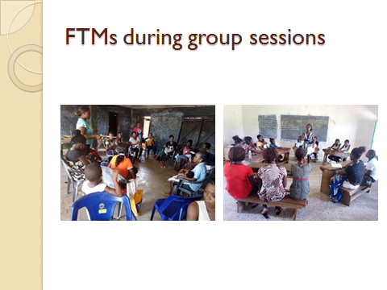

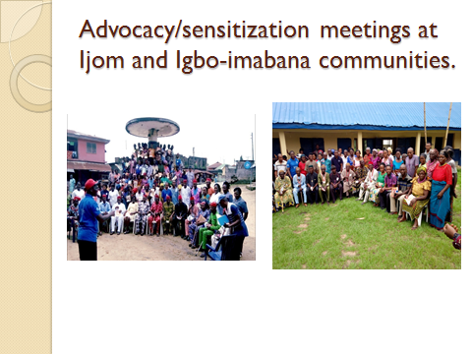

Partnersand Support groups:
- Pathfinder International.
- CUSO International.
- Girls Power Initiative (GPI).
- Cross River State (CRS) Ministry of Health
- CRS Primary Health Care Development Agency (CRSPHCDA).
- CRS Ministry of Women Affairs,
- CRS Ministry of Youths Development,
- CRS Agency for the Control of HIV and AIDS (CRSACA).
- First time parents (FTPs) groups.
- Community Volunteers.
- Other Community-Based organizations(CBOs) and NGOs.
Target groups:
- Women (including pregnant women),
- Men, Youths, Children.
Others include;
- Widows, Orphans and Vulnerable Groups.
- People with Disabilities (PWDs).

Current Projects/ Supports:
- Community-Based Intervention to improve Maternal Newborn Health and Family Planning institutional service uptake and reduce Maternal Newborn mortality in 42 Wards across Ikom, Obubra, Boki, Etung, Abi and Yakurr LGAs of Cross River State under ‘Saving Mothers Giving Life’ with support from Pathfinder International, through USAID – November 2016 – 31st March, 2019.

- Adolescents’ Health Information and Services Project for in-school young people especially girls through outreach programmes/activities in six (6) selected Secondary Schools in Ikom LGA supported by Girls Power Initiative (GPI), Calabar for 15 Months (April 2018 to June 2019).

- Evidence to Action (E2A) for Strengthened Reproductive Health;Addressing Sexual and Reproductive Health and Rights issues/needs of young First time Parents (FTPs) and scale up contraceptive uptake in Ikom and Obubra LGAs with support from USAID through, through Pathfinder International - 2018- 31st March, 2019.

Staffing:
Greater Hands Foundation is currently working with seven (7) full-time staff, 8 office Volunteers, two (2) International Volunteers and 108 Community Volunteers across 41 Wards in Abi, Yakurr, Obubra, Ikom, Etung and Boki LGAs in the Cross River State Central Senatorial District.
Networks/Partnership/Affiliations:
Understanding the importance of networking, partnership/affiliations, GHF is currently partnering with the following networks
- CRS Civil Society Network on HIV/AIDS (CRSCISHAN).
- Water Integrity Network.
- Network of NGOs Ikom.
- Local Action committee on HIV/AIDS (Ikom and Etung LGAs).
- Family Planning-Advocacy Working Group (FP-AWG), Cross River State

Corporate contact:
Office of the Project Director:
No. 22 Ediba Road, off RigbuAmba Street, Four Corners, Ikom
Cross River State,
Nigeria.
Website: https://greaterhandsfoundation.org
Phone: +234-8028977956,
WhatsApps: +234-8037386403
E-mail: greaterhands@gmail.com
Facebook: greaterhandsfoundation.
Skype: greaterhandsfoundation
Twitter: @greaterhands

SOME ACTIVITIES OF GREATER HANDS FOUNDATION IN PICTURES.

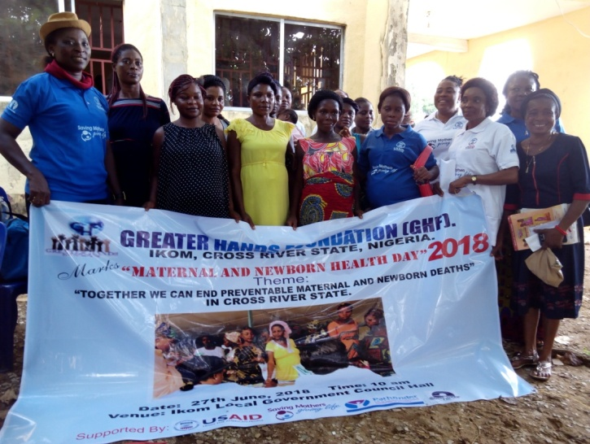
GHF team with pregnant women during 2018 World Maternal Day Celebration

First-time mothers during peer group session in Ababene, Obubra LGA.
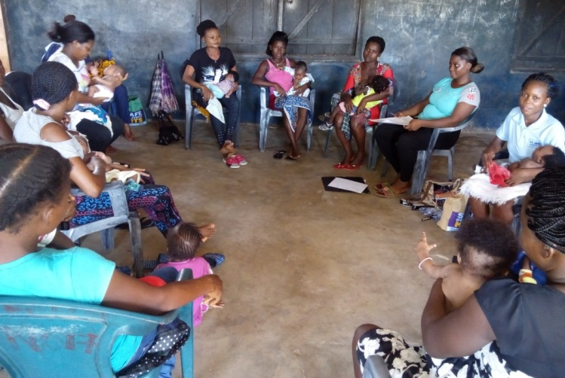

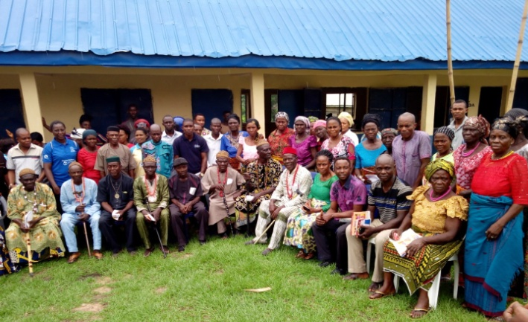
Community members during Town Hall meeting with Greater hands Foundation team at Ababene, Obubra LGA.

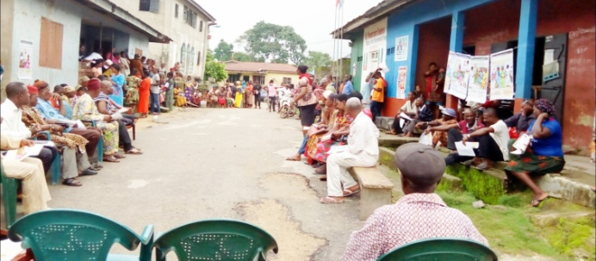
Cross section of Community members during Town hall meeting at Ajassor, Etung LGA.

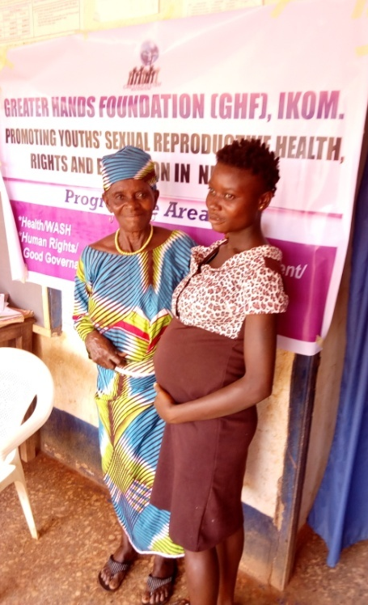
Young and vulnerable pregnant girl being escorted to the health facility during r Greater Hands Foundation Free Ante Natal care registration by her grandmother.

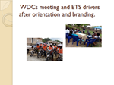

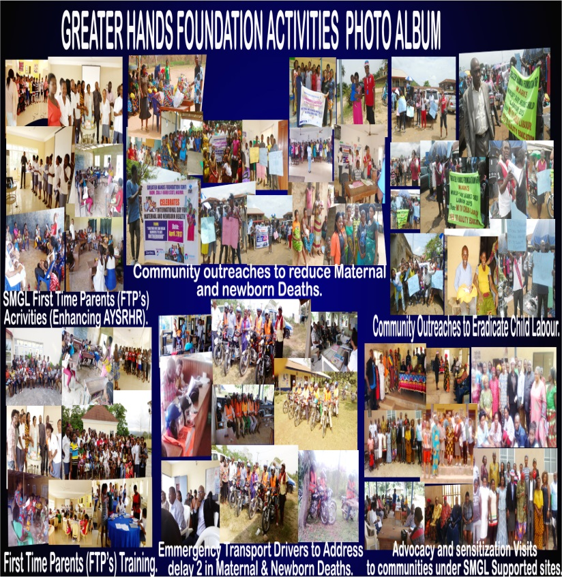

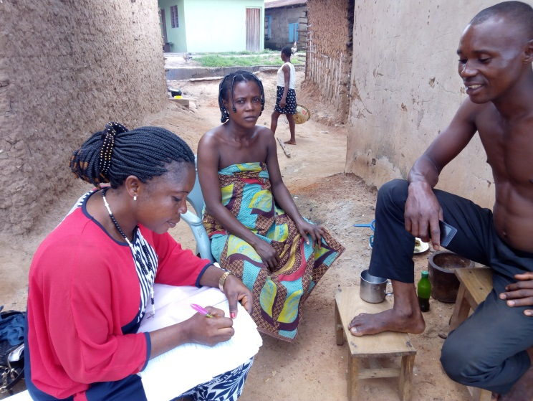
GHF Volunteer during home visit at Ababene, Obubra LGA, filing a referral form for client while the spouse watches in admiration.

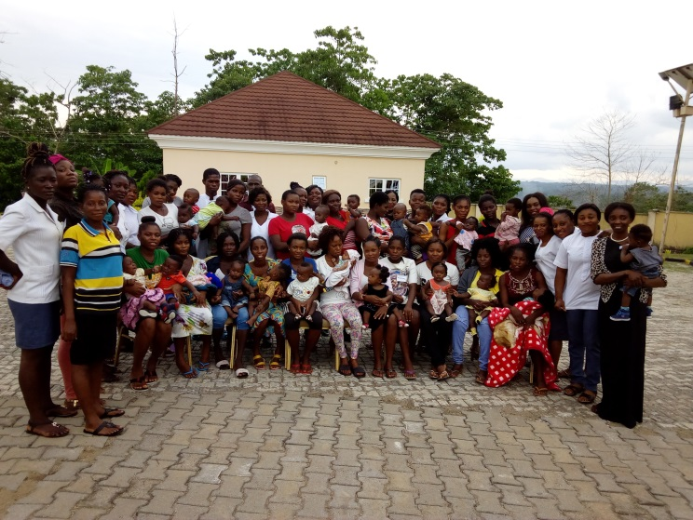
Cross section of Volunteers and FTMs after Training at Ikom.

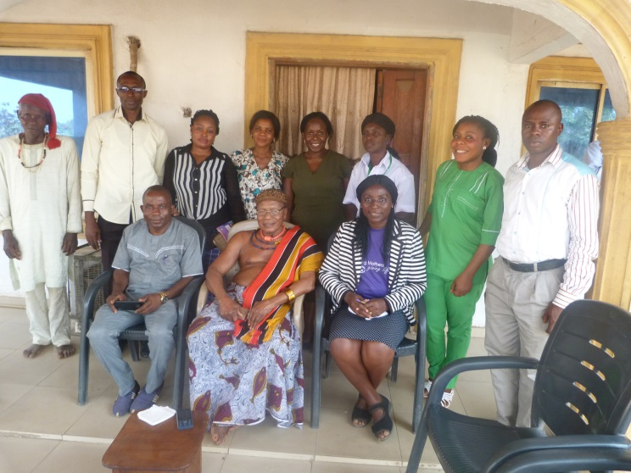
Courtesy Visit to ObolLopon of Nko, Yakurr LGA.

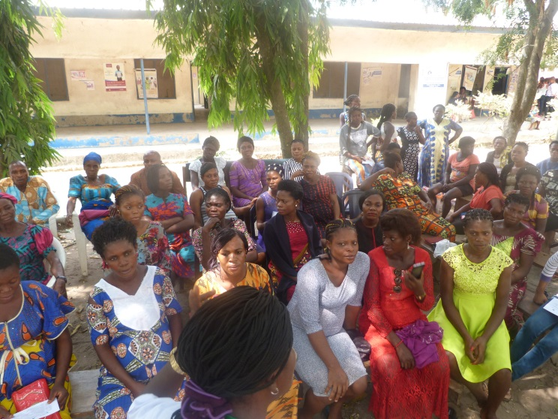
Cross-section of participants during town hall meeting at Nko, Yakurr LGA.

