Tackling Youth Unemployment

Bridging the Skills Acquisition Gap

IFES FOUNDATION

Make a Difference Where it Counts
Youth in countries around the world are unable to find employment, or are dramatically under-employed due to lack of education and training. The problem is worsening year after year, as children born to underemployed parents are not able to get the education they need to lift themselves out of poverty.
Many organisations are attempting to solve this problem, but to date none have really succeeded in reversing the tide. We believe we have a unique solution that brings the necessary training directly to the people who need it most – bringing them from underemployment to the possession of a recognised certification in a high-demand skill in just a few weeks.
IFES FOUNDATION would like to present a project that will make a REAL difference to REAL people and provide REAL solutions to the world youth unemployment problem.
This is not necessarily a totally new way to deal with the problem, but rather an innovative, practical solution for addressing a problem that we already know exists.
Willing, but not Able
The Global Trends for Youth Report 2015 reports that three out of five workers in Sub-Saharan Africa do not have the level of education or training necessary to make them productive on the job. McKinsey Centre for Government reports that in Greece, Spain and South Africa, more than half of young people are unemployed, and jobless levels of 25 percent or more are common in Europe, the Middle East and Northern Africa.
Paradoxically there is also a critical shortage of people with specialised job skills. We have a growing need by the formal sector for skilled employees to fuel their growth needs. Only 43 percent of employers surveyed by McKinsey agreed that they could find enough skilled entry-level workers, often citing the lack of industry-specific workplace skills, qualifications and certifications as their major challenge to either filling vacancies or achieving their desired levels of staff productivity.
Millions of talented youth are stuck in a dilemma: without training they cannot get a job, and without a job, they cannot afford training. Meanwhile, companies operating locally who could benefit from enthusiastic young workers continue to bemoan the lack of skilled candidates.
While facilities are currently in place to provide some vocational training at government TVET-colleges, private institutions and in-company training programs, these are not filling the gap and too many motivated young people are financially and physically unable to gain access to the training they desperately need.
Many current initiatives under way focus on providing traditional academic education but these are unfortunately discovering that an unemployed person with a senior school certificate remains an unemployed person until they have a practical skill set that is needed by industry or the private sector.
IFES FOUNDATION would like to propose an effective way to make a real difference in the lives of unemployed youth.
Rapid Results of the Right Kind
At IFES FOUNDATION, we believe we could make the greatest impact on this problem in the shortest period of time by identifying promising hard-working candidates and providing them with the best suited vocational and technical skills they require to become instantly employable.
Specific vocational skills along with recognised certification will immediately improve the employment prospects of underemployed youth. By aligning the provision of skills to the scarce skills needed in a specific geographical area – for example, masonry certification in a city with ongoing construction projects – we have the ability to transform underemployed young people into highly sought after prospects.
IFES FOUNDATION is a training and skills development organisation with a global footprint, and we know how to create effective training programs that produce results.
However, we cannot make the major impact we would
like to on our own.
We are looking for a number of forward-thinking organisations to get involved with us to use vocational training to turn around the prospects for the youth and build a better future for them.
We want to partner with private sector companies, funding organisations, governments and NGOs to create Vocational Training Programs and fund the ongoing training at our centre to allow unemployed, poverty stricken youth to complete these programs and receive the skills they need to productively enter the workforce.
We have internationally and locally recognised accredited programs, experienced trainers, access to training centres, partnerships with youth organisations to provide students and a wealth of experience in running these kinds of projects.
All we need from you is your financial support for
this life-changing initiative.

Community Vocational Learning Centre
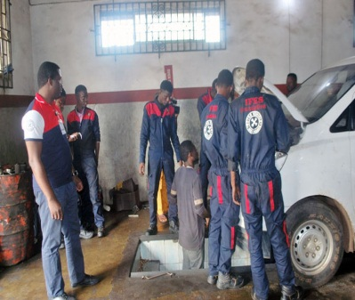
The IFES FOUNDATION Vocational Centre project will work with a variety of partners from the private sector, funding organisations, governments and NGOs to impact more than 1 thousand youth per year by setting up Technical/Vocational training programs working with impoverished communities where the skills are most desperately required
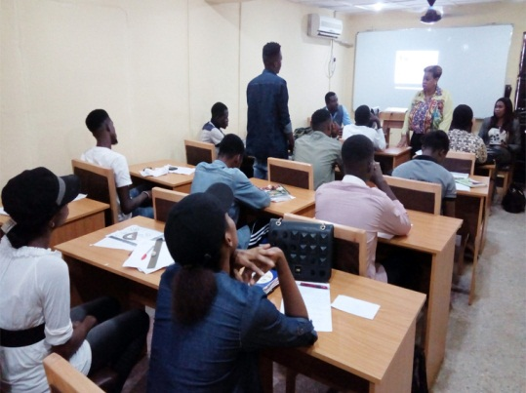
The Vocational Learning Centre is a stand-alone training facility that will be branded and supported by a funding partner that will be located in or near local communities.
This centre will deliver practical vocational courses leading to recognised international or local qualifications on subjects most relevant to the community, industry or State where the centre is located.

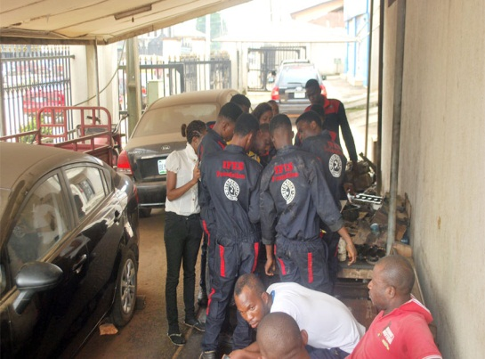
IFES FOUNDATION will work with non-profit organisations active within youths in the community to source and prequalify unemployed youths to be offered places on these training courses. Students accepted onto the programme will be provided with full Personal Protective Equipment (PPE) and in some cases, paid a stipend to cover their travel costs. The courses run over three to four weeks, and at the end, the students are assessed and issued with a recognised qualification, and where possible, assisted with finding employment.
The training centre will be set up to exit between two hundred and one thousand students a year. The scope of the training offered is wide-ranging - from traditional artisan roles – welding, plumbing and electrical to construction, painting, automobile and carpentry to less manual skills such as hospitality, retail, call centre and even basic work readiness in the administration field.
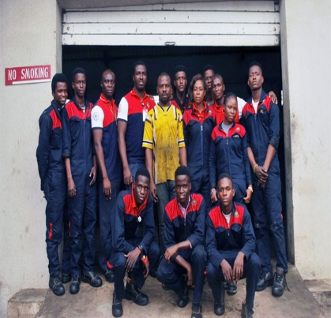
Give back to your community – or make an incredible and memorable difference in the lives of those who need a chance to succeed. Your sponsorship comes with full branding rights, the pick of the students if you need staff and many other positive PR opportunities. We hope to see many of our funders build incredible legacies that will forever be remembered.

How you can get Involved
IFES FOUNDATION is looking for dedicated partners to help make a real difference in the lives of young people. We are looking for funders who will make a 1-3 year commitment to helping us set up centres and start imbuing the youth with vocational skills.
Each Project is completely ready-to-go and IFES FOUNDATION will manage every step of the process and has the experience to do so efficiently and effectively. We will project manage the creation and equipping of each centre, create the curriculum, provide excellent trainers in each skill, locate and prequalify promising students, arrange for certification and even help our students secure employment after the program is completed.
Sponsors in return will have the right to put their name and brand on the centres in which they invest, provide input into the location, skills trained and even the student base to align this with their specific social responsibility objectives. Sponsors are encouraged to create awareness about their involvement in the program, while IFES FOUNDATION will work to ensure their participation is recognised by maximising the exposure and positive PR opportunities that arise.
Your sponsorship means that thousands of young people will be influenced every year, markedly improving their job prospects, their income, and the quality of life they can provide for their families, bringing the next generation even greater prospects in higher education and ultimately making a real difference to their economies.

Vocational Skills for Employment
Vocational skills are, quite simply, the skills you need to prepare yourself for an occupation. This can include traditional craftsman skills such as masonry and carpentry, but also extends to many other skills in the manufacturing, transport, hospitality, services and retail industries.
IFES FOUNDATION solution to the unemployment crisis is to promote training courses at our centre that are intensely practical in nature and include not only the hard, practical skills young people need to win jobs, but all courses include a “Work Readiness Module” which includes elements of basic communications, business etiquette, interpersonal skills and interview skills to ensure that our candidates stand the best chance of getting a job and making a long term success of this employment opportunity.
Put simply? Our students walk into our classes underemployed or unemployed. Two to four weeks later, they walk out with the skills they need to get job offers. You can’t get much more direct results than these.

