Child Protection Society Organisational Profile

Corner Snowdon & Herbert Chitepo
+263 242 710024/5, 8677 004814
www.cps.org.zw

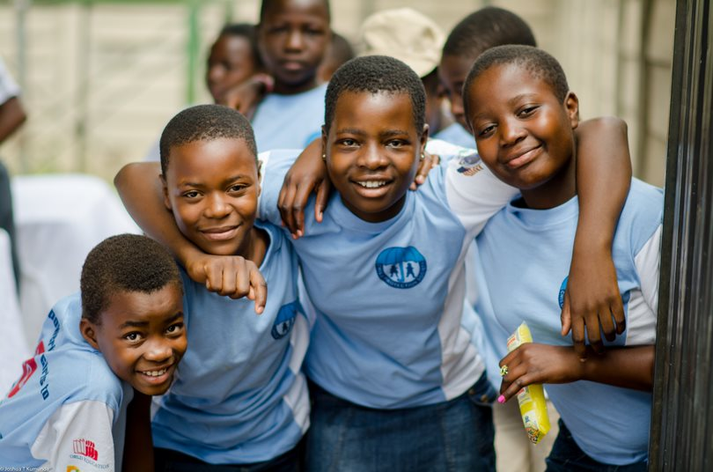
2019

Who is Child Protection Society?

Vision: “A child friendly society, which facilitates the achievement of full potential for every child”.

Mission: “To protect and promote the well-being of all children and assist them to be self-reliant and responsible citizens”.

Child Protection Society (CPS), headed by Mercy Sakanya as the Country Director, is a non-governmental child rights organization based in Belvedere, Harare. The organization has projects implemented across all 10 provinces of the country. CPS began operating in 1952 with Day Care Centers, in Belvedere and Eastlea, for children from underprivileged families. In 1962, the organization established a residential care institution, Chinyaradzo Children’s Home in Highfield, Harare, for orphaned and vulnerable children on a place of safety basis, marking the Society’s institutional child care programme. In the 1970s, CPS began child rights advocacy work in an effort to promote the welfare of all children in Zimbabwe and transformed this initiative into a fully-fledged Child Rights Advocacy Programme in the 1990s.

In 1998, CPS initiated a multi-pronged transformation of its programming to respond to the growing impact on children with HIV & AIDS. This was done by introducing the community-based child care programme which aimed at building the capacity of the communities to look after orphaned and vulnerable children (OVC). The organization has, therefore, evolved into implementing Education (ECD, primary and secondary school) projects, Early Childhood Stimulation, Nutrition, Health, Child Protection, Parenting, Economic Strengthening and Adolescent Empowerment projects.

2.0 Governance structure
CPS is governed by an Executive Committee that is composed of highly experienced professionals from various disciplines. A finance sub-committee oversees the financial management of the organization and the treasurer acts as the internal auditor. The organization has well developed systems for human and resource management. Financial policies are in place to control all expenses in the organization. An Annual General Meeting is held to project future activities, review audited accounts and elect the Executive Committee every consecutive year. The day to day management of the organisation is overseen by a full-time director who works closely with a management team of professionals.

Organizational structure
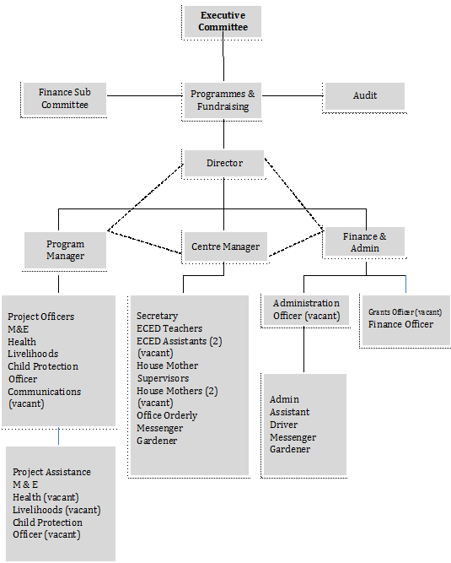
3.0 Strategic Focus
Goal I: Promote Early Childhood Development Education and Stimulation
CPS works with vulnerable communities, and in the context of education, vulnerable schools, particularly those in peri-urban, rural areas and informal settlements. These are typically characterized by lack of access to basic services, cater for the low-income populations, are resource constrained and are unable to provide quality education to learners. In some cases, distances to school are long, resulting in high levels of absenteeism, and in light of ECD lead to lack of prioritization of children attending ECD. These communities are additionally most affected by vulnerabilities such as floods and droughts leading to poverty, food insecurity, and undesirable coping strategies amongst others.

Further, vulnerable children, particularly those in rural areas, lag in developmental milestones due to various factors including lack of knowledge in early childhood stimulation (ECS) on the part of the caregivers, malnutrition, disability and HIV, amongst others. Child Protection Society’s strategic focus is to work with these communities by improving access to ECD, retention of children in early learning and adequately preparing them for transitioning to primary school. Moreover, the organisation’s focus is to improve communities’ knowledge on ECS, promote children’s rights to early learning and create awareness within government to support, provide resources and adequately fund early childhood development in schools.

Goal II: Increasing policy makers’ and service providers’ consciousness of children’s rights
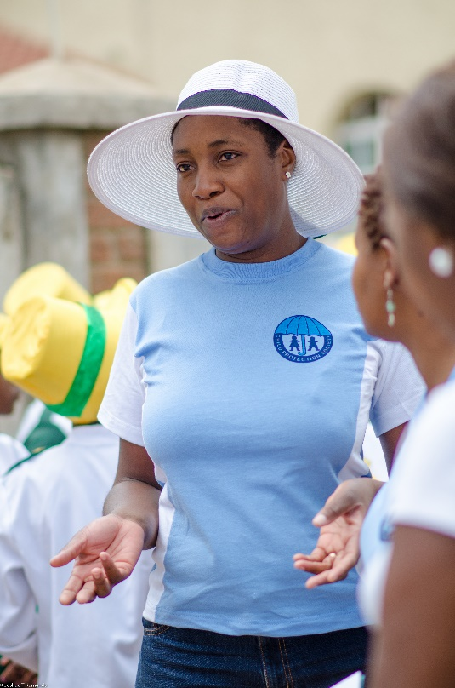
Vulnerability of children is increasing due to HIV, poverty and disabilities. Additionally, children affected in emergency situations become vulnerable due to displacement and family separation. Advocacy is aimed at provincial and national level for pro-child policy framework, child friendly service delivery and prevention of sexual exploitation and abuse in regular and emergency programming.

Goal III: Promote successful reunification amongst children in conflict with the law and on the streets
Noting the risk of family separation for children in conflict with the law with regards to gaps in rehabilitation, Child Protection Society aims to address the issue through the development of a national rehabilitation strategy for children in conflict with the law. The outcome of the strategy is to benefit both children in training institutions as well as children on the streets promoting sustainable reunification.

Goal IV: Promote adherence to treatment for children on second line treatment
Acknowledging the negative effects of failed adherence to treatment on first line treatment, and aligning to the new 95 95 95 UNAIDS goal, the organization seeks to promote adherence for children on both first and second line treatment. This comes from the rate of deaths in adolescents from HIV/AIDS due to failure to adhere to treatment giving way either to opportunistic infections and/or challenges in accessing third line treatment which is typically expensive and has low availability.
CPS COUNTRY DIRECTOR

Goal V: Promoting utilization of Information and Communication Technologies (ICTs)
The organization acknowledges the positive influence of social media in bringing awareness to child protection issues and aims to utilize these platforms to create dialogue around current child protection topics. Additionally, the organization’s strategic focus is to utilize ICTs to develop management information systems which will improve programming in child protection.

4.0 Objectives and Programming Areas

The objectives of CPS are as follows:
- Promote and protect the rights of all children
- Provide holistic support, child and social protection for all children
- Strengthen community capacity for protection of children.

These are achieved through the following three core programmes which include:
School Readiness Initiative
This project focuses on early childhood development in 8 districts in Manicaland, Mashonaland East, West and Central. The project aims to establish processes of joint responsibility for early learners, improve access to quality ECD and enhance competency of educators on early learning. The major outcomes of the project being to influence prioritization of resource mobilization around ECD within government from national to community level thereby improving access to early learning, in addition to retention of children in ECD and ultimately transitioning into primary school.

Child Protection for Children in Alternative Care
Implemented in 65 districts and 10 provinces of Zimbabwe, this program focuses on children in alternative care including children in residential care institutions, children in foster care, in training institutions and children on the streets. The program is implemented in partnership with the Department of Social Welfare and funded by UNICEF. The program is disability inclusive and HIV sensitive, as well as pays special focus to children in conflict with the law, children on the move and children living and working on the streets.

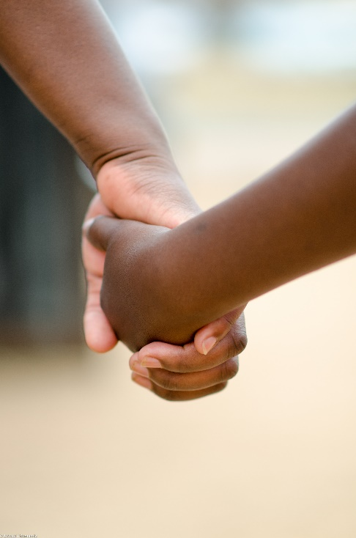
Promoting Adherence for Adolescents on Second Line Treatment
Targeting adolescents between the ages of 10 to 18, this project aims to provide adherence support to children on second line treatment. Through this project adolescents are assisted with access to treatment, home visits for adherence support, linkages to support groups and nutrition support.

DREAMS: Girls Empowerment Program
With a history of in working with adolescent girls and young women (AGYW) from 2014 Child Protection Society is engaged under DREAMS as a technical partner to organization rolling out the program in Gweru, Mazowe, Gutu, Chipinge, Buhera and Mutasa, amongst other DREAMS districts. Through the organisation’s technical capacity partners have rolled out adolescent girls empower (AGEP) group sessions, provided second chance education to young mothers, established mentorship programs and increased employability of AGYW through training in work readiness and vocational training.

Chinyaradzo Children’s Home
Child Protection Society runs the Chinyaradzo Children’s Home Units in Highfields. The home has sheltered children in need of care and facilitated in the tracing and reunification of children in addition to foster care placement.

5.0 Key Achievements

5.1 Awards
The organization received 5 awards in the implementation of the Vana Bantwana (VB) Project mainly focusing on children in ECD, primary and secondary school. Awards received include most effective, reaching one of the highest number of children in the project, most efficient in terms of utilization of funds against reach and partner reaching most vulnerable groups particularly adolescent girls.

5.1 Strengthening and Monitoring of National Residential Care Standards
The organization developed national residential care standards which were adapted by the government of Zimbabwe and is currently utilized for residential care institutions monitoring visits for compliance checks and the developments of action plans towards improvement.

5.3 Foster Care Handbook
The first of its kind, the organization, together with the Department of Social Welfare developed a foster care handbook. Recently validated, the handbook will guide inform foster parents on critical issues including statutory and non-statutory guidelines and parenting.

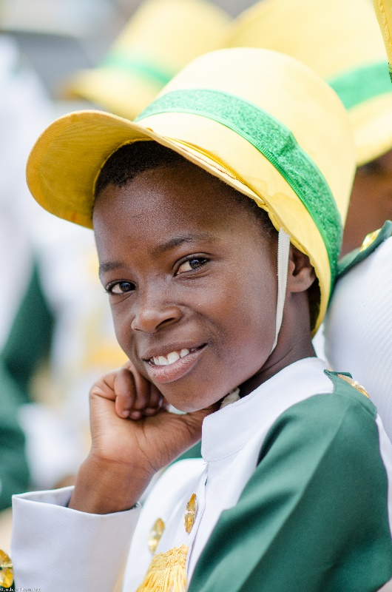
5.2 Child protection for children in care
The organization has established child protection surveillance structures through child rights and safeguarding training for children and caregivers, establishment of focal persons for reporting and suggestion boxes for anonymous reporting. Child protection cases have since been reported through this system

5.3 Development of MIS for children in alternative care
Although in the formative stage, this innovation will improve programming at national level in terms of child protection, facilitate progression in data analysis and use of data in improving the quality of care for children in residential care and training institutions. This MIS will complement the existent National Case Management MIS.

6.0 Financial audits
The organization has a clean audit record, audited annually by independent, external audit firms, in addition to audited by donor organizations for transparency and accountability. The latest report available is for FY18 records.

