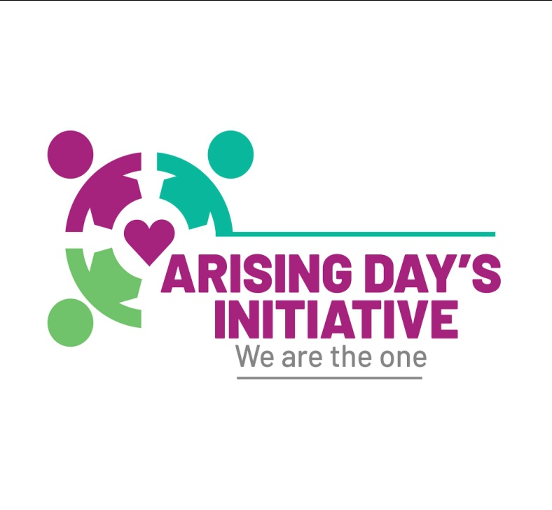 ARISING DAY'SINITIATIVE,
38 DONGWE ROAD,
KAMWALA, LUSAKA.
Email: arisinggroupzambia@gmail.com

THE AWARENESS PROJECT OF A GIRL CHILD FOR POVERTY REDUCTION
RAISING THE AWARENESS OF EARLY PREGNANCIES AND MARRIAGES
Pregnancies are most common in teenagers and adolescents of our time. This makes Arising Day’s Initiative sad as it mostly leads a girl child into early marriage. And being a country victimized of the above stated issues, Arising believes in changing the mindset of the society on a girl child. These two stated items cannot be completely wiped out but rather be reduced through raising the awareness. There are a lot of issues leading to the above mentioned items but the main of it being poverty. Poverty is the state of being extremely poor or the state of being inferior in quality or insufficient in amount. As a country that believes in helping and building a better world, Arising day’s initiative join in the fight for Human Rights on the girl child.
Believing in the girl child's future, Arising is carrying out a project to promote and protect a girl child and this program is called THE AWARENESS PROJECT.
The awareness project is implemented for the benefit of the girl child
We propose that: When The sponsors provides sponsorship (Funding) for the awareness project, the Arising team will move from town to town, city to city in discovery of schools and communities with highest rate of girl children school drop outs. Some of the areas are well known but this is a long-term project that needs the whole country to know about.
There are many challenges the girl child faces that lead them into getting pregnant and eventually married. In order to prevent this from continuing, the following solutions can be offered:
- Providing the necessary requirements to a girl child: Girls lack the necessary requirements during the girl child special time of the month. If the sponsors can provide detergents, Hand wash, soaps and pads for maintaining hygiene to ensure that the girl child friendly environment is created as they would always be in school. This should be done in both rural and urban schools to prove the direct way of improving a girl child’s life. Lacking the above necessities in many homes, leads the girl child into having sexual relationships to carter the above items and leading them into pregnancy.
- Providing transport solutions to girls traveling long distances getting to school: This is very common in rural areas where the girls travel long distances to get to schools while others resort to being in weekly boarding homes which also makes them spend more and lure themselves into sexual relationships with older men or schoolmates to help them with other needs. With the above scenario, I) the sponsors can undoubtedly prove to be passionate about improving a girl child’s life by funding the construction of a mini boarding house where the small number of girls travelling long distances to get to school will be staying. It will be easy to monitor the girl children by teachers as they will always be in the hands of the school. The mini boarding house will then be branded with the sponsor’s logo and pictures with a statement “Funded by ………………………………., II) the sponsors can also provide labelled bicycles for the girl children that travel long distances. This will mostly enable them to attend prep as the issue of worrying about getting home late will be no more.
- Teaching parents in the community: Teaching the community that the girl child is not for sale but should be taken to school and be educated will help parents realize and change their mindsets on the girl child. Forcing the girl child to getting married at a tender age should be emphasized against. If a girl child is learned, she becomes the pillar of the community and enhances community developmental programs.
- Empowering girl child parents with business grants: Many single mothers are widows or divorced, and it is due to this fact that they become marketers who sell goods in order to sponsor their children’s education; they also make a living out of the same business which commonly makes some lose capital as they have a lot of responsibilities to sort out in their homes for the kids. Helping those who lost their businesses, would really improve their girl children’s academic performances. The girl children would not worry about their school fees and other needs once they see their parents provided with grants hence their academic performances will not be affected and we will have more girl children who are learned.

A girl child is the mother of the nation and has to be treated like one. Working with a girl child, the sponsors will have direct access to people and their contacts in the society as we will be conducting the awareness project in the society hence the company, sponsors, donors or government will have more people wanting to work with them for the good deeds being done in the community.

CONDUCTING WORK SHOPS FOR THE AWARENESS

The ministry of education should really help on this one to build up and spread the awareness to every corner of the nation.
Schools will be the first priority of this project due to the fact that a lot of girl children have stopped school after becoming pregnant and getting married. This hinders and ends their dreams of pursuing further studies as they have a lot of responsibilities and many times not having money to continue with their education.
Raising the awareness project in schools will help a girl child to be protected because we teach both the girl child and the boy child then make them understand the reasons why a girl child drops out of school? Teachers need to understand the rights of a girl child and teach more about the awareness too. Schools are the foundations of every leader in the country or the world, hence setting a strong core of the awareness in schools will really help a girl child’s protection.
Working with HEAD TEACHERS in schools to help set up a long-term and teaching project is the aim.

USE OF MODELS AND ROLE MODELS TO SENSITIZE THE AWARENESS
Amongst Zambian models and role models, some had children at a tender age when they were not even in the state of becoming mothers. It would really carry wait if they stood up and taught their young sisters concerning the dangers of early marriages and pregnancies. The models to be used for the project will also be the face of the sponsor’s projects in the future. It is a girl child project hence it has to be a ladies program.
This will give the sponsors a very good reputation in the country as ladies are always being left out on many projects. This will then follow the human right to freedom from discrimination based on gender, age, race, color, language, religion, ethnicity, or any other status, or on the status of the child's parents. And the sponsors will be given credit for that.

PRINTING OF T-SHIRTS FOR THE AWARENESS PROJECT
Both Arising Day’s Initiative (ADI) and the sponsors will require their logos to be put on the t-shirts that will be used for the awareness project. Everyone involved in the project will be required to put on the T-shirt with logos upon presenting the awareness project. The t-shirts will have the following: 1. Depending on the agreement between the two parties, either the front or the back of the t-shirt will have; a) Awareness project of early marriages and pregnancies, b) Arising Day’s Initiative and the sponsor’s logos.
Some t-shirts will be used as give away for the project; this will enable fast spreading of the awareness project especially on the teaching events, radio and TV.
USING ARTISTS TO TALK ABOUT THE AWARENESS AND INFLUENCE THE MOVEMENT
Artists are the fast, reliable, strong and easy tools to use for the spreading of the awareness project. Sponsoring the video for the song dedicated to the project will make the awareness project move fast and easy to understand by the society. A wide coverage of radio and TV stations would help to build a project that will stick to people’s hearts and minds. Arising has a song dedicated to the awareness project and it is titled “Tingachinje”. The song talks about loving and changing the lives of people in need but mostly a girl child. It would be great to spread the song, market it and play it at every awareness event. The song features various artists. The sponsors will get more business recognition through sponsoring the awareness song as it will be another form of advertising the company in the video.
Using the renowned and influential female and male artists will help the movement to be strong and get to the fans and the whole country fast. Following their fan base and their music will make the project get direct to the people in the country. Cleo-ice Queen, Mampi, Macky2, Bflow, Chef 187, Slap Dee, Bobby East and many other maybe influential artists to work with on the awareness project.
OFFERING OF SCHOLARSHIPS TO A GIRL CHILD
In the society, many school leavers or some that are still completing their grade 12 are lacking sponsorship of going to college or university. Offering of scholarships to the girl child in need will build up the reputation of the sponsors.
Doing what the community is lacking, will build the reputation of the sponsors in the society. By picking girls that need sponsorship, arising team will be on discovery (Provided with transportation by the sponsors) of girls who are school drop outs but willing to go back to school and girls from families that are vulnerable with challenges of paying their school fees. We are targeting 50 girl children (5 per province) but depending on the fund we will receive, we can add more girls in the country and they have to be going into grade 11. We need to pay their school fees, buy all the necessary requirements for them to be in school.
This will lift up the image of the sponsors to the society in all the 10 provinces of Zambia. It will also help the sponsors to have a close relationship with the community as they are doing community development.
CONDUCTING INTERVIEWS ON RADIO AND TV FOR THE AWARENESS PROJECT
The awareness project is not only budgeted for the road show program, but also be put on radio and TV for raising the awareness to everyone in the country and the world at large. Using all media platforms will really help the awareness to spread at a super-sonic speed. Other Medias to be used are: Facebook, Twitter, Instagram and Whatsapp.

PASSION FOR WORK
Arising team has a passion of working towards bettering the community. This will prove in the event we hosted for Miss Matero on 2nd march, 2019 in which the Queen Lisa Chansa was awarded the grand prize of K1000. This is just one of the community events we hosted to help promote and empower a girl child though our main goal is to help a girl child be educated. Gladly the winner was able to start up a small business. At arising we believe that without passion we are unable to go far because we need to have a driving force within us. We have so far hosted more than 5 events in which all of them were financially motivated by the contributions of the Arising members. The proposed project will go up to 2 years in Zambia but if the sponsors are willing to use the Arising team go to other African countries to spread the awareness, it will be a fulfilled vision for Arising.
ARISING DAY’S INITIATIVE is a charitable, non-profitable and non-governmental organization founded by a team of vibrant youths teaming up to fight for a better change of tomorrow beginning with the community. The foundation of every leader begins from the community. The community has very few programs to teach and educate their people on the things that affect the society hence all things or offences being done seem to be normal to some extent for them, therefore Arising comes in to advocate against;
- Early marriages
- Early pregnancies
- Gender based violence
All the above being what we advocate against. Choosing a girl child project was driven from the large number of child mothers in the society.

ORGANIZATION AND BANK DETALS:

Name: Arising Day’s Initiative
Registration no 120190001141
Activities: Arts, entertainment and recreation
Email: arisinggroupzambia@gmail.com
Contact person: JAMES CHIFUMPUKA
Position: DIRECTOR
Cell : +260964612239
T pin: 1018497753
Bank name: First National Bank
Account no. 62819604902 (FOR FUNDING)
Name under Account: Arising Day’s Initiative

