NAME OF THE ORGANISATION
SOLVING AFRICAN YOUTH ISSUES TOTALLY (SAY IT)
TITLE OF THE PROPOSED PROJECT
YOUTH EMPOWERMENT THROUGH GOAT ENTERPRISE (YEGE)

MAIN CONTACT
TUSINGWIRE OBED
EXECUTIVE DIRECTOR
+256777246640/+256782287041
tusobed@gmail.com/sayityouthgroup@gmail.com

POSTAL ADDRESS: P.O Box 11
KIHIHI-KANUNGU-UGANDA-EAST AFRICA

REGISTRATION NUMBER: 1468/18

FACE BOOK PAGE: https://web.facebook.com/Solving-African-Youth-Issues-Totally-238408913508942
Our website: https://www.trepup.com/solvingafricanyouthissuestotallysayit
https://www.instagram.com/tobedson
https://www.linkedin.com/in/tusingwire-obed-restorer-373b61164
https://twitter.com/TusingwireObed

TIME FRAME: 3 YEARS
ESTIMATED REQUEST: 143,338,000 ($38,740)
EXECUTIVE SUMMARY
Solving African Youth Issues Totally (SAYIT) is a Community Based Organisation in Kanungu District-Uganda that seeks to support youth to start income generating projects to fight poverty in their communities. The founding members of the organisation have so far bought 1,000 birds to generate sustainable income for themselves. Seeing how lucrative group projects are, they desire to spread their impact to other needy youth in Kanungu District. They shall select needy 60 female and 40 male youth from their existing groups to benefit from Youth Empowerment through Goat Enterprise (YEGE) Project. Each youth will be given 3 female goats and be supported to access good male goats for breeding. Each of the 100 youth will bring back 2 female kids to the organisation to redistribute to other needy youth. More youth up to 500 will be selected to benefit from female kids first beneficiaries bring back to the project before December 2021. Youth have knowledge of goat rearing from their families and communities. Their households also have land where to rear them from; and, good enough goats have high direct local market the reason why they believe youth will benefit greatly. The organisation will train the beneficiaries how to care for goats and make manure from goat houses to improve productivity of crops they grow. The beneficiaries will be selected from the poorest villages of Kihihi, Kayonza, Nyanga and Nyamirama and mobilised into groups called Village Goat Rearing Associations (VIGORAs). At the end of the project, the groups will be organised into Kanungu District Goat Rearing Association (KAYOGORA) which shall help the young goat farmers to change the trends in the goat business in Kanungu District. To fully execute this project, the organization needs 143,338,000/= (One hundred forty three million, three hundred thirty eight thousand Ugandan shillings only) equivalent to $38,740 (Thirty eight thousand, seven hundred forty US Dollars only) to start with. $387.4 mobilized can provide all goats and the stated services to one youth throughout a period of two years.

BACKGROUND OF THE ORGANISATION
Solving African Youth Issues Totally (SAYIT) is a not-for-profit Community based organisation that acts as an advocate for young people in Africa to access basic needs and quality services. It was founded by Tusingwire Obed who served as an advocate for young people in poverty in Compassion International-Uganda for 4 years. As a poor child unable to afford education beyond Primary, he was sponsored by a gracious family from Europe through the Diocese of Kinkiizi Church of Uganda-Anglican. Their sponsorship enabled him to acquire Secondary and University Education after which he was able to serve needy children and youth like he was. He understands needs of young people that call for concerted effort to be met. The organisation was registered under the laws of Uganda at Kanungu District Local Government and authorized to serve young people in Africa-starting from Kanungu, to remove them from all forms of poverty as their slogan says “It is our commitment to kick poverty out of Africa forever.” They believe that when youth are empowered with quality education, income generating skills/projects, good health care, proper nutrition, and protection from abuse, they can transform their communities through good leadership, advocacy for human rights and provision of quality services to all people irrespective of their differences. Now the youth in this organization are mobilizing fellow youth in Kanungu to start income generating projects in groups.

VISION, MISSION AND OBJECTIVES OF SAY IT
VISION
A self-sustaining African youth
MISSION
Establishing a youth driven community development model
OBJECTIVES
Our organisation has three major objectives as shown below;
- To increase employment opportunities for the youth
- To encourage youth to join the global campaign of protecting the environment
- To encourage youth to promote food and nutrition security in their communities
OUR SLOGAN
“It is our commitment to kick poverty out of Africa forever!”

OUR CORE VALUES
Integrity, Open-mindedness, Innovation, Equality, Advocacy and Focus on young people

ACHIEVEMENTS OF SAY IT
- We started our organisation on July 5th 2018 and registered it at Kanungu District Local Government on 23rd October 2018.
- We started when we were 34 members in one group. We mobilised more youth. The total number of youth has reached 250 in 11 groups.
- We started when we were dealing in poultry. We started with 200 chicks. Now we have 1,000 birds ready for sale
- We also have gathered 10,000 Omumba tree seedlings ready for planting to conserve the environment
- The five groups have a Village Saving and Loan Association as a microcredit. We pool resources and start our own projects
- We have written 5 other proposals to mobilise funding to strengthen the groups and other youth we shall mobilise into more groups. They are;
- Hunger Riddance through Rice Growing By Youth (HURRY)
- Youth Empowerment through Fruit Growing and Processing (YEFP)
- Youth in Poultry for Poverty Alleviation (YUPOPA)
- Youth Empowerment through Skills Training (YEST)
- Clean spring per village

PICTURES OF OUR CURRENT POULTRY BUSINESS
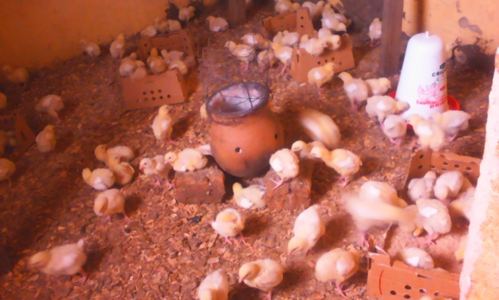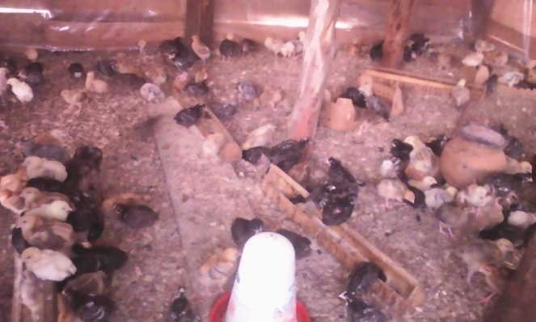

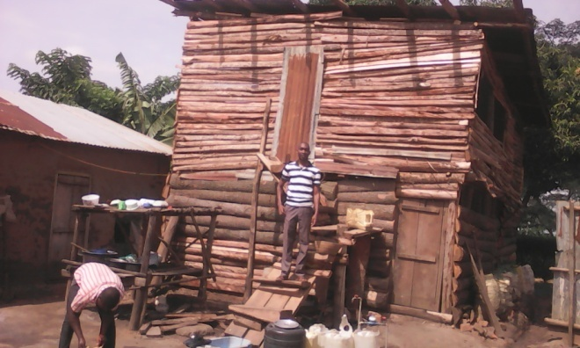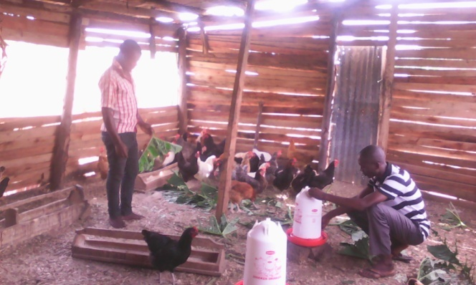

Picture1: 200 broiler batch
Picture 2: 800 Croiler batch
Picture 3: our first poultry house
Picture 4: Obed the Executive Director feeding the Croilers

RATIONALE FOR YOUTH EMPOWERMENT THROUGH GOAT ENTERPRISE (YEGE)
Youth Empowerment through Goat Enterprise (YEGE) is a project designed to enable 1,000 youth to obtain sustainable income from their own established goat enterprises to support themselves. It will support 300 females and 200 males. It is intended to run for 3 years to cover the District of Kanungu-Uganda. We have noted that most of the poor youth in Kanungu, either failed to go to school or failed to continue schooling because of poverty. Females are more affected than males. The underlying factors are; unwanted pregnancies, poverty and negative attitude of parents on Girl Child Education. When girls drop out of school, they run into early marriages where they have low ability to make wealth because of lack of skills and access to productive resources. As a result of this, the cycle of poverty is repeated. To break this cycle in our communities, SAY IT has provided an innovative solution. They will partner with every one willing to provide goats to needy youth in Kanungu District. They will ensure to distribute them carefully to the selected beneficiaries beginning from the neediest of the needy. Goats are locally adapted, resistant to diseases and can be kept by tethering. People in Kanungu have enough land where to rear goats from because families possess land which youth access from their parents.
Goats have a direct high local market; therefore, youth can easily convert the goats into money when selling time reaches. Good enough, SAYIT’s staff will train beneficiaries on modern methods of goat management and support them in financial management and planning for the funds received from sale of goats.

OBJECTIVES OF YEGE
Our strategic objective is to have at least 500 youth in Kanungu District sustaining themselves using income generated from their own Goat Enterprises by June 2022.
Specific objectives of this project are;
1. To support at least 500 needy youth to start Goat Enterprises for income generation to fight poverty in their communities by December 2022
2. To train the 500 needy youth good methods of goat rearing for sustainability of the project by December 2022
3. To assist at least 500 goat farmers access credit to boost their agribusiness by December 2022.

IMPLEMENTATION STRATEGY
This project is focused on assisting needy youth in Kanungu District to start goat enterprises to generate sustainable income by June 2022. The staff of SAY IT will select beneficiaries from the youth groups they have formed in the poor communities of Kanungu district. An assessment will be conducted to find out 100 youth that will pilot the project. Each of the 100 youth will be given 3 female goats and be supported to access a good male goat. In the course of the project, each of the 100 youth will be requested to bring back 2 female kids to redistribute to other needy youth and the cycle continues.

PLANS AND OUTPUTS
OBJECTIVE 1: To support at least 500 needy youth to start Goat Enterprises for income generation to fight poverty in their communities by December 2022
The planned out puts of this objective are listed below;
1. Selection of 100 beneficiaries for the goat project
Advertisement of the contract for supplying goats on local radios
2. Selection of the vendor(s) for supplying goats in a Committee Meeting
3. Ensuring that every beneficiary has a good shade for the goats.
4. Purchase and distribution of goats to the respective beneficiaries

Objective 2: To train the 500 needy youth good methods of goat rearing for sustainability of the project by December 2022
The planned out puts of this objective are listed below;
- Identification of beneficiaries to care for male goats
- Recording the goats mated and their owners to identify service delivery
- Organisation of beneficiaries into groups called Village Goat Rearing Associations (VIGORAs).
- Training of all groups of youth involved in goat rearing practices
- Ensuring that all beneficiaries have or plant enough grass for the goats
- Encouraging youth not to sell off all goats but keep some for sustainability of the income from goats
- Processing a periodic report about number of kids produced in each VIGORA

Objective 3: To assist at least 500 goat farmers access credit to boost their agribusiness by December 2022.
- Mobilising credit at the organisation level for youth to borrow and pay back at a very small interest rate.
- Identifying groups with more credit needs to benefit from the scheme
- Supporting the groups in formalization to obtain official registration
- Recovery of funds borrowed to be able to support other youth in need

OUTCOMES OF THE PROJECT
Some of the crucial outcomes are listed below;
- Increase in number of youth with productive resources especially capital to sustain their projects.
- Increase in number of youth with knowledge to manage at least one project to generate income in order to develop their communities
- Increase in number of youth accessing credit to put in their income generating activities

PROJECT DELIVERABLES
- Goat distribution reports
- Goat Management training reports
- Number of kids returned and redistributed
- Number of youth using goat manure to put in crops
- Monitoring and evaluation reports
- Financial reports
- Completion reports
INDICATORS OF SUCCESS OF THE PROJECT
- Funding of this proposed
- project At least 300 female goats bought and distributed to selected youth
- At least 20 male goats bought and distributed to selected youth
- At least 200 female kids returned to the project and redistributed to other youth
- Proper housing for the goats bought
- Family ownership of the project not just leaving the youth selected to care

SUSTAINABILITY PLAN FOR THE GOAT ENTERPRISE
- Monitoring Mechanism
The organisation will constitute a Committee in charge of monitoring the goats. Each member of the committee will follow up beneficiaries in a selected sub county/village.
- Goat Welfare
Each beneficiary will be required to construct a shelter for the goats at household level. The beneficiaries will be divided into groups for the purpose of knowledge sharing and learning. The beneficiaries will make a commitment to provide required security of the animals from theft.
- Disease Management
Part of the cost of treatment for the goats will be catered for by the beneficiary households. The incidence of goat infections and illness will be reduced through continuous training of beneficiaries.

- Expansion Plan
Each of the 100 beneficiaries will sign a Commitment to return two female kids to the organisation in the first two years of the project for the purpose of re-distribution to other needy youth selected.
- Goat Ownership
In our visits and trainings, we shall encourage family members to work together to care for the goats and handle the enterprise as a family business. They will be encouraged not to sell all goats but keep selling some when in need leaving others to multiply to sell in future for sustainable income
- Formation of Kanungu Youth Goat Rearing Association (KAYOGORA)
The Village Goat Rearing Associations (VIGORAs) will be merged into a district goat rearing association (KAYOGORA) which shall be registered at Kanungu District Local Government to continue the Goat Enterprise after the close of this project (YEGE).

IMPLICATIONS OF NOT RECEIVING FUNDS
The implication of not receiving funds is that the families will continue to be impoverished. The economic future of the youth will be restricted to subsistence farming and unemployment. The youth as mentioned earlier will be the most affected by the deprivation of essential needs especially females. The overall implication will be that the youth will live under conditions that are not favoring for their Sustainable Economic Development.

IMPLEMENTATION RISKS
The main risk during implementation of the goat rearing project is that the goats may suffer from common goat diseases. The project however has made a provision for drugs at the start of the project in order to manage any cases of infections and diseases. The youth families will manage the succeeding treatment incidences during and upon completion of the project.

MONITORING AND EVALUATION

In monitoring and evaluation we shall ensure to check the following;

1. Schedule
A detailed schedule of all activities for all objectives before the beginning of the project will be designed and followed timely.

2. Quality
At the beginning of the project, we shall generate a quality plan for all management practices and deliverables. At the end of every project phase we shall do a quality review to ensure that what we do meets the standards.

3. Cost
We shall ensure that funds are spent on core objects of the project. Both internal and external audits will be conducted to evaluate use of funds on the highest priorities of the project.

BUDGET
PLANS AND BUDGETS | QTY | PRICE | AMOUNT | GL.GIVING | SAY IT | USD GL. GIV
Advertisement of the contract | 1 | 185,000 | 185,000 | 185,000 |  | 50
committee meetings | 4 | 210,000 | 840,000 |  | 840,000 | -
Purchase of female goats | 300 | 185,000 | 55,500,000 | 55,500,000 |  | 15,000
Transport for purchase and distribution of goats | 2 | 740,000 | 1,480,000 | 740,000 | 740,000 | 200
Housing for goats | 100 | 300,000 | 30,000,000 |  | 30,000,000 | -
Village Goat Rearing Associations formation | 4 | 740,000 | 2,960,000 | 1,480,000 | 1,480,000 | 400
Training of all groups | 12 | 370,000 | 4,440,000 | 2,220,000 | 2,220,000 | 600
Planting of enough grass for the goats | 100 | 200,000 | 20,000,000 |  | 20,000,000 | -
Tagging of goats for easy identification | 320 | 7,400 | 2,368,000 | 2,368,000 |  | 640
Market survey for good breeds of male goats | 1 | 500,000 | 500,000 |  | 500,000 | -
Purchase of 20 male goats | 20 | 370,000 | 7,400,000 | 7,400,000 |  | 2,000
Medical care for goats | 320 | 74,000 | 23,680,000 | 11,840,000 | 11,840,000 | 3,200
Record keeping | 4 | 100,000 | 400,000 |  | 400,000 | -
Project motorcycle | 1 | 7,400,000 | 7,400,000 | 7,400,000 |  | 2,000
Motorcycle fuel | 36 | 185,000 | 6,660,000 | 3,330,000 | 3,330,000 | 900
Monitoring and evaluation | 6 | 185,000 | 1,110,000 | 555,000 | 1,110,000 | 150
Wages and salaries | 18 | 1,480,000 | 26,640,000 | 13,320,000 | 13,320,000 | 3,600
Seed Capital | 1 | 37,000,000 | 37,000,000 | 37,000,000 |  | 10,000
 |  |  | 228,563,000 | 143,338,000 | 85,780,000 | 38,740

