**Report**

The group "Volunteers COVID-19" is continuing its already known activities since the beginning of the COVID-19 pandemic in Kosovo. Also during the months of November 2020-January 2021, there was a continuous and accurate dissemination of information on new measures by the Government to prevent the spread of COVID-19, on cured daily numbers, infected with COVID-19, dissemination of various awareness news for COVID-19, continuous identification and reporting of cases that need clothing and various food items, medicines and medical equipment, sanitation, etc. - these needs have arisen even more as a result of the impact of the pandemic on the financial situation of many families.

**On December 22**, in cooperation with the "Meridian Express" corporation, **we launched the campaign** **"Make them happy for the holidays, donate you too"** (*the original name of the campaign in the local language: “Gëzoje për festa, dhuro edhe ti”*), which aimed to help families in need with food and hygiene items - based on their needs identified by "Volunteers COVID-19" group, on the New Year’s Eve. The campaign lasted a full week and the food and hygiene items were donated by “Meridian Express” customers. Throughout this week, our volunteers were deployed to five (5) “Meridian Express” outlets to promote the campaign and guide customers on what food and hygiene products they could help with.

***As part of the campaign "Make them happy for the holidays, donate you too" were collected over 200 packages of food and hygiene items***, ***49 of which were distributed to 49 families in need on New Year's Eve - December 31, 2020.*** *Distribution of other packages continued throughout January 2021*. All of these packages were prepared and distributed to families in need by our volunteers. This activity helped families in need from almost all municipalities in the country.

On the following two pages find some photos from the campaign the “Make them happy for the holidays, donate you too” activities.

*Baskets filled with food and hygiene producfts at Meridian Express outlets:*

*Volunteers in the warehouse preparing packages for distribution:*  
  
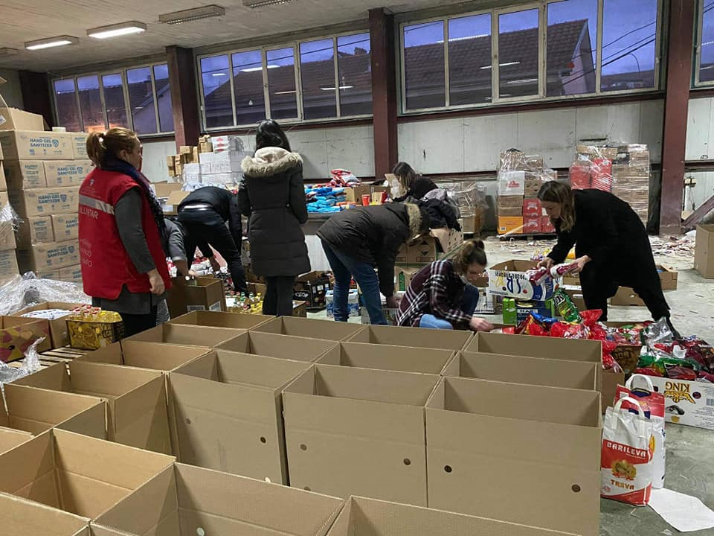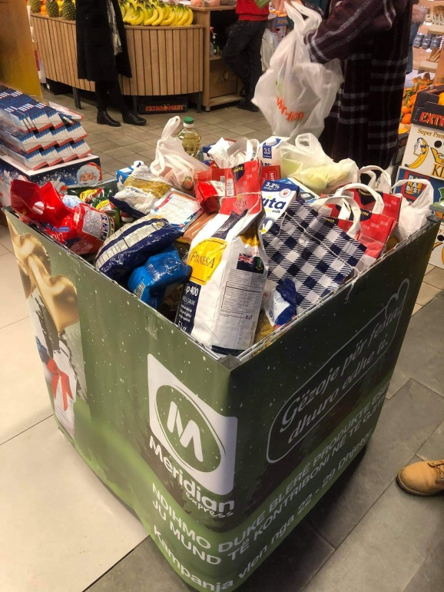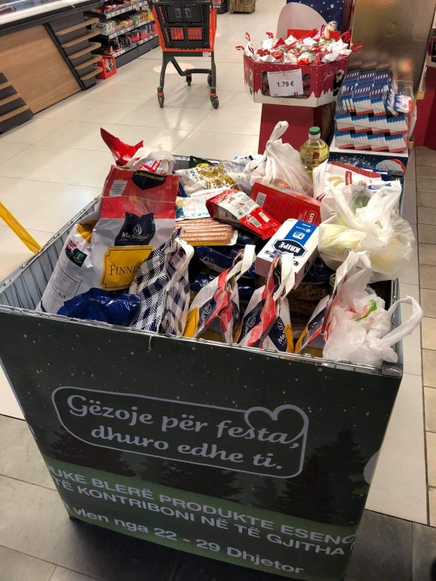 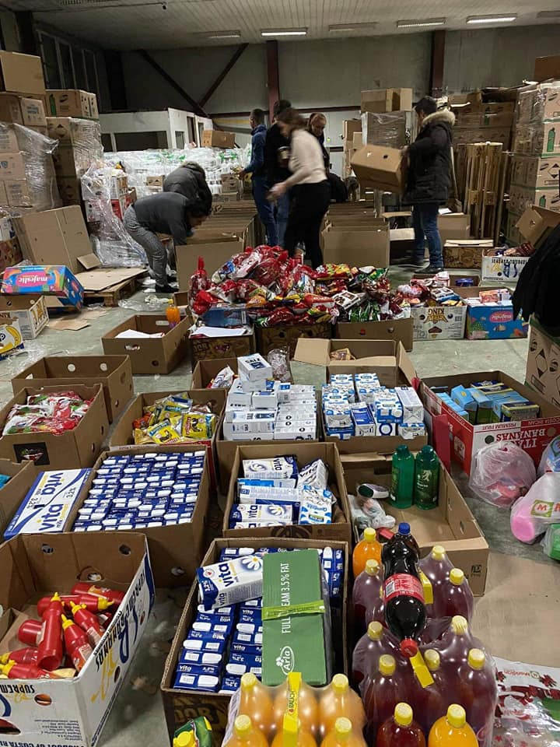 *Distribution of packages in the field - to the families in need:*

