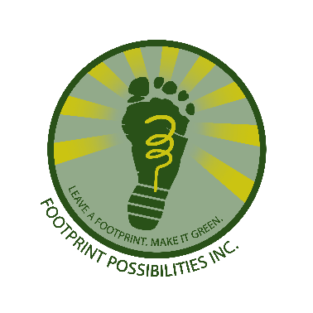
Footprint Panama
PH Mira Mar, Ave Balboa
Bella Vista, Cuidad de Panama
Rep de Panama

Motto: Do a lot, with a Little…fast!

Date: 12Jul20
Memo: 3d Quarterly Report CSAG Footprint Books for Kids Org #68120
A. Fundraising – Fundraising has bene difficult and made more so due to the COVID19 Pandemic. Footprint entered the quarter with $504.00 in the account. Global Giving crowdfunding has raised $73.25, but Footprint was most pleased and honored to receive a $1000.00 grant from GG. In total we now have in the account $1577.25! This allows funding for more books. Books for Africa was contacted and they are still in agreement to send pallet loads of books to Ghana for Footprint. This avoids buying entire containers. A pallet holds 1100 books and the final cost per pallet, door to door, is not known. Last shipment we were able to land a pallet in Ghana for $515, so that means if costs stay the same for each $1.00 donated we can send 2 books! With the grant and what has been saved up, we can look at sending up to 4 pallets, or 4400 books this year (with some supplies stuffed in the boxes). Books for Africa has also been shut down due to the Pandemic, but think July-August, 2020 should be the timeframe for the next shipment.
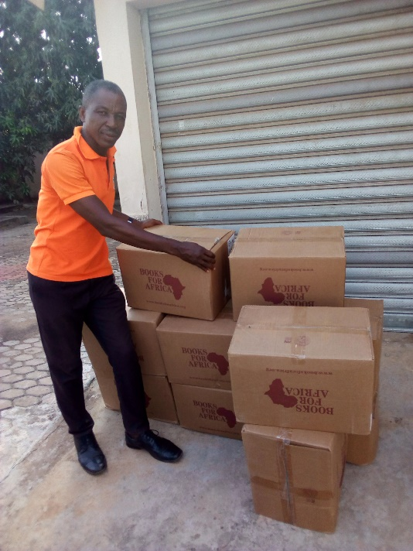 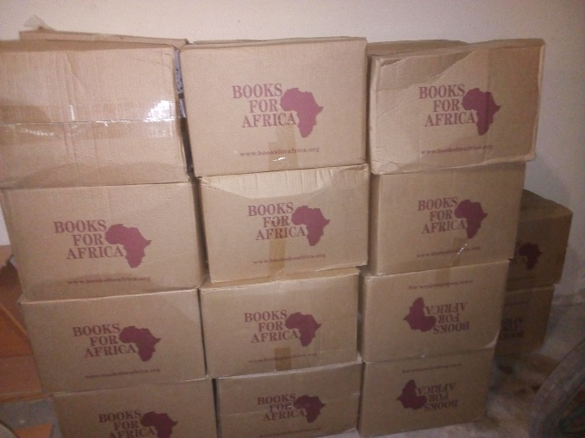
Min Emmanuel Akida – Last Shipment Boxes on One Pallet of Used Books – 1100 Total
B. Library proposal Japan - Child Survival Aid Africa (CSAG) has made its application to the Ghana Embassy of Japan for funding of a village library. Footprints is please to be CSAG’s technical resource. CSAG has made it past the Phase 1 selection process for the Japanese Embassy and is now in Phase 2 of the selection process. Footprint has worked with CSAG and has helped review and proof each application phase formwork package. The process is slow, but phase by phase we are advancing.
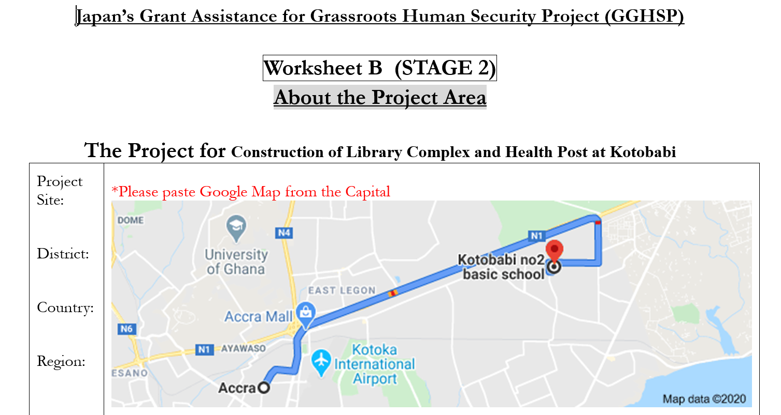
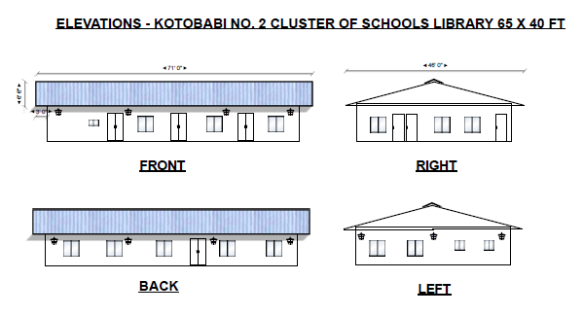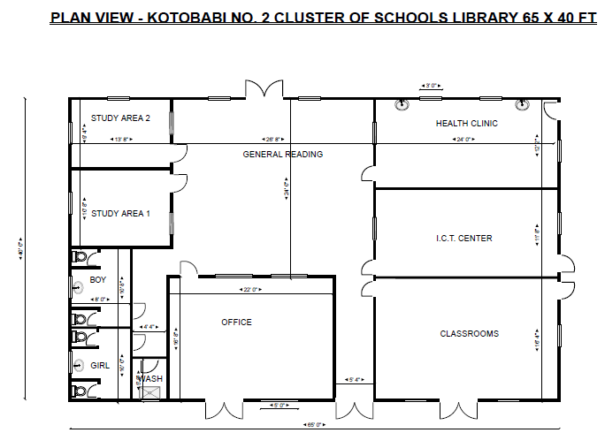

C. MTU iDesign Program: CSAG Selection – CSAG was selected by Michigan Technological University for it iDesign program for the year 2020. The program is an excellent opportunity for the organization and will provide finished design drawings with a bill of materials and description for a complete fresh water sourcing, conveyance, storage, treatment and distribution network. The local Library does not have a source of potable water at this time and the currently draws raw, untreated water from a nearby river, which is moved on foot to the village. The Library and community will benefit greatly from fresh, potable drinking water. Once a design is in hand, a campaign will be needed to raise funds for this important work.
