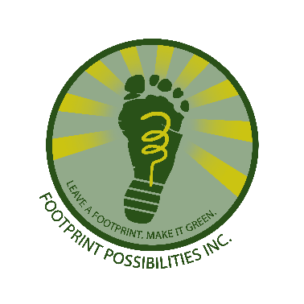
Footprint Panama
PH Mira Mar, Ave Balboa
Bella Vista, Cuidad de Panama
Rep de Panama

Motto: Do a lot, with a Little…fast!

Date: 07Mar20
Memo: 2d Quarterly Report CSAG Footprint Books for Kids Org #68120
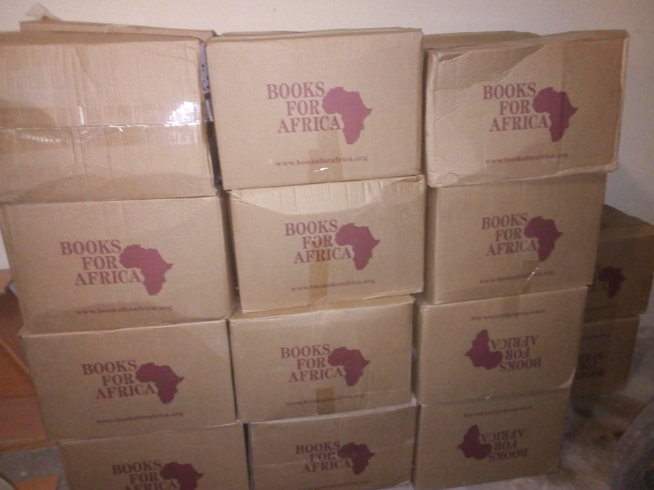
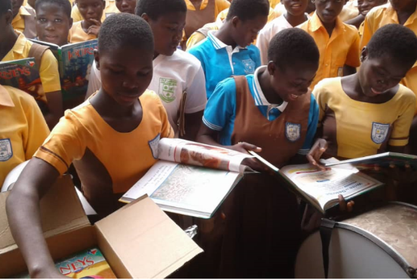
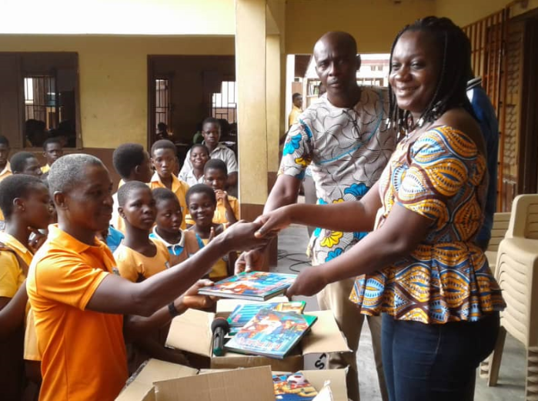
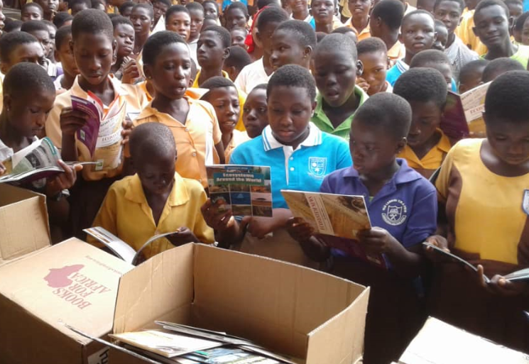
A. Additional funds - Account balance a have been compiled. To date We had $135.75 balance accrued and available for additional purchase of book pallets. These were funds raised previously from OneToday and GoFundMe. Additionally $368.75 in funds have been raised on Global Giving. This provides our charity with a total $504.00 balance. A pallet, with 1100 books, costs $515 so we are almost to the point of ordering an additional shipment. We are hoping with our recent success that more funds can be raised and that additional pallets of books can be sent.
B. Adword traffic - traffic has increased dramatically. The web site has totaled 39,434 views with 4,386 unique visits. Our web site points back to GG so all this traffic has bee of benefit for sure. With a visitation rate of 11.33% this is a successful advertising campaign, as a successful campaign by Google is any that has a CTR, or visitation rate, over 5%. We will keep this traffic up and hope more contributions are forthcoming.
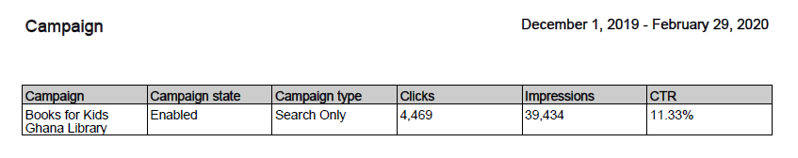
C. Books arrived - our shipment has arrived. We are pleased to report that Books for Africa has confirmed that our 2200 books have arrived. These books were well received and are greatly appreciated. Books for Africa will commit to sending additional pallets. Pricing is based on a pallets share of shipping charges for a full container, so our previous pricing may change. But what’s important is that as little as one pallet can be sent. But, let’s not limit our sites on one pallet! Global Giving allows us to grow that total to hopefully one day sending an entire container of 20 pallets. That would be a great day. Here are some great images of the kids receiving their books.
2
D. Library proposal Japan - Child Survival Aid Africa (CSAG) has made its application to the Ghana Embassy of Japan for funding of a village library. Footprints is please to be CSAG’s technical resource. A detailed design has been prepared and a bill of materials has been generated. Phase 1 of a 5 phase application process has been submitted. This pre qualification of our proposal is pending. Stay tuned for more progress on this application. It would be beyond words if our project is chosen. Global Giving would then be our platform to raise funding to fill each shelf with the books these kids need and want.
