**SINKUNIA COMMUNITY DEVELOPMENT ORGANIZATION (SCDO)-Sinkunia Scholarship Fund 2018.**

**BACKGROUND**

Today, education remains an inaccessible right for millions of children around the world. More than 70% children of primary education age are not in school and 95% adults are illiterate and do not have the awareness necessary to improve both their living conditions and those of their children.

For many children who do not have access to education, it is notable because of persisting inequality and marginalization. Sinkunia and other communities alike, children do not have access to basic education because of inequalities that originate in sex, health, political and cultural identity (ethnic origin, language, religion).These children find themselves on the margins of the educational system and do not benefit from learning that is vital to their intellectual and social development.

**PURPOSE OF THE SINKUNIA SCHOLARSHIP FUND (SSF)**

The Sinkunia Chiefdom has a high rate of illiteracy and poor educational capacity to promote education. The chiefdom cannot boast of any educational institution that can cater to the needs of its inhabitants, and parents cannot afford to send their children to good schools in distant places. The standard of education has further declined as a result of less qualified teachers, lack of learning materials, and conducive learning environment for the pupils. As a result, there is high prevalence of unemployment, dropout, poverty, and high disease prevalence among the youths.

**Sinkunia Community Development** **Organization (SCDO),** seeking to promote tertiary education in less developed communities in Africa, provided financial support to seven (7) University Students in their first year of enrollment in Sinkunia-Sierra Leone this year (January, 2018).

**BENEFICIARIES OF THE SINKUNIA COMMUNITY DEVELOPMENT ORGANIZATION (SCDO) SCHOLARSHIP FUND**

Below are pictures and testimonies of some of the students who benefited from the Sinkunia Scholarship Fund in 2018 Academic Year:

1. **Fatmata K. Kamara**

**First Year Student at Njala University reading Agriculture**

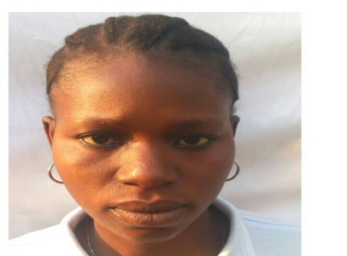“In Sinkunia, many girls are at risk of never receiving an education; more than 80% of girls will never have the opportunity to go to school. Even more alarming, the lack of schooling and poor education have negative effects on the population. The children leave school without having acquired the basics, which greatly impedes social and economic development of our community, and country at large.

Between boys and girls in the Sinkunia community, the education of girls is in jeopardy. Today, it is girls who have the least access to education. They make up more than 70% of the non-schooled population of the community. Girls are destined to work in the family home, whereas boys are entitled to receive an education.

I’m really thankful and proud of SCDO for your financial support. Hope your generosity will continue!”

1. **“Kabba K. Kamara**

**First Year Student at Njala University reading Agriculture General.**

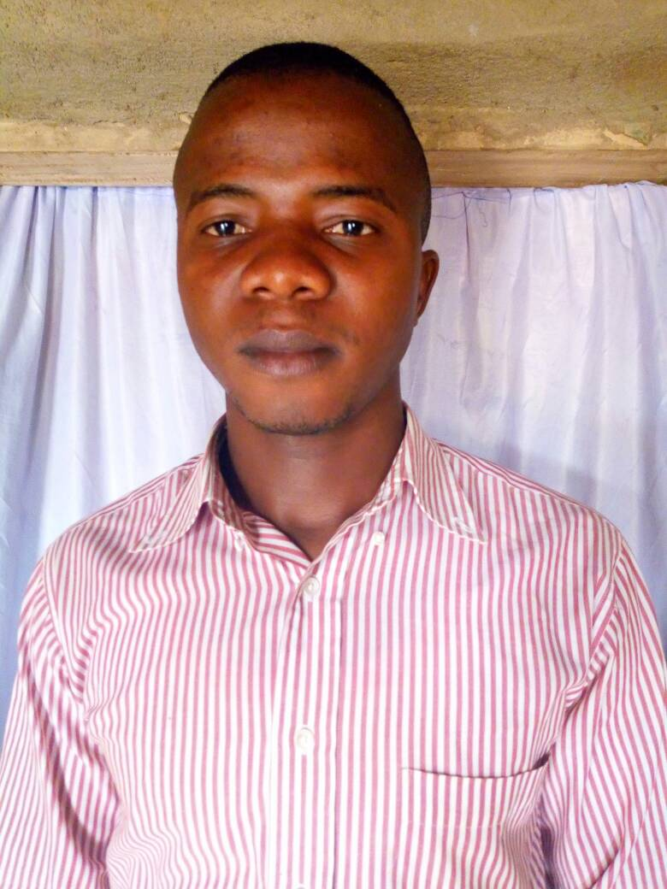

“Poverty is a world of darkness, education is knowledge and knowledge is light that one can use to see through. Together we can fight poverty with education. Thanks to our Sponsors- **SCDO”**.

1. **“Sorie S. Mansaray**

**First Year Student at Njala University reading Agriculture**

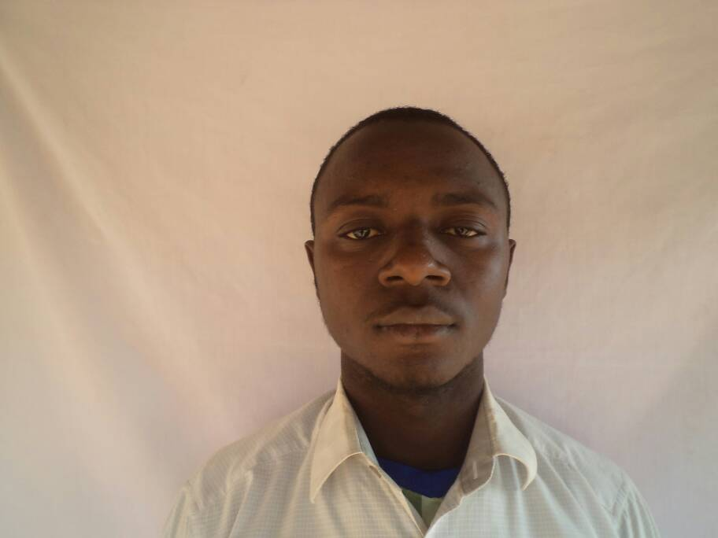

I believe “education is the bedrock of development of any society. If Sinkunia is to ever develop, we need to consider education as our top priority to combat the many tribulations affecting life in the community. We say thanks to **SCDO** for your generous financial support. Together we can make a positive change and create a better world for all.”

1. **“Mohamed K. Kamara”**

**Second Year Student at Fourah Bay College (FBC), University of Sierra Leone reading Social Work.**

I believed “life is like a coin, if you can’t succeed using one side of it turn around on the other side of it and make a try. If our ancestors have tried one side of life all in farming without success then we need to try **EDUCATION** as the other side of it. With **SCDO,** we will surely make it. Bravo to **SCDO**. Thanks.”

1. **“Lahai F. Kamara”**

**First Year Student at Njala University College reading Animal Science**

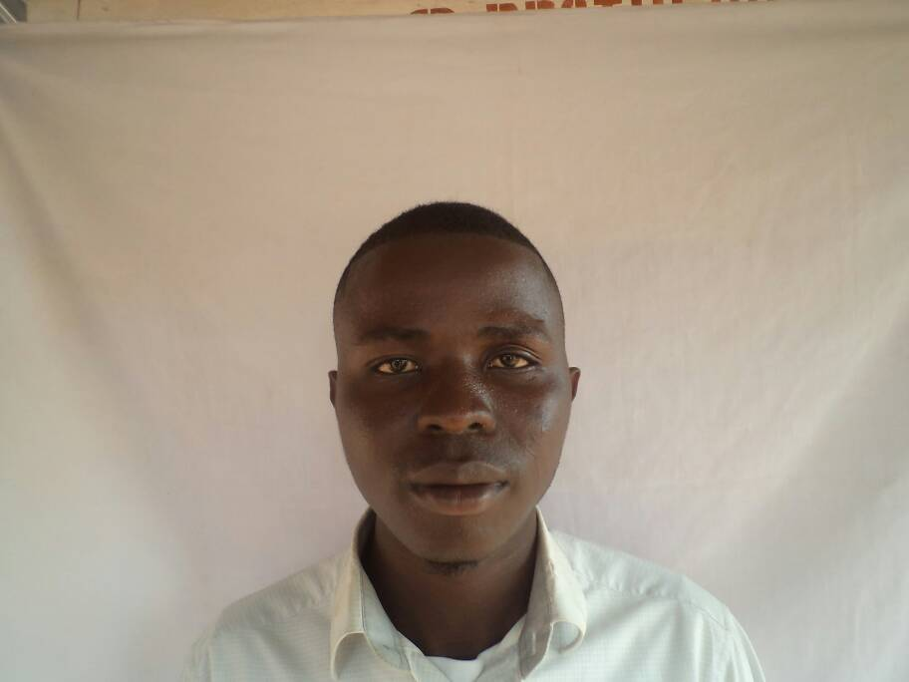

“It’s a dream come true. I have been pondering all the while on how to advance my studies, but **SCDO** has provided me with the answer this year. Thank you **SCDO**. I’m impressed and grateful.”

1. **“Osman A. Turay”**

**Second Year Student Institute of Public Administration and Management (IPAM) reading Computer Science.**

“Since my parents cannot afford to send me to University, I considered myself as a young school leaver and a drop out, and my faith faded day by day not until when **SCDO** refreshed it for me again this year. It is never late for me to achieve my target. With **SCDO** we will make it for sure. I say thanks to our sponsors, **SCDO**.”

1. **“Samba S. Kamara”**

**First Year Student at Njala University College reading Agriculture & Business (Agric. Bus.)**

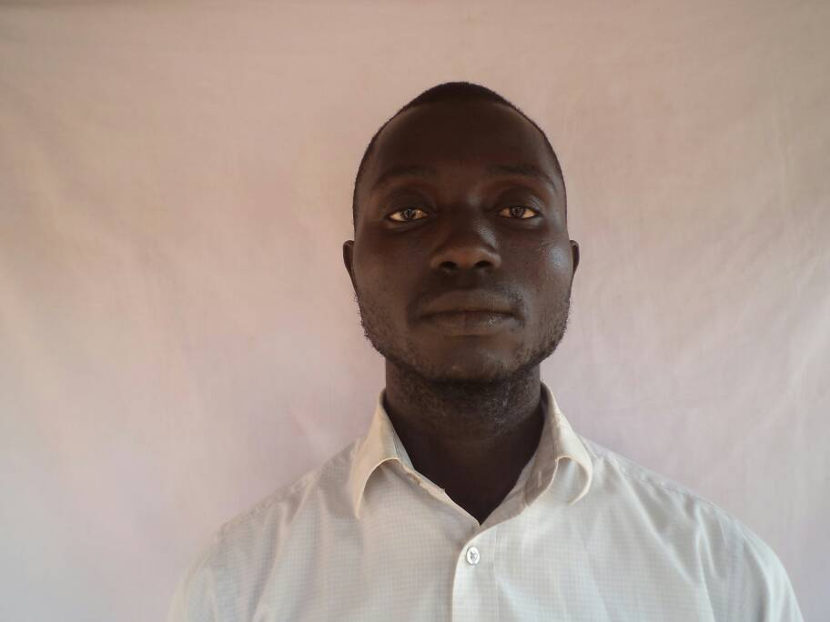

**“SCDO** has re-ignited our faith, especially we the youth in the Sinkunia Community in terms of education. We hope they will never leave us till the end of the academic struggle. Thanks to **SCDO**, our sponsors.”

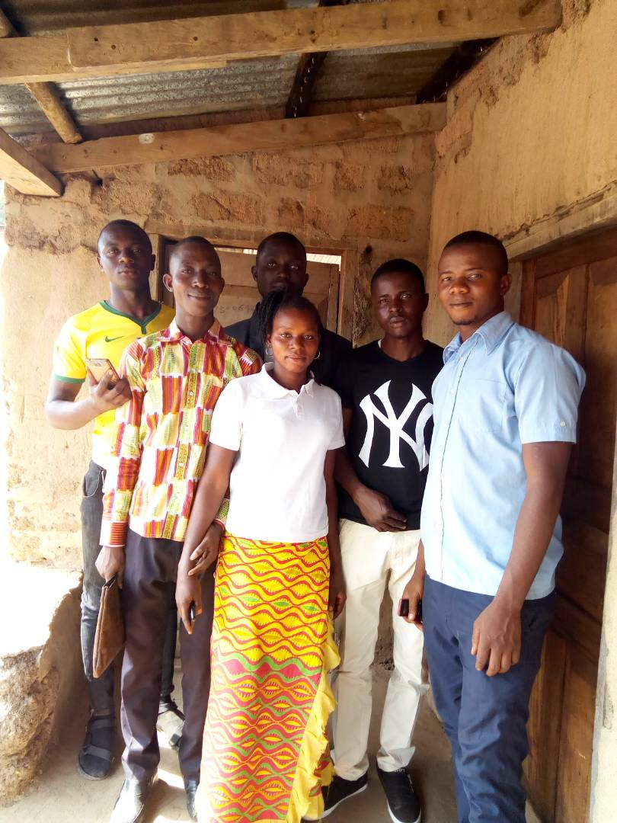

A picture of cross section of the Sinkunia Scholarship Fund beneficiaries in northern Sierra Leone.

“***THANKS TO SCDO FOR YOUR SUPPORT.”***

***“Mamoud Balla Kamara” A Graduate from Njala University College, 2018.***

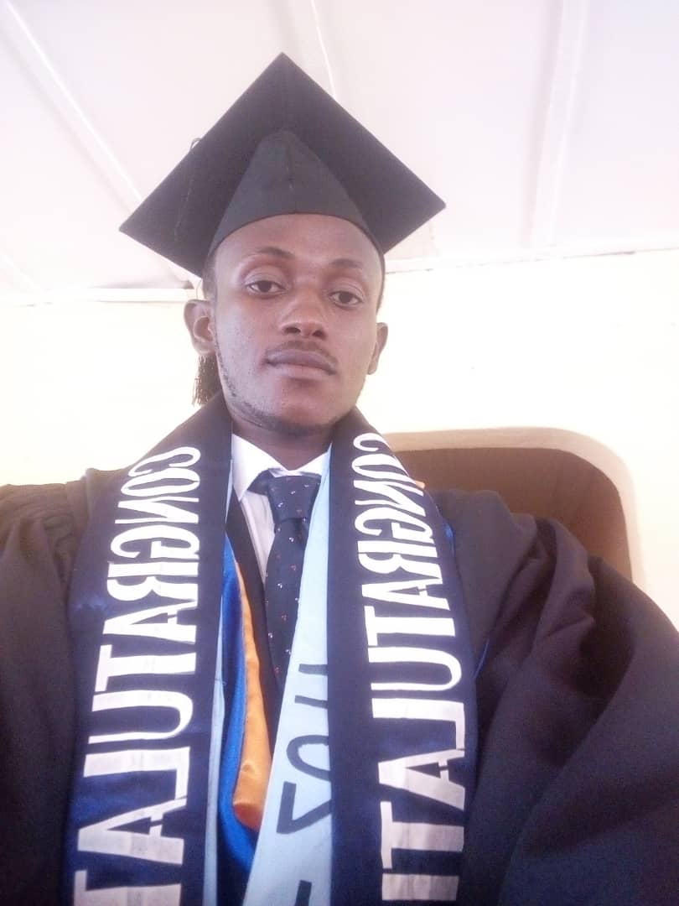 Sierra Leone is a country that needs trained and qualified young people (youths) who can contribute towards the social and economic development of the nation. In most African countries especially Sierra Leone, quality education remains a big challenge for most youths.However, the fate of every nation lies in the hands of the work force/the young generation. Therefore, I am indebted to those who in one way or the other stood by me during my course of study especially the **SINKUNIA COMMUNITY DEVELOPMENT ORGANIZATION (SCDO).**

I wrote to the West African Senior School Certificates Examinations (WASSCE) in 2011/2012 academic year which guaranteed my admission to any University in the country. But the dire financial situation of my parents almost made it impossible for me to further my studies; where I considered myself to be a drop out not until when **SCDO** intervened in my academic life.

It was a dream to me when I received my first year university fees from **SCDO** through the Sinkunia Scholarship Fund in 2013 academic year; thereafter, I started another academic journey at Njala University College to pursue a Bachelor of Science Degree with Honors in Environmental Management and Quality Control (EMQC). My faith and strength and my educational opportunities were all built by **SCDO** throughout my tertiary education. In June 2018, I graduated with a First Class Honors Degree in the aforementioned field of study.

In lieu to the preceding statements, I wish to express my profound gratitude for your generous effort in supporting and strengthening educational opportunities for the less fortunate youths in the country.

**SCDO has been the best organization which I have benefited from; I** hope there will be provision for career advancement. I’m ready and willing to work for **SCDO**!

We the people of Sinkunia believe and love **SCDO**. Thanks for your generous support.”

**A BIG THANK YOU SCDO!!!**