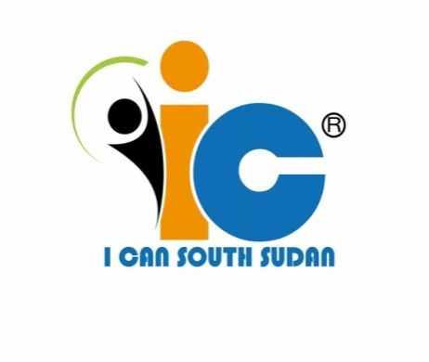
I CAN
South Sudan
Refugee program for kids
BIDI BIDIREFUGEE CAMP
P.O.BOX 2627 Kampala Uganda
Tel: (+256) 784423615/0781037069
Email: icankids829@gmail.com
Web:www.icansouthsudan.com

PROJECT TITLE : Give light to children in Bidibidi

APPLICANT : Stephen Wandu Bimo
AMOUNT : $9,985
ORGANIZATION : I CAN South Sudan
Registration Number : RMG/000387
Postal Address : 2627 Kampala Uganda
Legal Status : Non-Profit Community
Based Organization
Email : icankids829@gmail.com
Mobile Telephone : +256 784 423 615
Website : www.icansouthsudan.com

Give light to Refugee children in Bidibidi
Give Light to Refugee Children in Bidibidi is initiatives to provide solar lamp and Solar power to Children and villages in the refugee settlement that have no access to Electricity or light source at night to allow them read at night.
We intend to procure the solar lamps from Kampala to Bidibidi refugee settlement. We will provide a type of lamp that is charged by solar and it can be able to light up 3 bulbs in the house for hours upon charging completion. It has at the same time a radio from which families can listen to news and information on radio, it also have audio player and USB input port on which mp3 music can be played for entertainment of the family and it can at the same time charge 2 phones at once
Other approaches includes, providing solar panels, batteries, inventors, bulbs and wires to villages (Blocks) in the refugee Settlement for the refugees to be able to access power in their area
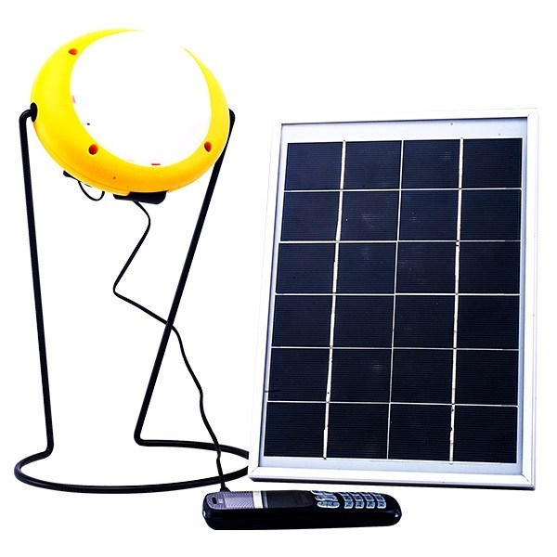
Mission of the Project: to ensure that refugee families in Bidibidi have access to power source for light, connectivity, safety and social cohesion
Goal: To provide and connect 100 households with solar power by 2019
Motto: “Yes we can!”

BACKGROUND
- Geographical location and Population of the area
Bidibidi is a refugee settlement in northwest Uganda. It is located in Yumbe, a district in the West Nile sub-region. Opened in August 2016, by December of that same year it was closed to new arrivals. With an estimated population of 285,000 refugees, Bidibidi was, at the time, the largest refugee settlement site in the world.
Bidibidi was founded on 250 square kilometers of communal land by the host community, in a deal negotiated by the Office of the Prime Minister (OPM), via local officials and local community leaders. The government of Uganda and the UNHCR call the areas where refugees reside "settlements", not "camps", because refugees in Uganda are not legally restricted to camps. Instead, they are given plots of land on which to build houses and cultivate food, and are allowed to seek employment. Due to a challenging peace process and the ongoing insurgencies operating in Equatoria, many refugees and humanitarian organizations project a potential long-term refugee presence in Uganda, with some anticipating protracted displacement through 2025.
- Political, Natural Resources and people economical bases
Tensions in South Sudan escalated in many locales throughout early 2016. The troubles began with the mobilization of local militias of the Equatorian Sudan People’s Liberation Army-In Opposition (SPLA-IO), catalyzing government forces to respond in kind. Some refugees describe the increased deployment of SPLA during this period in their areas, including the deployment of the so-called ‘Mathiang Anyoor’, a paramilitary ethnic Dinka government force, before and after clashes in Juba in July. After the breakdown of the ceasefire, fighting between local Equatorian SPLA-IO forces and government militia quickly escalated, creating a spiraling cycle of retaliations in rural areas, and insecurity in urban areas, where civilian populations were often targeted.
These accounts largely support existing research on the conflict, which links the mobilization of Equatorian militias to the national crisis and peace process. South Sudanese from Juba and villages around Yei and Kajo Keji started fleeing to Uganda in July 2016, but the numbers escalated in August, when it became clear violence was not abating. In some areas further south, such as Morobo and Kaya, the wave of refugees fleeing Yei caused further displacement in response to the fear that the same insecurity would spread. In other cases, refugees would cite specific incidents, such as returning home to find relatives missing, getting caught in a firefight, or being targeted by the government or SPLA-IO themselves as the circumstance that caused them to pack their belongings and flee. One male refugee, for example, said that he had been concerned about escalating insecurity but then came home from his trading business to find his wife, children, and mother missing. “Government soldiers accused me of feeding the rebels,” said another refugee. “They came to my house and investigated me. I was bringing food from Juba to village and some vegetables to the town. I snuck out.” The collapse of the peace deal saw a surge in insecurity and indiscriminate killings. This, accompanied by food insecurity and a decrease in social services (such as the closure of schools and clinics) forced many to seek refuge in Uganda. According to Alan Boswell 2018 in the report Contested Refugee, Bidibidi is composed primarily of under-utilized “hunting grounds” considered by the host community as unsuitable for agriculture. The area is composed of low, rolling hills and, for the most part, rocky soil. The Bidibidi land was chosen in a way to ensure that it fell between host community settlements, which border some parts of Bidibidi’.
Bidibidi is composed of five zones, and each of these zones is divided into clusters, which are further divided into individual villages. Refugee leadership structures parallel Uganda’s own local governance model, which is composed of ascending levels of Local Councils. At the village level, there is a Refugee Welfare Council 1, or RWC1; at the cluster level, RWC2, and for each zone, an RWC3. These are decided by elections overseen by OPM. The RWC at each level is headed by a chair. The refugee population in Bidibidi is primarily female, with adult women outnumbering adult men by a 3:2 ratio and most households headed by women. These numbers likely underestimate the day-to-day women-to-men ratio, since refugees report that many men maintain a transient presence in the settlement while pursuing livelihood activities elsewhere or inside South Sudan or fighting in the war. Refugees perceive women as vastly outnumbering men in the settlement. While the refugee population in Bidibidi is ethnically diverse, vast portions are Bari speakers from Central Equatoria. The Bari-speaking ethnic groups include the Bari, Mundari, Kuku, Kakwa, Pojulu, and the Nyagwara. Most of the rest of the occupants are from other areas in Equatoria, primarily Eastern Equatoria, in particular the Ma’di and Acholi groups. There are also smaller refugee communities of other large groups in South Sudan, including the Nuer, the Shilluk, and the Dinka. Most of the non-Equatorian refugees in Bidibidi were living in Equatoria, primarily in Juba, in 2016.
Socially and Culturally
In 2014, Yumbe district’s recorded population numbered roughly 485,000 Ugandans. Yumbe is the historic land of the Aringa people, the majority of whom are subsistence farmers and followers of Islam. Yumbe is one of the poorest districts in Uganda. Schools and health centers are severely under-resourced and underperforming, infrastructure is underdeveloped, and economic opportunities lag behind the rest of the nation. The Aringa’s history of conflict, poverty, and Islamic faith provide a backdrop of perceived and actual marginalization of the Aringa inside Uganda. Unlike other communities in northern Uganda, the Aringa do not report sharing direct ethnic ties to communities across the border in South Sudan; however, many Aringa are aware of distant kinship with many groups of South Sudan. The Aringa language is part of the Central Sudanic family, which also includes South Sudan's Ma’di, Avokaya and Moro languages. Aringa is distinct but related to the Lugbara spoken in Arua. Aringa is variously categorized as a dialect of Lugbara or as a separate language of its own. Many Aringa speak both Aringa and common Lugbara. There are no known indigenous Aringa populations in South Sudan. However, some Aringa feel an affiliation with their South Sudanese neighbors as marginalized groups with shared historical and kinship links.
Problem Statement
According to UNHCR Refugee Information Management System (RIMS) - Office of the Prime Minister, “Refugees were provided with non-food items (NFIs), such as saucepans, solar lamps, mattresses and jerry cans, upon arrival to the settlement. These have, however not been re-distributed since the refugees' arrival, which therefore means they are for the most part worn out or broken. This forces refugees to share with their neighbors and take it in turns to cook. The lack of access to functional NFIs reduces the living standards of refugees”
82,947 refugees are attending school in or around the settlement, with gross enrolment rate. All these children or students lives in total darkness. Bidibidi Refugee settlements do not have electricity or have access to power. Charging of phones and the use of computer is either by generator or solar power and only few can afford all these items. Refugees walk for a distance to the local market area to get their phones charged. Few of the youth who have smart phone are unable to stay online because they can’t afford charging their phone batteries always. Business people are taking advantage of this scarcity of electricity to exploit the refugees by selling at higher prices some solar lamps. To a vulnerable widow or single parents who survive only on relief food, they can’t afford to access or buy the solar lamp.
In a normal life situation in Bidibidi, children especially girls find it hard to read or revise their books once they are home as they are engaged in households work like standing in a long queue to fetch water, collecting firewood, cooking, bathing the younger children. Once it is night hour, the refugee settlement remains dark. Most Households uses small torch to search for things at night, cook, and for emergency. Children in most case are not allowed to use the torch and hence they are completely denied access to light and can’t revise their book and hence leading to poor academic performance at school.
Hence with this gap we believe our intervention will make provide 100 families with solar lamp. Out of 280,000 registered refugees, only 3,603 refugees have access to self-employment or facilitated businesses and hence majority of the refugees cannot afford getting a solar lamp for themselves.
“Child protection was reported as a significant gap in Bidi Bidi settlement. Refugees’ highlighted child-headed households are not provided with the appropriate services they need. Moreover, children, particularly young girls, are often sent to collect firewood for their families far from the settlement, which has led to cases of rape and sexual and gender based violence (SGBV). Additionally, theft was reported to be an issue in the settlement where food items are often stolen at night” According to UNHCR Refugee Information Management System (RIMS) - Office of the Prime Minister.

“Access to quality education is limited for both refugees and the surrounding host community. Schools are few with insufficient classrooms and insufficient teachers leading to low teacher per student ratios. This was reported to severely inhibit the students’ learning environment. This is further deteriorated by the lack of school materials and lack of training for teachers. Moreover, the absence of vocational training institutions limits the opportunities available for students unable to access secondary school or those unable to access tertiary education. This significantly reduces their chances to access livelihoods opportunities in the future.”

“21% of unaccompanied or separated children have not been provided with interim or long term care, “96% of child PSNs needs to be provided with individual case management” Hence these vulnerable children need special attention and support to be able to remain in school and pursue their education in the face of difficulties in refugee camps.

“82,947 refugees are attending school in or around the settlement, with gross enrolment rates” only 15% of children enrolled in school can afford light at home to read and the 85% need our urgent intervention to help them improve in their education

“46,710 households still need to receive improved cooking stoves and efficient energy for cooking” According to UNHCR Refugee Information Management System (RIMS) - Office of the Prime Minister

EXISTING AND PREVIOUS PROJECTS
UNHCR provided non-food items (NFIs), such as saucepans, solar lamps, mattresses and jerry cans by, upon arrival to the settlement in 2016. These have, however not been re-distributed since the refugees' arrival, which therefore means they are for the most part worn out or broken. This forces refugees to share with their neighbors and take it in turns to cook. The lack of access to functional NFIs reduces the living standards of refugees.
There is no other organization who have come forward to redistribute specially the solar lamp to the refugees.
Businessmen and women have taken advantage of this situation by selling solar lamp to the refugees and electronic appliances at a higher price which most poor refugees cannot afford.
There are efforts to connect electricity to the refugee settlement but it is still a negotiation between UNHCR with the government of Uganda to enable this to happen.
TARGET GROUP FOR OUR FUTURE PROJECT
- Unaccompanied refugee children
- Single mothers
- Widows and widowers
- Youth
Working in partnership with:
- Journalists
- Local authorities
- The government of Uganda
- The office of the Prime Minister in Bidibidi, Refugee Department
Reason for selecting the Target Group
- The unaccompanied refugee children lacks support of their parents to provide for them basic needs and their foster parents cannot provide all their needs
- Most women in Refugee Settlement are widows and single parent in poor status who cannot afford power for their households
- The refugee youth needs to charge their phones and access internet to be connected to the rest of the world
Perspectives of the target group to their situation and their objectives
These refugee children have resorted to reading late in the evening after completing the work assigned to them by parents like fetching water, collecting firewood, cooking and many more. However the time is not enough and convenient
Families use a small torch for searching, cooking and for emergency. Youth charges their phones by the market at a fee they can hardly afford.
Number of Households to be reached
This project targets 100 households in Bidibidi Refugee Settlement Zone 1
Expected impact of the project
The distribution of solar lamp will have the following impacts
- Children will have access to light at night to read and revised their books and hence this will improve their performance at school
- It will provide light in family and hence protect against harmful items at night
- It will reduce the burden of buying dry cell batteries for the torch
- Most households in the refugee camps are grass touched and covered by tents and hence it will reduce the risk of fire outbreak due to use of candle
- It will help in night emergencies like sickness and snake bites
- It will improve the social cohesion of families and refugees
- It will bring happiness to the families
WORK DONE TO DATE
Achievements of the Objectives by the previous Project
- Distribute three (3) times the scholastic items like books, mathematical sets, and body lotion to the children
- Engage the children in drawings
- Record music album for the children on unity, peace, love, coexistence, forgiveness, reconciliation
- Shoot a video for the children on unity, peace, love, coexistence, forgiveness, reconciliation
- Provide some clothes and shoes to the children
- Take the children to recreational center
- Legally registered in Yumbe District
- Open Bank Account in the name of the organization
- We created a website www.icansouthsudan.com with a bouncing rate of 57.69% monthly. The website is to inform the world about what we are doing and to engage them in finding solutions for peace in South Sudan
- We opened a Twitter Account @ICANSouthSudan3 with so far 313 followers and SoundCloud http://soundcloud.com/user-371124983 account having 197 play already of our song
- Above all, we have seen the children united together as they eat, play, sing and dance together, regardless of their tribal differences
- We arranged outings to bond the children together, and to give them a much-needed treat
- Our Children have featured in the Music video of David Heitler-Klevans, a music teacher at Temple University Ambler, Co-President at The Children’s Music Network and former Music Teacher at The Philadelphia School and Friends School, Haverford
- We have been embraced by the refugee community at Bidibidi, who are encouraging and appreciative of our efforts
- Our Children performed their song in the recent World Refugee day in Zone 1

Lessons Learnt from Previous project
Our 2018 project taught us that we needed to provide services beyond musical education. The situation in the camps is increasingly desperate, with a lack of food and other basic necessaries resulting from lack of adequate funding. While we believe that musical education continues to be culturally and emotionally important for children, we wish to expand the project to improve the economic situation of the children’s guardians. We believe that an intergenerational effort of this kind is necessary if a whole generation of children is to be able to grow up with hope and a vision of a productive future.
Funding Period: The funding period for the project is one year, however the program is expected to continue running as more households will need same service too
Objectives
Strategic Planned Activities
We will design a monitoring and evaluation frame work that will demonstrate proof of how output, outcomes and goal will be measured
- We will use the refugee community leaders to identify families that cannot afford the solar lamp or light in their families. Through observation, interviews, formal research and the existing humanitarian agency, we will come up with the 100 households that urgently need this support across the settlement. The duration for identifying and the households in need will be 2 months
- We will then select the vibrant member of family from each household to attend training on how to operate, sustain, maintain and repair these solar lamps. Give them the ways to use the solar lamp and precaution of using them. Parents will also be advised to allow and ensure these lamps be used by children for their reading at night. This will be a 3 months training
- On completion of training, then we will distribute the lamps to the vulnerable communities for use in their house. We will have cohorts of beneficiaries and will design special time for distribution
- We will also train youth and open for them workshops equipped with spares for repairing these solar lamps across the camp (3 months training)
- We will continue to monitor the progress of the project and measure the impact from time to time across the duration of the project
- Install 50 solar power in the Villages within the refugee settlement to easy access to phone charging

Pictures of our Activities

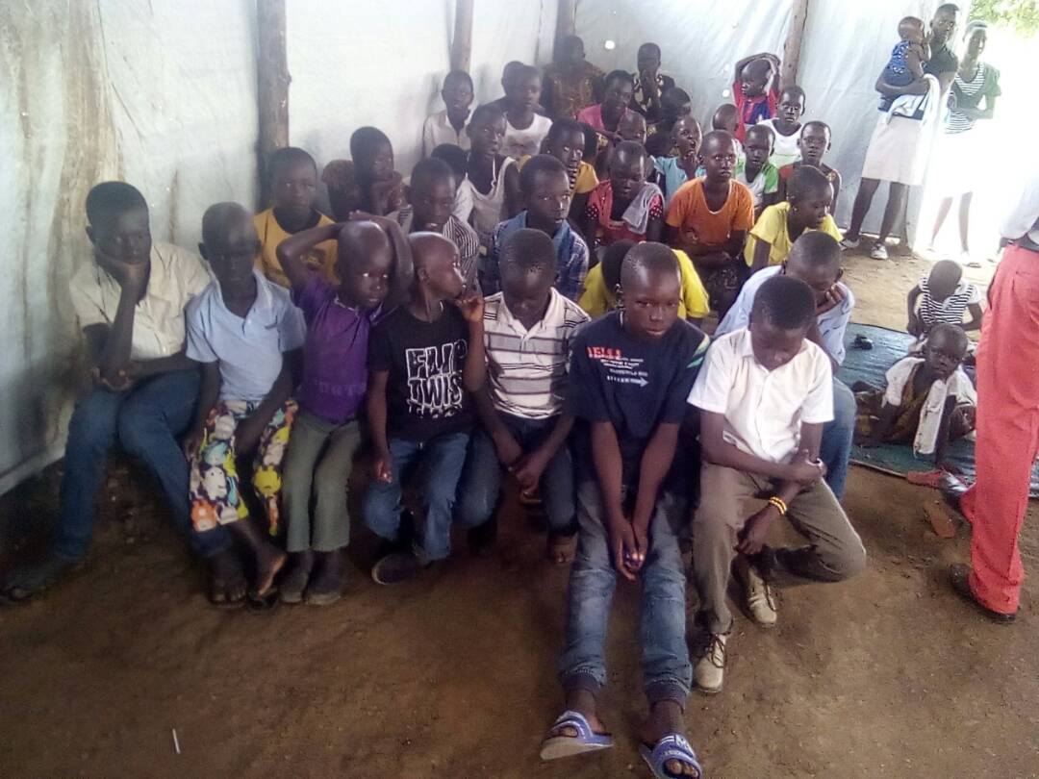
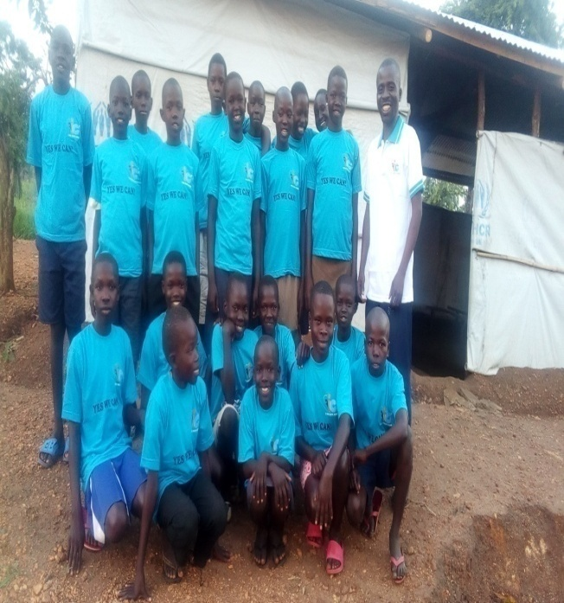
Group picture with the children in Bidibidi Picture During our first Auditioning
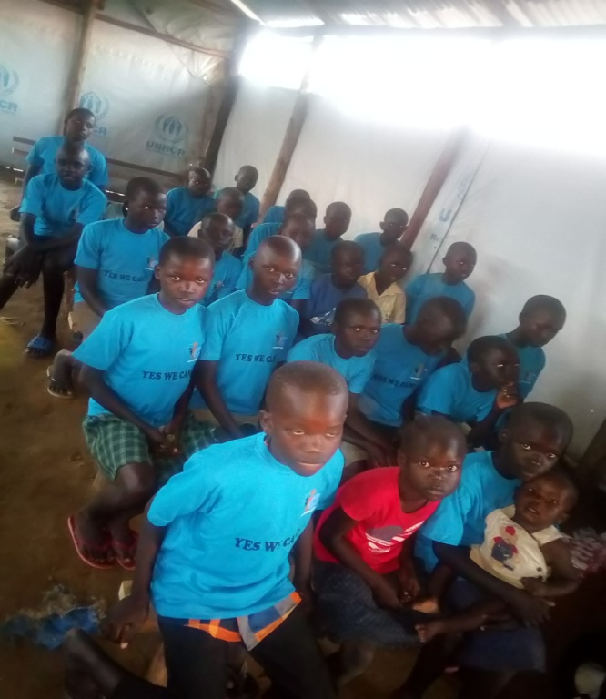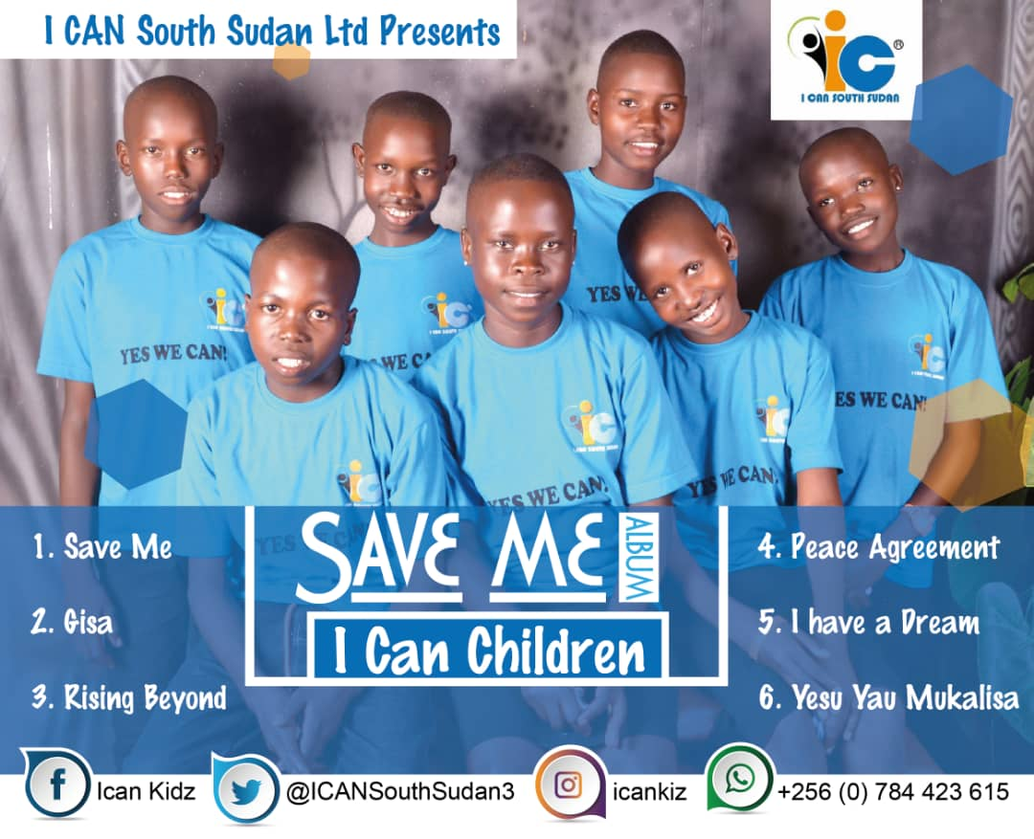
During Practice in Bidibidi Music Album Cover of I CAN Children

POSSIBLE OTHER EFFECTS
We expect the following result from this project
- Children will have access to light at night to read and revised their books and hence this will improve their performance at school
- It will provide light in family and hence protect against harmful items at night
- It will reduce the burden of buying dry cell batteries for the torch
- Most households in the refugee camps are grass touched and covered by tents and hence it will reduce the risk of fire outbreak due to use of candle
- It will help in night emergencies like sickness and snake bites
- It will bring unity and happiness in the family
- It will connect the refugees to the rest of the world
Indicators
- The improved results in exams at school
- The improvement in child knowledge
- The reduction of family members wounding or getting snake bites at night
- The reduction in fire outbreak in homes
- The ability of families to stay together at night and converse, and parents able to gather families and advise them
Effects involving reduction in injustice and conflict
- Hardship and struggle will be reduced and hence the children will grow into responsible young citizens in future
- Issues like trauma and isolation which leads people to do go into conflicts will be reduced
- Poverty will reduce hence reducing acts of conflicts in the community
- It can contribute in restoring peace, coexistence, harmony in the refugee settlement
Possible Long time Other Effects
- It will bring about unity among the diverse tribes of South Sudan in the refugee settlement
- It will expose the undiscovered talents/strength of the children
- It will open doors for the kids to further their education

Effect of political, social and economic context
Political Context
- The political situation in South Sudan continue to be suspicious despite the signing of peace in September 2018 and hence, refugees still fear to have voluntary repatriation to South Sudan at the moment and they still doubt the peace agreement and hence they will stay long in the camp and hence they still need these basic service
- The availability of light at home provides security to the house and hence thieves may scare away when light is in the house.
- The possibility of charging phone through the power lamp will also provide security for the house in case of an emergency at night
Socially
- The absence of light source at home prompt members of the family to enter and sleep early and hence the introduction of these solar lamp can ensure that family have time together in the evening to discuss their issues.
- Family gathering or events are held always earlier to prevent late event because of darkness but the introduction of light can encourage socialization among the refugee communities
- It will bring smile back to the families
Economically
- Majority of refugees do not have job or have business that can allow the survive the hardship and others depend solely on the food distribution by UNHCR to survive and hence this project will save their little money from buying torch and dry cell batteries frequently
Foreseen challenges
- Parents or guardians privatizing these solar lamps only for their rooms and deny use by the children for the purpose of reading
- Overuse of the solar lamp to listen to radio and music and hence not saving enough charged power for light at night
- Misuse of the solar lamp and they are broken easily
- The rainy season with no enough sunlight to charge the solar lamp
The planning process
The planning of this project was done in consultation with the unaccompanied children, the refugee community in Bidibidi Zone 1, Cluster 2, and freelance contractors. We made special efforts to consult with guardians of unaccompanied children, to find out how we could best help the younger generation. The team has experience in the field, backed by lessons learnt from our previous project.
Commitment of the I CAN team to achieving this project
We have a team of committed young people who are educated and equipped enough to manage grants. We will contract technical persons and companies to deliver where our staffs cannot deliver. We will have monthly meeting to review the track of this project and adjust where necessary and we will ensure that people assigned for a particular task are motivated and equipped to successfully carry their duties

Scale and sustainability
We will contract private companies for the supply of the solar lamps and also for the training of the refugee communities on how to repair, maintain and use the solar lamps
We will work in collaboration with the local humanitarian agency to monitor and device policies on how to improve the lives of the refugees through meetings and partnership
We will work closely with the refugee community leaders, local government to ensure the progress of the project
We will scale up security and legal measures to prevent risks to the project
Sustainability plan
- We will train one person from each household on how to use, repair and maintain the solar lamp
- We will open up a workshop and supply spare parts which will be sold at cheaper price for the community to buy once it breakdown and such income will sustain those working in the workshop and continue to supply more spare parts
- The plan is to keep monitoring the project in its life cycle and provide solution whenever possible
Monitoring, steering Process
Our monitoring tools are as follows
To monitor the work we are doing and measure impact, we will do it through designing a survey before and after the project. We will have regular assessment and entry of data to ensure the monitoring of the project.
We will have regular meetings to monitor the progress of every activities and know whether we are achieving our objectives or not and lay new policies in case we realize our approach is not working
We will make sure we appoint or delegate the right person for the right task and will continue monitoring their work and if needed support them to improve where they have weakness
We will work as team and support each other where we see weakness so that we can achieve as a team.

Safety, security, anti corruption
Our organization has an established Anti Fraud and Financial Control policy that guides the control of all funds received by our organization and hence we will ensure that these policies are not breached or any person who trespass meets the due consequences
All our projects are monitored by the office of Prime Minister Refugee Department and we give them monthly report.
Evaluation
We will evaluate this project by analyzing data collected throughout the project cycle and give a statistical report
We will evaluate the project through data collected from radio plays, number of callers during our programs, the request for our music, the attendance of audience at our concerts and events, the social media followings, likes and comments.
The project will be evaluated by the response and support of the communities
We will be able to evaluate our project and provide accurate information to the donors with supporting documents; however the donors are free to bring in an external auditing and evaluation team to evaluate the project at the end of the project
Work Plan for 5 months
Activities | Month |  |  |  |  | Person Responsible
 | FEB | MAR | APR | MAY | JUNE
Identification and selection of vulnerable families for distribution of solar lamp | + | + |  |  |  | Project Coordinator
Identifying and selecting Vibrant family members to train on how to repair |  | + |  |  |  | Local Refugee Area Council and Program Manager
Train Family members on how to repair the solar lamp |  |  | + | + |  | Hired Technician and repairer
Install solar power in blocks in the refugee settlement |  |  | + | + | + | Technician
Distribution of Solar lamp |  |  |  | + | + | Assistant Project Coordinator
Monitoring and Evaluation | + | + | + | + | + | Program Manager
Reporting | + | + | + | + | + | Executive Director

BUDGET FOR THE PROJECT
Budget Line | Particulars | Qty | Unit Price (UGX) | Amount (UGX) | Amount ($)
Solar Lamp
IC/03/G/001 | Buying Solar Lamps | 100 | 300,000 | 3,000,000 | $821
IC/03/G/003 | Cables |  | 20,000 | 1,000,000 | $274
 | Sub Total |  |  |  | $1,095
Solar Panel
IC/03/G/004 | Buying Solar panel | 10 | 300,000 | 3,000,000 | $821
IC/03/G/005 | Batteries | 10 | 400,000 | 4,000,000 | $1,095
IC/03/G/006 | Inventor | 10 | 150,000 | 1,500,000 | $411
IC/03/G/007 | Wires | 10 | 30,000 | 300,000 | $82
IC/03/G/008 | Bulbs | 100 | 5,000 | 500,000 | $136
 | Sub Total |  |  |  | $2,545
Administrative cost
IC/03/G/014 | Phone calls |  | 300,000 | 300,000 | $82
IC/03/G/015 | Transport for staffs and the item |  | 2,920,000 | 2,920,000 | $800
IC/03/G/016 | Internet |  | 620,000 | 620,000 | $170
IC/03/G/017 | Office supplies |  | 2,000,000 | 2,000,000 | $548
IC/03/G/020 | Refreshments during Training |  | 522,000 | 522,000 | $143
 | Sub Total |  |  |  | $1,743
Payment of staffs
IC/03/G/021 | Executive Director |  | 500,000 | 3,000,000 | $821
IC/03/G/022 | Admin and Finance |  | 450,000 | 2,700,000 | $740
IC/03/G/023 | Project Coordinator |  | 450,000 | 2,700,000 | $740
IC/03/G/025 | Program Manager |  | 300,000 | 1,800,000 | $493
IC/03/G/026 | Public Relations Manager |  | 300,000 | 1,800,000 | $493
IC/03/G/028 | Accountant |  | 300,000 | 1,800,000 | $493
IC/03/G/029 | Logistics and Procurement Officer |  | 250,000 | 1,500,000 | $411
IC/03/G/031 | Assistant Project Coordinator Bidibidi |  | 250,000 | 1,500,000 | $411
 | Sub Total |  |  |  | $4,602
 | Grand Total |  |  |  | $9,985
 | Exchange Rate | $1=3,650 Uganda Shillings

