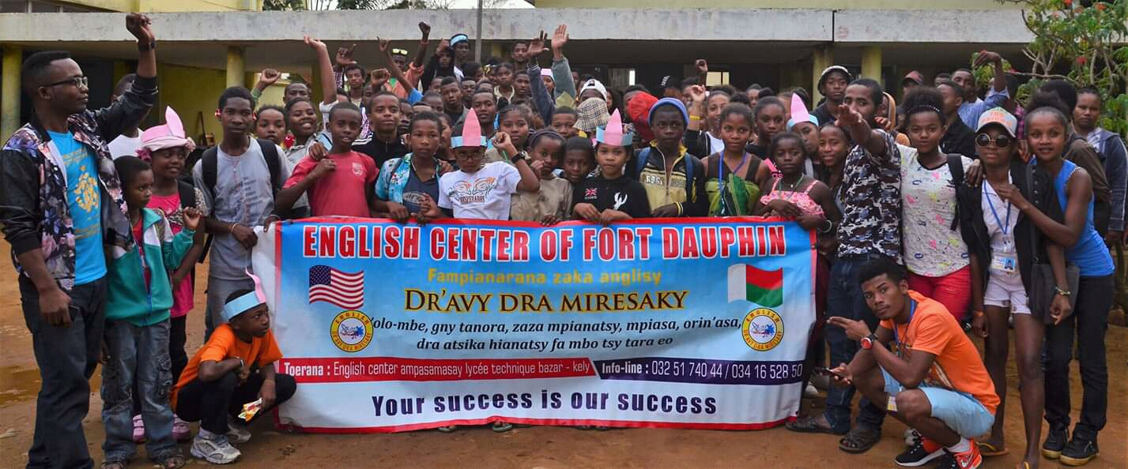
THE COMMUNITY ENGLISH CENTER OF FORT DAUPHIN

The community English Center of Fort Dauphin is a non-governmental organization in Madagascar, Fort Dauphin ( Tolagnaro) is dedicated to help development in Fort Dauphin through education and environment and people lives. and it is our fundamental principal that development is based upon the reality and what the community needs and find the solution. And creating a job for the youth .
About the Center
The Center is designed for everybody who wants development. The Center started in 2012 by the Region office, Peace Corps, and local community members. Collectively we decided to develop the Center incrementally with each person contributing whatever possibleWhen we began the Center, we only had four chairs and one table. Working together we steadily increased the number of tables and chairs to meet the demand for
Fort Dauphin has many international NGOs that are in need of bilingual English Malagasy workers. Additionally Fort Dauphin is a touristic destination and there is an increasing demand for English speaking guides. Therefore there is an interest in the training we provide.
Who is our focus :
We support primarily low-income underprivileged out-of-school youth and children whose parents are unable to afford secondary public school fees and therefore wander the streets without direction or hope. but there is a potential for them to have a better future or can support their self and their family . so we are trying to unlock that opportunity for them through giving them an education .
How is it operational ?
At the EnglishCenter we teach students English from level one to level four. Additionally we providelife skills training and leadership opportunities through structured community volunteer projects.
Currently the Center has two head teachers and eight volunteer teachers. We teach everyday in morning and afternoon sessions. We have been fortunate to have teachers who have been volunteering for 5 years which has really been good for the EnglishCenter. So the EnglishCenter is functioning by the student fees which is running all of the activities we offer .

The EnglishCenter has had a big impact since it began in 2012.
For example any NGO have hired translators. Additionally our students can apply for seasonal tour guide jobs offered by a cruise company.
One student wanted to be a teacher. He/she achieved their dream by opening an English school in ( Ambovombe in the south Region of Tolagnaro in october 2018 )_____. Therefor we are fulfilling our goal to train students and they have improved their employability and are contributing to their communities.
What are we doing ?
Education: teaching English, providing computer and life skills, and helping youth to find or create jobs.
Environment: : cleaning the neighborhood, beaches, and planting trees.
Sending kids to school : we send the underprivildged children who stopped learning an we have been trying to send then them back to public school and we provide their admission fees and school bag and copy book a well as giving them after class activity.

