KITABU INTEGRATED DEVELOPMENT ASSOCIATION
(KIDA)
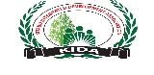 KYARUMBA- KITABU - MUGHETE, TEL: +256789327899
Email: kidar651@gmail.com
PROJECT SUBMISSION
BY
KITABU INTEGRATED DEVELOPMENT ASSOCIATION (KIDA)
PROJECT TITTLE: CONTRUCTION OF THREE CEMENTED TANKS TO SAVE THE LIVES OF WOMEN AND YOUNG GIRLS

SUBMITTED BY: Mrs. MBABAZI JANET
KASESE – UGANDA
Email kidar651@gmail.com
TEL: +256789327899

SUBMITED TO: GLOBAL GIVING
PROJECT DURATION: 1.2 YEARS

ORGANISATION BACKGROUND
KITABU INTERGRATED DEVELOPMENT ASSOCIATION (KIDA) is a community based organization that was established in 2011 by a group of seven women after having realized that widows, women and girls in their community are left out on matters concerning economic and social development, decision making and also finding out that men suppress the women and under look ( equaling them to almost nothing) because they do not contribute to the household income or because that they depend on them for their survival and most of their husbands spend most of their time drinking alcohol and gathering meetings in the community of no help to the house hold income and in the evening come back in the family to demand for what they supposed to equip with their families hence leading them to absolute poverty levels. Therefore Mrs. Mbabazi Janet with a few visionary women who felt the need to promote efforts t that will enable local grass root widows and marginalised women and girls to initiate development programs that will contribute to up lift their standard of living mobilized other women and then we amalgamated and took an idea of first becoming friends of what men called “women naturally born not to contribute to the family house hold income” and for men fighting to provide basic needs at home they intent to go for poaching which has put the number of widows in our area kitabu at a high rate and we associated to suppress men’s under development thoughts and limiting habits of undermining women and the association formed “KITABU INTERGRATED DEVELOPMENT ASSOCIATION” (KIDA).
Mission
Empowering widows, women and young youth girls with the available knowledge for
Sustainable economic and social development.
GOAL
To work and advocate for improved quality of life and preservation of the dignity of women, widows, and young females and disabled in our community.
VISION
A poverty free community that values women, widows and dignity, rights of female population and conserves nature.
MOTTO
Working for better lives
Our objectives
- To enhance incomes among the group members through revolving funds
- To promote and educate communities on the importance and appropriate ways of conserving the environment.
- To promote health programs among widows and disabled in the community
- To promote agriculture productivity through practicing the use of sustainable modern methods of farming.
- To promote programs on the access to clean water, proper sanitation.

Summary of Project
- Needs assessments based on socio-economic backgrounds (situation analysis)
The community of concern has eleven villages that depend on the five wells in the community which has led to many problems such hunger, violence, low girl child education, rape case, snake bites to women and high abuse of women who wake up at night at around 3:00 am of the night to try have clean water and avoid the over lining for over six hours to have a twenty liter jerycan fetched because of the long line. Thus we see construction of three capital cemented tanks on these wells will solve the problem of over lining for a 20 liter jerycan (tin), access to clean of the population of 25,000 people with over 3,125 families is a dream that we believe that will be solved by constructing the capital big cemented tanks that will accommodate over 150,000 liters each of well cleaned and sieved water. depending on the five wells and one tap that was rennovated early in 2013 by KIDA which will also be tapped to the tanks and it is just not doing the best to satisfy the population we saw it wise constructing three large cemented tanks to trap water such that the population can fetch at any time and reduce on the time wasted (8 hours) waiting to fetch a single Jerri can and put like five taps on each tank that will make ten of taps and this will provide clean water
The community is experiencing a high violence cases and family breakups, rape case of female partners who wake up at night to fetch water and exposure to dangerous animals like snakes.
The project will be justifiable in that it will reduce on the violence cases in the community because of water, increase on food production because female partners will have more time to cultivate food and income will increase because of less spend on waiting for water, improvement of girl child education because they are the most people affected by the task of going to the wells to fetch water and always miss schooling, zero rape cases because no more waking up at night by women and improved living standards.

- Target population and number of beneficiaries
Over 25,000 people with 3125 families in mainly mughete-nyondo village and the neighbor villages of nyakakindo and nyakabale and Kitabu, karambi, buswagha, kihororo, kahokya 3,kilambayiro, mughete lower and upper and over 5 primary school of St Augustine Kitabu, Nyondo, Kilambayiro, karambi, quran primary schools.

- Requested items (outputs), together with expected outcomes and other impacts through the project
Procurement of 800 cement bags, metallic pipes, plastic pipes, aluminum pipes, 30 trips of concrete blocks, 600 trips of sand, sieves mesh to clean water before the tanks, jointers and blots, tap rings, allowance to the local technical water plumbers and porters, gravel stones (local contribution) concrete stones, transport to take materials to the site and project site visit to subject the proposal to proper revision by the experts .

Out comes
- There will be reduced domestic violence and rape case in the affected villages and accidents of snake bites.
- Reduced trauma of women and young girls waking up at night at 3:00 am to catchup with the filled wells with water
- Improvement in the attendance and performance of girls at school because of the relief they to get after the construction of cemented tanks as they are the one who suffers most in the African culture setup they do most of the domestic work.
- There will be access to clean and filtered water from the harvesting place to tanks then to the taps installed thus reduced water diseases.

- There will be increase in food production because women will have time to cultivate and improved living standards.
- There will less school drop out by girls because they are used to missing classes to go for water and end up missing classes and the end result is to leave school because of poor performance.
- Gazetting the area of water catchment pledged help from the sub county authority from the land owners neighboring the water sources. And this will led to environment conservation in the long term of the project.

Below are the photos showing the wells to accommodate the cemented water tanks 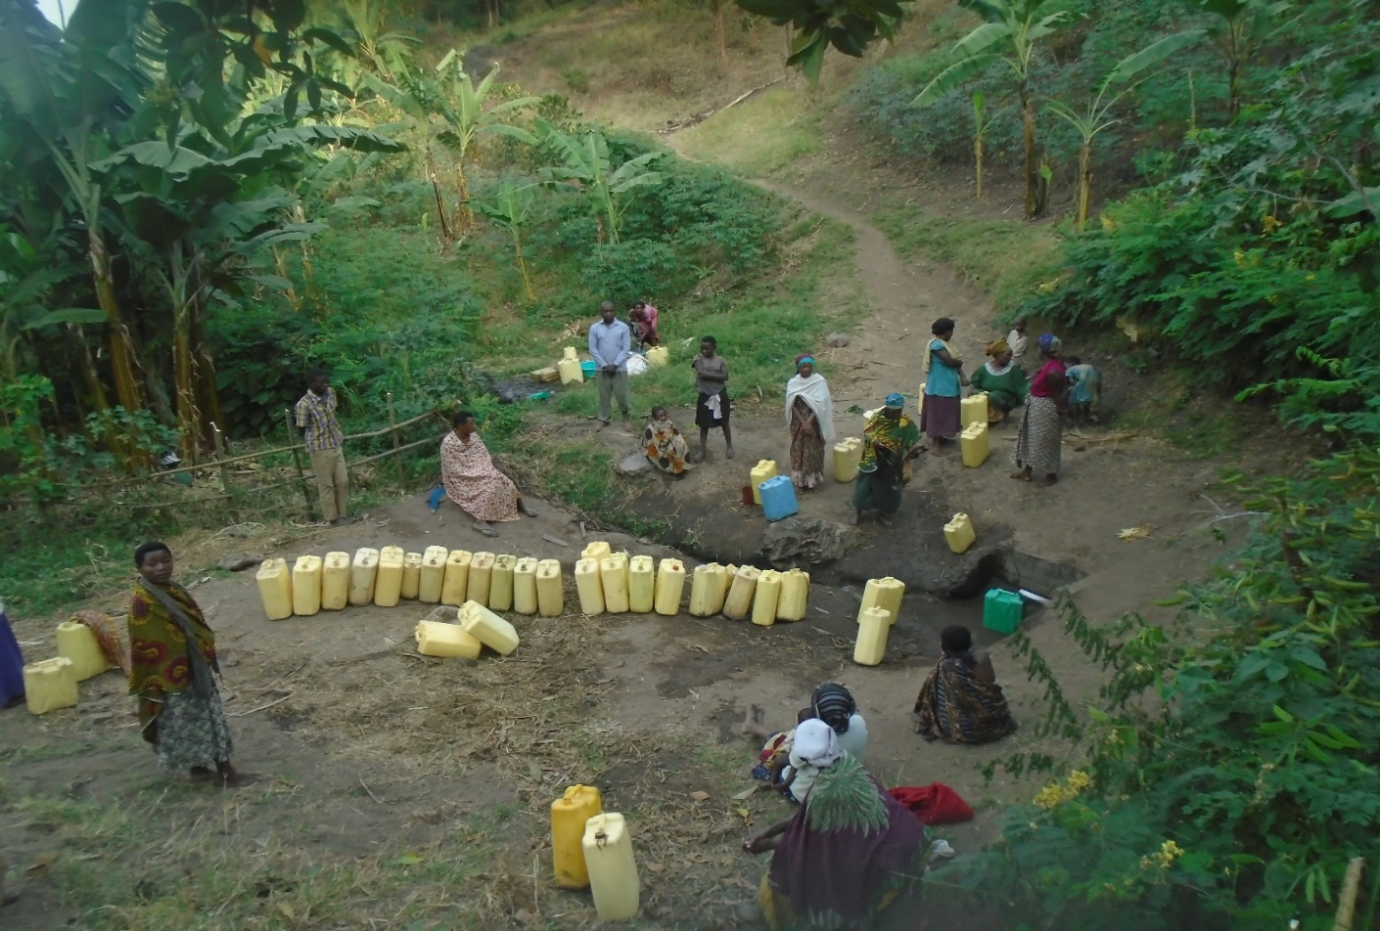
Women waiting for water where a single 20 liter jerrycan takes over three hours and this was constructed by KIDA in 2013 and is not doing well because people sit even on top of the source water (where it tapped) do to the over lining for water and women experiences a lot of abuse because even at night is like this

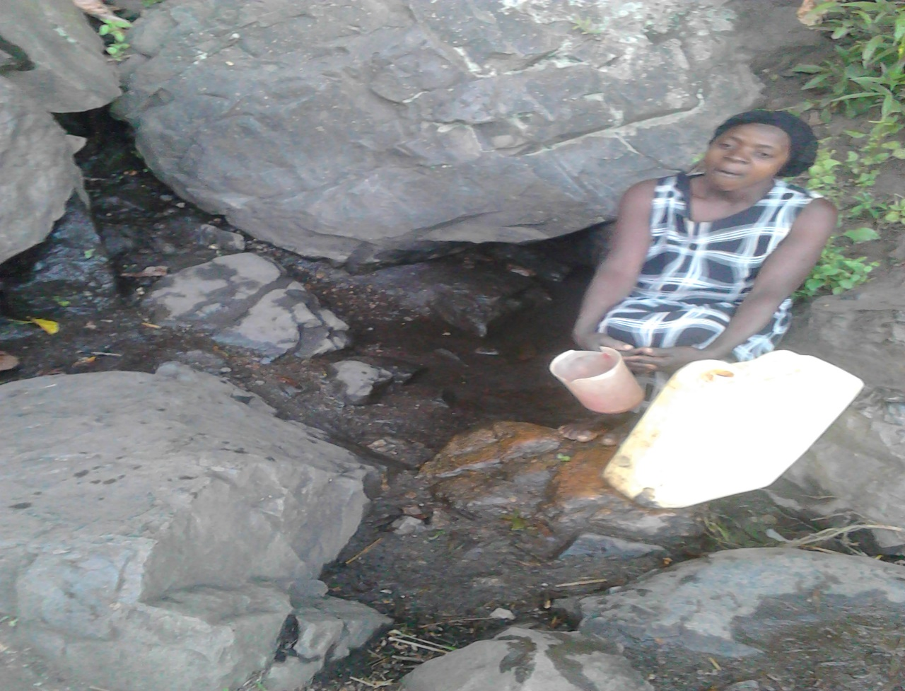
A woman fetching a drop by drop filling her tin on one the wells to be tapped to the tanks
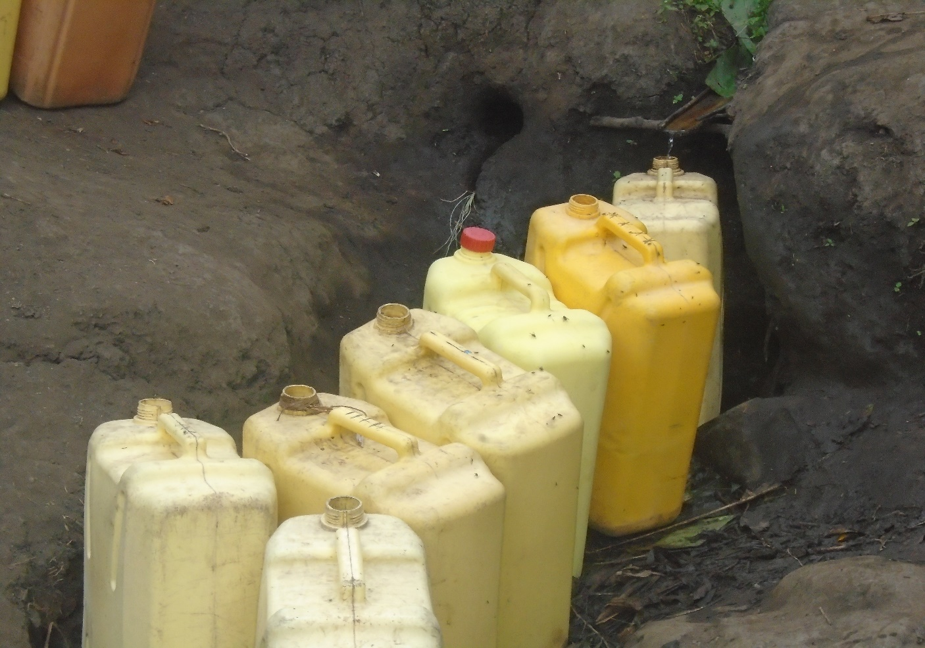
One of the clean after eliminating the well where the jerrycans are standing one the source to the tanks

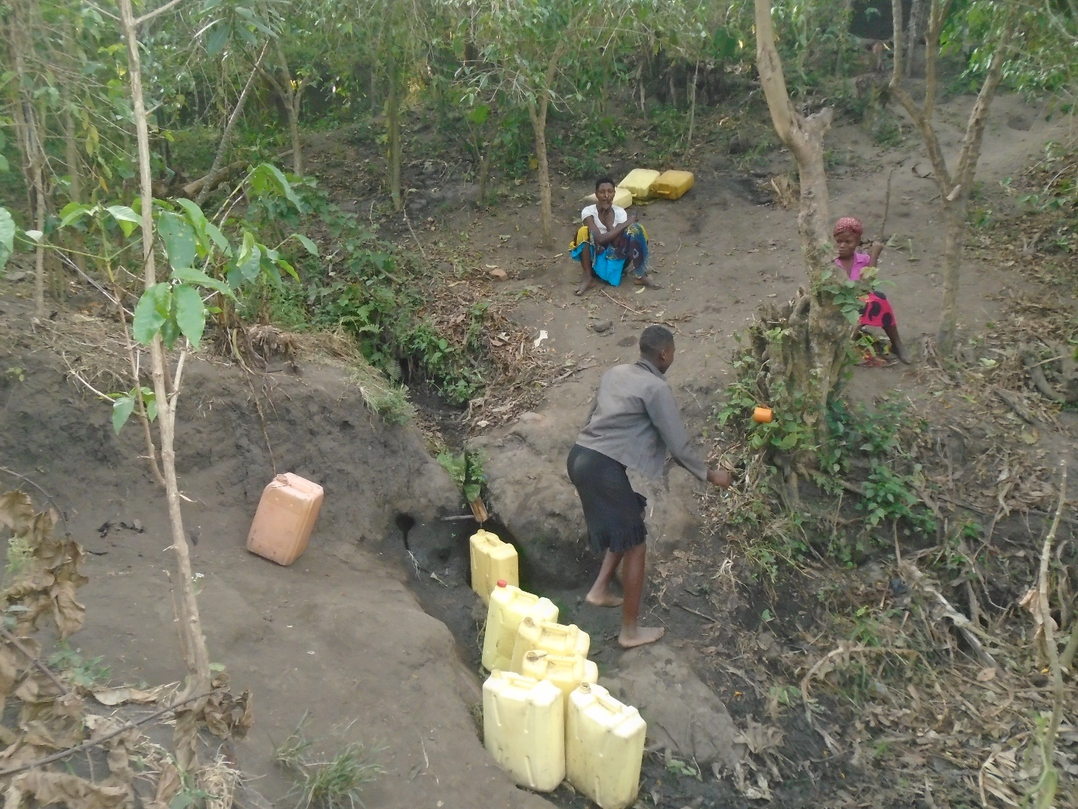
People waiting for filling of tins is delaying young school going girls and their hope is to have tanks that will store water and fetching be done at ones convenience.
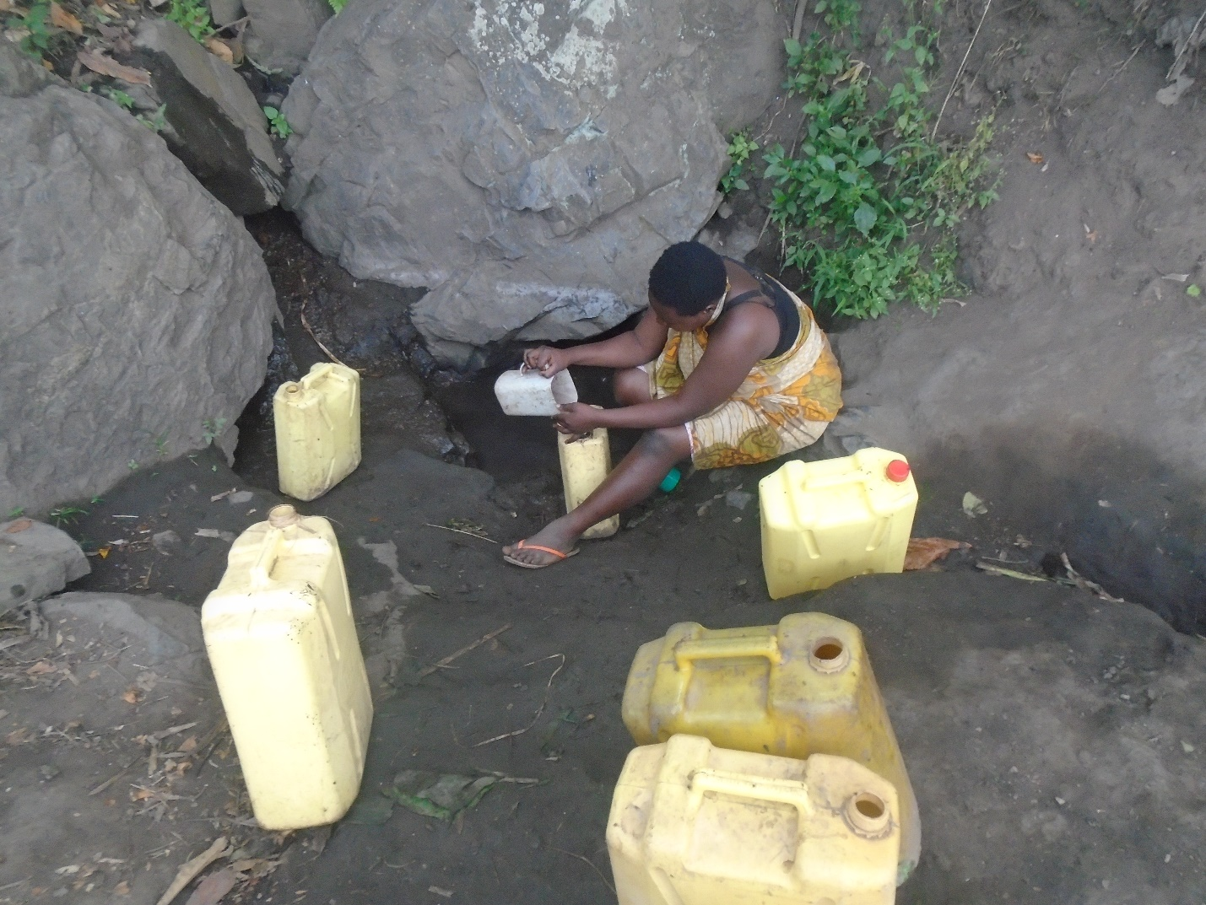
A school going trying to fill her tin because some families tried to manage wake up at night and dried the well and the other water flow to the ground.

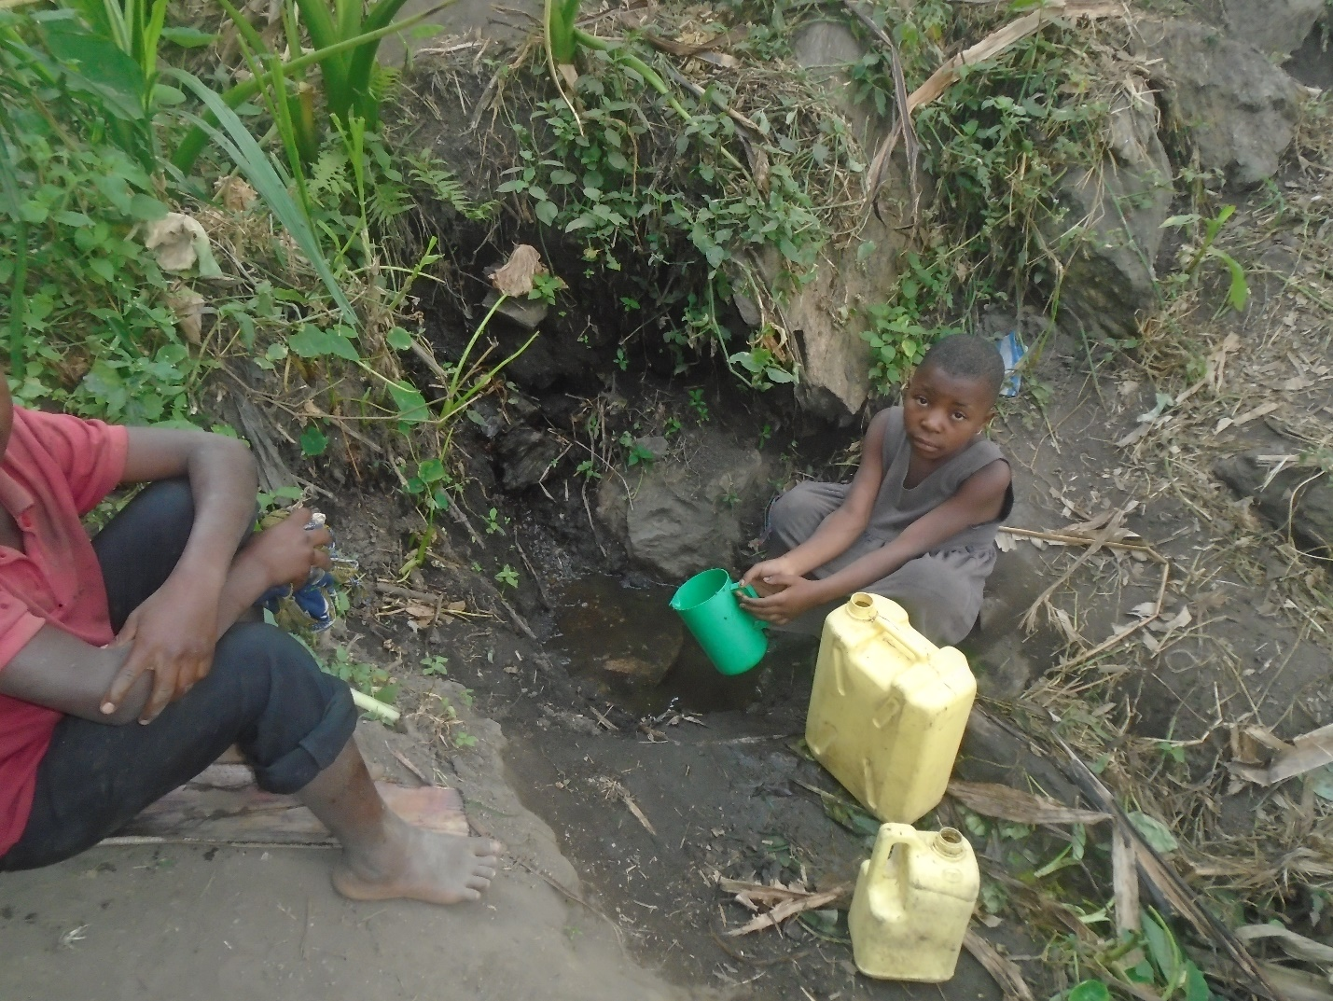
This innocent girl waiting for water in the morning who is going to wait for over 4 hours which will force her miss going to school.

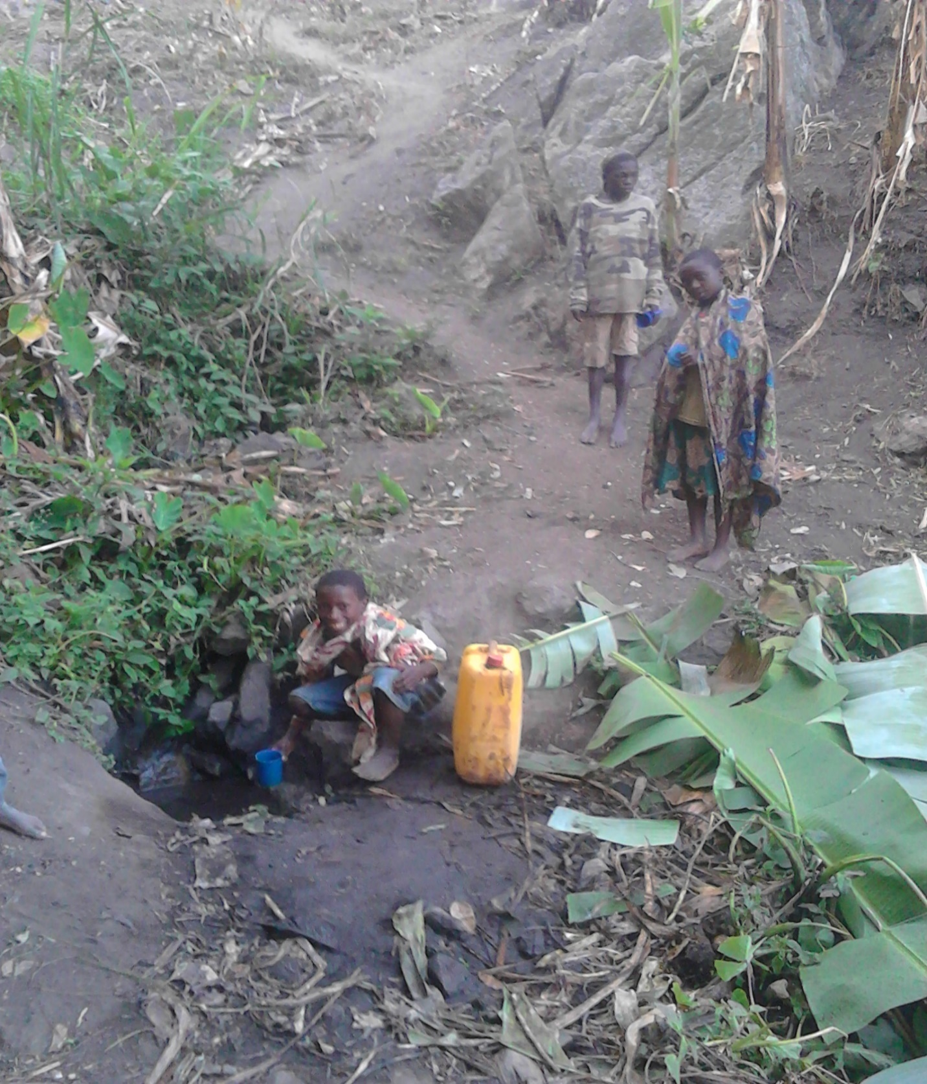
Young school going ready to miss school because the water in the can fill one jerrycan and the standing ready to miss school

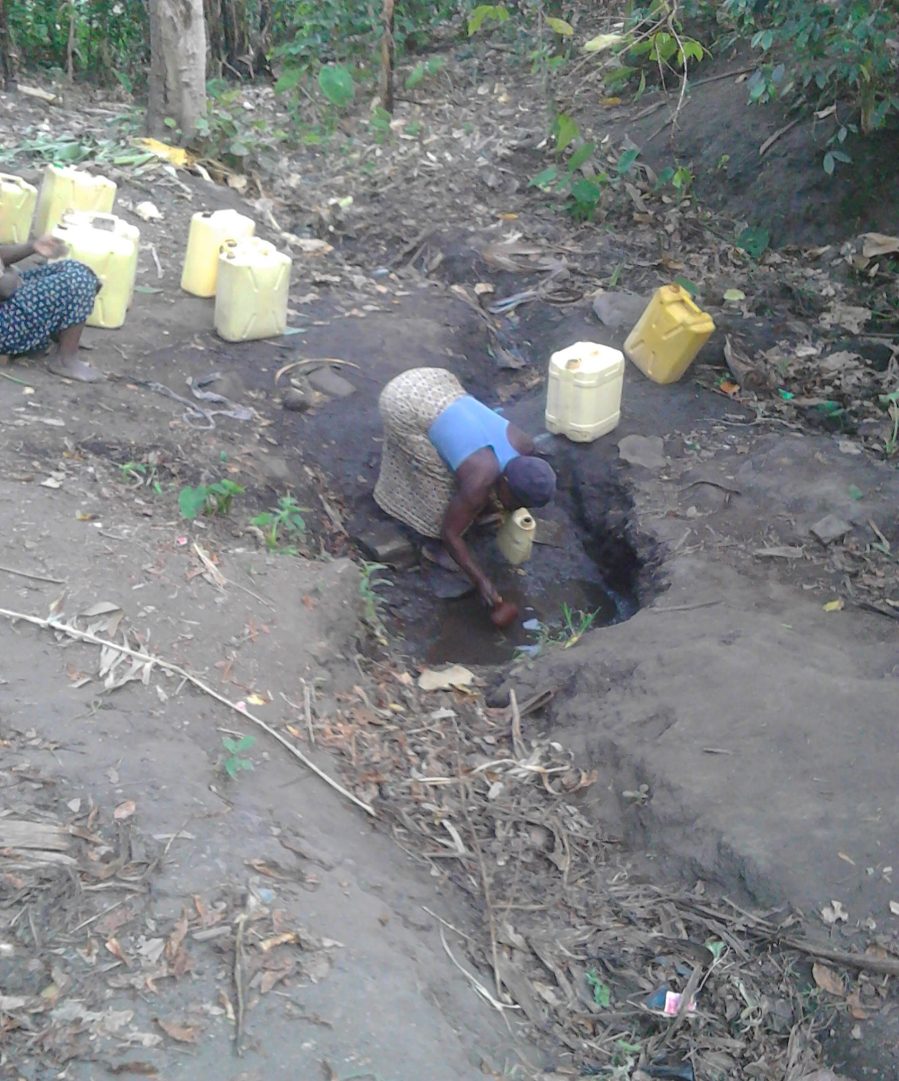
A woman fetching little by little in a small tin to fill the jerrycan avoiding the flow back but at some time these wells get full and water flow freely on ground and the water cycle is being disturbed by people over destroying the vegetation covering the water points which will be avoided after the construction of tanks because they will be no more delays that leads to destruction of vegetation growth.

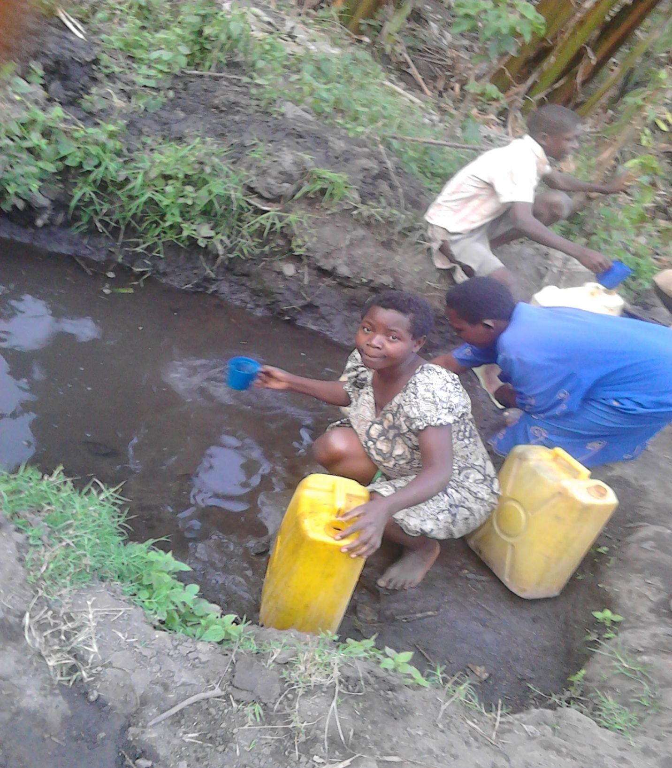
After cleaning the well it tried to serve at least three people at once.

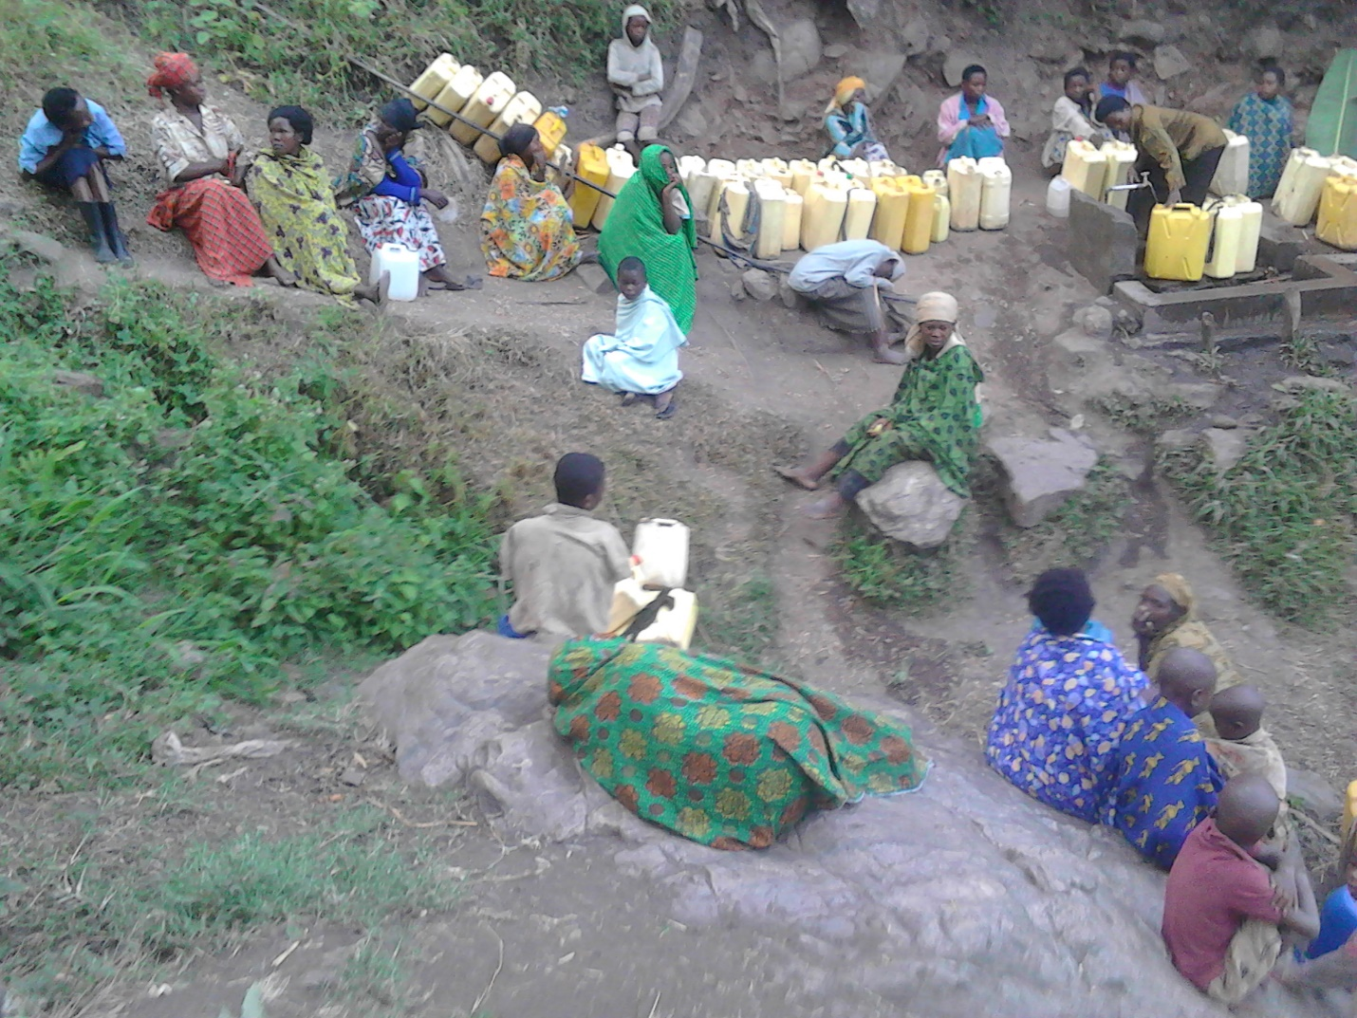
This tap drips little water which requires more renovation and more inlets to the tank and putting up another a new tank the little drips cause a line because it has more than enough dependents and others finalizes their sleep on stones because they wake up early in the night as the overview photo is telling it all that allow the affected people are mostly the women.
We welcome the funder for project site visit to subject the proposal for more revision and more design.

