|  |
| --- |
| **Progress Report**  **DMRC Children’s Home for Boys**  **September, 2018-March,**  **2019**  **Submitted by Salaam Baalak Trust** |

**Contents**

Introduction 4

Key Activities at Centre 4

Snapshot of Achievements of DMRC CHB September, 2018 to March, 2019 6

Challenges 8

Future Plan 8

Testimonies of Change 8

**Why investment in a child care institution is required?**

* Children living on the streets are the most marginalised population, as they are vulnerable to all types of abuse and human rights violation.
* Surviving on garbage or food donated at temples, street children have high rate of malnutrition leading to stunted development.
* In cases of girls, they become victims of sex trafficking and sex perverts.
* Residential centres are 24*7 centres which provide shelter (long-term or short-term) and a package of childcare services based on continuum of care approach to children.
* These services include medical care, food and nutrition (three hot cooked meals and evening nutrition), education, vocational training, job placement, restoration and rehabilitation.
* They support girls to develop in-depth understanding of their problems, psychological trauma and help them leave behind their emotional baggage.
* The centres also provide sports and latent talent development opportunities for all round development of children.

***Given an opportunity, these young lives soar to their highest potential. It fills our heart with pride when we see them achieving academic excellence and gaining self-confidence.***

# Introduction

Recognizing the need to protect the future of the children residing on streets, Salaam Baalak Trust (SBT) was established in 1988. SBT’s residential centres intend to fulfil street children’s longing for safety and security by providing them a caring and nurturing environment with a sense of security. A safe place to sleep, a small cupboard to store personal belongings, a somewhat set pattern to life (e.g. regulated timings for food, study, play, roll call and going to bed etc.) is fostered at the residential centres. Additionally, the Trust also has a vision of ensuring access of street children to high quality services ranging from health, nutrition, education, vocational training, and restoration and reuniting children with the families to job placement.

The Delhi Metro Rail Corporation (DMRC) Children’s Home for Boys (CHB) managed by Salaam Baalak Trust (SBT) caters to a large number of boys rescued from streets and difficult circumstances. The DMRC CHB has been operational since 2010; and it is registered under the provisions of the Juvenile Justice Act, 2000. It follows a child-first approach where in all services provided are aimed at holistic and all-round development of children. The children are provided shelter, health and nutrition, education, vocational training, skill development and rehabilitation services at the CHB. The team and staff at the CHB adopt a sensitive and caring attitude towards children to help them leave behind their traumatic past and lead a normal and productive future life. At any given point of time the CHB continues to provide shelter to around 120-150 children. The functioning of the CHB is guided by following objectives:

* Providing safe, child-friendly and caring residential space to children rescued from the streets
* Enabling children to lead an independent, dignified and quality life
* Collaborating with relevant institutions and organisations to increase children’s access to fundamental opportunities, like education, skill building and job placement

# Key Activities at Centre

Towards these objectives, DMRC CHB conducts following activities for holistic development of children.

* **Extending educational support**: Children’s education remains a primary focus at the CHB. All children coming to the CHB are linked to various modes of education including formal, non formal and open schooling given their existing learning potential and capacities. The aim is to capacitate children to access formal schooling and good educational qualification. Importance of education at the CHB is not only emphasised for securing a good job, but also for one’s intellectual development. To sustain children’s interest in studies and ensure retention of children in schools, SBT in-house teachers conduct regular classes at the CHB using play-way methods and interactive techniques. This flexible and supportive approach to educational programme has enabled children at DMRC to perform well in schools.
* 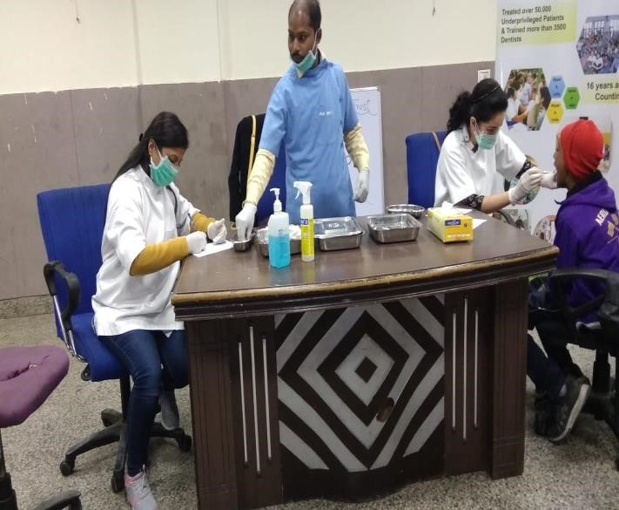**Laying foundation of good health and nutrition**: Prevention of diseases and promoting good health among children remains a key focal area for DMRC team. Towards this end, three hot cooked meals and supplementary nutrition is provided to undernourished children. SBT in-house doctors conduct regular medical checkups and vaccination rounds to protect children from preventable diseases. Health cards and records of all children are maintained by the medical social worker. A trained counsellor conducts individual and group counselling sessions with the

Children to help them voice their doubts, *Health Check up*

Problems and concerns. The counsellor further suggests constructive solutions to these problems. This ensures that children receive regular psychological and mental health support.

* 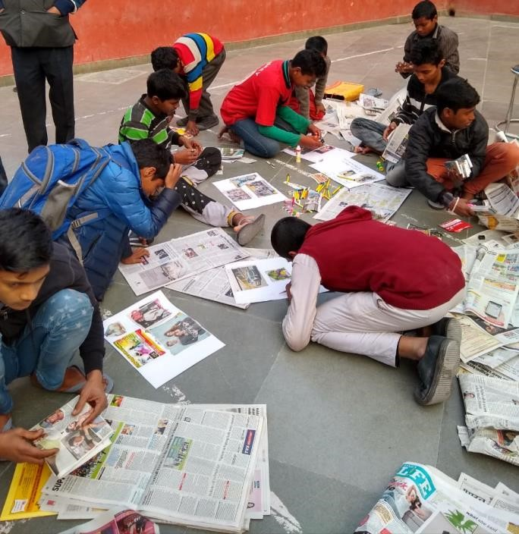**Extracurricular Activities**: Apart from education, different form of extra-curricular activities such as discussions on topical issues, festival celebrations and drawing and painting competitions and sessions are organised at the CHB. All children at DMRC actively participate in these activities and work collaboratively to learn and enjoy with each other. These activities ensure that children use their different faculties for their allround development.

*Craft and creative activities*

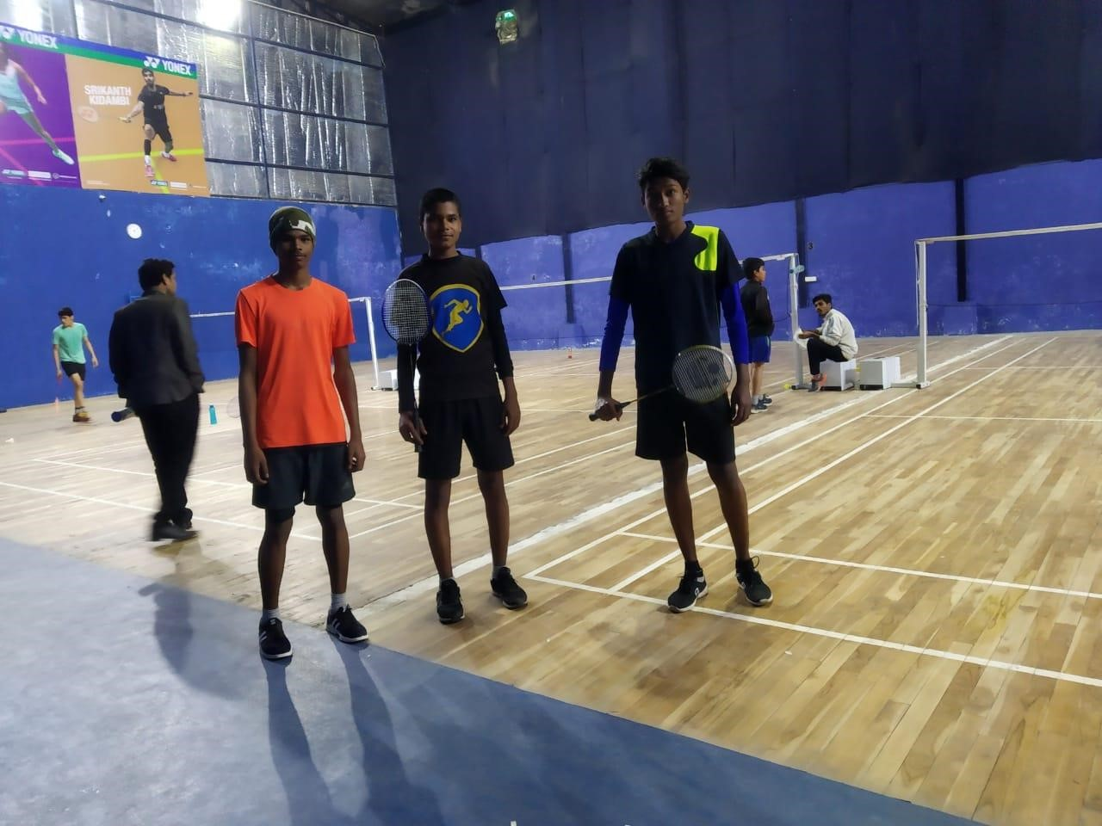

*Children participating in sports activities*

* **Skill development and job placement:** Laying the path of children’s bright future necessitates that they become independent and capable individuals. In this context, skill development of children and preparing them to take up gainful jobs become crucial. The team at DMRC has been making consistent efforts to link children to various skill development courses, including vocational training and latent talent development facilities ranging from dance, dramatics, acting, music, singing and puppetry among others. Life skill education sessions such as banking, interacting with others, cooking, writing an application further capacitate children to learn the most necessary skills to lead a life of their own. Children and young adults who are above 16 or have passed Class 10 have been linked to vocational training and higher education. Many children from the CHB have also been linked to jobs. Children have opted jobs in computer industry, hotel management and marketing.
* **Rehabilitation and reuniting with families:** Post vocational training and job placement, young adults are supported in finding a place of their own to live, they are also provided basic items for setting up a house such as utensils, bedding gas stove and expense to buy groceries. The DMRC CHB team remains in touch with these adults through regular follow up. Many children who run away from their natal homes or are missing or separated from their families, even though settle well in children’s homes but long for their families. SBT also believes wherever possible, it is in the best interest of the child to live in a caring family setting. Thus, the DMRC CHB team traces the families of such children and reunites them with their parents, guardians or significant others. Sometimes, the process of restoration to families is beyond the national territory in countries like Nepal and Bangladesh. In these cases also, DMRC CHB team takes the children to their homes, counsels the parents and follows up with them on child’s status.

# 

# Snapshot of Achievements of DMRC CHB September, 2018 to March, 2019

Through above mentioned activities, the DMRC team achieved positive results in terms of increasing children’s access to basic services and enabling them grow to their fullest potential. A snapshot of progress is depicted below.

|  |  |  |  |  |  |
| --- | --- | --- | --- | --- | --- |
| S.No. | Service |  | No. of Achieved  Data | Remarks | |
| 1. | Education |  | Formal Education- 50  Children  NIOS - 15 Children  Non - Formal  Education (NFE)- 26  Children | * Of these, two children have been restored to their   families   * During the reporting period various types of educational activities such as quiz competition, storytelling, art and craft, remedial classes and video aid learning etc. have been conducted. * Educational support is being to two children who are residing with their families. * Periodical assessment and in-house exam of children (formal schools & NFE) were conducted. | |
| 2. | Health  Nutrition | and | First Aid - 1101 times  Medical Check-up - 431 times, 66 Children Investigation - 236 times, 116 childrenReferred to Hospital - 352 times, 148 children  Admitted in hospital -  7 times, 5 children Admitted in drug deaddiction centre - 8 children  Medical Camps - 2  times (Dental) HIV Test - 4 Children | * Two medical social workers take care of children’s medical needs. * Presently, 8 children who are undernourished or malnourished are being provided special nutrition as prescribed by the doctor. | |
| 3. | Vocational  Training and skill development | | Vocational training -  11 children  Skill development - 39 children | * Sukur, Class 10, NIOS is pursuing Food Processing course of 6 Months from Aurvindo Ashram, HauzKhas. * Dev, Class 7, NIOS, is pursuing SMO course of 3 Months   (GMR GrandhiMallika Arjun Rao), Dwarka   * Rohit P, Class 10, NIOS is pursuing a Hardware. Networking of 12 Months from Jetking, Karol Bagh * Gaurav D, Class 10, NIOS, is training under City Walk programme of SBT. * Raja, is pursuing an Art & Craft course of 12 Months from DFDW (Delhi Foundation of Deaf Women). * Abdullah is pursuing a course of 45 Days from GMR, Dwarka. * Saminul is pursuing a Hair Cutting course of 12 Months from The Professional Touch, Chandrawal Nagar, Delhi. * Raghav, Class 10, NIOS is being trained under City Walk programme of SBT. | |
|  |  | |  | • | Dev of Class 7 is doing a hair cutting course of six months from The Professional Touch, Chandrawal Nagar, Delhi. |
|  |  | |  | • | Raj Kumar, Class 10, NIOS is pursuing a course on Event Management of 4 Months from Filmeez, East of Kailash. |
| 4. | Job Placement | | 2 children | • | Abdullah was placed as a House Keeper in Bangalore with Rs 9300/ month Salary with residence facilities. |
|  |  | |  | • | Peter was placed as sales Executive at Decathlon Sports Company, Gurugram with 25,000/- Month Salary. |

# Challenges

The team grapples with following challenges:

* Resource mobilisation to link children with substance abuse to better de-addiction centres
* Linking children with disabilities with professional institutes

# Future Plan

• Networking with institutions providing deaddiction services and educational services to children with disabilities

# Testimonies of Change

## Dreams become a reality

DMRC CHB team found Samir from Hanuman Mandir when he was 7 years old. He didn’t remember much about his family, but he told the staff members that his father was in jail and her mother was a drug addict who lived on the streets. Upon becoming aware of his present condition, the SBT team produced Samir before the Child Welfare Committee (CWC). The CWC directed his admission to SBT’s DMRC CHB for his proper care and Protection.

During initial days, Samir took time to acclimatize himself at DMRC CHB. However, the staff and other children warmly welcomed him. Slowly he became comfortable and began interacting with the team and other children. He exhibited interest in various activities of the centre. He began attending in-house classes and was linked to a formal school. Presently, Sameer is studying in Class 7.He is doing really well in his studies. Samir is keen to learn acting. As a result the team encouraged him to participate in the Annual Theatre Programme named ‘Street Dreams’. Seeing his talent, the Clean Slate Films auditioned for a Mumbai-based Production house and selected him in a suspense thriller Series of Amazon Prime which will be shot in Delhi in March, 2019. Samir’s dream of becoming is indeed coming true at a very young age.