Camp days and duration: Summer camp was a fifteen days event from the 5th May 2019 to the 19th May 2019. The camp activities were divided into three five days segments on each subject/topic and they were upgraded each week (please see the curriculum below) and the learning modules were learner friendly at the same time challenging.
Participants and age group: 7 to 14 with the exception of three participants. A tenth grader who is just 14 plus was accepted and two 5+ years old first graders were admitted as well. They all are mainly Tamil speakers and all of them learn English as second language. Three students paid the registration fee of Rs.750 for the entire camp and their parents made a small contribution for the food and beverages. Four received a 2/3rd fee waiver and paid Rs.250. For all the others it was free since they could not pay the fee. The configuration of students was very diverse and was very inclusive. The group got along very well, which is very visible in the activity and practice photos and the final performances. Everyone had an equal role and responsibility, be it theatre, dance or science tasks. Originally we had planned to have the rural children over. Since we could not mobilize the travel fund, we identified the participants from closer by locations, and cut down the number to 21.
Academic committee:
The creative head and main leader of the Academic Committee is Dr.V.A.Vidya. She proposed the curriculum to the other committee members, and they suggested the required changes and improvement in the modules. Then it was finalized. Dr.V.A.Vidya : Head of the Academic Committee Prof.Krishna kumar : Chief advisor for science curriculum Dr.Sugantha Ramamoorthy : Reviews all the proposals and makes recommendations. Artist Babu Kothandam-K.Veluchamy :Associate Director for curriculum in visual arts Ms.Nivetha Mohan under the tutelage of Dr.Bala Nandakumar is the Associate Director for curriculum in performing arts. There were many sessions of planning before the modules were created and the lectures finalized. Ms.Prathima Rohini Rajasekaran designed the learning modules and materials for theatre.

Teachers, trainers and volunteers: Mr.Allwin Mebsraj A junior research scholar pursuing his PHD in microbiology in conjunction with Dr.Vidya created the learning modules and lecture sessions for STEM lectures. Given the age group of the children, the lectures were simplified, with lucid everyday examples with support YouTube audio visuals. Ms.Monisha Surendran a second year MA student in music and performing arts also gave three sessions of lecture on trash management and the science behind trash segregation. Ms.Gayathri and Ms.Swarnalakshmi along with Nivetha Mohan, Monisha surendran were trainers for the Bharathanatyam and theatre session.
Typical hourly schedule: 10:00 AM to 4:00 PM with an hour break for tea and lunch
Total number of hours: 75
Art classes with Artist Babu : 20
Banking and money management with Dr.Vidya, and volunteers:4
Craft with Artist Babu :6
Science is fun- scintillating science lectures with Prof.Krishnakumar and Allwin Mebsraj : 10
Theatre with the SSSV Music College students: 15
Music with the SSSV Music College students: 5
Bharathanatyam with SSSV Music college students: 15

Curriculum:
Art classes with Artist Babu : 20
Learning goals and outcome: Art to understand self and the life around – Perspectives, landscape and people
Working with Artist Kothandam Babu. This has been an unforgettable experience for summer camp 2019 participants. The summer camp participants as well as the volunteers learnt art, craft and multimedia skills from Babu. The theme was the five landscapes of Tamil Nadu. During the first five days the children painted five different landscapes - Kurinji, Mullai, Marutham, Neithal and Paalai. By learning about the landscapes they also learnt about the fauna, flora and people of the landscapes, life and culture and the present situation. This was also connected to the contemporary challenges of consumption and trash generation and depletion of resources.
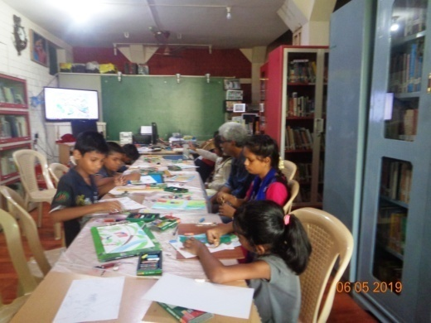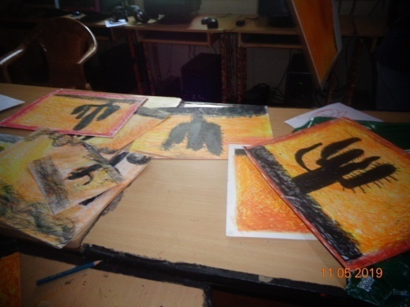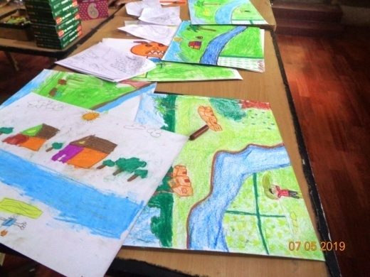

Banking and money management with Dr.Vidya, and volunteers
Learning goals and outcome: Understand cash / cashless economies and handling money / Saving and planning purchases – Right to open a savings bank account after one is 14 years old
During the summer camp 2019, we introduced the "business of banking" and handling money. They got to fill up real cheques, deposit slips and withdrawal forms. We explained about bank's role in educational loans, the schemes available for children above 14 years. Even the youngest participant -a six year old, filled up the form... The interesting fact is that Indian school children start writing early - perhaps even before they learnt to read fluently and comprehend.

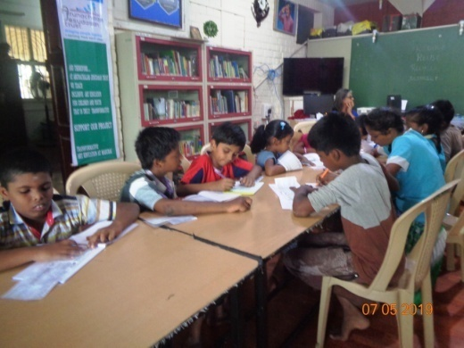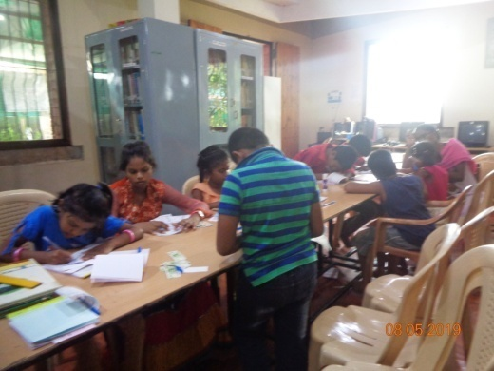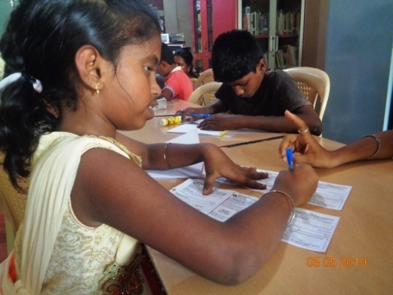
Craft with Artist Babu :6
Learning goals and outcome: Designing, - Small things and Nano technology developing patience to work with fingers and handle minute things and produce quality work.
On the other days they tried something similar to Tanjore painting, by sticking artificial gems and gold strips.. They all made a mother's day gift of a bracelet and a choker necklace - gems set against velvet. Summer Camp 2019 had a session for improving the loco motor skills..The children learnt about designing minute things, sticking smaller objects into a pattern and handling small articles. They all produced art pieces similar to Tanjore art - that is working with gold rakes and gems. The children used artificial gold strips and gems to produce a gem studded picture of an elephant, bracelets and choker necklaces. To produce these, all worked very patiently and meticulously for six hours spread over three days!
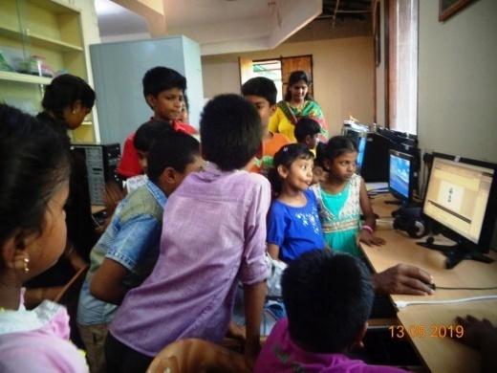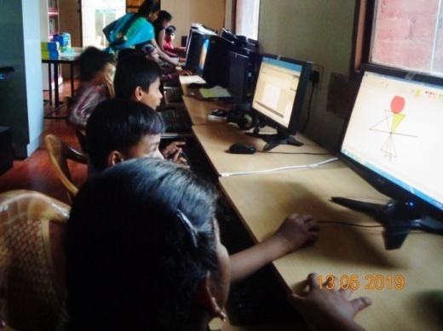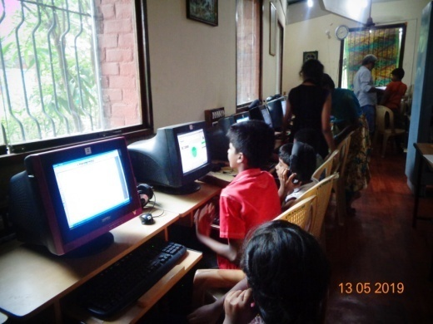
Science is fun- scintillating science lectures with Prof.Krishnakumar and Allwin Mebsraj : 7
Learning goals and outcome: science is life. No progress without scientific understanding about anything and everything.
Learning science with Prof.Krishnakumar, Young research scholar Allwin Mebsraj, assisted by Monisha Surendran. Prof.Krishnakumar's lecture was lively, and lucidly worded and the narration was superb. The children could relate to the stories and concepts quickly. He kindled the curiosity about mathematics and physics, and gave many examples in the history of science, on thinking out of the box. and made the participants ask questions or answer the questions spontaneously and originally. Allwin Mebsraj, a PHD researcher on bio fuel, handled three lecture sessions and covered a wide range of topics - cells, plants, human body, decaying bio matter, compost, good and bad bacteria, the beneficial bacteria around humans etc. He took the kids into the garden and gave a short tour, explaining the chemical actions, reactions and other transformations that happen in the plant world.
Monisha Surendran gave a great presentation about waste management, segregation of trash, and its importance. In fact this became the central idea for the play "Kuppai" - Trash by the children.
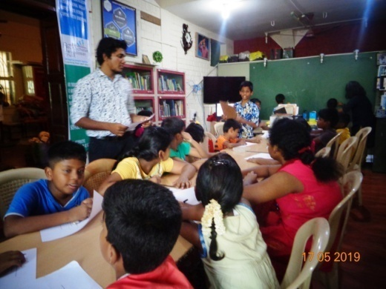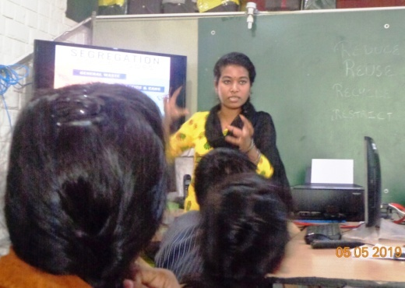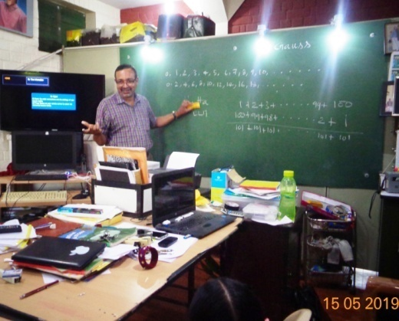
Theatre with the SSSV Music College students:
Learning goals and outcome: Understanding real life “skits” team work, perception about a problem or challenge, presenting a problem, presenting a solution – On the whole enjoy theatre!
The summer camp participants and trainers at work. They all learnt about theatrical skills, stage management and self directed performance, develop time sense, and team work on stage.
The four senior dance students directed two of the plays produced at the end of the camp. One was an adapted version of The Little Red Riding Hood, and another about the global challenge of urban living and generating mountains of trash. All the children had equal role in the two plays. Fifteen days hard work and practice.... The children were tireless during the practice session; they were all great learners and taught each other. There was a lot of laughter and action
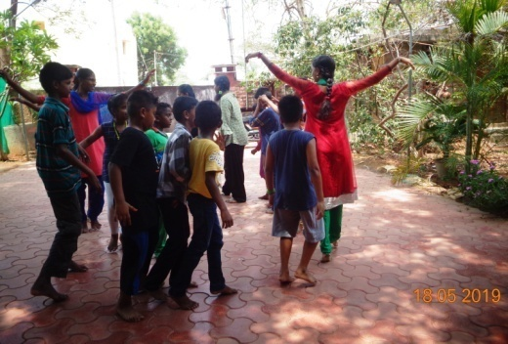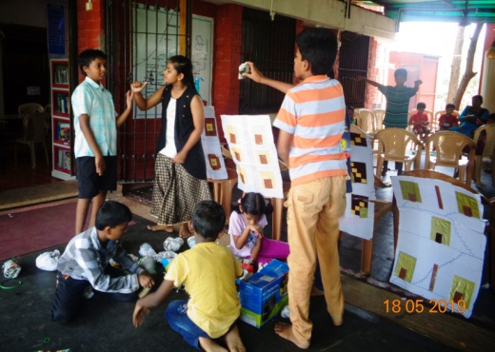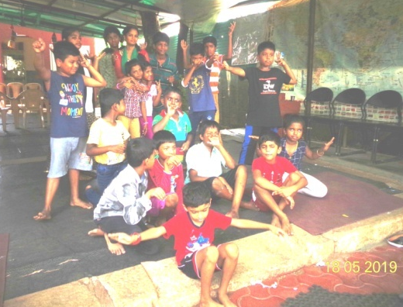
Music with the SSSV Music College students:
Learning goals and outcome : Sing for happiness, sing together for enjoyment!!
For the summer camp 2019, we made an exclusive recording of music composed by Dr.Vidya, Ms.Nivetha Mohan and the SSSV College students. It had only an accompanying percussion instrument played by another student of SSSV College, Mr.Arun Thiagarajan
The students learnt four Ragas –classical scales - Atana, Bilahari, Shanmuga Priya and Sama.
The song in Bilahari was composed to explain the importance of forest, its fauna, flora and security as a home for the animals. This dance piece followed the adapted version of the Little Red Ridinghood, that had a happy ending of the grandmother and Little Red Ridinghood reviving the forest.
The specific skills training in music was to understand pitch, note, and staying with the tune and rhythm.
Special event: Dr.Vidya, The project leader translated Nobel Laureate Bob Dylan’s blowin in the wind. The children learnt about the Sri Lankan bomb blasts on the Easter. We dedicated the song to the victims. The song is an exact translation of the verses in Blowin’ in the Wind
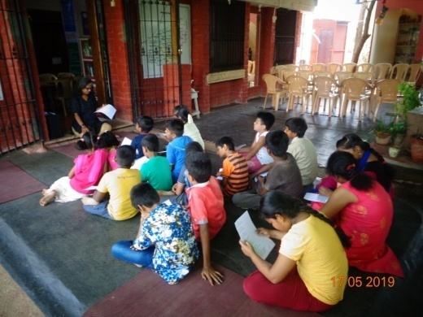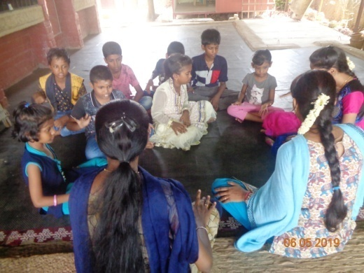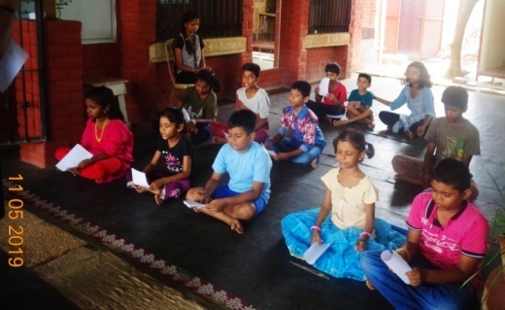
Bharathanatyam with SSSV Music college students:
Learning goals and outcome: appreciation of performing arts – understanding all the nuances of Bharathanatyam
Hats off to the trainers from SSSV Music College and their mentor Ms.Nivetha Mohan guided by Dr.Bala Nandakumar the Principal of Sri Satguru Sangeetha Vidyalayam. In fifteen days time, the entire group learnt to appreciate the various aspects of Bharathanatyam. They learnt about body movements, animal movements, mudhras, bhavas, and few basic adavus. These they applied in the two plays produced for the summer camp. Apart from that the beginners performed the mime part of the choreography and the basic steps and the seniors performed a Kauthuvam. It was really heart warming to see the children's involvement and their love for the art. They were prepared to learn even the toughest things.
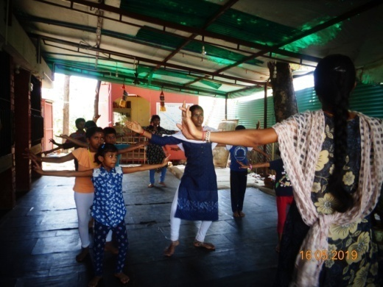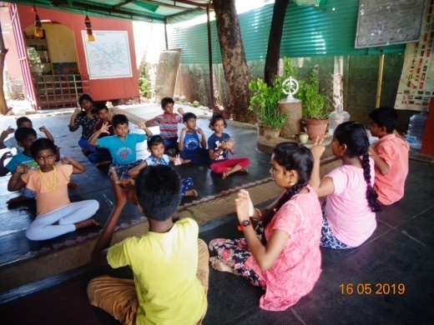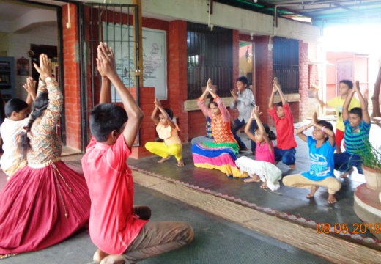

AJ Trust’s Stipend Commitment to the teachers and trainers: The Trust pays a minimum per hour compensation for the trainers. This will accumulate and go into the scholarship of the student trainers. For all the volunteers we pay travel stipend since they cannot afford the travel expenses. The travel stipend will be between Rs.50 to 110/- per day, since the bus fare costs Rs.25 to 55 one way, depending on the distance.
BUDGET FOR SUMMER CAMP 2019 for 21 students for 15 days
TOTAL FUNDS RAISED : $1025.00 Abstract : Per student cost is USD 127.14
Fixed cost for 21 students for 15 days: USD 1675 Variable cost for 21 students for 15 days : USD 995
Total for 21 students for 15 days : USD 2670.00 DEFICIT : USD 1645
Sl. No. | Budget Category | Expenses Quotation | Total
 | Teacher’s stipend together with travel support for fifteen days. This will pay their annual school fee and cover a few more expenses. AFTER MOBILZING THIS FUND, IT WILL BE DISBURSED. | For 6 teachers and trainers @USD200per head | $1200.00
 | Lecture fee and travel support for professors or expert presenters | INR 1000x 7 | $100.00
3 | Travel expenses for 15 days  day’s rent for mini vans 5000/- to bring the rural children The rural children could not be included this time. Travel support could not be mobilized. We had all the 21 children from local areas | Rs.5000x 15 = 75000  Rs.2500 one way 75000.00 | 0.00
4. | Electricity and petrol for Generator | Rs.350 per day x 15 | $75
5. | Communication expenses WiFi  One connector can provide internet connection to four computers 5x500 | 3500 for 15 days Cost of three dongle charges WiFi USB for Broadband connection | $50
6. | Water charges (for drinking and utilities) | 200 per day for 15 days +cushion 3500+ cushion | $50.00
 | Total |  | 1675.00
Variable charges
Sl. No. | Budget Category | Expenses Quotation | Total
3. | Materials – Art supplies, and other stationery | 1050 x 21 = 22050 | $315.00
4. | Refreshments and lunch for students  $ 385 covered so far. Deficit : $245 | ₨.2100/- (per head) for 15days =44100/- | $630.00  $385.00
6. | Hi Tea – Final Day | Rs.35/- (per head) x100 = 3500 | $50.00
 |  |  | 995.00

