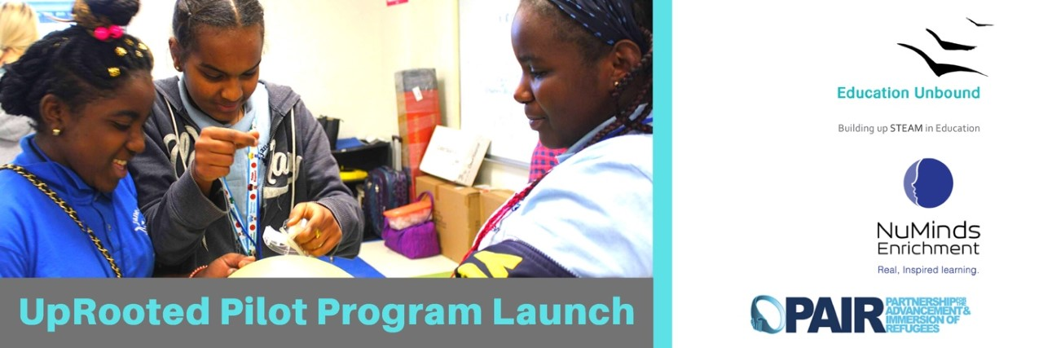

Dear Patrons, Friends, and Family,

At the end of last year, the first Global Refugee Forum in Geneva ended the decade by translating the principle of international responsibility-sharing into concrete action. Looking at the rising number of refugees and the specific pledges made by the forum, we are very proud to have a solid educational plan rooted in values and integrity.

Looking over the last decade, the response to refugees has been slow and unreliable. Refugees are often cut off from the social and economic life in their hosting communities, marginalizing the sharing responsibility.

As the new decade dawns, 23,000 refugees have settled in the US – and it’s time to reboot our responses to this population.

At Education Unbound, we are championing this reboot by building the support to rally behind these extraordinary efforts and accelerate and expand them as we move into a new decade.

The initiative to start with only ONE organization has trailblazed into four others because the need is so great, and thousands of refugees wait to be part of STEAM education and enrichment for a more promising future.

With our practical plan to train staff and provide enrichment programs for sustainability and continuity, we thank you for being part of this journey.

Today, we are delighted to report we have launched our new pilot program bringing after-school STEAM enrichment to 25 refugee children, in partnership with NuMinds Enrichment, an innovative provider of engaging, mixed-age STEAM programs. Over the course of the next 3 months, students in grades 6, 7, and 8 will challenge themselves with mixed-age STEAM (Science Technology Engineering Arts and Math) programming.

As you may recall from my last update, we’ll be doing this crucial work with PAIR (Partnership for the Advancement and Immersion of Refugees) administering the program. PAIR empowers youth to navigate American society, reach their academic potential, and ultimately become community leaders.

In a traditional classroom, students aren’t exposed to the same learning opportunities afforded in a high-quality, subject-integrated STEAM Enrichment program. For refugee students in particular, exposure to experiential learning can allow a full engagement, because the teaching is aimed at the whole child. This also means for refugee children, who are contending with trauma, reigniting a passion to learn and cultivating a stronger belief in themselves can ultimately develop character traits closely associated with positive, long-term outcomes.

These traits, which include resilience, divergent thought, mental flexibility, critical thinking, emotional and social awareness, collaboration, and creativity, are often hailed for success in 21st-century jobs and are likely a crucial difference in the long-term outcome for many of refugee children today.

Of course, these children are grappling with more than just a need to excel in future careers – they’re struggling to overcome severe trauma, discrimination, and abuse, which means it takes the right kind of support to engage the students.

In our pilot’s after-school enrichment, students will Count Down to 2030, and ask themselves exhilarating questions, such as:

Who flies the rocket that takes your family to Lunar Disney World?
Who is the referee for zero gravity soccer?

In the spring, while school is on break, 50 students will be invited to take a Spring Brain Break--a program that reignites passion, play, and problem-solving that fuels their curiosity with classic games - but on an epic scale - and brain-teasing problems with a twist.

Looking beyond the pilot, our next task is to kick off a longitudinal study to examine the link between educational enrichment in childhood and well-being in adulthood for refugee people. Through observations and assessments from teachers and students involved in the program, we will, in collaboration with PAIR, observe how baseline performance indicators change over time.

We believe the study will highlight what we passionately declare: access to quality enrichment just may be the most cost-effective way to challenge inequity.

We continue to be deeply grateful for your donation and ongoing belief in this crucial work. Thank you for supporting refugees and Education Unbound’s work to help provide educational enrichment for a better future. Enjoy the energy and smiles as you browse through these pictures.

Kindly share with family and friends who would like to support refugee children: https://www.globalgiving.org/projects/uprooted/

Don’t hesitate to reach out, I would love to hear from you!

Warmest Regards,
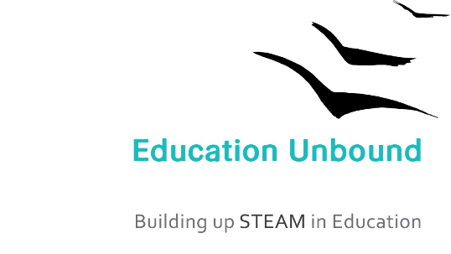

Weeda Hamdan & Team
Director
Education Unbound

