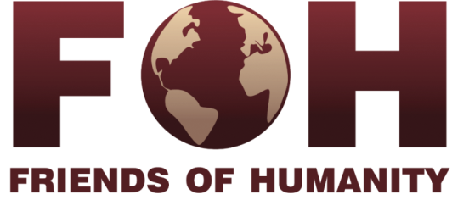

Support Application
Alice School Project: construction and maintenance of a school for disadvantaged children in India

FOH supports the beautiful project of Alice School since 2009. It was created since 1994 in India by an Italian professor named Valentino Giacomin. From the beginning he welcomed 60 children and now, more than 800 of them! These children enjoy a unique educational system offering self consciousness practices and the preservation of their traditional culture.
The Alice School offers an almost free of charge education for children within disadvantaged communities in particular the Chakmas, who are a persecuted Buddhist minority refugee in India.
The current project envisions a new school in the state of Arunachal Pradesh. This particular place allows to overcome the social differences as well as the preservation of their culture. The school already welcomes 125 students and the project plans to give a free of charge education and also to pay for general expenses.

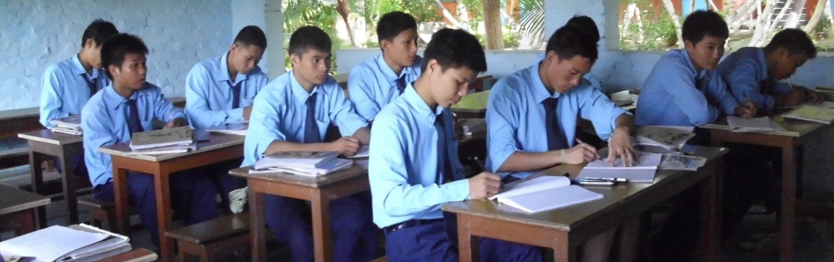

Information about the project

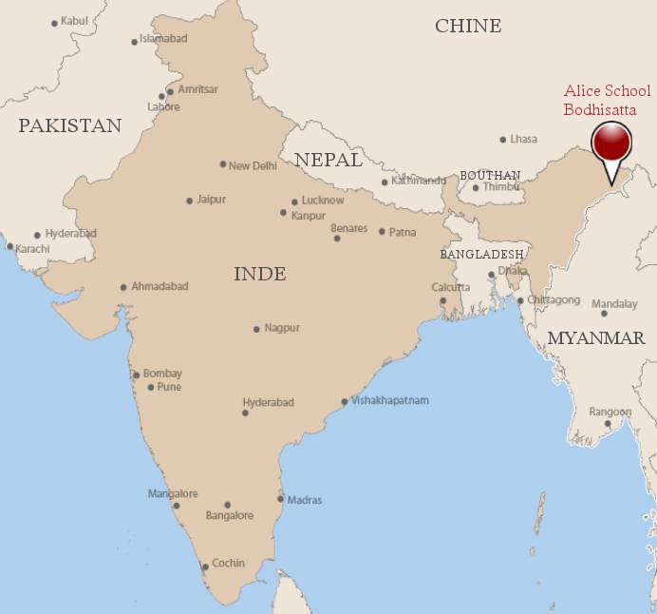

Duration 15 months
Location Country : India
State : Arunachal Pradesh
District : Changlang
Village : Bodhisatta, Deban

Beneficiares 125 permanent students

Organisation Friends of Humanity SA
Rue des Pâquis 51,
C.P. 74 - 1201 Geneva, Switzerland
IBAN UBS : CH260024 0240 4170 8001 W

Local Partnership Alice School Project
Bodhisatta, Deban. P.O-Deban via Miao,
Dist. Changlang, Arunachal Pradesh

Budget USD 20’000

Education in India
India has the most high illiteracy rate in the world with a 74% against a world average of 84%. There is a significant difference between men and women (82% against 65%) even if the women literacy increases faster than the men’s one.
There is likewise a strong geographic disparity between the regions of major cities like Calcutta, Bombay, New Delhi or Bengalore and the remote and underdeveloped regions like Uttar Pradesh, Bihar, Rajasthan or Arunachal Pradesh where the literacy rate does not go higher than 60%.
The Arunachal Pradesh village, where the project is located, has certain conditions that put this region in disadvantage compared to other regions in India.
Being located in the limits of the north-oriental part of India and having a mountainous geography makes it difficult to have access to this region and therefore it is an obstacle for any kind of infrastructure development. As a consequence, Arunachal Pradesh is a region underdeveloped : the economic activity is nonexistent, the tourism has limited success despite the huge potential this area has and at last the literacy rate (67%), is one of the lowest rate in all India (nevertheless there has been an improvement from 10 years ago when it was 54%)
The children won’t go to school first because there are no schools and also because they have to walk for miles until they actually find one.
These deficiencies on the educational plan are one of the factors that obstruct certain regions to get out of poverty: 238.5 millions of Indians (21% of the population) still live in poverty. In the Arunachal Pradesh village the rate is of 18%.
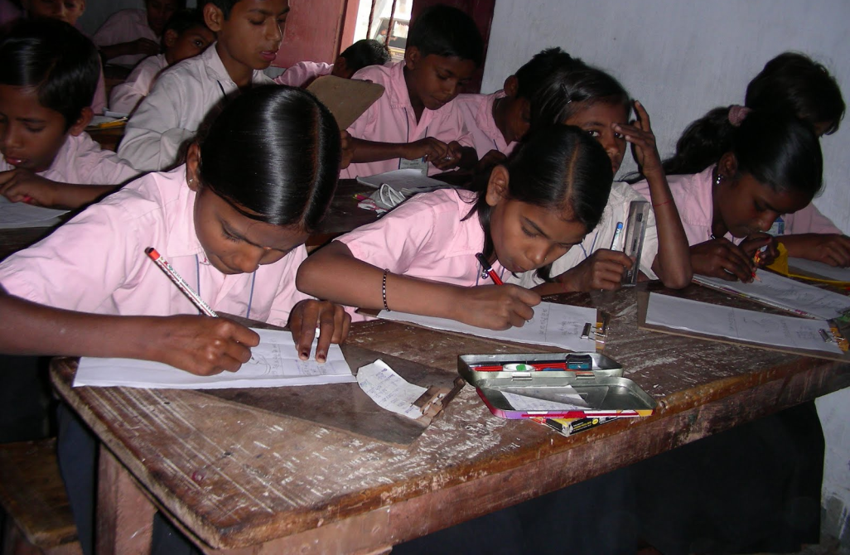
Students in Bihar

Alice School Project
Since 2010, Friends of Humanity supports the Alice Project Schools in India. The first school was created in 1994 in Sarnath, by the Italian professor Valentino Giacomin. The Alice School offers a unique educational system to students from underprivileged backgrounds, specially the Chakmas, an ethnic minority from Bangladesh.
The educational method from Alice Project consists in: uniting the education with the preservation of the student’s cultural inheritance in order to coexist within the idea of self consciousness and to finally be able to improve their environment and their society.
Nowadays there are 800 children that study in three different schools (Sarnath, Bodhgaya and Bodhisatta) and most of them are considering to obtain a diploma which would be impossible to have without the Alice Schools.
Friends of Humanity supports this project since 2010 and since the first year it has achieved to obtain about 10’000 CHF. In 2011, we have decided to concentrate our efforts into supporting another Alice School situated in Bodhisatta in the region of Arunachal Pradesh.
Alice Project has opened in 2009 a primary school in the Bodhisatta village, where the Chakmas are located. In this region, the Alice School allows children without previous education to have access to one of the facilities of this Project.
Unfortunately, the lack of support has obstructed the school’s development. Thanks to Friends of Humanity and other partners help, the Alice Project in Bodhisatta is going to be finally relaunched.
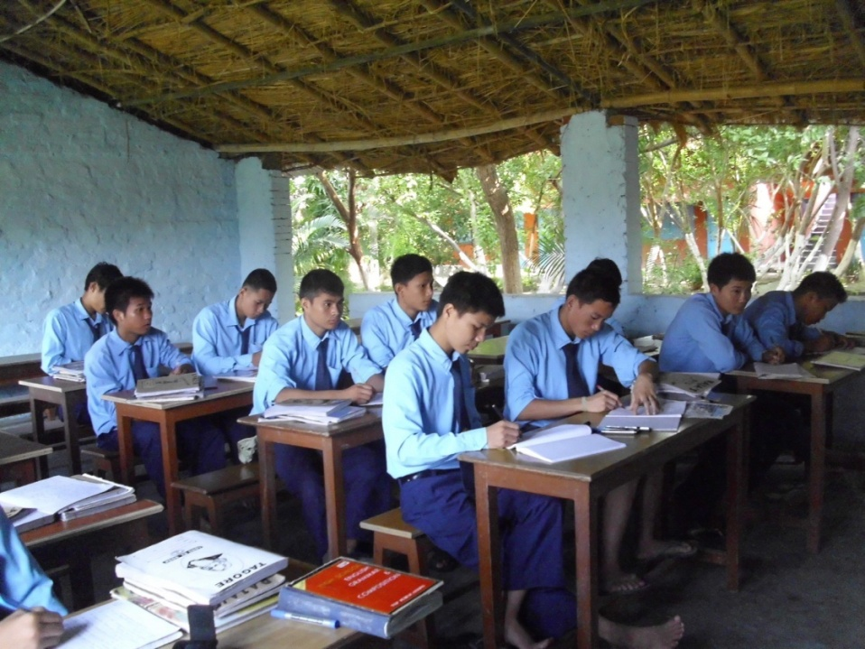
Students from Alice School in Sarnath, Uttar Pradesh

Project Activities
The project aims to consolidate the functioning of Boddishata School in order to allow all the children and specially the Chakmas minority to be able to reach to a free of charge education.
The education given by Alice School, will let the children rediscover their self-confidence, hoping for a better life (afterwards many children go to high school) and to overcome poverty and distress.
The children’s family and the whole community are weld behind the school’s project which is the nerve center of the village. A lot of development initiatives are launched. It is really important to support it not only for the children but for the community that was created.
Nowadays, the School gives a warm welcome to children from 6 to 9 years old and would like to complete the cycle until 13 years old.
The Project is declined in one basic point and the expected result is:

To Educate 125 children during 15 months
If the budget allows, 40 to 50 other children will be welcomed mid-term. Many of them have been missing school, because there were no facilities, or because they were too far away.

There are a lot of requests coming from the surrounding villages and unfortunately we have to refuse them for a lack of space or funds.
Budget
Projet de l’école Alice à Bodhisatta, Inde
En CHF convertis des roupies Indiens, soumis à variation
Frais de fonctionnement école pendant 20 mois | Salaires enseignants (6) | 10,266
Frais de fonctionnement école pendant 20 mois | Salaire Personnel (2) | 3,042
Frais de fonctionnement école pendant 20 mois | Dépenses générales (nourriture, logement) | 951
Projet atelier couture | Achat matériel et machines à coudre, professeur de couture, construction atelier | 3,517
Projet accès à l’eau courante et potable | Installations, matériel, maintenance | 6,897
Urgences | Moyen de transport | 10,308
 | Total | 34,981
During our FOH event this last 18 september we raised about 12,000 CHF. That is why we are asking for 20,000 CHF, so we can achieve our goal.
The Chakmas
The Chakmas are originally from the Chittagong Hill Tracts which is in the current State of Bangladesh and they have been living there even before the separation between India and Pakistan in 1947. A second separation followed in 1971, gave birth to Bangladesh in the Oriental Pakistan territory.
Recent migration from the Bengalis region, where traditionally the Chakmas used to live in Bangladesh, has caused some tension: the Chakmas are Buddhist in a country where the majority is Muslim. Those tensions were hardly repressed by the government. Furthermore, the ethno-religious conflicts and the construction of a dam inundated lots of cultivable land that belonged to the Chakmas. In consequence, thousands of Chakmas left their land and took refuge in India, principally in the region of Arunachal Pradesh were the project of Friends of Humanity is located.
The Majority of Chakmas from India live today in difficult conditions, first because they don’t have the Indian nationality, then because they are not allowed to leave the country, to acquire a driving license, opening a bank account or even to buy lands.
A better access to education will improve their standard of living and will enforce their rich cultural heritage.

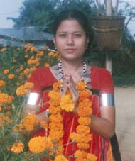
Young girl from the Chakmas Minority

Project Team
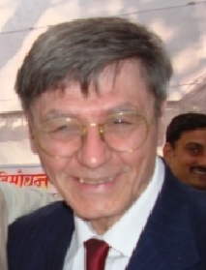
Valentino Giacomin
Director of Alice School Project
Nationality Italian
Biography
Valentino is an Italian professor who founded in 1994
the Alice School Project in India with Luigina de Biasi’s help.
He has opened three schools welcoming more than 800 children.

Contact Head Office Alice School Project
Sarnath Varanasi, Uttar Pradesh.
+91-9973918773
v_giacomin@hotmail.com

Bimal Chakma
Project Referent in Bodhisatta
Nationality Indian
Biography
He has worked over 10 years in the Alice School Project in Sarnath before being installed in
Bodhisatta for leading the construction of one Alice School. He is currently studying in the University.

Contact Bodhisatta, Deban. P.O-Deban
via Miao, Dist. Changlang,
Arunachal Pradesh
+91-03807-201012

Reporting
Communication

FOH is constantly in touch with the project referents. That is why we have regular access to news, testimonials, pictures or videos in order to send to you if you ever wish to receive them.
We also publish all the material on the Internet through our project’s webpage:
http://friendsofhumanitych.blogspot.com/search/label/Alice%20Projects

Activities Report

Our president Graziella Zanoletti, goes al least once a year in order to follow up the projects and to have the latest news personally.

We can provide you with a report every six months (more often if you wish) including:
- A summary of the global situation of the project
- The progress of the project
- The current difficulties

Once the project is over, we will provide you with a final report in which we give you the details of how were the funds distributed.

