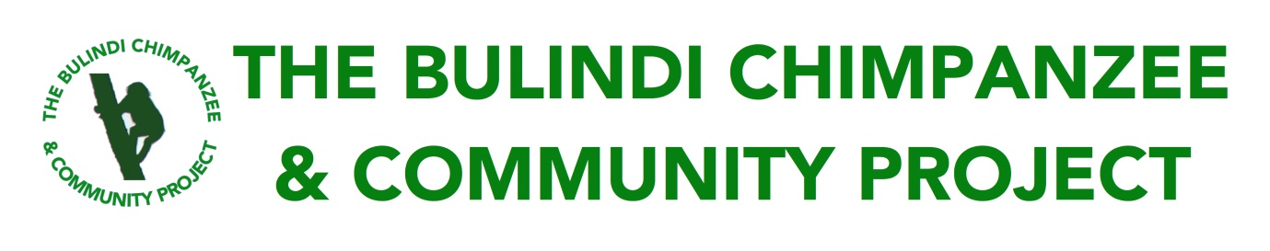**Urgent Support for a Borehole to Reduce Human–Chimpanzee Conflict in Nyaituma-Lower Village, Hoima District, Uganda**

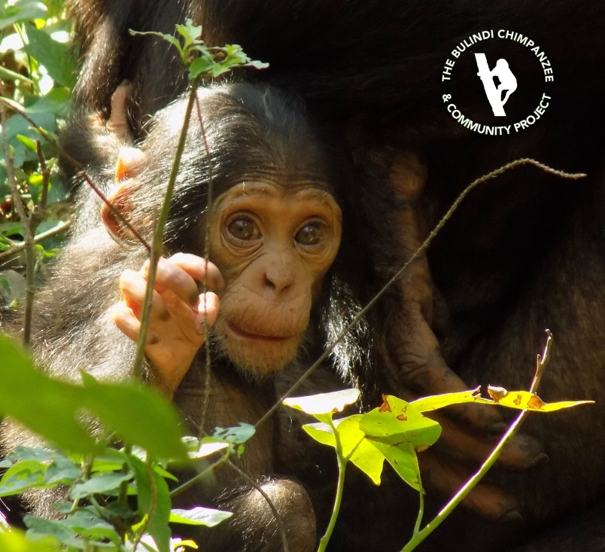

**A 5-month old infant chimpanzee – the latest member of the Bulindi chimpanzee community whose range includes Nyaituma village.**

**Background**

The *Bulindi Chimpanzee & Community Project* (BCCP) is a grassroots-level conservation organisation established in 2014 to address urgent threats to wild chimpanzees living alongside rural farmers in Uganda’s Hoima District.

While chimpanzees are legally protected in Uganda, their habitats often aren’t. Most forest in Hoima is unprotected and owned by local village households. During the last two decades, most of the forest was logged for timber and cleared for agriculture by local households seeking to improve their livelihoods. As a result, a population of 300 chimpanzees have lost their natural habitat. They survive in tiny remnant patches of degraded forest surrounded by expanding agricultural land, villages, schools and roads.

In Hoima, it is mainly women and children who are tasked with collecting water. They mostly fetch water from open water sources such as forest streams, risking exposure to waterborne diseases. These open water sources (typically located by streams and papyrus swamps) suffer contamination from domestic animal waste (cattle) as well as wild animal waste, especially from primates including chimpanzees and monkeys, which can carry pathogens transmissible to people.

Further to these risks, villagers face encounters with chimpanzees when collecting water by the forest. Some local people, especially children, shout and throw stones when they encounter chimpanzees, or chase them with dogs – behaviours which can provoke aggressive responses from the chimpanzees. Mature chimpanzees can be very dangerous. In Hoima, a number of serious attacks by chimpanzees on children have occurred when children were fetching water at forest streams. Thus, constructing boreholes away from forests serves two purposes: (1) it provides local residents with an accessible source of clean, safe water and (2) it reduces potentially dangerous interactions between villagers and chimpanzees.

**Incident on 16th June 2019**

On 16th June 2019 a serious incident occurred in Nyaituma-Lower village in Bulindi, Hoima. An 8-year old girl was grabbed and dragged by a chimpanzee while she was collecting water with other children at a spring alongside a strip of forest, used on a daily basis by chimpanzees. Luckily, a local farmer was nearby; upon hearing the girl screaming he intervened to chase away the chimpanzee. She sustained a deep laceration on her head that required stitches (possibly caused by a bite) and was rushed to a nearby clinic; as of 27th June, her treatment is on-going. Given the strength of a chimpanzee, the girl was lucky: her injuries could have been far worse. In rare instances, chimpanzees elsewhere have killed small children.

There have been long-standing problems with groups of children harassing chimpanzees at this particular forest spring, and also at a second nearby spring (also at the forest edge) in Nyaituma village (see Map below). Thus, it was only a matter of time before a serious incident, such as this one, occurred.

Nevertheless, the girl’s family and the wider community in Nyaituma are understandably angry and afraid and are demanding that something be done about the chimpanzees.

**Solution: Construction of a borehole away from the forest**

We kindly request urgent support for a borehole in Nyaituma Lower to be constructed in the village away from the forest. After consulting with residents, we propose to situate a well alongside the main village road, which is where most houses are situated. This road is located 500 metres from the forest (see Map below). A borehole situated here would greatly reduce the need for residents (and especially children) to go to the forest to fetch water, thus limiting encounters between residents and chimpanzees.

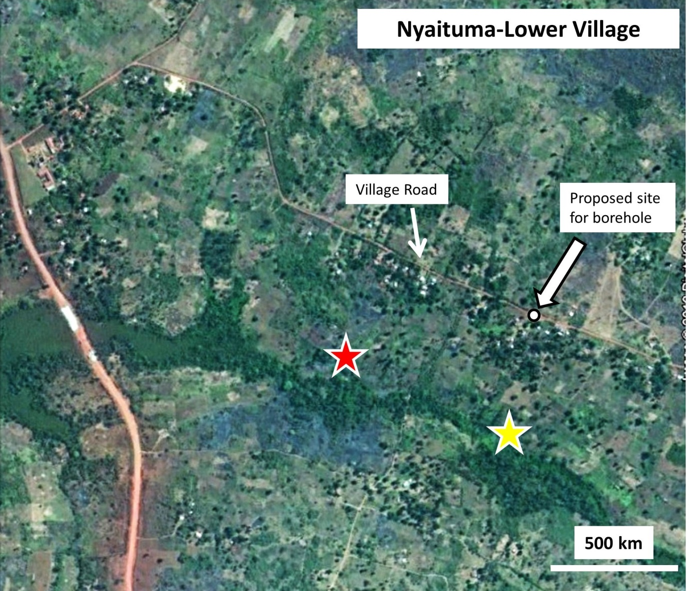

**Map of Nyaituma-Lower village showing the locations of two current water sources (indicated by *stars*). These springs are situated at the edge of a narrow strip of riverine forest (*dark green area at centre*), which is used daily by the Bulindi chimpanzees. The *red star* indicates the location of the chimpanzee attack on a child on the 16th June 2019. The *arrow* shows the proposed location for a village borehole, along the main village road where most homes are situated and 500 meters from the forest.**

A preliminary survey of the proposed site by Steven Beingana (Suubi Community Projects–Uganda) indicated a borehole would most likely require drilling. The borehole would serve more than 100 households (i.e. about 500 people). A new borehole would also be a huge boost to our community conservation program in Nyaituma and surrounding villages in the Bulindi area. This program includes a ‘school holiday club’ which teaches local children about chimpanzee behaviour and how to be safe when encountering the chimpanzees (see image below).

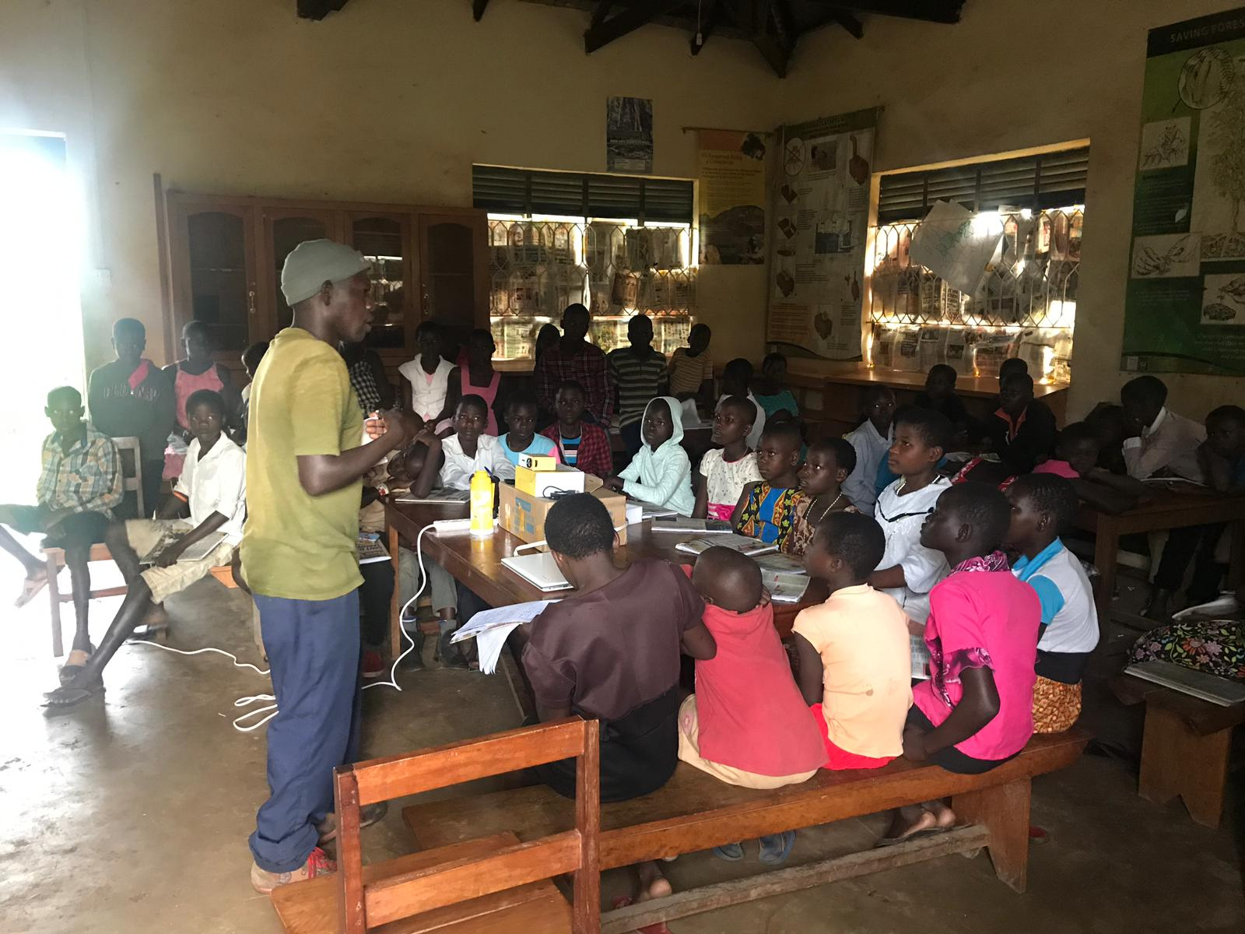

**Long-term BCCP Chimpanzee Monitor, Tom Sabiiti, talking to children from Nyaituma village about chimpanzee behaviour and conservation (May 2019)**