Report on Ruchika Play Pchool -
The kids of 10 play schools of Ruchika appeared their annual exam in the second week of March. They were given their math, English, conversation, art, rhyme test. At that time they were very confident. At the time of admission and after one year there was a very drastic change with their behavior, conversation, reading, writing style. In school these slum kids behavior are different from other children of slums. They were maintaining their hygiene, sitting posture all these things.
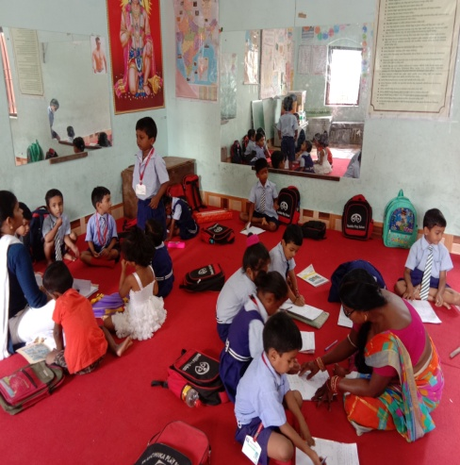
Annual exam of Ruchika Play School
These kids also celebrate our special days like Independence day, Republic day in this year (2019-2020). All these days were celebrated in their slum. They also sing the national anthem in our school. We also celebrate 14th November, childrens day. All kids were participate in this programme .we all are very happy to be a part of this. 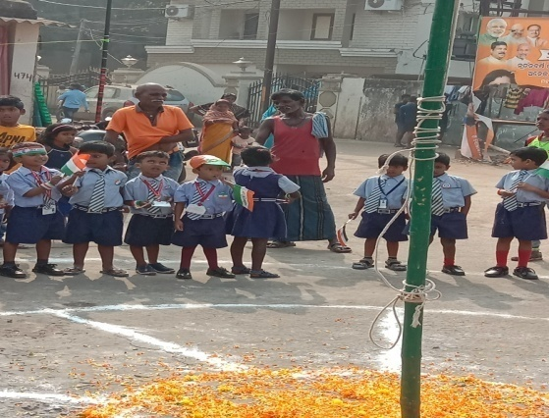
Republic Day celebration of Play school
