Ruchika play school
Case study (feb-2021)
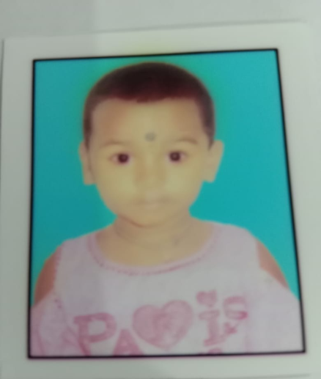
Gupchup ( Golgappa ) saler‘s daughter is now a student in a play school …….
A girl named Pralipta(Not Real Name) lives in Jharana slum. Her father is a gupchup ( golgappa ) saler and her mother was a house wife. She loved her mother but at a very young age her mother left her .she was in a traumatic situation .Her father could not take out enough time for her. He could not even care for her or give her enough attention as she needed. So he decided to send her to aunt’s house where at least her mood can be lifted. So she went to her aunt’s house but still she missed her mother very much. Her aunt thought that if she mingles and plays with some other children she might feel better. So talk to one of the teacher of our school and she suggested her aunt to bring her to Ruchika Play School for some days; if she finds any change in her behavior then she can enroll her in our school .From the very next day, she brought to our school .pralipta was also happy .She also enjoy with other students. Gradually she forgot all the sorrowful situation of her life and became a joyful child once again .After noticing such a great change in her, her aunt finally agreed to enroll him in Ruchika Play School. Now she is doing very well in academics and she and her aunt feel that our school is like a dream come true for them.

