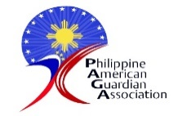
PHILIPPINE AMERICAN GUARDIAN ASSOCIATION, INC.

Program Report
November 2022 – June 15, 2023
Introduction

By the first quarter of 2023, the children were back in school. To help them transition from almost 2 years of living in a virtual mode to a face-to-face environment, PAGA found it critical to implement its Stress Management and W.A.S.H. (Water Sanitation & Hygiene) Campaign.

Our registered Social Workers determined that while the transition may be a stress point, a heavier one would be the impact of the pandemic on the economic situation of their family. Some parents lost their employment while others were their source of whatever little businesses they started prior to the pandemic.

The back-to-normal mode of the country did not ring positive for a lot of Filipinos, given that businesses had to recover margins. The families of our beneficiaries were not spared from this, making it a challenge for them to make ends meet for almost 2 years and into the present. The need to keep food on the table and spend for school requirements and other essentials puts pressure even on the beneficiaries.
It is a situation where they ride with the back-to-normal wave, but unfortunately, without the economic support to go with it. And therefore, aside from the monetary benefits given to student beneficiaries, we saw the need to provide psychosocial guidance through the conduct of Stress Management “Love Yourself” workshops so they can cope with the change and stay on track to complete their education.
The back-to-normal situation has also ushered in a sense of complacency toward hygiene and sanitation. This is why it was necessary to embed WASH in the minds of the beneficiaries to help keep them healthy and raise awareness of how most illnesses, not just COVID, are caused by unsanitary practices.

Moving Into a Better Life

This year we will be wishing all the best to 3 beneficiaries who will be graduating this year. It is with gratitude and pride that we share this news with all who have helped them complete their academic journey. One has a Bachelor of Science degree in Criminology, the second, Bachelor of Science in Business Administration, and the third Bachelor of the Arts in Communication Research. They now move on to the next step of gradually ending generational poverty that challenges their families.
Thank you for being with us on this journey of Hope so no one gets left behind. We wish all of you the best!

Activities

Webinar on Financial Literacy
We continued to implement our plan guided by health protocols. With most of the families of
PAGA beneficiaries taking a cut in their income, a Financial Literacy seminar became more valuable.
We launched the 2nd series through Zoom, and we had 38 participants.

Educational Assistance:
Awarding of PC Tablets and supplies

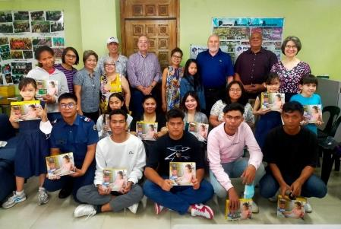

Christmas in the time of COVID
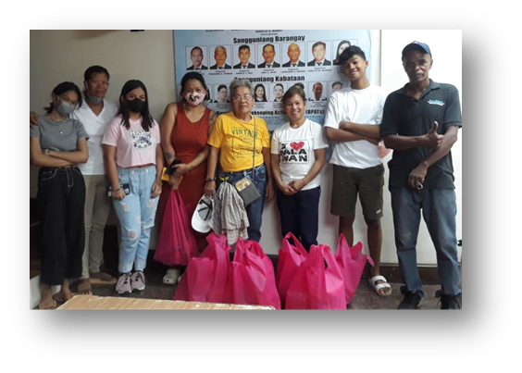
This was a long-distance Christmas celebration. With COVID-19 protocols still in place we had to send Christmas cheer and goodie bags via online delivery. The groceries were ordered online and delivered to houses of volunteer beneficiaries who repacked these and brought them to the barangay hall for distribution. For the NCR beneficiaries, it was a socially distanced one. They were able to pick up their Christmas goodie bags at the PAGA office. This was also an opportunity for the social workers to do a face-to-face catch-up on their situation. The Christmas goodies helped ease the anxiety caused by the pandemic and helped put Noche Buena or Christmas Eve dinner on the table for their families.

Goodies for a Christmas eve dinner

2023

Transition to the Face-to-Face Mode
Stress Management Workshops
“Love Yourself”
By the first quarter of 2023, the children were back in school. To help them transition from almost 2 years of living in a virtual mode to a face-to-face environment, PAGA found it critical to implement its Stress Management and W.A.S.H. (Water Sanitation & Hygiene) Campaign.
Our registered Social Workers determined that while the transition may be a stress point, a heavier one would be the impact of the pandemic on the economic situation of their family. Some parents lost their employment while others were their source of whatever little businesses they started prior to the pandemic.
The back-to-normal mode of the country did not ring positive for a lot of Filipinos, given that businesses had to recover margins. The families of our beneficiaries were not spared from this, making it a challenge for them to continue struggling to make ends meet for almost 2 years and into the present. The need to keep food on the table and spend for school requirements and other essentials put pressure even on the beneficiaries.
It is a situation where they ride with the back-to-normal wave, but unfortunately, without the economic support to go with it. And therefore, aside from the monetary benefits given to student beneficiaries, PAGA saw the need to help keep the beneficiaries afloat and strong enough to cope with their situation.
The back-to-normal situation has ushered in a sense of complacency toward hygiene and sanitation. This is why it was necessary to embed WASH in the minds of the beneficiaries to help keep them healthy and raise awareness of how most illnesses, not just COVID, are caused by unsanitary practices.
The Campaign was rolled out in Bulacan, Pampanga, and the NCR for all PAGA beneficiaries.
The approach we took was participatory. Most of the activities were designed to draw out input from the beneficiaries, making them relevant because they would be based on real experiences. We also integrated creative tools like the use of theatre. The children were asked to dramatize a stressful situation and how this was managed and resolved. Three top stress points were shared: a) sustaining good academic performance b) affording additional expenses for school projects and c) and the rising prices of basic commodities.
Our Social Workers discussed the “anatomy” of stress and ways to cope with this. The discussion was focused on the many factors that generate stress for the youth. The concept of Me Time, Love Myself was introduced as a foundation for youth to stand strong against stress. And the thread continued with the idea of loving oneself began with staying healthy. Segue to the WASH component.
The second component of the campaign was WASH. The discussion stressed the need for hand washing and steering away from unsanitary situations. This was supported by the distribution of hygiene kits filled with alcohol, shampoo, toothpaste, toothbrush, and bath soap. They were also given a gift certificate worth P500. From Mercury Drug for vitamins and other medicine.
For the beneficiaries who needed help to comply with academic requirements, we were able to provide some support. This was for science experiments and an educational tour as part of the Tourism course. The financial difficulty was because their mother could not recover from the loss of employment during the pandemic.
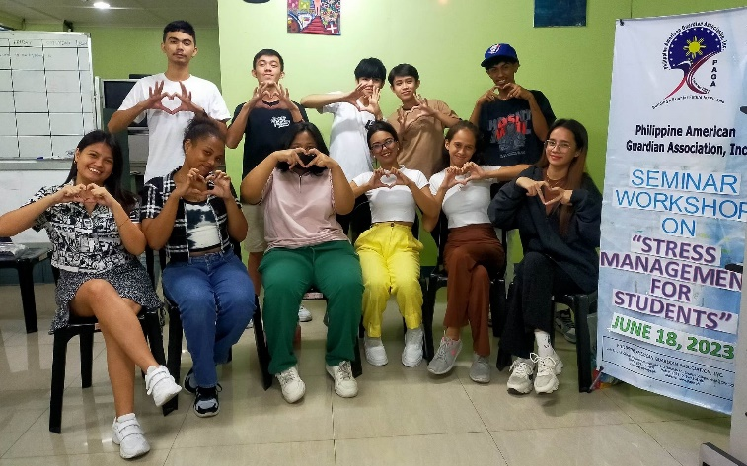

Beneficiaries send out the message of Love Yourself to everyone as a key to coping with stress.

Staying On Track
We will sustain the psychosocial programs that are focused on mental health and stress management. These are important, especially for the youth, so they are able to maintain a healthy perspective and ride the wave of challenges as they complete their education. We will also be helping them become more competitive and empowered by providing supplemental training in IT, Communication and Sustainability. The rollout of the Stress Management workshop was relevant. It addressed a real need not just of PAGA beneficiaries but of the youth. The social pressures are amplified by the fact that the country has not recovered from the economic loss during the pandemic. And poverty brings with it social stress points that are weighed on the shoulder of our beneficiaries.
Pride of Place
Building the pride of the children in their heritage helps keep their heads up amidst the teasing they sometimes experience at school or in their neighborhood. Or perhaps to cushion the story of their grandparents or parents being left behind. These traditions also help give the beneficiaries a sense of community with the ENF officers, their children, and their PAGA guardians. So, when they step out into the world, they will always look back with pride.
Memorial Day
For the first time, the Bulacan beneficiaries traveled to Manila to witness Memorial Day. The beneficiaries agreed that it was worth waking up at 4:30 in the morning to travel.
There was so much to take in commemorating heroes for freedom. One of the highlights was the special tour of the Visitor Center which was filled with historical facts that were exhibited in a very engaging style. Their guide shared stories that could not be found in textbooks.
It was a treat to meet the grandson of a WWII hero and the first Filipino West Point graduate. a celebrated hero featured in the exhibit. As an added treat, they had fun looking for the names of their family on the Walls of the Missing and some did find them.

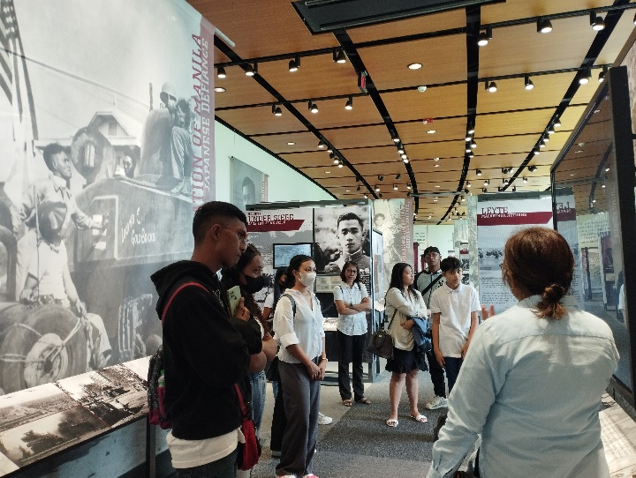

Beneficiaries learn more about World War II as the guide brings them through the journey of those American and Filipinos who fought side by side for freedom.
Flag Day
This yearly tradition to commemorate the adoption of the flag of the United States on June 14, 1777, gave the NCR beneficiaries a chance to connect with their long-time partners at ENF. They enjoyed learning about the evolution of the flags and getting to be one of the flag bearers.
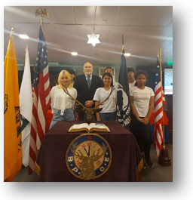

Financial Assistance
During the pandemic, we extended help through the distribution of funds. And seeing how the economic condition of the beneficiaries’ families has not improved to absorb the increase in the prices of basic commodities and transportation, we continued this to help keep the beneficiaries in school.

Next Steps
Preparing the Beneficiaries for the 22nd Century
Love Yourself (Continued)
The Stress Management workshop designed for the youth, is a continuing activity to ensure that the beneficiaries are given the social support they need to stay on the course of completing their education. A goal that will hopefully put an end to generations of poverty and usher in a better life for them.
This component will be composed of the following activities:
- Sessions with Life Coaches who specialize in the youth sector.
- Youth Art Therapy Boot Camp
Technology and Communication Savvy
The 4th industrial revolution has raised the bar for technological literacy. And while we are preparing for AI and Nanotech, there is an increase in the demand for collaboration which requires effective communication. What PAGA would like to do is empower the beneficiaries with technology and communication skills that are at par with the demands of the times so they may be competitive. The activity will include computer/digital literacy and communication upskilling.

S.O.S. (Simple. Organic. Sustainable.)
Giving back as responsible citizens
This is envisioned as a flagship program for the youth spearheaded by PAGA and its partners. The goal is to develop the youth as thought leaders in their communities for sustainability. They will be honed in environmental management and together with the youth of their community will lead the identification of simple, organic, and sustainable projects that can help embed the culture of sustainable communities. One example would be a project of Zero Waste through simple practices of composting, upcycling, and other activities that may also become a source of livelihood. This positions the beneficiaries as responsible citizens giving back and inspiring other youth: So, No One Gets Left Behind.
These Next Steps will help beneficiaries stand out in the crowd and inspire other youth to help bring positive change in their community. They stand a better chance out in the real world with a healthy attitude, upskilling, and a sense of community.

For more than 100 years, PAGA has been very fortunate to have partners who share the dream of keeping hope alive, one child at a time. The kindness and generosity of our partners have helped build sustainable lives for many children. And it is this sense of humanity that we need so no one is left behind.

Thank you and we wish you all the best!

