Heroes for Education
In our last report, we shared how our beneficiaries are part of the 16.7 million Filipinos who live below the poverty line. And among the poorest Filipinos, only 17% can attend higher education.
This landscape amplifies how valuable your continued support has been to our beneficiaries.
Your support has taken them from the streets and into school from elementary to college. This is simply amazing. If it weren’t for your support, they would either be in the streets begging, selling rags, or doing odd jobs for a pittance, and putting themselves at risk just to subsist.
But with your continuous support, these children can now afford to go to school, take a ride and not walk, and have a decent meal, school supplies, uniforms, and shoes instead of slippers.
Your generosity has increased the percentage of Hope. As our beneficiaries stay the course and complete their college education, you will eventually contribute to lowering the 17% statistic. You are truly heroes, and we are grateful.
In this report, we would like to give you a snapshot of how you have been a hero to these children. Not just for changing their lives, or helping them to complete their education, but also for helping them gain opportunities to develop themselves as responsible citizens while getting closer to their dream of ending generational poverty and building the life they deserve.

Staying the course from elementary to college
In the last quarter, we were able to celebrate our graduates:
4 college students, 7 senior high school students, and 1 elementary student.
For our college graduates, walking beside them has been a wonderful journey since they were kids. We recall how they were diligent at school and kept good grades despite the odds brought about by poverty. Getting to the finish line of their academic journey is already a life-changing achievement for them.
Three of our graduates are working, using their Marketing degrees. One is studying for the Board exam for graduates of Criminology. He is quite idealistic and hopes to join the Philippine National Police and bring some positive changes in the name of genuine service. In between studying, he finds time to volunteer for our activities to help shepherd the kids.
Our licensed social workers continue to stay in touch with them ready to provide advice or link them with mentors to help move them forward in their careers.

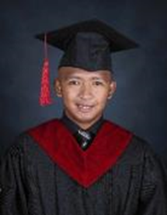
_____________________________________________________________________________________
Paying it forward
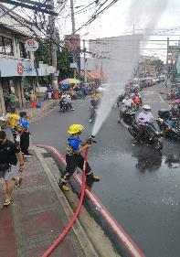

Helping save lives
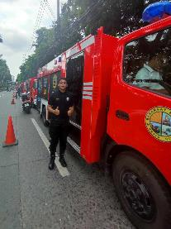
One of our beneficiaries is up for graduation.
This school year. He is in his last year of completing a BS in Criminology. To help his family put food on the table, he also works part-time as a messenger. And to help his community, he has been a volunteer firefighter in his community since he completed his training in 2021. Even at his level, he risks his life because of his strong spirit to help save lives.

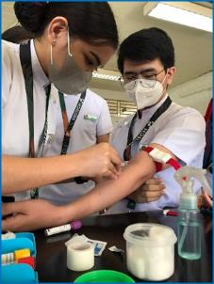

Helping provide medical services

Another college-level beneficiary who is studying to be a medical technician finds time in between having to memorize all procedures and technical terms, to help during medical missions conducted by organizations of doctors. During these missions, she helps administer vaccines. Her volunteer work takes her to urban depressed areas where she meets men, women, and children who cannot afford to seek medical attention let alone, three healthy meals a day, which is like her family’s situation.
(photo is of her in class)

Caring for those left behind

A ten-year-old beneficiary has chosen to join a school organization to help children in an orphanage. At a young age, she has been busy bringing food, clothing, and other basic needs for them. At times, she simply spends time playing games or just sharing stories with them.

_____________________________________________________________________________________

From street smart to school smart

As the sun rises, he would be up and about walking the neighborhood next to the slum area where he lives. He knocked on doors offering to collect the garbage and bring these to the pick-up point. He would earn P10. pesos (approx. ($.20) for every household he services. After his rounds, he would have enough to buy some eggs or bread to bring home to add to breakfast for his brother, his 2 sisters, and his parents. He did not have the chance to go to school because transportation alone was a cost, they could not afford every day.
Today, he still wakes up as the sun rises to get ready for school. He is 9 years old and is in the 3rd grade. Recently he was recognized for his good performance in school.

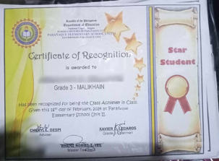
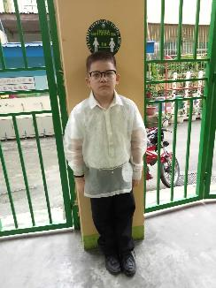
(picture shows him dressed up for United Nations Day representing the Philippines)
_____________________________________________________________________________________
(Nothing follows)

