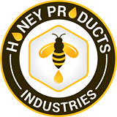____________________________________________________________________

- Respondent Name/Group and Contact Information

Greenlivelihoods (GL)
(Lead role: co-creation with farmers, capacity building and convening food/honey hubs)
The Executive Director -P.O. Box 338, Lilongwe, Malawi
Tel.: +265111900855/+265888773452
Email: greenlivelihoods@yahoo.com
Web: www.greenlivelihoods.org

Implementing partner
Honey Products Industries – HPI (Ltd)
(co-lead role: honey processing, buying and marketing linkages)

Collaborative partners
Malawi Organic Growers Association (certification process & market linkages)
Innovation for Poverty Action (Honey traceability research)
Segal Family Foundation (provided feasibility assessment support)
Ministry of Trade & Industry (Cooperative accreditation)

b) Response Title (Catalytic Sustainable Development)
Commercialization honey value chain for 1000 youth in Malawi
(Towards Increased Quantity, Quality, Traceability and Certification of Honey Products in Malawi)

1.0 Project idea summary
Target districts | Dowa (pilot phase)
Overall objective | To Increase Quantity, Quality, Traceability of Commercialised Honey Products.
Enterprise | Honey Value chain products and market linkages for the 1000 youths in Malawi
Product | Honey and modern beekeeping technology
Market | - Honey Hubs, Honey Products Industries, Supermarkets, hotels & GL Fund  - Export market will be pursued through fair trade and organic certifications
Investment/funding | Co-investment: Global Giving grants, business innovation fund (share equities), community own contributions (in kind) and GL’s Green Fund
Impacts sought | - Increased income among beekeepers  - Increased number of women and youth beekeepers from 50 to 1000  - Strengthened understanding of cooperative and contract business management plus market linkages (profitable markets)  - Increased volumes of honey produced in Dowa (Malawi at large)  - Increased quality of honey for increased profitability  - Increased incomes among bee keepers and indirect affiliates  - Increased incomes among out-of-school youth & women headed households  - Functional innovations fund
Direct target beneficiates | - 1000 small scale progressive youth bee keepers (50% women and 50% men)  - At least 100 young aggregators recruited (change agents via honey hubs). Honey hubs will act as community innovation incubation and learning centres including honey aggregation for marketing purposes
Budget estimate | - US$80,000.00

2.0 Project idea background/problem statement
Despite donors injecting approximately $1 billion/year in assistance through NGOs, Malawi records meagre progress since independence (1966). In the face of continued rapid population growth, the pressure to feed, educate and provide jobs and government services is increasing—putting more pressure on limited financial and environmental resources (USAID, 2018). Failure of development aid to make significant impact is undeniably due to faulty ‘dead aid perceived’ development models that promote consumerism ‘investment’. However, Greenlivelihoods (GL) promotes self-help group driven ‘green entrepreneurship’ or natural resource based enterprises. GL believes that creating local solutions from the ground up improves the chances for long lasting effects on investment. Our experience entails that involving locals in crafting development solution increases process ownership and development success. Our community context appraisal used the Assert Based Community Development (ABCD) as engrossed in community led Design and Systems Thinking models and its findings has informed the design of this Project idea’. The ABCD process engaged communities in informing the project content; assesses resource pool/gaps and investment needs. Furthermore, there has been documented evidence on the need for beekeeping scale-up into honey value chain commercialization through one of GL’s implemented project called “Promotion of Right to Adequate Food and Community Resilience to Effects of Climate Change Project in Dowa district. This project is funded by Dan Church Aid (DCA).

The idea of co-generating investment resources, knowledge and solutions to local problems through an active involvement of farmers to innovate for local financing to their socio-economic circumstances bridges the missing links in green entrepreneurship programming. GL and partners therefore express interest to concretize commercialized business thinking on honey value chain enterprises development for increased quantity-quality honey products. In Dowa, there are 200 smallholder bee-keepers who belong to 10 groups and own 8 traditional hives per group. Each group harvests an average of 40Kgs of honey every half a year, while use of langstroth hives could lead to 4-5 harvests per year. Price check indicates that local market prices of 250ml is at MWK1100 while similar volume at the supermarket was selling at MWK2500.00. National statistics show that Malawi’s demand for honey is estimated at 200 tons per year but only 80 - 90 tons of honey is traded on the domestic market (CAMPASS, 2016). The industry is said to be worth US$2 billion on the global market but Africa’s share is only 13% and Malawi even less despite honey’s growing demand on the market.

Our rapid assessment validates that, low production, low quality due to use of traditional methods and tools, non-existence traceability systems and lack of certification standards leads to limited competitiveness against imported honey. This has resulted in failure of the country to yield benefits from commercialized honey value chain. Uncoordinated market systems, limited time, skills and resources are all constraints on small-scale farmers to become active players in productive supply chains also affect local bee-keepers. Through cooperative business approaches, this project therefore is designed to increase farmers’ income from honey value chain, create more jobs for the youth and women in the honey value chain and establish a sustainable and legitimate multi-stakeholder honey value chain transactional platform at district and then at national level. The association will set up an innovation fund which will be run as a trust by honey value chain stakeholders. The fund will provide business expansion loans and investment plus market growth funding source to value chain players.

2.1 Project theory of change

Figure 1: Diagrammatic presentation of the identified challenges to be addressed through the honey VC project.

3.0 Partnering and anticipated project impact
This project will be delivered through community self-help group based NGO-private-public-research partnership model. GL and HPI will take a leading role in analysing and planning the development of the project, acting primarily as co-creator while farmers will be key in implementation of the Honey Hubs as part their capacity building process. GL will also play a key role in ensuring that information is shared and value chain actors co-create to solve value chain and market bottlenecks. This will help develop rights based relationships between partners such as extension officers, beekeepers, MOGA, Malawi Bureau of Standards (MBS) and research agencies (IPA) and honey VC input suppliers. The proposed honey innovation trust fund will have been established by year 2 of the project and this will act as forum where beekeepers and other value chain stakeholders will co-create on green investment and monetization processes. The fund management team will advise on business/investment strategy, lobby on conducive policy-practice business environment and broker market deals at national and international level in respect of honey marketing.

To grow the value chain base, GL and partners will steer investment scale-up by recruiting new bee-keepers, lead on capacity building; link with IPA on research on honey traceability and inclusive finance analysis and ensure quality control monitoring mechanism. GL is also responsible in forming partnerships with stakeholders such as government and community leaders. Actors in the Associations/cooperatives will be organized under one umbrella to foster innovation and good practice sharing. The investment fund will encourage ‘save – buy shares – investment loans’ culture among all shareholder including bee-keepers. This approach will boost capital availability and cushioning business economic shocks. This investment basket will be supported by GL, HPI, communities and Pamodzi Program. The project will introduce innovative technologies that will result in production of high volumes of quality honey to meet market standards. The enterprise intends to scale-up smallholder farmers access to modern bee keeping equipment, conduct quality control starting from the hive, trace the source of honey and undertake honey classification and certifications. The enterprise will also pursue international certifications such as organic honey certification, ISO and Fair Trading. The business plan is to build upon GL and HPI’s experience to increasing hone yields through using modern beehives and involving women and youth key players.

3.1 Project Innovation and sustainability elements:
- Community-innovator-private sector co examination of the barriers and solutions to plugging the local financing gap for honey commercialization
- Langstroth hives: replacement of traditional hives and methods of bee keeping will increase volumes and quality of honey produced by small-scale bee keepers in Malawi. HPI has partnered with a Kenyan company, ABL, to produce these hives locally at affordable prices.
- Reflectometer for measuring quality of honey: quality honey will fetch a better price on the market. GL/HPI through this project will procure 100 Reflectometers, one per group, which will be used to measure the quality of honey and classify it from the source before reaching the market.
- Traceability of honey from the hive: each hive will be fitted with GPS equipment to monitor hive health and source of nectar used to make the honey. Upon harvesting, each honey will be tested to analyse floral composition and classify the honey.
- Honey certification: acquisition of Fair Trade and Organic certification will mean that Malawian honey will find its way to shelves of prime supermarkets across the world.
- Honey exports: Malawi is the least exporter of honey in SADC. Zambia, lie on the same geographic zone and share floral characteristics with Malawi but are the highest exporter of honey in the SADC region.
- Youth empowerment: HPI will empower 200 rural youth to work as master bee keepers, honey aggregators and honey innovation hubs managers.
- Formation/revitalization of honey value chain district/national platform will promote innovation and knowledge sharing plus market brokering
- Innovation/Investment fund: for innovation, research and investment portfolio support

3.2 Key activities to be implemented
- Capacity building of small-scale bee keepers and young aggregators in modern bee keeping
- Supporting acquisition of modern equipment such as Langstroth hives, extractors & bee suits
- Tagging of hives and hive monitoring; Honey quality control using Refractometer and other technologies; Honey aggregation and purchases at community level & Installation and operation of a honey filling line; Installation and operation of a Langstroth hive production unit
- Processing of other bee products such as bee wax and candles; Honey certification processes
- Establishing bee keepers’ association in the project catchment areas; Association formation into cooperatives, and registration
- Training of bee keepers (belonging to the association) on association/cooperative management (co-facilitated by the ministry of trade & industry and MOGA)
- Facilitating linkages to government, private sector and other players in the value chain.
- National level stakeholders’ forum formation
- Formation of impact investment fund (formation, registration and framework development etc.)

Organization Capacities at glance

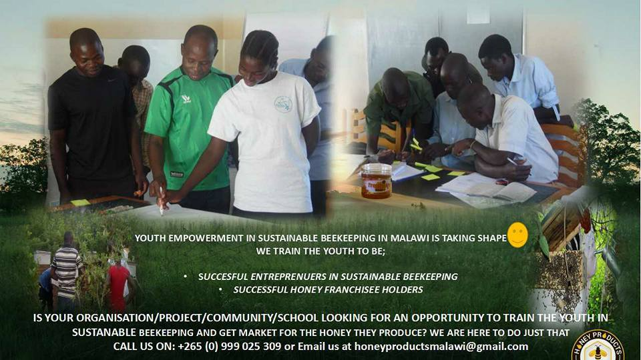
Green Livelihoods (GL) is a dully registered local Non-Governmental Organization in Malawi with its Secretariat situated in Lilongwe district. GL’s thematic areas of focus include social innovation in agriculture, green business value chain development, and environment and climate Change programming. GL is driven by a vision of a Nation with sustainable livelihoods. GL’s mission is to work with high potential but resource restricted rural farmers and progressive social entrepreneurs (especially the youth and women) in crafting solutions to challenges they face as a result of social economic imbalances and effects of climate change. Among other projects, GL is a bee-keeping project as a component of the “Promotion of Right to Adequate Food and Community Resilience to Effects of Climate Change (PRAFOCRECC) Project in Dowa district on the need for commercialization honey value chain enterprise development. Current experience from this Dan Church Aid’s funded PRAFOCRECC validates the need for honey value chain commercialization as this would culminate into the breaking barriers to local climate and green economy financing leading into triple win (environment, social and economic security empowerment) for honey and other natural resource value chain local actors especially women and the youth (out of school). PRAFOCRECC is a 4-year project ending in 2020. For more details on GL profile see www.greenlivelihoods.org.

Our partner: Honey Products Industries is a Malawian social enterprise that engages the youth to create a value chain out of organic honey. We promote sustainable bee keeping and offer markets for honey thereby creating social, economic and environmental impacts. The youth operate micro-franchise businesses that purchase honey and sale modern bee keeping equipment in their communities. The honey is transported to our factory hub in Lilongwe where it is packaged, branded and sold through supermarkets. From 2014 to 2016, HPI worked on the “supporting the commercialization of honey value chain through a honey micro-franchise business model” supported by IFAD through Rural Livelihood Economic Enhancement Programme (RL EEP). Other efforts on the honey value chain are noted from programmes such as CAMPASS II and others which helped the value chain to be relatively integrated. Lessons from GL and HPI programming indicate that forest community dependent communities have the potential to continue moving away from charcoal selling and eventually divert to honey as a source of income if the honey value chain is fully commercialized and can make a reliable income source for their livelihoods. Findings from IFAD supported project completion reports further indicates that beekeepers registered a 55% on business knowledge, 83% good agriculture practices, 38% access to finance, 48% access to market, 66% quality of honey. However, lack of grassroots driven commercialization renders the sector unsustainable.

Governed by an executive & board of trustees, GL is green economy focused organization with clear systems and policies supporting green entrepreneurship. The organization has the experience facilitating beekeeping projects at community level and has qualified technical and finance personnel. www.greenlivelihoods.org

