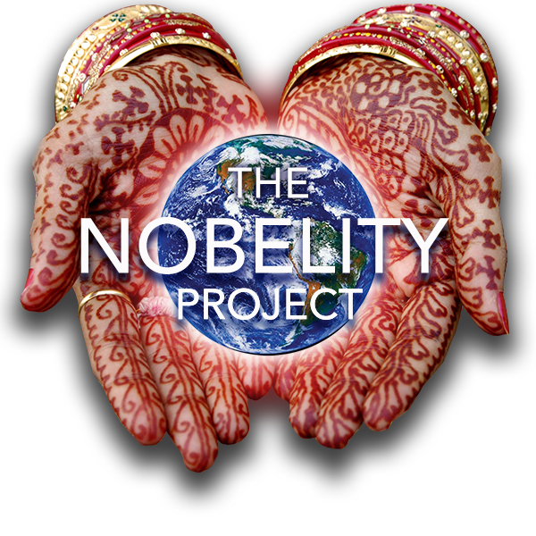
MAHIGA HOPE HIGH SCHOOL
Education shouldn’t end after the 8th grade

St. Joseph’s Mahiga Primary School and The Nobelity Project

The Nobelity Project is a 501c3 education and action nonprofit based in the U.S. and working in schools and on partner development programs in several countries. In 2005, while filming the feature documentary Nobelity, Turk Pipkin first visited St. Joseph Mahiga Primary School and planted 100 trees with the students. Learning that the school had no source of clean water and that kids were walking 1.5 miles each direction for water that often made them sick, Turk pledged that The Nobelity Project would build a water system for the school.

Four years later, this unique partnership has produced great results. Even through these drought years, the new rainwater collection system with UV purification continues to provide clean water for all students and staff. Water-borne illnesses have dropped dramatically while attendance has increased. The school has electricity for the first time, a new block of sturdy stone classrooms, and The Nobelity Project Computer Lab with 17 OLPC computers. The primary school students have become proficient on these small laptops, with the lab being overseen by one of our partner groups, the 50x15 Foundation.

St. Joseph Mahiga is now the top rated school in the district, and we believe a good deal of this progress is the result of an extraordinary community that recognized an opportunity and has worked hard to take full advantage of it. The school’s motto is “Hard Work Pays”

A High School to Serve Every Child
The Nobelity Project is partnering with the Education District and the local community to build the area’s first high school. Mahiga Hope High School will be a four-year high school with 8 classrooms, a physics/chemistry lab, biology lab and garden, a computer lab and a traditional book library. The school is intended to serve between 320 and 400 students in grades 9 through 12.
An additional key component is The RainWater Court — the world’s first net positive basketball, incorporating a large rainwater collection and UV purification system, while providing a covered, protected space for outdoor classrooms, community meetings and even a movie theatre. The RainWater Court was the winner of the GameChangers Award, an international design competition sponsored by The Nike Foundation and Architecture for Humanity. Final design and construction of The RainWater court is being overseen by AfH Design Fellow Greg Ellsner, who is living in the community during the planning and construction phase.

In addition to serving the high school students, Mahiga Hope Library will serve every member of the community. Pre-school/early learning students will begin a lifelong familiarity with books and reading. Primary and Secondary School students will be well supplied with a wide range of books appropriate to their studies and to general interests. In the evening, the library will server as an adult literacy center.

Preliminary estimates are for 1,000 plus volumes targeted at secondary school students, 500 for primary school, with additional books for pre-school and adult literacy

The Kenyan government has strong and specific curriculum requirements with approved textbooks in all subjects. There is an excellent approved textbook and library catalog, with most books available in paperback editions at an average cost of $4 - $5 per book. These are a mix of English and Swahili volumes, and include expanded curricula-related books, technical and trade-related titles, and a good deal of African and world fiction. We are supplementing these with donated books, but donated books will be chosen just as carefully.

Key Community Partners

In addition to a dedicated principal and staff, and hard-working students, The Nobelity Project has relied on our community project director, Mr. Joseph Mutongu. Father of two children who had to moved to a boarding school during worst years here, Joseph was the child of local farmers, but showed a sharp mind and produced high test scores that resulted in a university education in England as a naturalist. A respected member of the community, he has played a key role in all of our work and continues to oversee project planning and construction while maintaining oversight of all expenditures. We also have the benefits of a qualified Kenyan architectural team, Multiplex Consultants.

Parents at the school are also highly involved, and a select group of parents, teachers and other community leaders serve on a school committee that plays a role in all decisions. The community also contributes labor to the construction projects. Our work has also drawn the attention of the Kienyi West Region Education District who, for the first time, have provided key funding of improvement projects at the Primary School.

Mahiga Hope High School - a partnership between The Nobelity Project, the Kenyan Regional Education District, and the people of Mahiga will provide a full 12-year High School education for every child.
One Peace at a Time

The inspiring story of St. Joseph Mahiga Primary School plays a key element in the Nobelity Project’s new feature documentary, One Peace at a Time. Watch the film’s trailer at www.nobelity.org. Numerous dedicated screenings of the film – plus a portion of all the film’s proceeds – continue to raise funding for the school. These funds and additional support grants provide the matching funds that effectively double all contributions through the 1000 Voices for Hope campaign.

High School Construction Budget

With The Rainwater Court already fully funded ($50,000) by The Nike Foundation and Architecture for Humanity, our funding efforts can focus on the 8 classroom block ($60,000), the libraries and science lab building ($80,000) and additional infrastructure ($60,000) that includes a kitchen and renovation of existing structures for to serve as offices and dining hall. This $200,000 total will be met by when we reach our target GlobalGiving goal of $100,000, matched and doubled by proceeds from screenings and additional grants.

1000 Voices for Hope – Join the Choir!

Our first donors, the first members of the choir, are Nobelity Project supporters Willie Nelson, Lyle Lovett and Emily Maguire of The Dixie Chicks.

1000 Donors x $100 = Hope (Mahiga HOPE High School)

Watch the 1000 Voices for Hope video, and join the choir!

