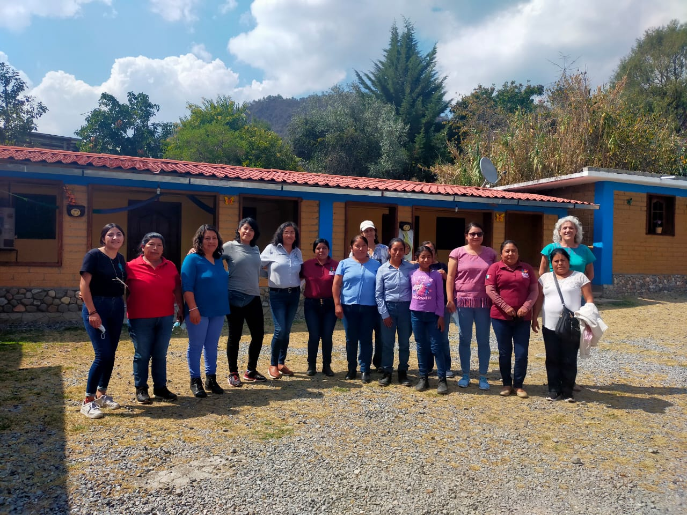

Empowers 100 Zapotec women to be government (40601)

Project Report

May 2022

**Dear friends and benefactors of Espiral por la Vida:**

We greet you in the hope that you are in good health and with your family!

From Espiral por la Vida we celebrate to continue sharing with you our progress in the magnificent work of promotion and defense of human rights of the Zapotec women of the Sierra Norte and Valles Centrales, as well as the Chatina women of the Coast of Oaxaca. We enthusiastically share with you the impacts achieved in this work.

CURRENT CONTEXT

In the indigenous communities of Oaxaca, the population has implemented diverse strategies to adapt to the current pandemic context, to care for and protect the community and to continue sustaining their essential activities; among the activities that the population strives to sustain is the participation in spaces of political representation.

Political participation is a highly valued and central practice in the community organization, since it is carried out according to very strict collective norms and must be developed with great responsibility; it is the population itself that is obliged to hold a position in the community government for the benefit of the community. In this arduous work, women participate actively, and in view of the new requirements of national laws, more women are joining the structure of their local governments.

WOMEN'S POLITICAL RIGHTS

The promotion and defense of political rights, as well as the training of women in human rights and gender issues is the main objective of our organization. In this work we have developed different strategies to achieve these objectives, adapting to the current context and making our human and material resources more efficient.

As a result of this great project, we were able to carry out regional face-to-face training, **benefiting twelve municipalities in the Sierra Norte, six municipalities in the Valles Centrales and five in the Coast of Oaxaca, providing workshops and specialised advice on political participation and municipal management. More than 120 women beneficiaries** have acquired the necessary knowledge to hold political office, prevent, address and eradicate gender-based political violence against women and actively participate in political issues in their communities.

We conducted the virtual training through a "Virtual Diploma Course on Women's Political Rights", and through this diploma course we have seen substantive changes in the participants, who have managed to acquire a mastery of digital platforms, but also in the contents; For example, the women trained through a virtual medium acquired skills in the access and use of technology, from the advice offered by our organization; on the other hand, regarding the contents of the diploma course, in addition to knowing their rights, local, national and international regulatory frameworks, they were also able to develop the ability to develop a social project for the benefit of their community.

For all this, we recognize that your contribution has been very important in achieving these objectives, since your donations have been a very important basis for the sustainability of our work and the empowerment of more than 100 indigenous women from the three different regions of the state of Oaxaca.

Receive our gratitude and recognition.

All the best.

Espiral por la Vida, A.C.

