**WOMEN EMPOWERMENT PROGRESS REPORT.**

**Executive Summary.**

Women empowerment program is one of The ngao Foundation’s pillar programs. It involves activities which are aimed at empacting women with knowledge and skills to make them better. The women use these skills to improve their livelihood and the general family’s wellbeing. These activities include: soap making, hair dressing, tailoring and mat making. Each activity has its own group members this report will highlight the progress made in each activity.

1. **Hair dressing.**

This group consists of 21 members and 2 trainers. The trainers take the entire group through the course outline. The group members meet on a daily basis, Monday to Friday. The Foundation provides learning materials and training facilities to ensure that no one is left behind especially those interested.

During the sessions not only does women learn about hairdressing. It also provides platform for them to talk and share ideas on various issues affecting them in Kangemi slums, topics like gender-based violence especially on women are discussed. Below are some of the pictures taken during various sessions.

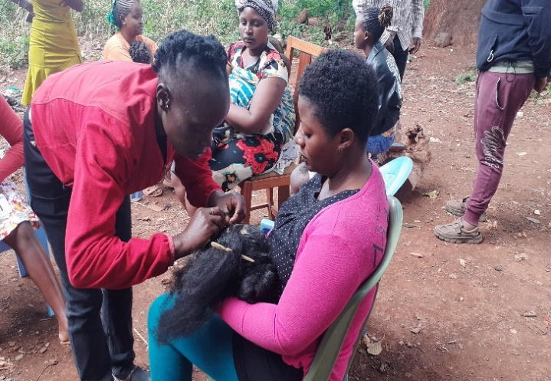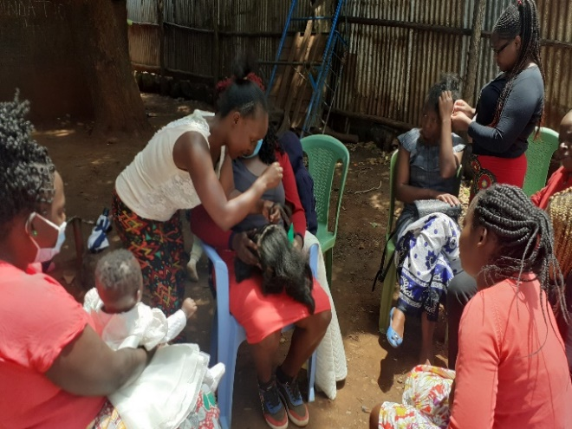

1. Figure 1. basic skills training

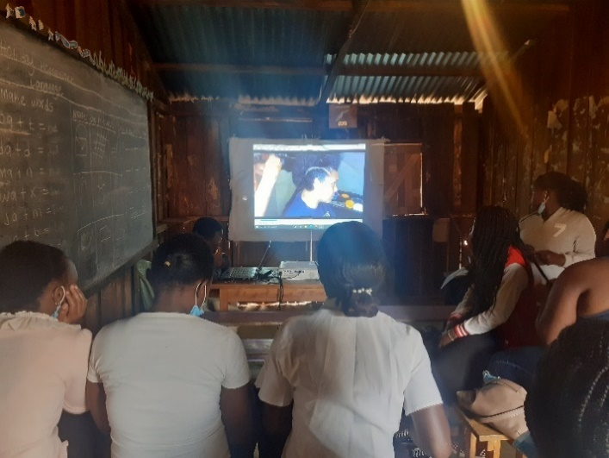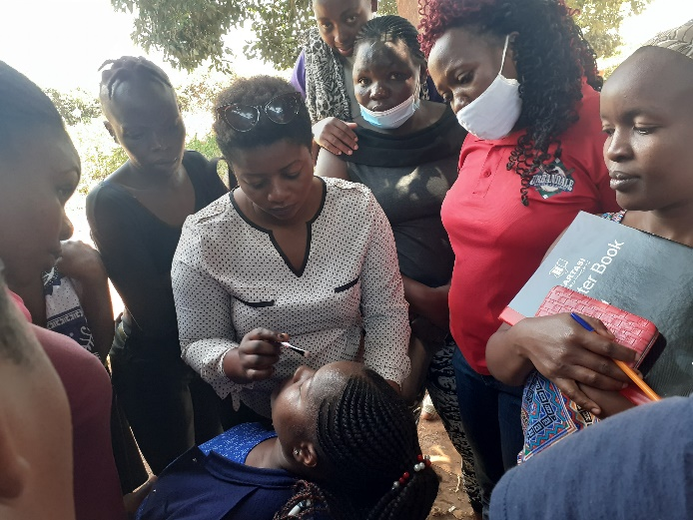

1. Figure 2. You Tube Classes Figure 3. Beauty therapy training
2. **Mat making.**

The mat making group consists of 15 members they meet every Monday and Thursday. One of the members volunteered to teach fellow colleagues about mat making. In this group, members have completed majority of the workload. The Ngao Foundation is in the process of providing them business training skills so that they can create their own market once they have completed mat making process.

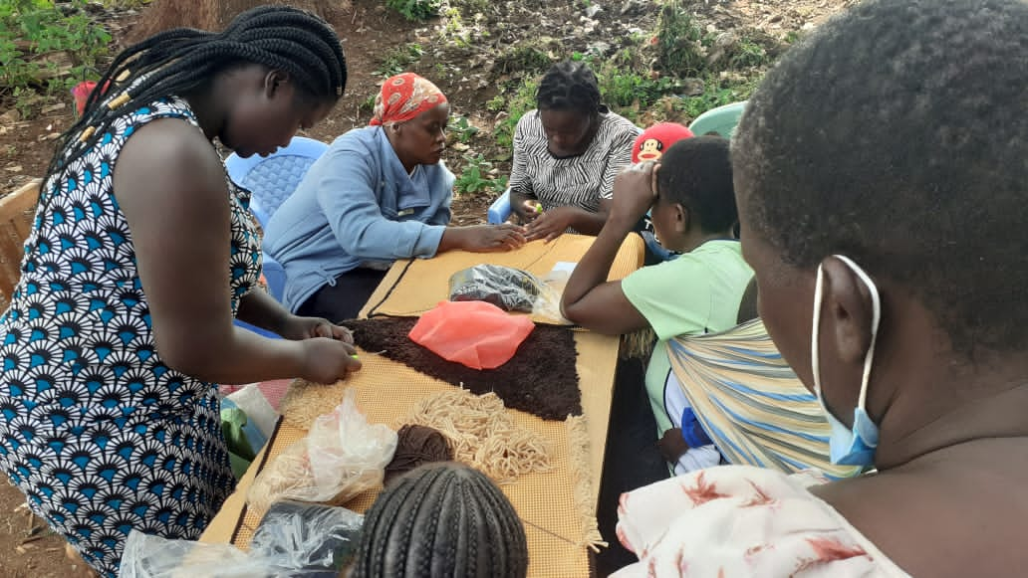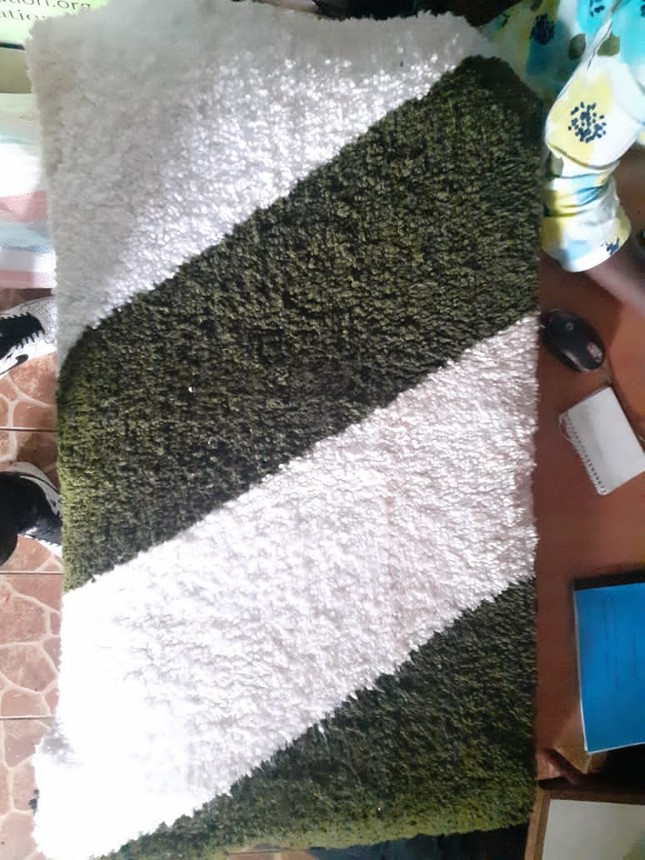

*tapestry*

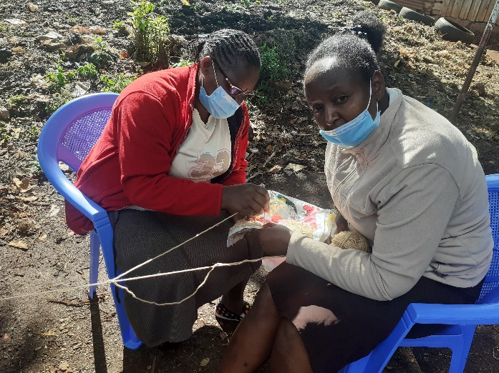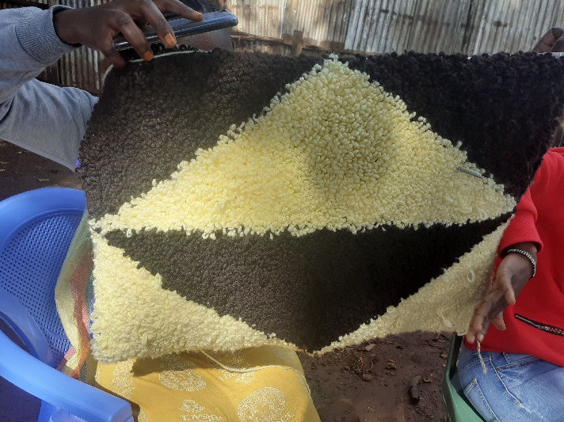

*Making mat out of sack.*

1. **Soap Making.**

The main aim of this activity is to provide knowledge and skills on how to manufacture locally made soaps at no cost and then these women are involved in selling the product. This activity has been able to benefit 20 women and the target is to reach 100 before the end of the year. Women search for the market themselves, the money gained is split into two, where a small portion is returned to the organization for the purpose of purchasing raw materials.

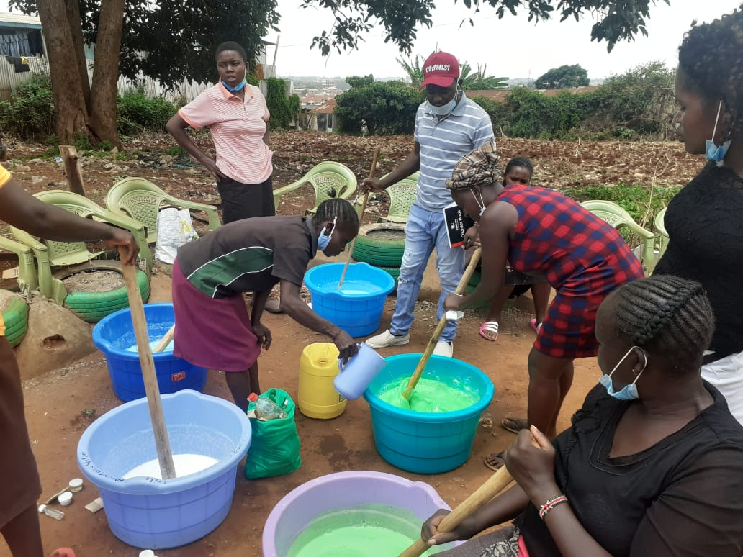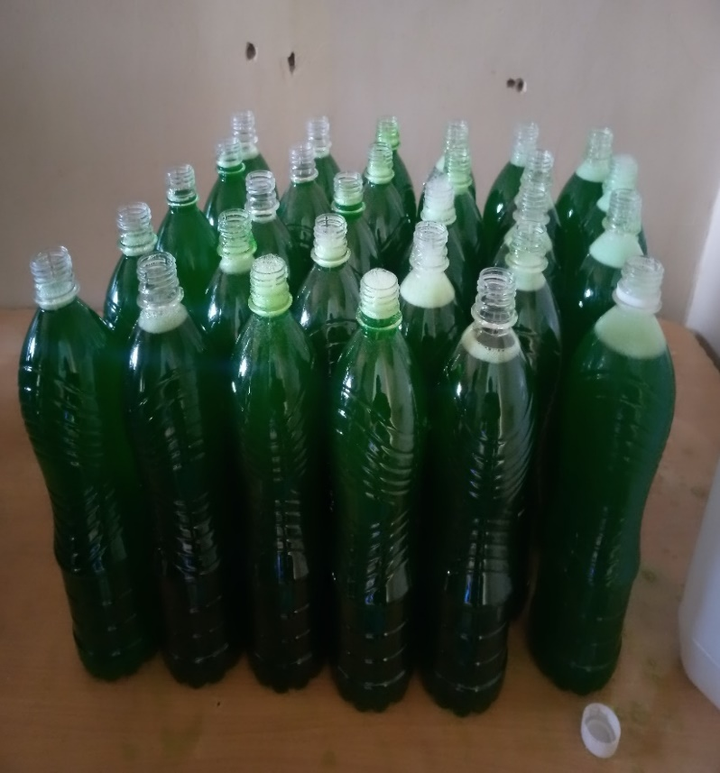 *Soap making process.*

*Ready made soap for packaging*

1. **Tailoring group**

The Tailoring group consists of 19 members, they meet every Wednesday and Saturday. At first these women were taught how to operate the sewing machine since majority of them were knew to all of this. So far, they have gained the basic skills on making Hemmings and button holes. These women are also offered a platform to interact with each and discuss ways in which they can improve their lives either by establishing a saving group or learning how to invest.

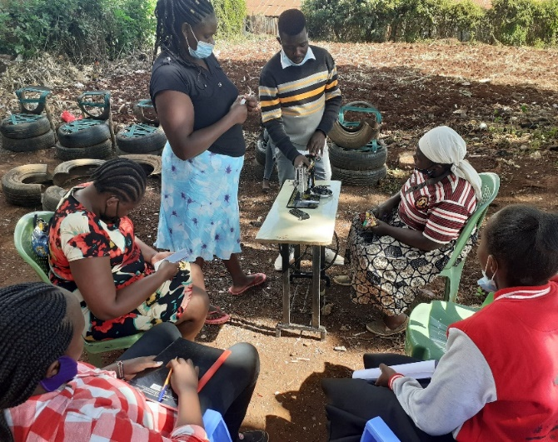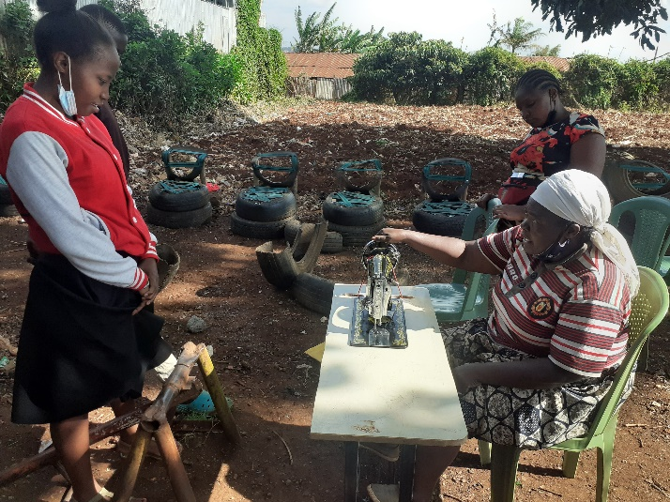

*Tailoring session.*