DETAILED PROJECT PLAN
“Fulfilling an essential need of 310 school children in a rural high school in the setting up of Library in Every House”
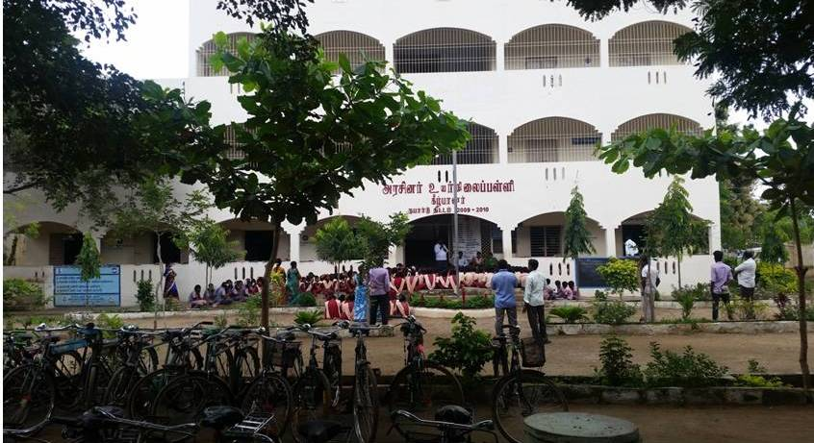
Duration of the project :
- 6 months
Project location
Village - Kilpalur
School - Government High School
Block - Kalasapakkam
District - Thiruvannamalai
State - Tamilnadu
Country - INDIA
Project Background :
The Government of Tamilnadu – run a high school at Kilpalur village in Tiruvannamalai district has earned laurels for facilitating to all the students in the institution to establish a library on their own in their houses. Putting together the books donated by friends, teachers and issued as prizes in competitions, 310 students studying in Government High School located at Kilpalur have established a small library in their houses. They have converted shelves and cupboards in their houses into a makeshift library to stock the books.
It is to be observed that this is the first of its kind in the district :
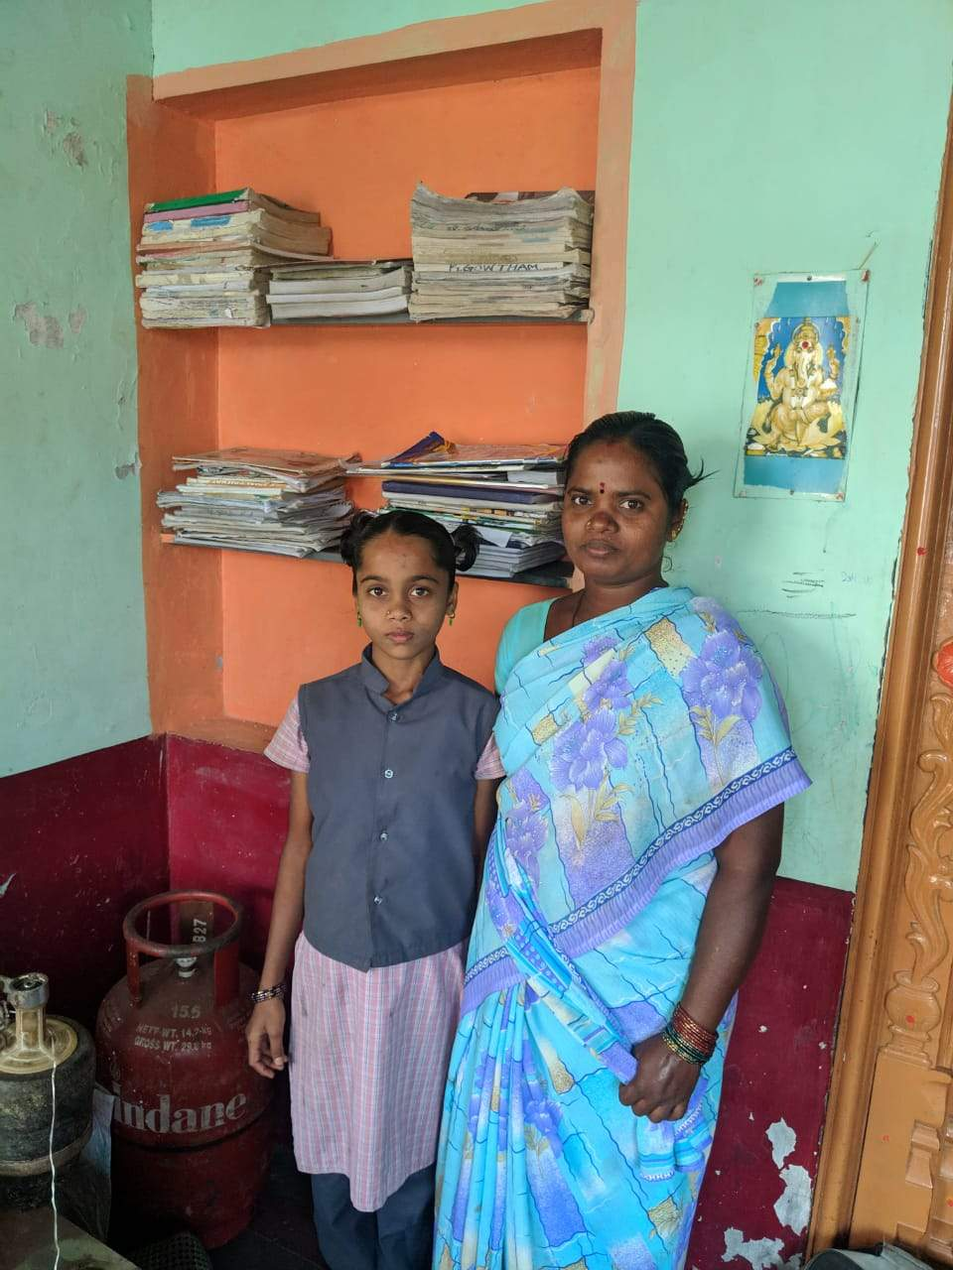
Statement of a school girl:
"I collected books from my friends. My teachers too contributed some books. Now I have set up a library in my house,” said E. Revathy, Class IX student.
She has managed to collect 159 books to create her own library.
K Arunkumar, a Class VIII student, is keeping 85 books in his makeshift library.
Dr S Meenakshisundaram is the proud Head Master of the school. It is mainly through his initiative and motivation the project has been carried out. Talking about the project Dr S Meenakshisundaram has observed:
“As many as 310 students of our school have set up student libraries in their houses. This will inculcate reading in them, instead of wasting time on entertainment gadgets,”
Dr S Meenakshisundaram added :-
“The project of establishing student libraries was started in June 2018. It is a six-month project. We have completed it successfully.”
The school received an award for successfully carrying out the student library project. The Chief Education Officer Mr. V. Jayakumar honored to all 310 students at a function held in the school premises. All the students were presented a shield, certificate and books in praise of their endeavor.
After launching of the project in June 2018, the headmaster, teachers and the school children make it a point to visit Book Fairs that get organized in nearby towns and cities and school children have made it a habit to buy books of their choice.
As far as the school is concerned specific names are given to each standard and they are as follows:
6th standard - All children in this standard will keep names of only flowers
7th standard - Names of trees
8th standard - Names of scientists
9th standard - Names of great poets in Tamil – the regional language
10th standard - Names of famous books / epics in Tamil
SPHEED, the applicant organization, has donated one book each to all 310 students.
The Present Need of the children / of the Library in Every House Program :
Discussions with the headmaster and teachers and representatives of students about the essential needs for affecting improvements of the Library in Every House Program has indicated the importance of fulfilling the following need
At present children have been found to be stacking their books in any place that is available in their houses and these could be almirahs, tables, benches, chairs or just floors. In the process, there are chances that the valuable books meet with damages. In order that the books last long and don’t get damaged the need of the children and their books is an iron racks.
Main goal of the project:
To provide one iron rack to each of the 310 school children to stack their library books
Project outcomes :
- The school children will have acquired a safe place to stock their library books
- A habit learnt as children will continue for ever – they can be expected to invest in books throughout their life time
- The reading habit that is fast disappearing will flourish in the 310 school children.
Project Budget :
The budgetary request is only for 310 students for this year.
For conveince sake the students in the lower standards will wait for the next year.

Total budget :
S.No. | Particulars | Amount in Rupees
01. | Iron rack to 310 Nos. of Students @ Rs.2000 x 310 Nos. | Rs. 6,20,000
02. | 20 table | Rs. 40,000
03. | S type chair 100 | Rs. 40,000
04. | Total | 7,00,000
 | Grant requested from GLOBAL GIVING, UK: | $ 10,000

