School children in Garoua Boulai, particularly in public schools, studying conditions are far below standard and unhealthy …

Our project aims at ameliorating access to education to 2417 pupils in four rural schools by providing 200, two seater benches enabling at least 400 boys and girls to sit comfortably in school

Provide 200 benches to four rural schools:
- Public school Goza
- Public school Nagonda
- Public school Doforo
- Bilingual Public school Sabongari

Pupils are exposed to parasites and contaminated soils
Learning will be confortable and more pupils will stay in school
A total of 2417 students have just 458 benches
4 to 5 pupils occupy a two seater bench with many seated on the floor
400 students will free from pains, writing difficulties and exposure to parasites and diseases from contaminated soils

400 pupils will be free from fighting over seats making class more disciplined and learner friendly

The quality of education will be enhanced and more pupils will stay in school thereby reducing high rate of school drop outs.

Pupils will remain safe and healthy in schools
Sitting in dust or wet floors is unhealthy
At least 400 students will have acess to 200 two seater benches

Most parents do not meet up with their 5000 FRS PTA
The greater numbers on the floor are girls
More girls will attend school
PTA can concentrate on other issues like payment PTA teachers

Most parents are poor and education is a low priority in the area
Many pupils drop out of school
Pupils have to fight over seats
Writing on the floor is painful and stressful
At least 400 pupils have access to comtable seats

Because …
…So…
By the end of the project

…So that…
We will…

Details of the four schools by classes; number of pupils , benches and number of pupils with disabilities:
- ECOLE PUBLIQUE NAGONDA.
Class | Boys | Girls | Total | Benches
Sil (class 1) | 90 | 75 | 165 | 32
CP (class 2) | 63 | 36 | 99 | 23
CE1 (class 3) | 43 | 36 | 79 | 03
CE2 (class 4) | 38 | 20 | 58
CM1 (class 5) | 18 | 09 | 27 | 14
CM2 (class 6) | 08 | O5 | 13
TOTAL | 260 | 181 | 441 | 72
Number of pupils in need of benches | 297
Number of disabilities = 00
NB- Classes 3 and 4 are joint. (two classes in the same classroom)
NB- Classes 5 and 6 are joint (two classes in the same classroom)
- ECOLE PUBLIQUE GOZA.
Class | Boys | Girls | Total | Benches
Sil (class 1) | 220 | 230 | 450 | 77
CP(class 2) | 141 | 133 | 174 | 40
CE1(class 3) | 112 | 94 | 206 | 39
CE2(class 4) | 88 | 69 | 157 | 30
CM1(class 5) | 57 | 75 | 132 | 34
CM2(class 6) | 29 | 18 | 47
TOTAL | 647 | 619 | 1266 | 220
Number of pupils in need of benches | 826

- ECOLE PUBLIQUE DOFORO.
Class | Boys | Girls | Total | Benches
Sil (class 1) | 22 | 39 | 53 | 35
CP(class 2) | 18 | 17 | 35
CE1(class 3) | 22 | 27 | 49 | 33
CE2(class 4) | 25 | 30 | 55
CM1(class 5) | 10 | 17 | 27 | 12
CM2(class 6) | 2 | 3 | 5
TOTAL | 99 | 133 | 232 | 80
Number of pupils in need of benches | 48
Number of disabilities = 01 boy

- ECOLE PUBLIQUE SABONGARI.
Class | Boys | Girls | Total | Benches
Sil (class 1) | 123 | 85 | 208 | 32
CP(class 2) | 59 | 43 | 102 | 22
CE1(class 3) | 40 | 39 | 79 | 15
CE2(class 4) | 31 | 25 | 56 | 8
CM1(class 5) | 22 | 11 | 33 | 9
CM2(class 6) | 00 | 00 | 00 | 00
TOTAL | 275 | 203 | 478 | 86
Number of pupils in need of benches | 306
Number of disabilities = 03 ( 2 boys and 1 girl)

PLAN FOR TWO SEATER BENCH
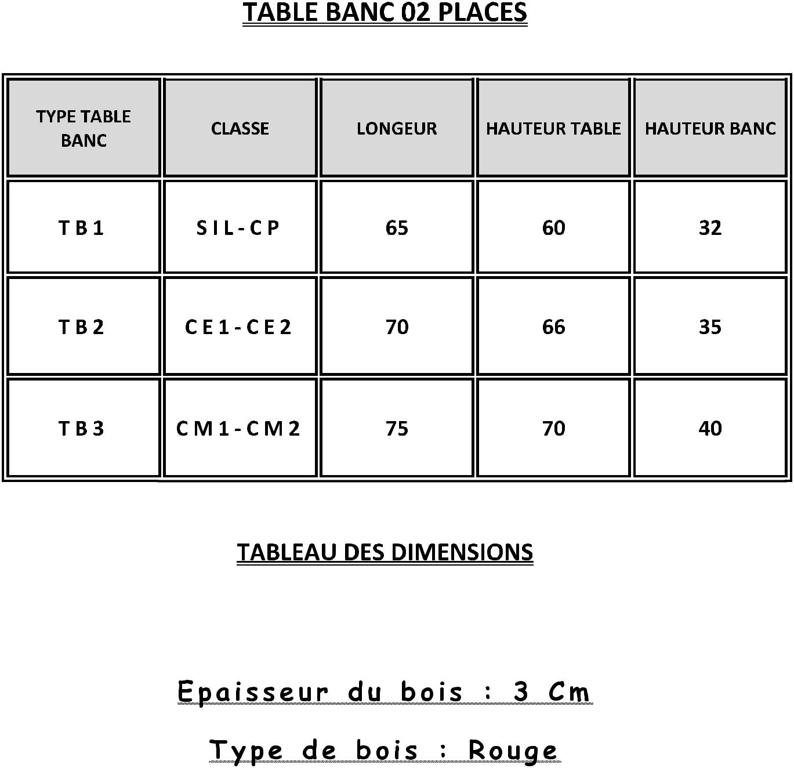

NOTE:
- TB stand for Bench type
- SIL (class 1), CP (class 2), CE1 (class 3), CE2 (class 4), CM1 (class 5), and CM2 (class 6).
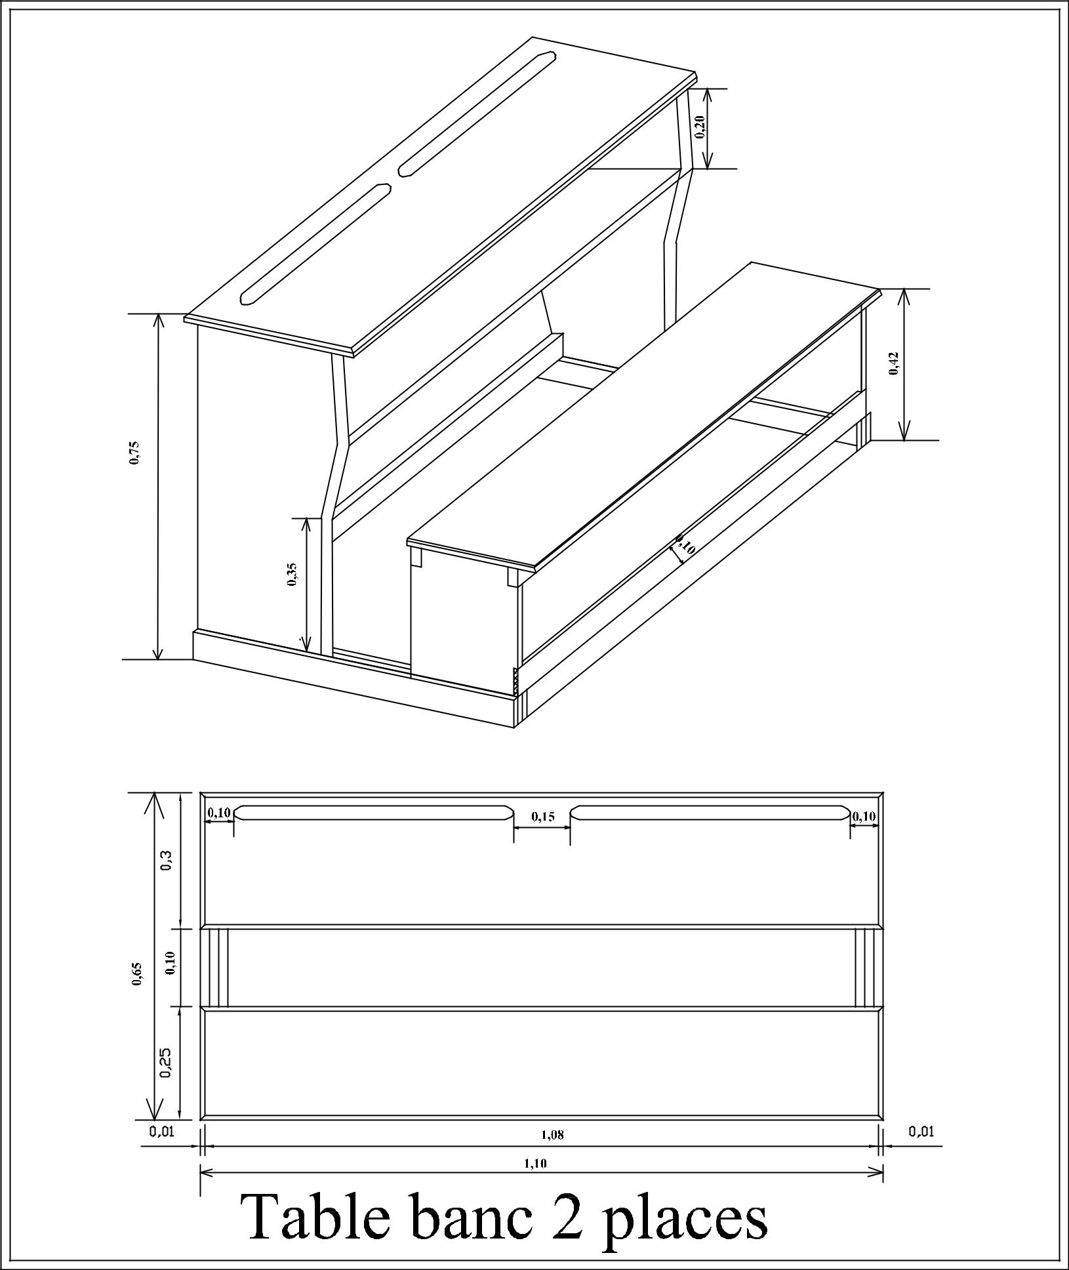
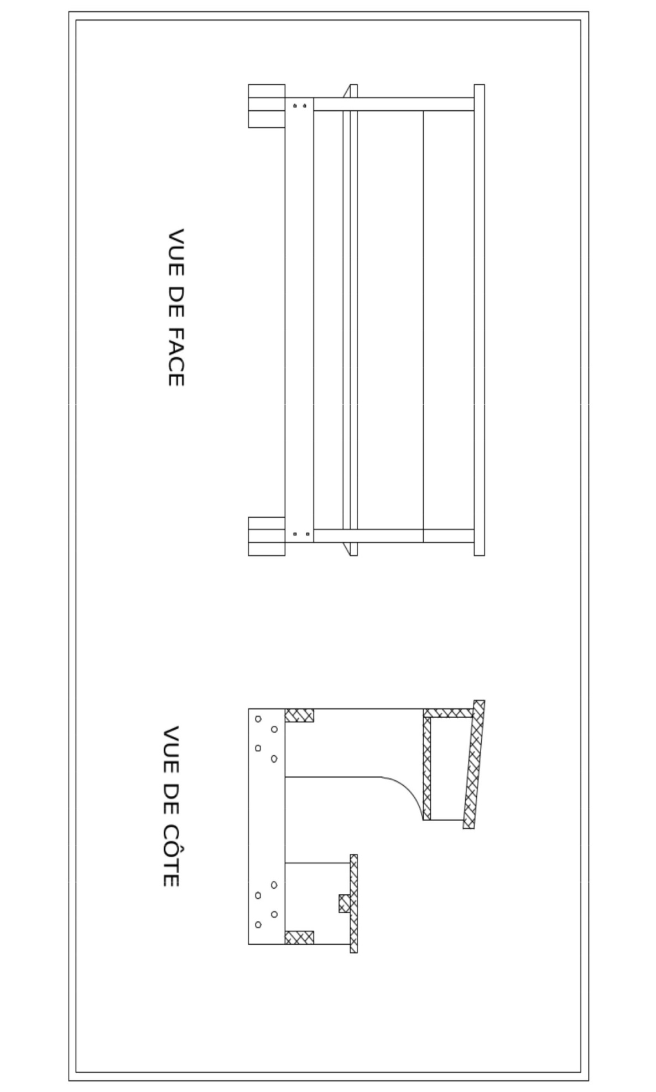
FACE AND SIDE VUES OF A BENCH

