**Luhira beneficiaries captured using the VRs**

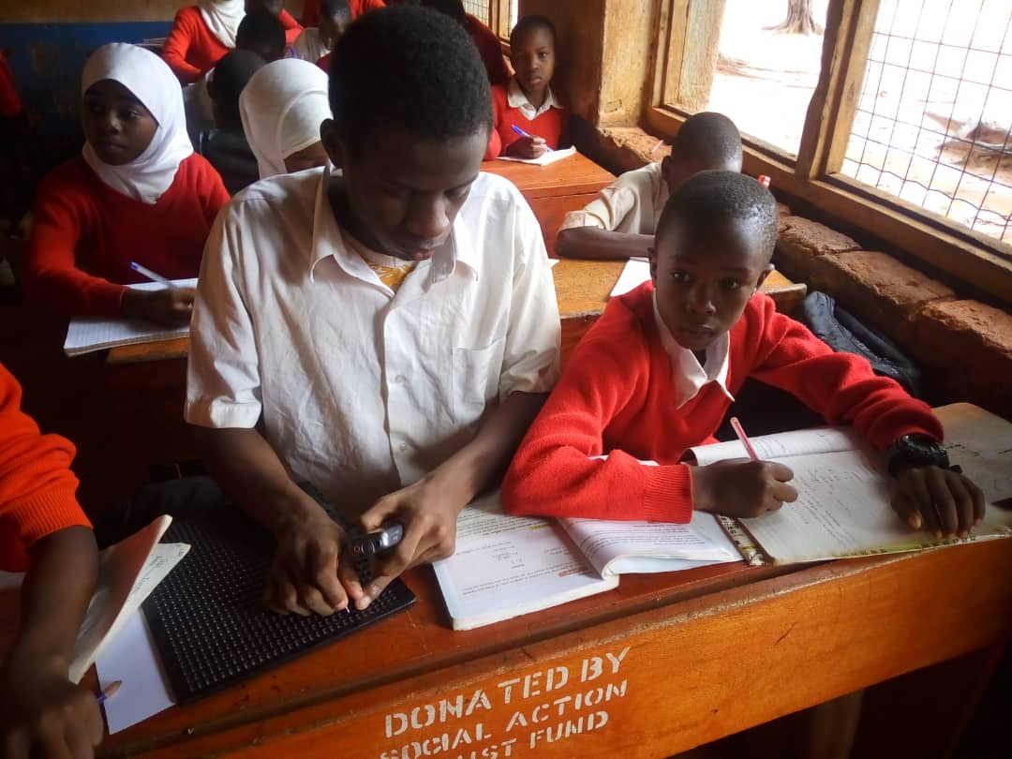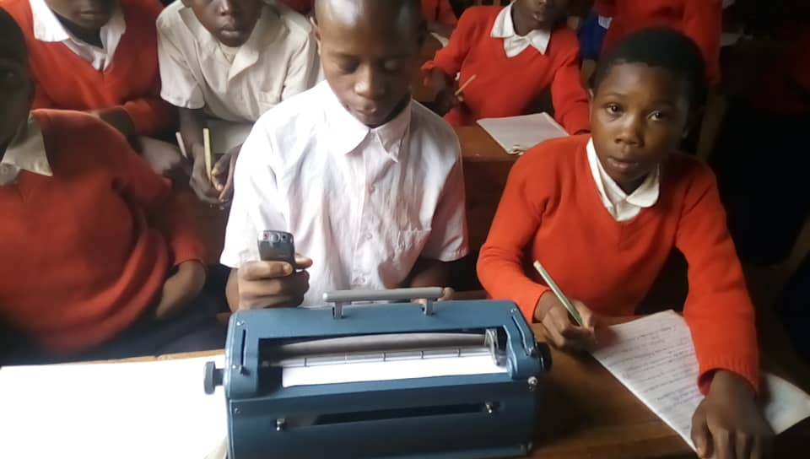

***Luhira primary School pupil Godfrey Hunja with Saidi Kalonga (@ the middle) setting his Voice recorder***

***his voice recorder during class session before commencement of his class***

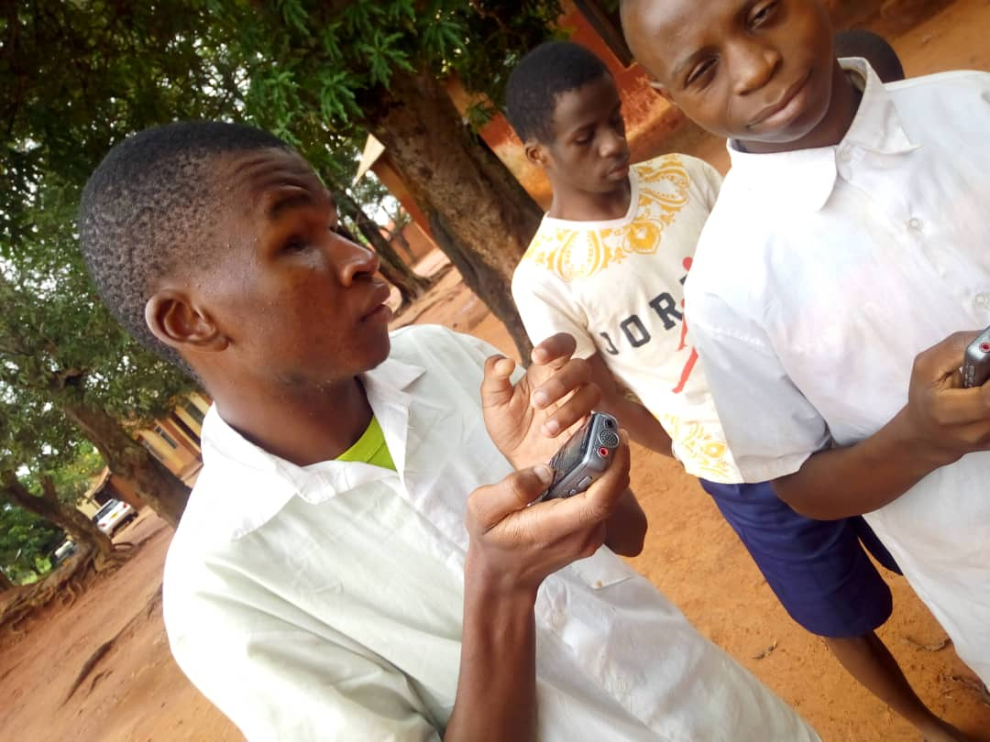

***Visual impaired pupils; Saidi Kalonga and Hmyawezi***

***Matembezi listening to their voice recorders outside their class***