
PROVISION OF 150 VOICE RECORDERS FOR VISUAL IMPAIRED PUPILS AT LUHIRA PRIMARY SCHOOL-SONGEA, TANZANIA
2ND PROJECT PROGRESS REPORT – DECEMBER 2019
Dear Donors,
We have the pleasure of submitting our 2nd Project progress report on the utilization and handover of the funds collected through the GlobalGiving platform ;
1.0 INTRODUCTION:
Luhira primary school was built in 1929 housing normal pupils. Luhira primary school is among public schools that have been designated to accommodate disabled children in Tanzania since 1982, including visual impairment. Currently, the school has 52 disabled pupils. The visually impaired pupils have been attending classes with other normal pupils thus fail to catch up.
2.0 OBJECTIVE:
To support Visually impaired pupils at Luhira primary with Voice Recorders. These efforts , this will enable the Visually Impaired pupils to get an equal opportunity to access education as other normal pupils. This is also in line with SDG 1,4 AND 10.
3.0 FUNDRAISING TARGET:
- Our target raise funds USD 11,250 for 150 pcs of Voice Recorders on behalf of Luhira pupils in Songea, The fundraising campaign was implemented from 10th to 28th June 2019 of which we have been able to raise USD 984 (9%) from 11 donors. Therefore, the funding gap stands at USD 10,266(91%). From the amount of USD 780, we have been able to procure 8 pcs of PX470 Digital Voice Recorder PX series.

3.0 HANDOVER CEREMONY
- We had a great moment with pupils at the school during the handover ceremony which took place on 21st October 2019 at Luhira primary school.We are delighted to share the pictures
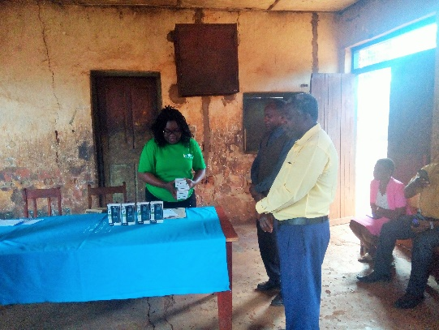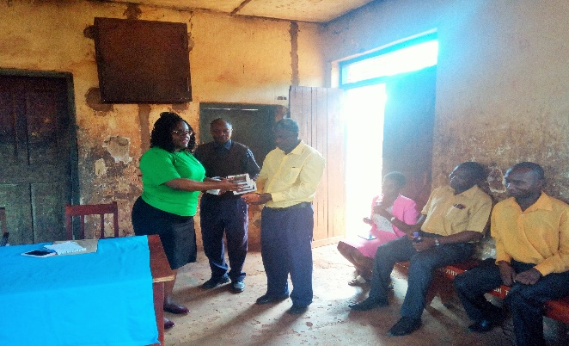
SATF staff(left) in preparation of the Representative from Luhira teachers receiving the
handover.Standing(right),Luhira teachers. Voice Recorders.

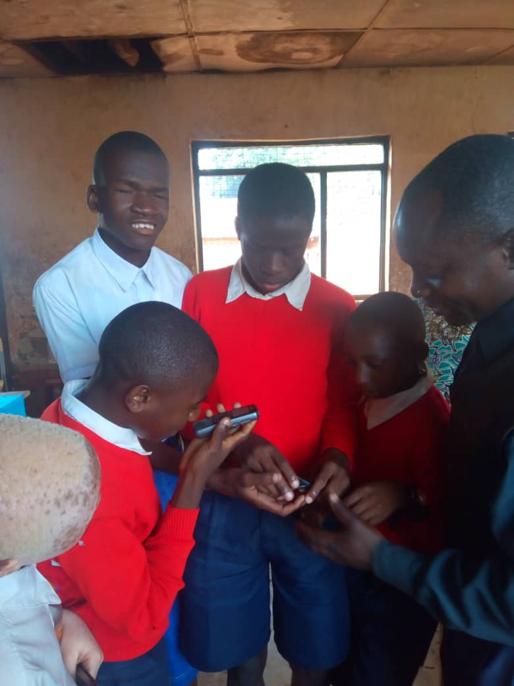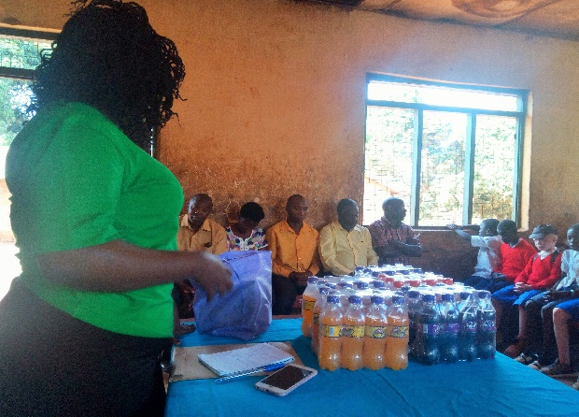
Pupils excitedly learning how to use the VRs……… …..SATF staff preparing refereshment during the
handover ceremony

4.0 APPRECIATION:
On behalf of the SATF team and beneficiaries, we once again extend our appreciate the support from to the 11 donors who have lent their financial support. We hope you will be able to support us in future fundraising campaigns.We also extend our appreciation to the GlobalGiving team for approving SATF to use the platform to raise funds.
We hope you
THANK YOU

Submitted by;

Ms.Beatrice Mgaya
Chief Executive Officer
4th September 2019

Encl:
1.Tax Receipt of the procurements
2.Pictures of the 8 pcs of PX470 Digital Voice Recorders (PX series)

