Collaborative Partners- Tracey Nails-Bell- (510) 541-2191

Steve King- (510)- 463-2887

Providing affordable housing is the only effective way to end homelessness and displacement. The urgency of the need demands that housing be created faster and more economically than standard development models can deliver. A Diamond in the Ruff, wants to deliver temporary transitional affordable housing units to 2-3 years, with the next phase to receive permanent housing.
This initiative, based on the premise that providing homes is the only effective way to end homelessness, aims to serve two populations: the homeless and the working poor facing displacement, not only are affordable rents under pressure, but the poorest households are also under incredible pressure
To move out, but with nowhere else to live affordably and safely.

A Diamond in the Ruff, Transitional Home/ Program, in East Oakland, on this property 5940 Hayes, building transitional independent housing secondary housing units with an opportunity to rent affordable rental units that share the parcel of land and a common house. Rent based on 30% of the client’s median income

Facts:
- Median rents across Oakland are at an all-time high, pushing low-income families into motels or family member’s homes, pricing working-class households out of their neighborhoods and creating fierce competition for available housing at all income levels.
- While the majority of the working poor have at least one person in the working full-time, estimates of rent increases on housing not under rent controlled range from 40% to 110%.
- Many homeless individuals require subsidized housing with supportive programs that enable them to resolve these issues and build stability for sustainable future housing
- A wealth of research confirms that homeless children perform worse on measures of academic achievement than their permanently housed peers and are also more likely to experience health problems and developmental delays. Nearly one in five homeless parents today was homeless as a child.

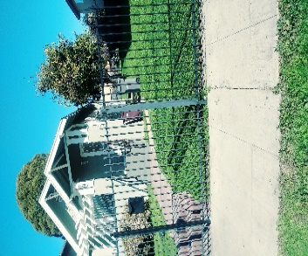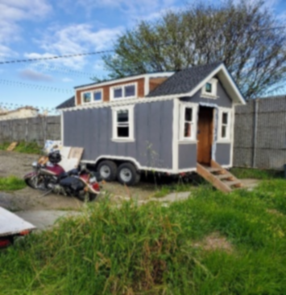Harvest House Secondary Units Project

A Diamond in the Ruff, would be able to serve low-and moderate income single women or women with children. With well – designed small units providing every amenity within a smaller footprint. Units that a fully are accessible.

The rental units for transitional independent living could be considered “tiny” between 330 to 500 square feet, but will offer full amenities: kitchen, bath, and living room to either a single woman or woman with child. The parcel of land of 8250 Square feet, could accommodate 1-4 secondary units.
Providing new affordable housing units on a fast-track basis can substantially reduce the homeless population, currently estimated at over 6,000 in Alameda County alone. Reducing homelessness, reduces pressure on emergency medical care, intervention and detention activities, and other services disproportionately used by homeless individuals.
Many homeless individual require subsidized housing with support programs.
A variety of socially progressive initiatives can be included either initially or introduced over time. They include: Resident support meetings that facilitate relevant technology training, job-readiness. job development, health and mental health, cultural activities.
This project recognizes the paradox of homelessness consist of: mental illness and substance abuse can be both the cause and effect of extended periods of homelessness.
This project espouses “housing first” a model that’s becoming the standard in Europe, and over 200 American cities.
INSIDE A DIAMOND IN THE RUFF
TRANSITIONAL HOUSE
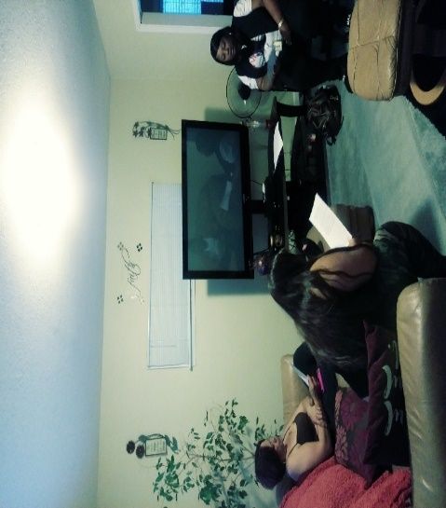
A Diamond in the Ruff, Mission speaks about Clarity to Impart with Cleansing and Healing to become Transparent to a Woman’s Soul...

A Diamond in the Ruff, has an 18-month Sober Living Transitional House/Program, Founded since 2011. We are a 501 (c) (3) non-profit charitable organization, serving single women in Alameda County and other nearby counties, who are at risk from being homeless, victims of domestic violence, those in recovery from drugs /alcohol, those coming out of incarceration and those who may have one or more barriers due to mental Health.
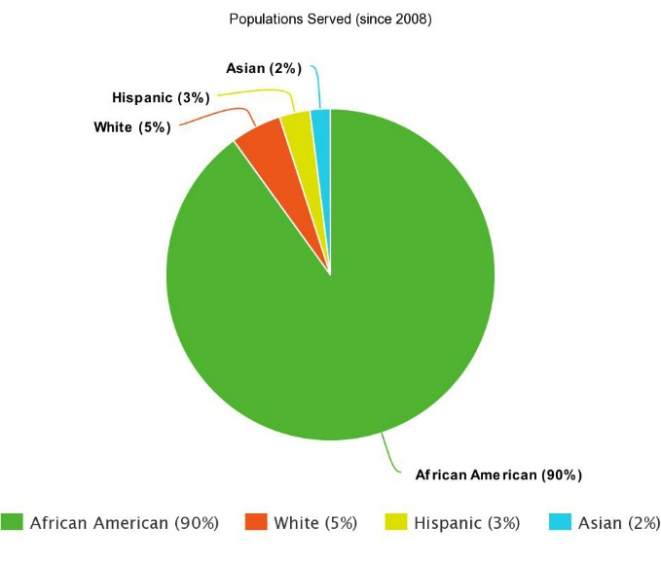
We offer supportive services to help strengthen women, who have been torn by life’s circumstances. Teaching women how to connect with their core essence and know their purpose, and helping them to find their pathway towards a healthier and stable lifestyle.

Since its inception, A Diamond in the Ruff, Inc., has been committed to improving the lives of victims and survivors of domestic violence, intimate partner violence and trauma. Some of the services we currently provide are:

- Supportive Therapeutic Services
- Case Management
- Open Forum Support Groups
- Life Skills
- Spiritual Awareness

A Diamond in the Ruff Program has served approximately over fifty single women here in Alameda County, and other nearby counties. 10% percent of those women, have completed the Program. Some have (success stories) becoming self-sufficient, having received permanent housing. Some have graduated, from two year colleges, receiving their AA Degree, and now are attending a four year college to obtain their Master’s Degree, in fields like Psychology, Sociology and Certificate of Drug/Alcohol Counselor.
Testimonial Story-
Homeless Survivor, Pamela Kime
I was 56 when I became a client of A Diamond in the Ruff. I was completely torn up at that time. I had lost my job, my identity, my self-esteem, my everything. And then God sent me to this beautiful place. I found love, I found people who were genuinely concerned about me and who would take care of me. I began to heal slowly inside and out. It was like I was a baby chick, peeking out of my shell. Then I began putting things together. Tracey, the Director of a Diamond in the Ruff, began to push me out of the nest gently, with all of the love in her heart. She began giving me missions, to carry out. Simple things to begin with, and as I was able to complete those, she began to diligently and compassionately pushing me.
Now here is the part that anyone looking at A Diamond in the Ruff needs to understand, this is a Spiritual Based Program. The home that houses us is God house. But if you BELIEVE in HIM and TRUST in HIM! I have been here for two years, some parts have been the hardiest, but even in the hardiest I have been surrounded by people that love me & want the best for me. Throughout this program I have been taught patience and endurance. And you will definitely hear Tracey talk about “Getting the Lesson”
Well I got the lessons, or enough of them, that I am moving on. Not moving away from this because this was my hospital. It helped me to heal within my skin and heart and operated on my self-esteem, and it gave me enough time to heal so, I could I know who I am what I am.
Blessings,
Pamela

