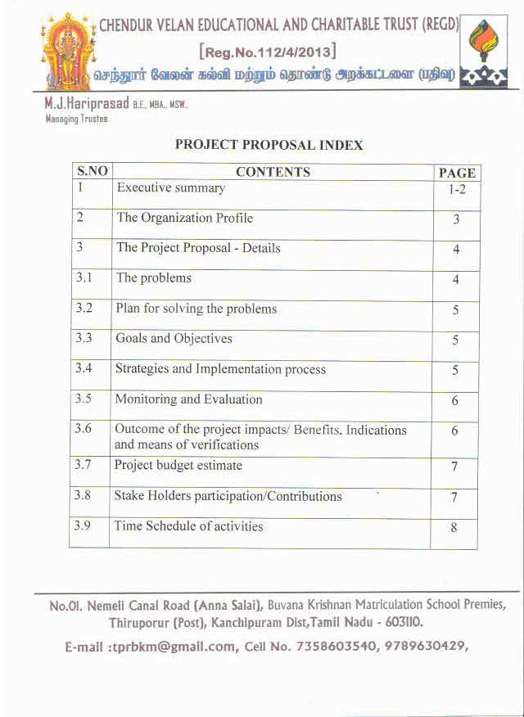

EXECUTIVE SUMMARY
PROFILE OF THE ORGANIZATION:
CHENDUR VELAN EDUCATIONAL AND CHARITABLE TRUST is a registered Non-profitable organization aims to provide quality education for the economically and socially, most backward class children without any kind of discrimination. It also involves in social and charitable activities for the upliftment of social and educational status of the people. The trust is functioning with effect from 2013 and running a school “BUVANA KRISHNAN MATRICULATION SCHOOL” by name with 1130 children. 95% of the children aged between 4 and 15 belongs to backward, most backward and scheduled class.
PROJECT PROPOSAL
PROJECT TITLE:
CONSTRUCTION OF SCHOOL BUILDINGS AND RELATED INFRASTRUCTURES – INDIA.
THE PROBLEMS :
The school is running on a lease land with shortage of class-rooms, rest rooms, various labs and a standard play-ground. The trust is unable to make any infrastructure development activities on a lease land. Major portion of the lease land belongs to a local temple and temple authorities are not permitting the school management to under take any kind of permanent infrastructures and temple lands are not for sale.
PLAN FOR SOLVING THE PROBLEM
The plan is to purchase a land and build 30 class rooms with toilets facilities, labs, library, computer class room and a standard well-equipped play ground as detailed in the estimated budget.
OBJECTIVES :
- To enhancement of educational infrastructure for the 1130 pre primary, primary and high school children.
- To provide a safe, healthy and conductive learning environment that will provide quality education.
- To develop children on intellectual competent.
- To build up good moral character students.

OUTCOME OF THE PROJECT :
IMPACTS / EFFECTS
- The project will strengthen the operational capacity of the school.
- 1130 children will get immediate direct benefits of the project
- Learning process will be enhanced by way of introduction of modern digital educational system by replacement of traditional educational system.
- A safe, healthy, better sanitation hygiene and conducive learning environment will be provided.
- All children will enjoy their childhood life.

LONG - TERM BENEFITS OF THE PROJECT :
To upgrade the existing level to higher secondary and then to higher study level so as to achieve the social and educational objectives of the trust.
ESTIMATED PROJECT BUDGET:
- Total project cost - USD 677300
- a) Contribution by board of directors - USD 289800
b) Contribution by the school - USD 72464
- Total Contributions - USD 362264
- External funds required - USD 315036
PROJECT DURATION : 14 MONTHS
PARTICIPATION / CONTRIBUTIONS
Out of the total project cost USD 677300, about 53.46% (USD 362264) of the project cost will be met by the Board of Directors by way of selling their own property which is for away from the school site and contributions to be made by the school.
We, the Board of Directors are very much thankful for the consideration of our school project proposal for the benefits of the Economically and socially weaker section of the community and for the valuable support.

PROFILE OF THE ORGANIZATION:
CHENDUR VELAN EDUCATIONAL AND CHARITABLE TRUST is a registered Non-profitable organization aims to provide quality education for the economically and socially, most backward class children without any kind of discrimination. It also involves in social and charitable activities for the upliftment of social and educational status of the people. The trust is functioning with effect from 2013 and running a school “BUVANA KRISHNAN MATRICULATION SCHOOL” by name with 1130 children. 95% of the children aged between 4 and 15 belongs to backward, most backward and scheduled class.
CHIEF OF THE ORGANIZATION
Managing Trustee : M.J.Hari Prasad
Secretary : R.M.Jagannathan
Contact Details : +91 7358603540
+91 9789630429
Postal Address : No.1, Nemmeli canal road, B.K.M School
Premieses, Thiruporur(Po), Kancheepuram(Dt),
Tamil Nadu(State), India
Pincode: 603110
Mail Id : tprbkm@gmail.com
jagannathan.rm@gmail.com
Target Area of Operation : Educational, Social and Charitable Activities
for the upliftment of Economically and socially
weaker section of the people without any kind
of discrimination.

PROJECT PROPOSAL
PROJECT TITLE:
CONSTRUCTION OF SCHOOL BUILDINGS AND RELATED INFRASTRUCTURES – INDIA.
LOCATION OF THE PROJECT SITE :
Address : Nemmeli canal road.Thiruporur(Po),
Kancheepuram(Dt),
Tamil Nadu(State), India
Pincode: 603110
Telephone : +91 9789630429
+91 7358603540
PROJECT IMPLEMENTATION AGENCY :
CHENDUR VELAN EDUCATIONAL AND CHARITABLE TRUST. Trust will constitute a Project Implementation Team which consists of board of directors, qualified engineers, chartered accountants and other related technocrats.
PROJECT GOAL :
To construct school buildings and related infrastructures.
THE PROBLEMS :
The school is running on a lease land with shortage of class-rooms, rest rooms, various labs and a standard play-ground. The trust is unable to make any infrastructure development activities on a lease land. Major portion of the lease land belongs to a local temple and temple authorities are not permitting the school management to under take any kind of permanent infrastructures and temple lands are not for sale.
And also the school is paying a huge amount of rent of USD 9000 per annum. Hence we are unable to manage 1130 children with insufficient number of class rooms, rest rooms, labs, library – staff room and seminar hall. Currently 11 toilets are shared by 1130 children and 50 staff of the school.
Therefore, the school is extremely in need of permanent basic infrastructure facilities to enhance the learning process to improve the children’s skills. This is the main problem of the school.
PLAN FOR SOLVING THE PROBLEM
The plan is to purchase a land and build 30 class rooms with toilets facilities, labs, library, computer class room and a standard well-equipped play ground as detailed in the estimated budget.
OBJECTIVES | STRATEGIES | IMPLEMENTATION PROCESS
i) To enhancement of educational infrastructure for the 1130 pre primary, primary and high school children. | - Construction of school buildings and play ground  - Enhancement of educational euipments, materials and to create conducive environment. | - Formation of Project Implementation Team consists of board of directors, qualified engineers and chartered accountants and other related technocrats.
i) To provide a safe, healthy and conductive learning environment that will provide quality education.  ii) To develop children on intellectual competent.  iii) To build up good moral character students. | - Formation of smart class rooms, practical classes, improve games and sports activities, yoga and meditation. | - Facilities for Students: Selection of qualified teaching staff on the basis of merit and better , labs, library.  - Facilities to hold vocational classes and computer classes.  - Games and sports materials, art and culture equipments.

MONITORING AND EVALUATION :
A progress indicator tools will be used to monitor and evaluate the project on regular basis.
Donors and partner organisations have the right to monitor and supervise the project to assess the performance and progress. The chief functionary of the organisation will assess the progress of the project through periodic review meetings with the project implementation team members.
OUTCOME OF THE PROJECT
IMPACTS / EFFECTS | INDICATORS | MEANS OF VERIFICATIONS
i) The project will strengthen the operational capacity of the school.  ii) 1130 children will get immediate direct benefits of the project. | New permanent infrastructure facilities will be created in the project site. | - Observation and interaction with parents and local community.
i) Learning process will be enhanced by way of introduction of modern digital educational system by replacement of traditional educational system  ii) A safe, healthy, better sanitation hygiene and conducive learning environment will be provided. | - More enrolment of children.  - Every year 150 additional children will have opportunities to study at our premises.  - Drop-out will be reduced  - Rate of illiteracy will be less in the surrounding 14 villages.  - Productivity of the staff will increase  - Child labour will be reduced – to stop child labour | - Admission register  - Attendance Register  - Dialogue with students  - Records about the Academic performance and success rate in the exams conducted by the government.
All children will enjoy their childhood life. | Games, sports, yoga and meditation classes | Observation and interaction with children.

LONG - TERM BENEFITS OF THE PROJECT :
To upgrade the existing level to higher secondary and then to higher study level so as to achieve the social and educational objectives of the trust.
To implement the government of India and state government educational schemes such as right to free and compulsory education for children from L.K.G to VIII Grade effectively for the benefit of the poor children.
Improvement of children’s self-esteem and well-being.
ESTIMATED PROJECT BUDGET
S.NO | EXPENSES | FUNDS REQUIRED
 |  | USD | INR
1 | Purchase of land 30084 s.ft | 289800 | 20000000
2 | Construction of School Buildings  a) 30 class rooms with toilets  b) Two science labs  c) One library room  d) One computer room  e) One language lab  f) One office room  h) One principal room  i) One store room | 373000 | 25740000
3 | Eductional Equipments | 14500 | 1000000
4 | Total project cost | 677300 | 46733700
5 | a) Contribution by board of  directors  b) Contribution by the school  Total Contributions | 289800  72464 | 20000000  5000000
 |  | 362264 | 25000000
6 | External funds required (4-5) | 315036 | 21737484

- Exchange Rate (TANTATIVE) 1 USD = 69 INR

PARTICIPATION / CONTRIBUTIONS
Out of the total project cost USD 677300, about 53.46% (USD 362264) of the project cost will be met by the Board of Directors by way of selling their own property which is for away from the school site and contributions to be made by the school as detailed in the estimated project budget. We, the Board of Directors also certify that funds available by way of external sources and contributions by Board of Directors and the school will be used exclusively for the execution of the project only and will not be diverted or utilized for any other purposes under any circumstances.
Further, the running costs of the school such as monthly salary of the Teaching staff (43Nos) and Administrative staff (7Nos), monthly payment for social security schemes for all the staff, electricity, rent, telephone charges, water, cleaning products, stationeries are covered by school tuition fees and we never collect any kind of donation from any students either directly or indirectly because more than 95% of the children of the school belongs to backward, most backward and schedule class and they are economical and socially weaker section of the community.
The project implementation team will actively participate in the execution of the project and closely supervise the project works.
Our trust is granted permission by the Ministry of the Home affairs, Government of India to receive required funds under Foreign Contribution Regulation Act 2010 with effect from 18.03.2019 and valid till 17.03.2024 and FCRA Registration certificate number is 075820446.
TIME LINE OF ACTIVITIES
S.NO | TIME SCHEDULE AFTER THE RELASE  OF THE REQUIRED FUND | ACTIVITIES
1 | 1st month | Formation of project implementation team
2 | 2nd , 3rd and 4th months | Purchase of land, drawing and preparation of building plan and approval by the concerned government department
3 | 5th Month | Selection of contractor for construction of school buildings and play ground.
4. | 6th ,7th,8th ,9th,10th and 11th,12th month | Purchase of materials for school buildings and to start the construction works and to complete the construction works and playground works.
5 | 13th and 14th month | Completion of the entire project works and submission of final reports to the funding agencies.

