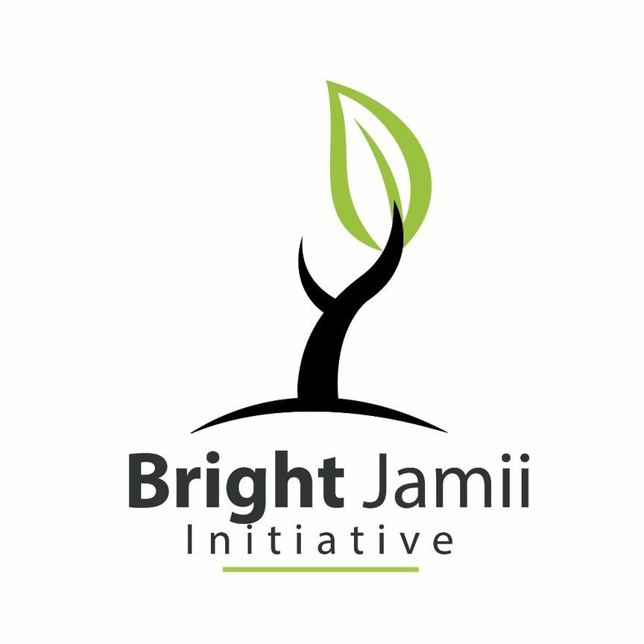

Project Title: Virtues ProjectTM in 5 Children Detention Centers

About Bright Jamii Initiative
Bright Jamii initiative is a non governmental and not for profit organization, registered in April 2018. BJI envisions a society where children live in safe environment that support their development and wellbeing. In so doing, BJI promotes soci0-economic rights of both women and children in the marginalized community. BJI has been strategically engaging Ward and District Women and Children Protection Committees (WCPCs), Women from self-help groups and religious institutions, Religious leaders, paralegals and councilors in analyzing the problems facing women and children, strength and gaps and engage and empower them in addressing the issues. The link to the video below summarize a success story on how BJI program that aligned with International Women’s Day in Kisarawe community engaged various stakeholders to bring about for social change for the betterment of women and girls: https://www.youtube.com/watch v=c7tIqhV9CKM one - info: www.bjinitiative.org

Project Summary
This one-year project will use the Virtues ProjectTM to enhance the capacity of care givers and teachers in five juvenile detention centers, Mwanza, Arusha, Mtwara, Dar es Salaam and Mbeya regions, in Tanzania- so as to offer rehabilitation services to the detained children that will awaken their virtues hence growing to be good citizens. Children will learn how to develop and express their highest qualities that are essential to the health mind that governs highest level of human achievement.

Amount requested: $25,000
Location: Dar es Salaam, Mwanza, Arusha, Mtwara and Mbeya regions of Tanzania
Duration: 12 Months

Project Beneficiaries:
- Children: aged 10-17 in the detention centers
- Adults (caregivers): women and men in the detention centers
- Local Government Authorities: Police Gender Desk and Social Welfare Officers in the District level.

Background of the Problem to be addressed
The overall capacity of the justice system to handle cases involving children in Tanzania is weak. The access to legal assistance and rehabilitation programs for children in contact and conflict with the law is limited, and in some rural areas non-existent. The presence of Juvenile detention centers are not sufficient to serve current needs since there are so many other children detained or jailed in adult prisons. Despite the provisions on juvenile justice in the Law of the Child Act, 2009 in Tanzania, issues such as limited number of necessary skilled personnel in the Juvenile Justice System, unavailability of sufficient number of alternatives programs to detention, and lack of rehabilitation services limit the realization of rights and entitlements of children who come in contact and in conflict with the law.

The Law of the Child Act (2009) has incorporated specific provisions as regards to the general responsibilities of the child in the context of the African Charter on the Rights and Welfare of the Children that put emphasis on creating parenting skills programs and space for children to express themselves.

Bright Jamii Initiative proposes to use Virtues Project as a means to promote rehabilitation in the detention center, improving parenting skills for the caregivers and insisting on positive disciplinary measures while capitalizing on the use of virtues’ strategies. BJI believes that Virtues ProjectTM is the sustainable alternative measure to detention that promotes rehabilitation and reintegration of children into community. In the long run, BJI expects the Children Detention Centers to prioritize rehabilitation of children instead of subjecting them to physical and humiliating punishments and hence contributing to the national success in meeting the Sustainable Development Goal No.16 on promotion of peace – and end all forms of violence and torture against children.

Objective:
To see children in detention centers access child friendly rehabilitation services.

Long term Impact
Through training to 100 Juvenile detention caregivers, 15 social welfare officers and 10 representatives of 5 District's Police Gender Desk officers on the Virtues ProjectTM will create positive learning climate in the juvenile centers as sustainable means to rehabilitate children in conflict with law and support their mental and physical development.

Strategic Approach
Virtues ProjectTM will support development of positive learning climate in juvenile detentions centers through development of virtues within both children and caregivers in the centers. BJI will use five strategies to Virtues ProjectTM
- Speak the Language of Virtues: The facilitators will orient detention center’s caregivers to use the language that shapes character. This language, will help the caregivers to replace shaming and blaming with personal responsibility and respect. It will create a reference of bringing the best out of the children in the detention center.
- Support caregivers in the centers to recognize teachable moments, recognizing the gift in tests that children are undergoing and help them to discern the life lessons before them each day. This will create humility and confidence to learn from their mistakes.
- Set virtues-based boundaries that are focused on respect, restorative justice and reparation. It creates a climate of peace and safety.
- Respect dignity of each person. It encourages the caregivers to take time for reflection, severance and beauty, to participate in the arts. Honoring special life events and sharing the life stories will help the children to create the meaning of their life, increase unit and morale in the children in the detention centers.
- Counseling approach: this will enable the caregivers to be deeply present and allow children ask “cup-empting” questions which allows them to get to the heart of the matter. It helps to define teachable moment and reflect on the virtues they need to call on. It supports children and caregivers to make moral choices and create intimacy in the parenting relationship. It is a powerful tool for hearing grief, anger and trauma.
Moreover, Children will have a special program on “virtue of the week” where they will gather and introduce virtue of the week in each week and meditate in-group or use it in form of arts and performance in a manner that will create meaning in living the virtue.

Expected Activities:
- Holding 1-day project introduction at the Ministry for Health, Community Development, Gender, Elderly and Children and the Ministry for Constitution and Legal Affairs;
- Printing of virtues cards that will be used during the training sessions at schools;
- Holding 5-days detention caregivers’ training in each of the five detention centers;
- In collaboration with caregivers, holding three session (in each detention center) with children in the detention centers to support the caregivers in practicing Virtues Project as a rehabilitation mechanism;
- Conduct weekly follow-up and support visit in the detention centers;
- Conduct bi-weekly inquisitive arts and performance in collaboration with children in order to enable them value dignity and respect for each other, awakening and utilize their virtues in everyday live;
- Conduct monthly monitoring visits in collaboration with the WCPC in the project areas (the 5 detention centers)
- Documentation of success stories of the children who have received rehabilitation services under the Virtues ProjectTM.

Monitoring and Evaluation:
BJI will employ participatory monitoring and evaluation approach where by, BJI together with representatives of District Women and Children Protection Committee (WCPC), will be visiting the detention centers in the field and reflect with facilitators at the end of each activity to ensure they produce aspired outputs and by the end of the implementation of these activities, they will have another reflection to see if the goal of the project has been achieved and to what extent and prepare the final report that will be shared with district WCPC leadership to get the approval.

