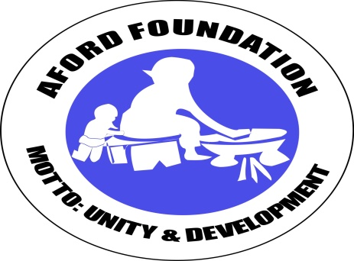AFORD PROPOSAL 2019
TAMALE, GHANA.
SUSTAINABLE WASH 1500 GHANAIANS

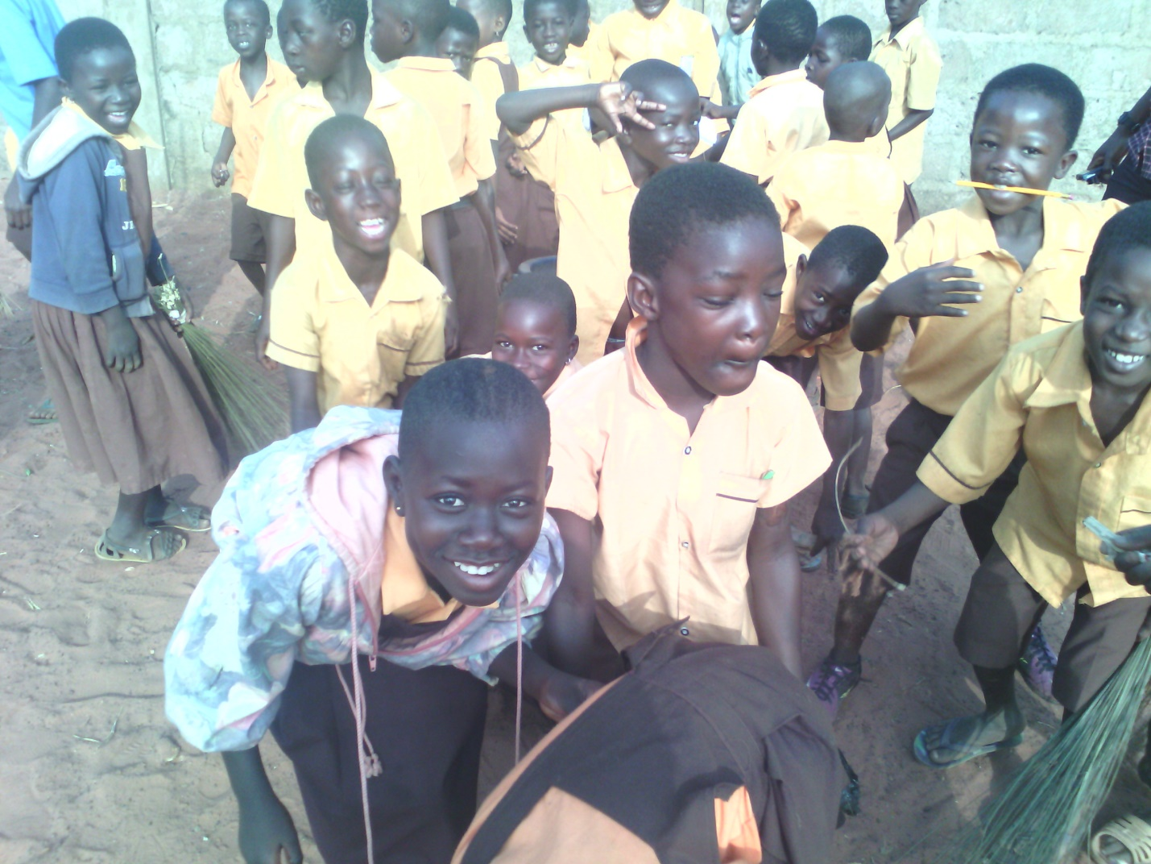

Table of Contents
BACKGROUND 3
CONTEXTUAL ANALYSIS 3
The Project Area – Regional Context 3
Implementing districts context 4
PROBLEM STATEMENT 5
PROJECT GOAL 6
PROJECT OBJECTIVES 6
EXPECTED OUTCOMES 6
EXPECTED OUTPUTS 7
OUTCOMES INDICATORS 8
OUTPUT INDICATORS 8
THEORY OF CHANGE 10
PLANNED ACTIVITIES 11
ACTIVITIES IMPLEMENTATION PROCESS 11
PROJECT STRATEGIES 13
Integration 13
Collaboration 13
Participatory approach 13
Gender mainstreaming 13
Programme Sustainability 14
MONITORING, EVALUATION AND REPORTING 14
Monitoring And Evaluation Framework 15
FINANCIAL CONSIDERATIONS 17
PROJECT MANAGEMENT ARRANGEMENTS Error! Bookmark not defined.

BACKGROUND
AFORD Foundation (Aid for Development) is a local non-governmental organization operating in the northern region of Ghana, with its headquarters in Tamale. AFORD was founded in 1996 and registered in 1997 by a group of development workers desiring to assist victims of the 1994 ethnic conflict in the northern region to rebuild their lives.
The organization has since grown from providing relief to victims of the conflict, to assisting in the general development of communities affected by the conflict.
AFORD is dedicated to assisting poor and deprived communities and vulnerable groups i.e. women and children to improve their standard of living through their own initiatives and efforts. AFORD works with the communities, identifying their needs and initiating and implementing programs to address those needs. We have supported communities in six (6) districts of the Northern Region namely Tamale, Yendi, Savelugu-Nanton, Tolon-Kumbungu, Central and West Gonja, to find innovative, practical and sustainable ways to apply knowledge and improve their health as a catalyst for growth and development of their livelihoods. We have inspired and enabled marginalized and vulnerable people and communities to find their voice, to make it heard, and to take action to improve their own health and wellbeing.
Vision
Peaceful Northern Ghana where meaningful and sustainable livelihood is attainable by all and poverty and disease are a thing of the past.
Mission
Work in partnership, using participatory communication approaches to improve the health and well-being and eventually the livelihoods of disadvantaged and vulnerable people in communities.

CONTEXTUAL ANALYSIS

The Project Area – Regional Context
This project would be implemented in districts of the Northern Region namely; Tamale Metropolis. The information below gives detail contextual information of the region and implementing district.
The Northern region of Ghana (the project location) occupies nearly a third of the land mass of the country (i.e. 70,390km²). It is one of 10 administrative regions in the country and the only region that stretches across from East to West. Tamale is the capital of the region. It has a total population of 2,468,557 (1,210,702 males and 1,257,855 females), PHC (2010). Northern region has guinea savannah vegetation with fairly thick forest from where community member’s farm, harvest firewood, rafters for construction, etc. Common tree species in the region include shea, dawadawa, baobab, neem, etc. Housing characteristics are predominantly mud structures with thatch roof. The region has a predominantly subsistent agricultural labour force constituting about 72% of the total. Poverty in the region can be said to be endemic. Only 4% of the population is in the highest wealth quintile against a national average of 22% (GDHS, 2008).
The Northern region has one of the lowest Water, Sanitation and Hygiene (WASH) coverage in Ghana – 61% for water against a national average of 83% (CWSA, 2010) and <10% for sanitation against a national average of 14%. Open defecation is estimated to be 73% in region (EHSD, 2012). Hygiene standards and behaviour are simply unimpressive.

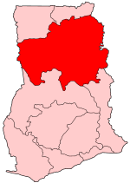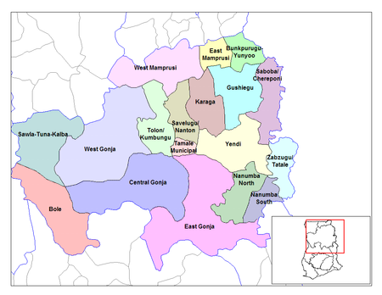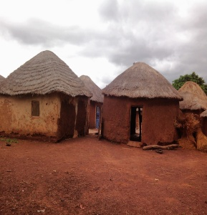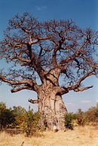
From L-R: Map of Ghana showing NR coloured red; Map of NR showing districts; A typical dwelling place (house); and a Baobab Tree

Implementing district context
Tamale Metro is centrally located in the Northern region and hence serves as a hub for all administrative and commercial activities in the region.

Tamale’s current population is 371,351. The metropolis is a densely populated city compared to regional and national averages. Whereas the Northern region has 35 persons per square kilometre and Ghana as a whole has 102 persons per square kilometre, the Tamale metropolis alone has an estimated population density of over 500 persons per square kilometre. This puts enormous pressure on the already limited WASH facilities and services in the metropolis.
The Tamale water expansion project was completed over half a decade ago, but many communities are still without safe water, particularly Tamale rural. Out of 62 rural communities with a total population of 35,661, only 16,396 (45%) are served (CWSA, 2011). The picture for the current water coverage in the three Sub-Metros are as follows; 58% for Tamale North, 28% for Tamale Central, and 14 % for Tamale South (MWST, 2011). Sanitation coverage is also alarming. It is estimated to be less than 11% (MWST, 2011) for Tamale rural.
The main cause of diseases in the district is related to the poor sanitation throughout the District. In terms of sanitation facilities, 89.5% have no toilet facilities therefore OD is the norm in this district. 10.5% have traditional pit toilets, 5.3% use public KVIP, 2.0% use flushed toilet and 0.9% use bucket or pan latrine. by the baseline survey (1999 Sept.).
According to the Baseline Survey of 1999, only 33% and 40% of the population have access to safe drinking water in the dry and rainy seasons respectively. The main water sources especially in the dry season are pond/dugout/dams. Other sources include streams and rivers, and rain water during the rainy season. About 70.3% and 62.6% (during dry and rainy season respectively) do have access to safe drinking water within a distance of 500 metres. This state of affairs coupled with poor sanitation, have very serious implications for the health of the people in the district.

PROBLEM STATEMENT
The Northern region has one of the lowest Water, Sanitation and Hygiene (WASH) coverage in Ghana – 61% for water against a national average of 83% (CWSA, 2010) and <10% for sanitation against a national average of 14%. Open defecation is estimated to be 73% in region (EHSD, 2012). Hygiene standards and behaviour are simply unimpressive. As a result of the poor WASH situation in Northern region, diarrhoea is among the 10 top most ailments/diseases commonly reported at out-patient departments(OPD) of health facilities in the region, especially among children and women. WASH-related diseases account for majority of hospital attendances and admissions. This exerts a disease burden on the region and cost in terms of money for treatment and lost time to recuperation and care giving.
Even though the Ghanaian building code provides for incorporation of WASH facilities in human dwellings and institutions like schools and clinics, this has not been strictly enforced or adhered to in the past. As a result, old school structures/compounds have no safe water and safe excreta disposal facilities in their design. The same applies to houses in the community.
In recent times, however, the trend is changing as new structures incorporate the construction of WASH facilities. But it is one of one-size-fit-all approach leaving many schools and their surrounding communities underserved. School population is often not factored into the design process. This has caused problems at schools. Most schools don’t have any drinking water supply of their own, and pupils and teachers are force to bring or fetch drinking water from elsewhere. Cleaning the school buildings or the latrines (if existent) becomes very difficult, and hand washing impossible.
Where WASH facilities are constructed, they are not gender sensitive, particularly latrines as there is no separation between boys and girls facilities. This affects the privacy and safety/security of the girl pupil, especially during periods of menstruation.
Another challenge is heavy pressure on the limited facilities. If latrines exist, pupils and teachers are forced to share too few and inadequate latrines facilities that cannot be cleaned and often not emptied easily. This pressure coupled with poor attitudes of users owing to, in some cases, lack of ownership, a weak sense of responsibility, low awareness of the importance of hygienic practices, weak management system and poor maintenance culture are all critical issues that require serious engagement to deal with.
Also, the absence of sufficient and adequate toilet facilities in the surrounding communities compel community members to encroach upon the school facilities without sense of ownership, and without sharing responsibility for the management and cleanliness of the facilities. There is currently limited positive indication of any facility management system in place in our institutions. As a result, over 50% of the existing WASH facilities in schools are broken down due to mismanagement, poor maintenance culture as well as weak financial and institutional structures for O&M.

Evidence abound that hand washing is one most effective way of breaking disease transmission and yet among children and community members, this is not a common practice. Where it is done, it is widely carried out without soap.
In addition to diseases and their debilitating effects, school children in particular are affected by one or all of the following ways:

- Report late for school due to long periods of hunting for water in the mornings
- Low or outright no concentration in class due to the fatigue of walking long distances in search of water or worm infections.
- Unable to satisfactorily carry out school assignments at home due to limited time available as a result of spending a significant part of their time fetching water after school hours
- Low attendance rate (especially for girl children during menstruating periods) due to the inconvenience of having no sanitation facility at school
- De-motivating for teacher posting, attendance and performance
- Poor academic performance

PROJECT GOAL
To improve health and well-being of the beneficiary communities and schools through improving hygiene practices and access to safe water and sanitation

PROJECT OBJECTIVES
To increase access to and use of safe water facilities for 3 schools by the end of 2019
To increase access to and use of improved sanitation facilities for 3 schools and communities by the end of 2019
To improve hygiene practices among pupils and teachers of 3 schools
To enhance the sustainability of water, hygiene and sanitation facilities

EXPECTED OUTCOMES
OBJECTIVE 1: To increase access to and use of safe water facilities for 3 schools by the end of 2019
Outcomes: Increased access to and use of safe water facilities for 3 schools
OBJECTIVE 2: To increase access to and use of improved sanitation facilities for 3 schools by the end of 2019
Outcomes: Increased access to and use of improved sanitation for 3 schools
OBJECTIVE 3: To improve hygiene practices among pupils and teachers of 3 schools
Outcomes: Increased number of pupils and teachers practicing hand washing with soap
Improved management of menstrual cycle by school girls in 3 schools

OBJECTVIE 4: To enhance the sustainability of water, hygiene and sanitation facilities
Outcomes: Improved lifespan and functionality of water, hygiene and sanitation facilities

EXPECTED OUTPUTS
Outcome: Increased access to and use of safe water facilities for 3 schools
Outputs: 3 rain water harvest tanks constructed in 3 schools
18 ceramic filters provided to 3 schools
Situational analysis of school water conducted

Outcome: Increased access to and use of improved sanitation for 3 schools
Outputs: 3no. four-seater latrines constructed in 3 schools
3 latrine cleaning schedules prepared by 3 schools
Situational analysis on school sanitation conducted

Outcome: Increased number of pupils and teachers practicing hand washing with soap
Outputs: 3 sensitization sessions on hygiene conducted
3 School Health Clubs formed and trained
18 hand washing facilities provided to 5 schools

OUTCOMES INDICATORS
Objectives | Outcomes | Indicators
To increase access to and use of safe water facilities for 3 schools by the end of 2019 | Increased access to and use of safe water facilities for 3 schools | - Number of schools accessing and using safe water facilities
 |  | - Incidence of diarrhoea among school pupils
To increase access to and use of improved sanitation facilities for 3 schools and communities by the end of 2019 | Increased access to and use of improved sanitation for 3 schools | - Number of schools accessing and using improved sanitation facilities
To improve hygiene practices among pupils and teachers of 3 schools | Increased number of pupils and teachers practicing hand washing with soap | - Number of teachers practicing hand washing with soap  - Number of pupils practicing hand washing with soap
 | Improved management of menstrual cycle by school girls in 3 schools | - Level of knowledge among school girls on menstrual cycle management
To enhance the sustainably of water, hygiene and sanitation facilities | Improved lifespan and functionality of water, hygiene and sanitation facilities | - Life span of water, sanitation and hygiene facilities  - Functionality of water, sanitation and hygiene facilities

OUTPUT INDICATORS
Outcomes | Outputs | Indicators
Increased access to and use of safe water facilities for 3 schools | Situational analysis conducted | - Number of schools with situational data
 | 3 rain water harvesting tanks constructed and | - Number of schools accessing and using safe water facilities  - Incidence of diarrhoea among school pupils  - Number of rain water harvesting tanks constructed  - Number of pipe extensions
 | 18 ceramic filters provided to 3 schools | - Number of ceramic filters  - Number of schools benefiting
Increased access to and use of improved sanitation for 3 schools | 3no. 4-seater latrines constructed | - Number of schools accessing and using improved sanitation facilities  - Number of latrines constructed
 | 5 latrine cleaning schedules prepared by 3 schools | - Number of schools with latrine cleaning schedules
Increased number of pupils and teachers practicing hand washing with soap | 3 sensitization sessions on hygiene conducted | - Number of teachers practicing hand washing with soap  - Number of pupils practicing hand washing with soap
 | 3 School Health Clubs formed and trained | - Number of school health clubs formed  - Number of school health clubs trained
 | 18 hand washing facilities provided to 3 schools | - Number of handwashing facilities  - Number of schools benefitting
Improved management of menstrual cycle by school girls in 20 schools | Girls in 3 schools sensitized on menstrual cycle management | - Number of sensitization sessions  - Number of girls reached
 | 3 toilet facilities having pad-changing rooms for girls | - Number of girls changing rooms
Improved lifespan and functionality of water, hygiene and sanitation facilities | 3 school management committees trained in facility management | - Number of school management committees trained in facility management
 | 3 facility management plans developed | - Number of facility management plans developed
 | 5 school management committees trained in business development model | - Number of school management committee members trained in business development model

Increased access to and use of safe water facilities for 20 schools
Water facilities are used
Safe water facilities are in existence
Information on appropriate technology is available
Information on school water situation is available
To improve health and well-being of the beneficiary communities and schools through improving hygiene practices and access to safe water and sanitation

Increased access to and use of improved sanitation for 20 schools
Improved hand washing with soap

Improved menstrual cycle management by girls
Improved lifespan and functionality of water, hygiene and sanitation facilities
Pupils and teachers use HWF
HWF are available in schools
Teachers and pupil have adequate knowledge on the steps in proper hand washing with soap
Separate facilities in School menstrual cycles Girls have
Adequate knowledge in effective menstrual cycle’s management
Schools develop and implement the plans
Schools generate revenue for O&M of facilities
School management appreciate the concept of sustainability

THEORY OF CHANGE
Institutional latrines are available
Latrines are used
Information on appropriate use of facilities available

PLANNED ACTIVITIES
- Animation and sensitization
- Construct rain water harvesting tanks and pipe extensions in 20 schools
- Provision of ceramic filters to 3 schools
- Construct 3no. -4seater latrines in 3 schools
- Facilitate the preparation of latrine cleaning schedules in schools
- Conduct sensitization sessions on hygiene in schools
- Formation and training of School Health clubs
- Organize quiz competitions on hygiene and the environment among SHEP clubs
- Provision of hand washing facilities to schools
- Sensitize school girls on menstrual cycle management

ACTIVITIES IMPLEMENTATION PROCESS
Animate and sensitize schools
In each of the schools, we would carry out animation and sensitisation. This would focus on information sharing about the project – objectives, scope of activities, partners, coverage area, etc. We would also discuss roles and responsibilities of the various partners/stakeholders, especially those that relate to participating schools. Participants of the animation and sensitization sessions would include staff and pupils of the school, school management committee (SMC), parent-teacher association (PTA), GES Circuit Supervisors, the District SHEP Co-ordinator, community chief or representative(s), youth groups in the community, soccer club(s) in the community (if any), WASH Committee(s), unit committee and the assembly person for the area. A total of 5 schools will be sensitized and animated.

Conduct situational analysis
This would involve a baseline survey to identify and prioritize the specific WASH needs of the schools. This is to ensure that we avoid a one-size-fit-all situation. The potential hardware needs of the school and their management arrangements would be mapped out to guide decision-making and implementation. This will be collected in all 5 schools.
Facilitate Participatory Action Planning (PAP)
Together with the participating school and other community-level stakeholders, we would undertake a planning exercise leading to an Action Plan for each school. Questions such as what has to be done, how much would what cost, who will pay for what, when will what be done and who will do what would be addressed through this exercise. This will be done in all 3 schools and communities.
Prepare FMP
As a sustainability measure and in line with the concept of Community Ownership and Management (COM), AFORD FOUNDATION would facilitate the participating schools to prepare Facility Management Plan (FMP) for the WASH and football infrastructure in their respective schools. A total of 3 facility management plans are expected to be prepared
Form and train School Health Education programme (SHEP) Clubs
School pupils would be encouraged and assisted to form SHCs. These SHCs would be trained in topical health issues and promotion skills. They would engage in peer and community hygiene promotion. There would be soccer, debates and/or quiz competitions among Clubs as part of the process. This project will form and train 3 SHEP Clubs. To make hygiene facilities accessible to pupils and teachers, the beneficiary schools will be given hand washing with soap facilities. A total of 18 hand washing facilities will be provided.
Provision of Water Facilities for Institutions (Schools)
Within the context of the project, suitable water facilities will be provided to some designated institutions (basic schools) to ensure access to safe drinking water. An assessment will be conducted to determine the type of technology option that will be suitable for a particular location. This may include, but not limited to rainwater harvesting systems, Pipe Extensions, etc. 3 water facilities will be provided (pipe extension and RWHT).

Provision of Institutional Sanitation facilities

Within the context of the project, suitable sanitation facilities will be provided to some designated institutions (basic schools) to ensure access to safe and sustainable sanitation. An assessment will be conducted to determine the type of technology option that will be suitable for a particular location. This may include latrines, etc. A total of 3 sanitation facilities are expected to be provided.

PROJECT STRATEGIES

Integration
As identified above, the WASH challenges in the schools are multi-dimensional. In summary, they include limited access, weak institutional structures, and bad attitudes. We would adopt a comprehensive approach that combines provision of hardware and software WASH interventions. The hardware would cover facilities such as pipe extension, rainwater harvesting tanks, hand washing facilities and institutional latrines, while the software issues include animation, training, hygiene promotion and community-led total sanitation (CLTS). We would strive to design our interventions in a manner that the facilities are self-financing and/or generate income for other basic needs of the target schools.

Collaboration
Currently AFORD FOUNDATION is part of WASH Alliance Ghana (WAG) programme. We are active members of the Ghana Coalition of NGOs in Water and Sanitation (CONIWAS), which has a strong sector presence and space. In our on-going work we work closely with sectors agencies such as Community Water and Sanitation Agency (CWSA) and Environmental Health and Sanitation Department (EHSU). At the local government level, we collaborate with District Assemblies (DAs) who are the planning authorities of their jurisdictions according to Act 462. We would explore our ever growing relationship with all these actors to ensure effective and efficient project delivery.

Participatory approach
Participation enhances ownership. In this regard, we would facilitate participatory analysis of the WASH situation in the various schools to identify and prioritise their specific WASH needs. This is to ensure that we avoid a one-size-fit-all approach but rather design of tailor-made solution(s) for every school. Schools would participate by way of constituting management committees for the interventions so that they are directly in charge of how those interventions run. Ours would be to facilitate the process and build their capacity.

Gender mainstreaming
Gender mainstreaming will form an integral part of these projects. Most often girls are left out in the design and implementation of WASH interventions hence their pressing needs will not be met. The projects would encourage girls’ participation by supporting them to hold executive position in especially the SHEP clubs.
Deliberate measures would be put in place to address gender related issues. For instance, special attention would be given to education on menstrual hygiene in schools with provision for girls changing rooms in every toilet facility. Likewise, women would be empowered to take up leadership positions and participate actively in decision making structures such as SMCs/PTAs, among others. As has being the norm, toilet facilities would be demarcated into girls section separate from that of boys by a wall to ensure privacy.
For the purpose of all-inclusiveness, features of School WASH facilities such as entrances and squat holes, among others shall be made disabled friendly.

Programme Sustainability

In order to ensure effective management of institutional facilities and longer term benefits to beneficiaries, a number of sustainable measures are being envisaged. Foremost is that the existing structures such as PTA, SMC and SHEP clubs would be revived and strengthened to champion O&M issues. Additionally, in line with the concept of Community Ownership and Management (COM), beneficiary schools would be supported to prepare Facility Management Plans (FMP) for the WASH infrastructure in their respective schools. As a result, a standard preventive maintenance schedule would be prepared and shared with the schools and a system put in place to respond to curative maintenance issues.

Similarly, as a measure to establish strong financial sustainability of WASH facilities in beneficiary schools, business models would be introduced depending on business ideas that would be effective in the respective schools/communities. This is to complement the limited funding sources that are already operational in the institutions for O&M.

MONITORING, EVALUATION AND REPORTING
A baseline data and situational analysis will be conducted at the start of the project to assess the necessary indicators.
Monitoring will be conducted on all levels in the organisation. Field staff will continuously monitor on the implemented components in order to optimise the effect and usefulness of these. The Management of the partners will monitor on the overall progression of the programme; the work of the field staff as well as on administrative practices.
To support and add to the quality of the monitoring and evaluation process, AFORD will adopt and integrate personal stories and experiences from beneficiaries. To capture the effect of empowerment, advocacy skills, social status etc. personal stories will be essential. These stories will be collected by field staff of partner organisations and reported to the management, who will integrate them in their reports. This process will also include feedback through the organisation, to constantly improve on implementation and monitoring.
Field staffs would compile monthly reports on progress of the programme at the partners’ level, while quarterly report will be compiled by partners showing the progress of the programme implementation. These reports will highlight the outcomes and activities carried out to ensure that the expected outcomes as stated in the work plan are reached. The Implementer AFORD and BOARD will review the reports.
Below is the M&E framework of the project

Monitoring And Evaluation Framework
OUTCOMES/OUTPUTS | INDICATORS | MEANS OF VERIFICATION | FREQUENCY OF DATA COLLECTION | RESPONSIBILITY
OUTCOMES
Increased access to and use of safe water facilities for 3 schools | Number of schools accessing and using safe water facilities | Discussion with teachers and pupils | Monthly | Monitoring and evaluation officer
 | Incidence of diarrhoea among school pupils | Review of school health records | Quarterly | Monitoring and evaluation officer
Increased access to and use of improved sanitation for 3 schools | Number of schools accessing and using improved sanitation facilities | Inspection of sanitation facilities | Monthly | Monitoring and evaluation officer
 |  | Discussion with teachers and pupils | Quarterly | Monitoring and evaluation officer
Increased access to and use of improved sanitation for 3 communities | Number of ODF communities | Observation | Monthly | Monitoring and evaluation officer and natural leaders
Increased number of pupils and teachers practicing hand washing with soap | Number of teachers practicing hand washing with soap | Observation | Daily | SHEP club
 | Number of pupils practicing hand washing with soap | Observation | Daily | SHEP club
Improved management of menstrual cycle by school girls in 3 schools | Level of knowledge among school girls on menstrual cycle management | Discussion with school girls | Quarterly | Monitoring and evaluation officers and school health teachers
Improved lifespan and functionality of water, hygiene and sanitation facilities | Life span of water, sanitation and hygiene facilities | Inspection of facilities | Quarterly | Monitoring and evaluation officers
 | Functionality of water, sanitation and hygiene facilities | Survey of facilities | bi-quarterly | Monitoring and evaluation officers
OUTPUTS
Situational analysis conducted | Number of schools with situational data | Reports | Quarterly | Monitoring and evaluation officers
18 ceramic filters provided to 3schools | Number of ceramic filters | Inspection of facilities | Quarterly | Monitoring and evaluation officers and school health teachers
18 ceramic filters provided to 3schools | Number of schools benefiting | Reports | Quarterly | Monitoring and evaluation officers
3 water systems provided in 3 schools | Number of rain water harvesting tanks constructed | Inspection of facilities | Quarterly | Monitoring and evaluation officers
3 water systems provided in 3 schools | Number of pipes extensions | Inspection of facilities | Quarterly | Monitoring and evaluation officers
3no. 4-seater latrines constructed in 3 schools | Number of six-seater latrines constructed | Inspection of facilities | Quarterly | Monitoring and evaluation officers
3no. 4-seater latrines constructed in 3 schools | Number of schools benefiting | Reports | Quarterly | Monitoring and evaluation officers
3 latrine cleaning schedules prepared by 3 schools | Number of schools with latrine cleaning schedules | Inspection of copies of schedules | Monthly | Monitoring and evaluation officers and SHEP clubs
10 sensitization sessions on hygiene conducted | Number of hygiene sensitization sessions conducted | Review of sensitization reports | Monthly | Monitoring and evaluation officers
3 School Health Clubs formed and trained | Number of school health clubs formed | Review of reports | Monthly | Monitoring and evaluation officers
3 School Health Clubs formed and trained | Number of school health clubs trained | Review of training reports | Monthly | Monitoring and evaluation officers
quiz competitions on hygiene among SHEP clubs organized | Number of quiz competitions organized | Review of reports | Monthly | Monitoring and evaluation officers
18 hand washing facilities provided to 3 schools | Number of hand washing facilities | Inspection of facilities | Weekly | Monitoring and evaluation officers
18 hand washing facilities provided to 3 schools | Number of schools benefitting | Review of reports | Monthly | Monitoring and evaluation officers
Girls in 3 schools sensitized on menstrual cycle management | Number of sensitization sessions | Review of reports | Quarterly | Monitoring and evaluation officers
Girls in 3 schools sensitized on menstrual cycle management | Number of girls reached | Review of reports | Quarterly | Monitoring and evaluation officers

 |  | AFORD BUDGET 2019
No. |  |  |  |  | AFORD
No. | Item | Unit2 |  | Qty2 | Rate2 |  | Amt2 (GH₵) | Amt2 ($)
a) | Activities:
1 | Animation and sensitisation | schools
2 | Situational analysis (baseline) | schools
4 | SHEP | schools |  | 3 | 2,500.00 |  | 7,500.00 | 1,428.57
5 | Provision of hand washing facilities | schools |  | 18 | 360 |  | 6,480.00 | 1,234.29
6 | Provision of drinking water vessels (ceramic filters) | schools |  | 18 | 300 |  | 5,400.00 | 1,028.57
11 | Post -implementation follow-ups | visits
 | Sub-total (Software) |  |  |  |  |  | 19,380.00 | 3,691.43
15 | Construction of water facilities | schools |  | 3 | 17,133.00 |  | 51,399.00 | 9,790.29
16 | Construction of latrines | schools |  | 3 | 43,293.00 |  | 129,879.00 | 24,738.86
 | Sub-total (Hardware) |  |  |  |  |  | 181,278.00 | 34,529.14
 | Grand Total |  |  |  |  |  | 200,658.00 | 38,220.57

