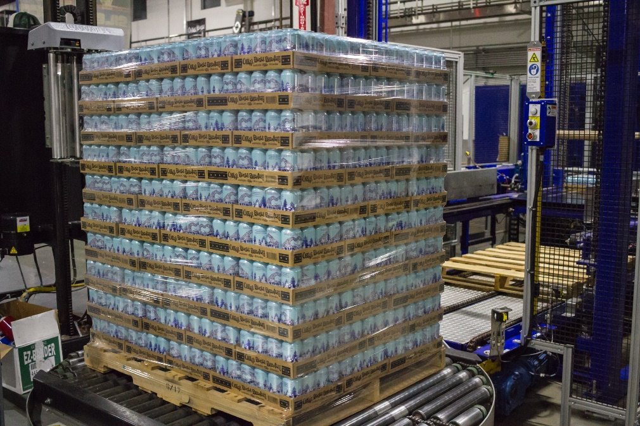

Your support is a critical factor in allowing us to distribute clean drinking water to communities in need, immediately and where needed most. Please see descriptions of current water efforts.
2019 Water Projects to date:
March 15, 2019 – 52,800 cans of clean drinking water delivered to Omaha, Nebraska. Historic “Bomb Cyclone Flooding” left people stranded and in need of vital necessities including clean drinkable water. Can’d Aid partnered with the Foodbank for the Heartland to distribute water to this community in need.
April 2, 2019 – 50,400 cans of clean drinking water delivered to Pine Ridge, South Dakota. Again, in reaction to the “Bomb Cyclone Flooding” Can’d Aid answers the call for help. The Flooding created a life-threatening situation on an already impoverished community. Can’d Aid partnered with the Oglala Sioux Tribe Office of Emergency Management to supply drinking water to residents of the Pine Ridge Indian Reservation, located in one of the country’s poorest counties.
May 22, 2019 – 50,000 cans of drinking water trucked to Phoenix, AZ. Due to unprecedented and early arrival of triple digit temperatures, Can’d Aid is working with the Salvation Army to distribute water to this struggling community in need.
June, 2019 – A shipment of another 50,000+ cans of water is scheduled to be trucked to Phoenix, AZ in early June. Again, Can’d Aid will work with the Salvation Army of Phoenix to distribute to those most vulnerable to life threatening heat related complications.
Thank you for your steadfast commitment to providing clean drinking water to communities in need through your impressive Water for All program. We are humbled by your generosity and proud to partner again with Atlas Copco this year. Please reach out should you have questions or want to discuss our request.
About Can’d Aid
Can'd Aid spreads people powered do-goodery through Towns, Tunes, Treads + Trails and Love Yur Mama efforts nationwide. Since its inception, Can'd Aid supplied 1.6 million cans of clean drinking water to communities in need post disaster.

