SUPPORTING RAINWATER TANKS FOR 10 VULNERABLE FAMILIES FROM KAMONYI
The water scarcity in Rwanda is still challenge for well being of the population, Kamonyi is one of 8 Districts of South province, in this District only 62% has access to improved water, and the remaining population suffers from water; Hygiene and sanitation is high level problem that the District is dealing with, the population travel long distance to fetch clean water and this has affected education of children, economic activities (Restaurant, Hotel, constructions)and the District economy in general.
On other hand, the problem become something else for widows , orphans and poor families who do not have someone aside to bring them water, however, the project on rainwater harvesting is designed to serve as one vital solution, it will serve as alternative water source for Domestic, livestock, small irrigation and for improvement of economic activities, the project intends to support 10 poor families from Kamonyi District, A tank ranging from 10 to 30m3 will be built on each household according to the roof size and this will help as contribution to access on clean water.

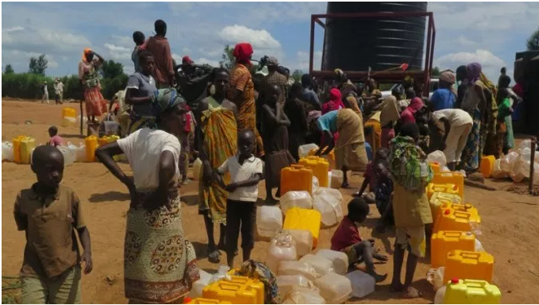

In collaboration with the District, vulnerable families will be selected according to their living condition; the beneficiaries will be widows and orphans of categories one and two (poor and poorest) according to their income.
PROJECT BUDGET
The project is expected to cost: 49,871 USD
DONATION OPTION:
- $ 130 buys 16 gutters to make a complete rainwater system for one poor widow family
- $ 25 will buy a full kit of accessories for one tank installation( tap, pipes and connectors)
- $ 50 will provide a standard home based water filter for one family
- $ 500 will contribute to the construction of one masonry/ Ferrocement tank for one family.

ISSUE, CHALLENGE AND PROBLEM
In 1994, in Rwanda( a Land rocked country in East Africa), it occurred a Genocide( civil war ) which devastated the country, this genocide left serious economic problems, in most case Families were disturbed so that husbands left families(dead or jailed), other exiled abroad, this left unlimited number of widows and orphans in the country; These families become poor as years come, however issue of water is stressing for them, the old widows are not able to make a long travel to fetch water( it takes 20km to get clean water), their children are not able to attend regularly schools and some drop out, the liing conditions of these families are conditioned by water. Kamonyi district present women at 52.4% of while 47.8% are men (Census 2012) according to this census countrywide, there are more widows than widowers (11% compared to 1%) of the total population, the water access is 62% for improved water, one jerrycan costs a 100Frw when transported it cost 200 Frw so these families are not able to afford prices, they keep re-using the same water used to clean meals and clothes and this is a source of water related diseases like cholera. The proposed project will serve as a vital solution to this calamity problem, Widow poor families will be selected in collaboration with local Government (District or Sector), each family will be supported with a complete rainwater system according to the roof size, 10, 20 and 30m3 tanks made in masonry/ Ferrocement, where it seems that the family is small, a tank will be shared by two families, Tanks will be constructed in grouped settlement to be able to collect much water and serve more population.
SPECIFIC CHANGE THE PROJECT INTENDED TO ACHIEVE AND RESULTS
Kamonyi District was selected for this project since it presents high water demand compared to its neighboring Districts, The proposed project has overall Outcome of : Improving livelihood living condition through multiple use of Rainwater( water for domestic, livestock and for small irrigation); to be able to achieve this outcome(Objective), Two outputs (Main activities) are proposed:
- Output 1: promoting rainwater harvesting by supporting poor rural widows’ families with Rainwater harvesting systems
- Output 2: water quality insurance
Each output listed will be achieved based on different project activities as follows:
Output 1: promoting rainwater harvesting by supporting poor rural widows’ families with Rainwater harvesting systems: This output will cover activities not limited to (i)Conducting workshop for raising awareness of project activities and explanation on selection of potential beneficiaries, this activity will bring together District representative and sector officers along with the organization to discuss about project and selection of beneficiaries,(ii) conducting detailed evaluation of selected beneficiaries house, his will be to assess the reliability of the systems( Roofs, soil conditions, and elaboration of bill of quantity), (iii) construction of rainwater harvesting systems for selected beneficiaries.
Output 2: water quality insurance
This output is very important to educate and train the beneficiaries about water quality insurance, most people hastate to use rainwater saying that it is polluted; it will cover activities like (i) organizing on field training and demonstration on water quality treatment and maintenance of the filters, this is because each tank will have associated Biosand filter. (ii) Workshop on home based water treatment technique; here beneficiaries will be trained on water treatment methods to ensure that the y use treated water.

Potential Long-Term Impact

The project will support 10 poor rural widows families from Kamonyi District with a Rainwater harvesting tank each family, collected water will be used for Domestic, Livestock and small scale irrigation; water quality training will be conducted to raise their attitude on water treatment; this support will enable these families to have access o water, it will help beneficiaries to improve their hygiene which leads to improved health and well being of widows.
From the general point view of the project, the project will make population shift from excessive poverty and poor living conditions, this result that a constructed tank will last at least 30 years, during this period children will go easily to school, irrigated chicken garden will provide legumes and vegetable which has double role likely improving their nutrition but also making money when sold,
On other hand, the project will serve as modal project as it will demonstrate that rainwater water can serve as other alternative source of water for productive purpose. Surrounding households will need to come fetch water to the beneficiaries and this will increase social cohesion and solidarity.
In addition to direct changes mentioned here above, the project is expected to contribute to the poverty eradication and water problem solving. In fact, the exposure and experience created by the project to a large number of people and at different levels, will contribute to positive behavior change toward rainwater management and climate change.

