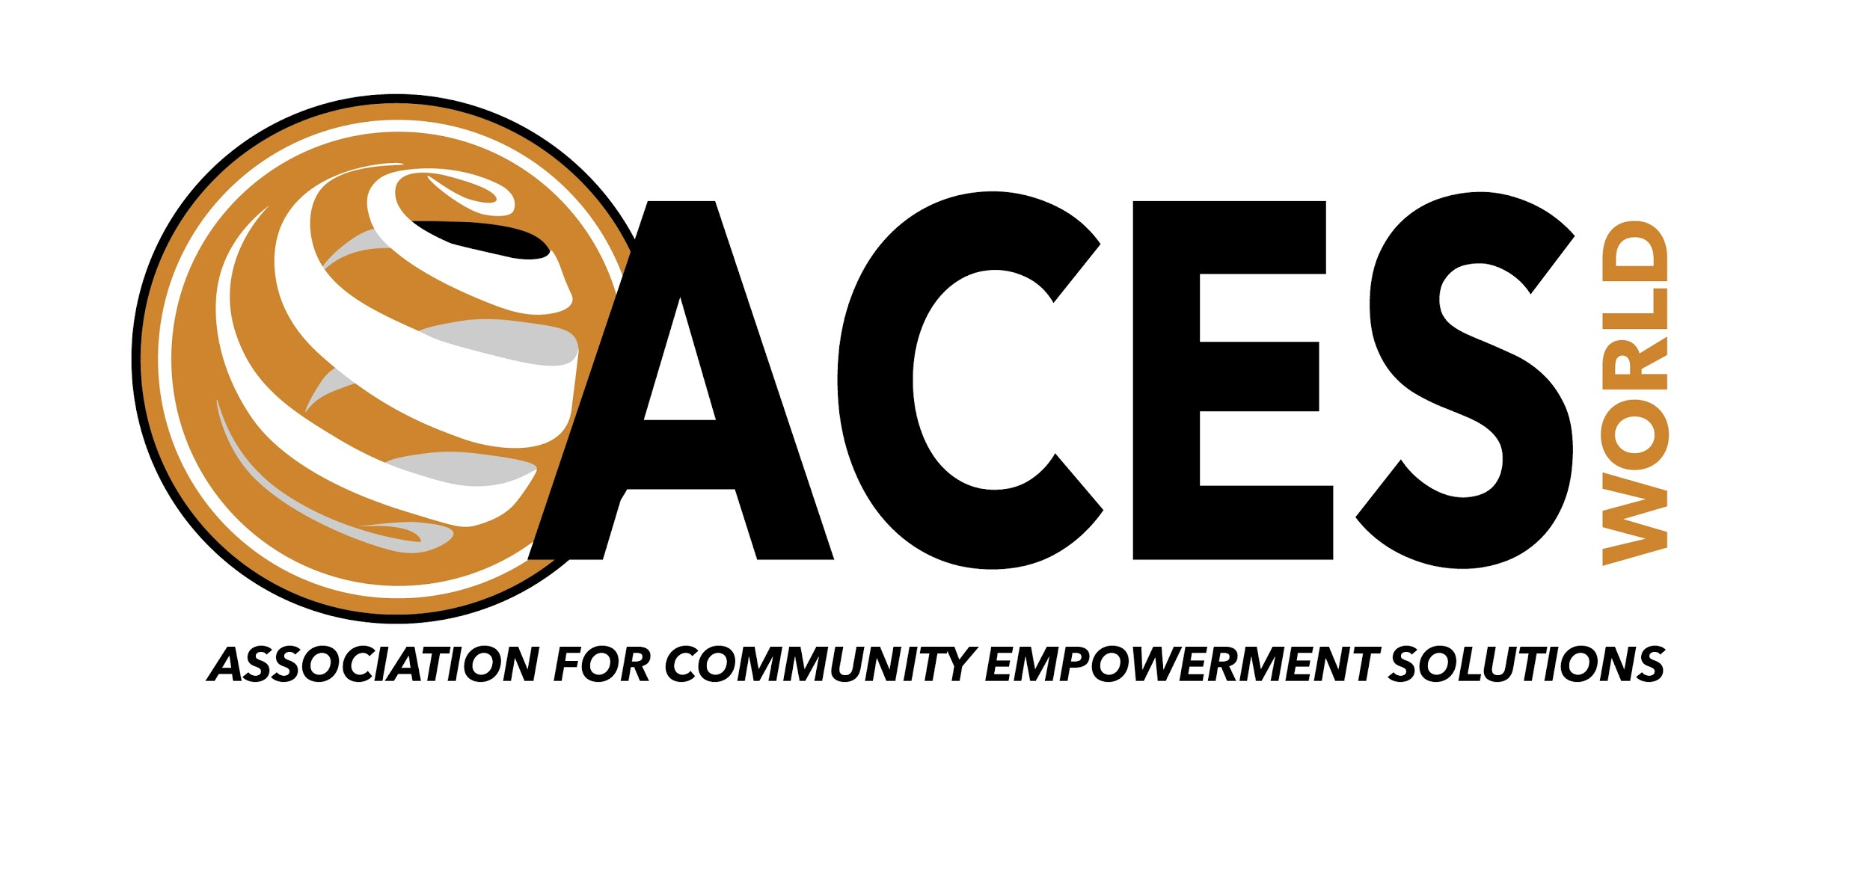
Executive Summary
Multidimensional Poverty Assessment
Nkoko and Kasindikwa Villages, Uganda
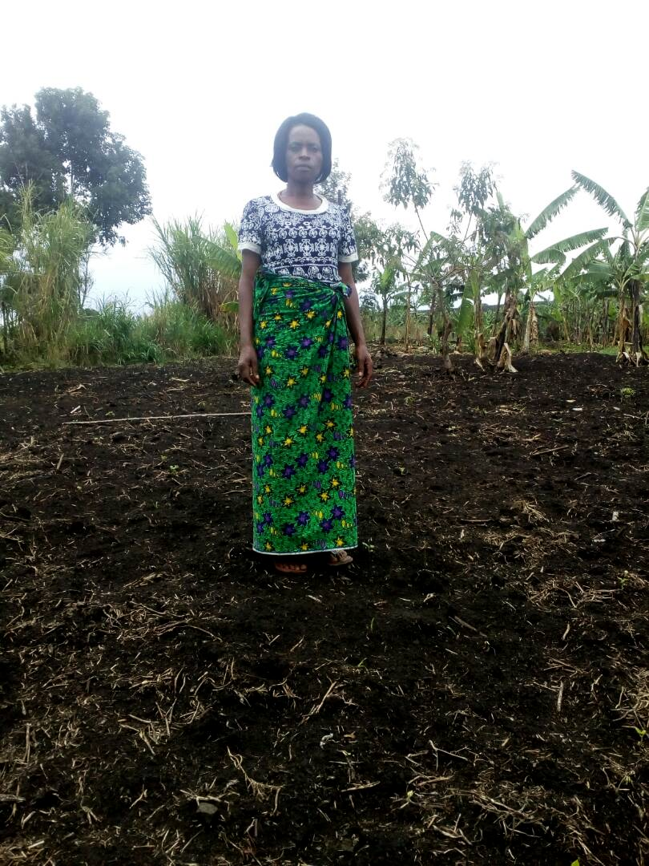
Seeds 4 Seeds farmer in Kasindikwa, Uganda
in her recently planted maize field

Contact Details
For more information, please contact:
Linda Jackson, President, CEO
Linda.Jackson@ACESWorld.org
www.ACESWorld.org
Follow us on social media @ACESWorld4All

- Introduction of Association for Community Empowerment Solutions (ACESWorld)
  - ACESWorld is a 501(c)(3) nonprofit whose mission is to accelerate an end to global poverty by removing the impediments to quality education through partnering and knowledge exchange to create a world of shared prosperity.
  - ACESWorld is headquartered in Washington, D.C., with projects in Haiti, Uganda and Ghana.
  - ACESWorld is a member of the Obama Foundation Global Girls Alliance selected to participate in the Global Girls Alliance Take Action campaign.
- Multidimensional Poverty Assessment Tool (MPAT) - International Fund for Agricultural Development (IFAD)
  - ACESWorld used MPAT to better assess rural asset, exposure and equality as well as fundamental needs to strengthen planning, design and monitoring and evaluation to contribute to rural poverty alleviation by reducing food insecurity to increasing access to education in Nkoko and Kasindikwa Villages in rural western Uganda.
  - ACESWorld provided funding and project management of the Multidimensional Poverty Assessment and selected The Rwenzori Center for Research and Advocacy as our implementing partner.
  - ACESWorld approaches every problem by first listening, searching for understanding, and developing a feeling for what it’s like to walk in a person’s shoes. We believe that understanding is required to design and implement relevant, beneficial interventions that enable people to pursue meaningful and rewarding lives and reduce poverty. What we do ..
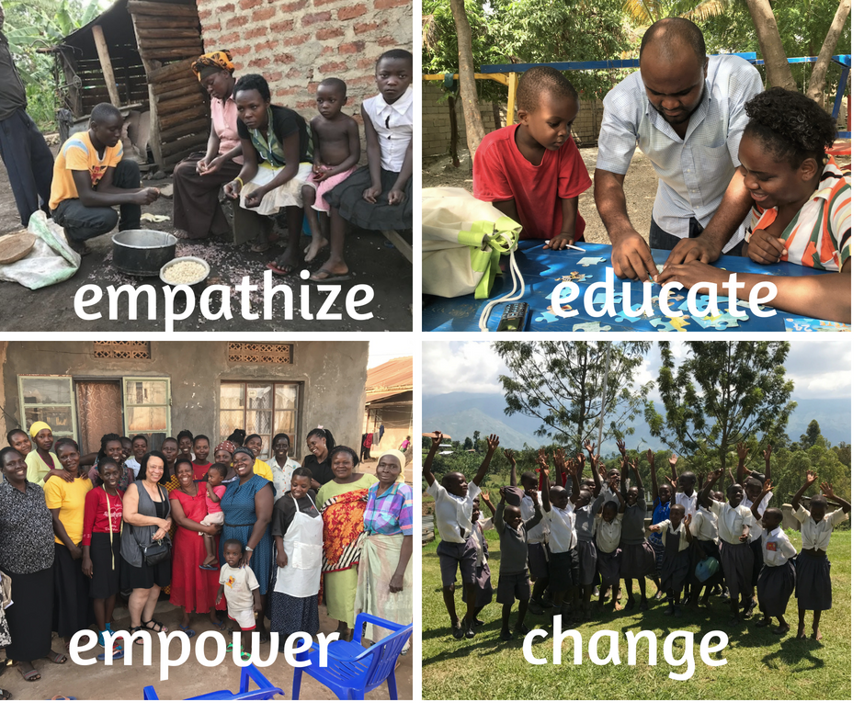
- Implementing MPAT in Nkoko and Kasindikwa
  - Stakeholder Engagement - The Rwenzori Center for Research and Advocacy (RCRA) conducted stakeholder meetings with village leaders and community members to determine where poverty was most pervasive and the village where the MPAT should be conducted in the Kasese area. The village of Nkoko was identified. The second MPAT was conducted in the Fort Portal area in the village of Kasindikwa. Stakeholder engagement in Kasindiwa was less formal. This village is the residence of the ACESWorld program associate in Uganda.
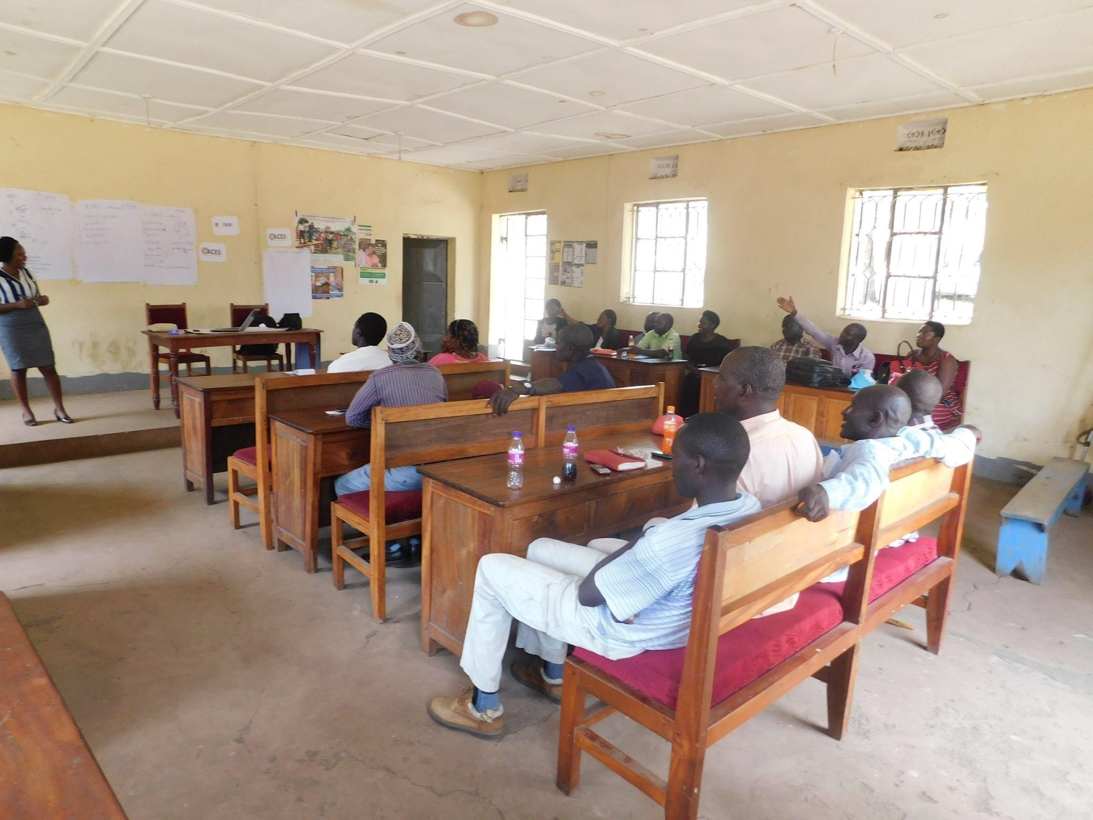
  - Enumerator Training - Training was conducted at the RCRA headquarters in Kasese, Uganda. Four enumerators were trained in MPAT methodologies and data collection. The ACESWorld Uganda program associated serves as the enumerator Supervisor. See the summary of MPAT enumerator training below. After the enumerators and enumerator supervisors were trained and the documents were thoroughly reviewed by project and MPAT implementation staff, a one day field practice/pilot with all enumerators and supervisors was conducted to provide a realistic experience in MPAT implementation in a ‘low-stakes’ setting.
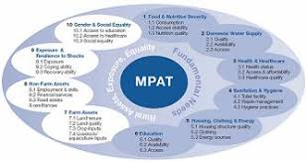
  - Data Collection - The MPAT assessment was conducted in January of 2018. The sample size was 60 households in two of the villages. The Nkoko Village is extremely isolated and can generally only be accessed by motorcycle and on foot, depending on weather and road conditions. The enumerators were bilingual and conducted interviews in the native language. Answer to the survey questions were entered onto a paper survey form. Surveys were conducted in Kasindikwa by the ACESWorld program associate. Data was collected over multiple consecutive days. Each Household Survey requires from 60-90 minutes.
  - Quality Control - The quality-control process for MPAT survey data is a simple, multistage process involving: (i) Checking (ii) Scoring (iii) Coding. This system, named the check-score-code (CSC) method, ensures that data are accurately, reliably and responsibly transferred from surveys to spreadsheets.
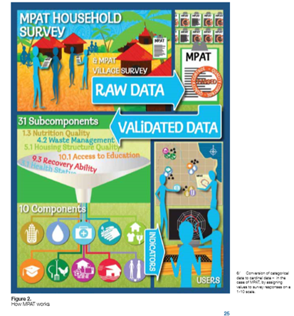
3.2 A poverty assessment using the MPAT was carried out in the Nkoko Village in Kasese district and Kasindikwa village in Kabarole, Uganda in January 2018. Below, you can see a map of Uganda with where the MPAT was conducted, as well as a few pictures from the process.
Map of Uganda and MPAT Villages
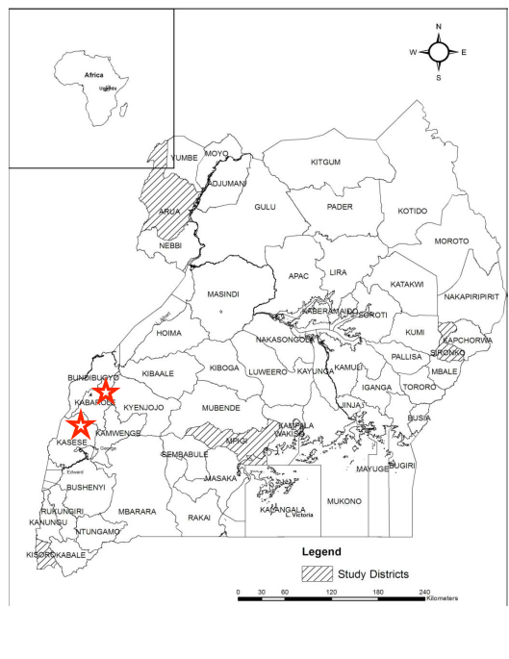
4. Results and Analysis of Multidimensional Poverty Assessment
Sample Results Nkoko Village MPA (January 2018) ©
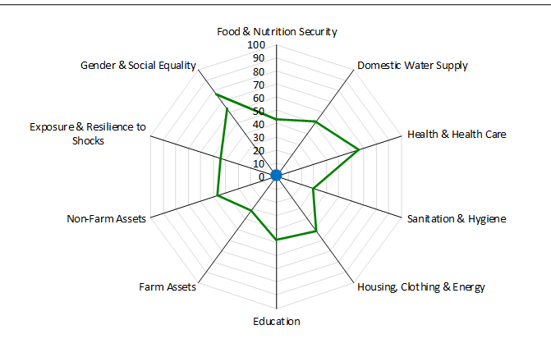
4.1 In January 2018 the Association for Community Empowerment Solutions, ACES World, funded and conducted a multidimensional poverty assessment in Nkoko and Kasindikwa Villages in rural western Uganda. The situation in these villages is dire for many households and ACESWorld developed a program to help families improve food security. The pilot project provides seeds and sustainable agriculture workshops for households best positioned to use this support to produce crops to feed their households and send their children to school. The goals of the pilot are to provide food for households, to encourage households to save seeds and to compost to enrich the soils to improve food security. These families did not have the resources to purchase seeds and rent land, but with the assistance of ACESWorld’s Seeds 4 Seeds program are now able to envision a future without food insecurity.
Seeds 4 Seeds Maize Farming Results - Cohort I
*Kato has his maize in storage waiting for maize prices to rise
Farmer | Harvest | Sold | Retained for Planting | Milled for Food | Children in School
Kule | 900 kg | 700 kg | 40 kg | 160 kg | 2/4
Furuma | 1200 kg | 950 kg | 50 kg | 200 kg | 2/3
Mahunge | 800 kg | 600 kg | 50 kg | 150 kg | 4/6
Kato | 1000 kg | 800 kg | 50 kg | 100 kg | 5/6

4.2 Currently ACESWorld is conducting a village wide training for farmers in Nkoko. Upon completion of the sustainable agriculture training Seeds 4 Seeds Cohort II will receive rice seeds. During the past growing season maize prices were depressed, but rebounded. Rice prices tend to be more stable. In addition, we would like to encourage cultivation of a variety of crops in the village.
5. MPAT Lessons Learned - ACESWorld successfully used data collected using MPAT to develop and implement a successful program to reduce food security and increase school attendance.
5.1 The MPAT has not only allowed the assessment and alleviation of poverty, but it developed a baseline from which future interventions can be evaluated. The data collected on rural poverty will inform project development because it defined rural poverty at both the household and village level. Although ACESWorld has been able to use this data to design successful interventions, we have not been able to complete the full analysis and therefore gain the full insight from the MPA. During the implementation phase of the project we made minor changes to the MPAT without fully understanding their impact on the data analysis application of the tool.
6. Future directions
6.1 60 farm families in Nkoko have received agriculture training for growing maize, bean and rice. Seeds4Seeds Cohort II consist of 26 farmers, principally female heads of households and widows. These 26 farmers will receive a total of 860 kg of rice and beans and planted a total of 14.5 acres of rice to reduce food insecurity and to pay school fees.
6.2 Farmers in Nkoko have formed a council to oversee the farms in the program and to ensure that best practices are used. Cohort II and subsequent cohorts will donate part of their seeds so that other farmers who have had the training can participate.
6.3 With additional funding, ACESWorld will extend the program to neighboring villages.

Stakeholder Meeting Kasindikwa
MPAT User’s Guide
MPAT User’s Guide
MPat User’s Guide
Map of Uganda and MPA sites, Population and Housing Census Map 2002
Sample analysis Nkoko VIllage

