ASOCIATIA NO EGO - Charity ID: 40335102,

is a non-profit organization that creates a better world for all the people in need. One-hundred percent of donations collected go entirely to our projects listed.

Phone : +40765904252
Email : contact@one.ngo
Email : info@one.ngo
105600 Campina, Str. Schelelor 2, Prahova, Romania.

The 2010 version of the study by the Save the Children Organization showed, for the first time, that education in Romania is only free in theory. In practice, parents were forced to pay for things that were not listed in any Education Law, and they did not receive any receipts for the majority of those payments. On average, the amount the students’ families had to pay as part of the educational experience back in 2010 was RON 1,490. After eight years, one week before the start of a new school year, Save the Children revealed that the average amount parents have to pay yearly for their children’s education has doubled to RON 3,093 – and costs ​​are higher in the urban environment than in rural areas (RON 3,351 versus RON 2,757).
We all dream to see our kids as great leaders in the future. But this ambition can only happen if we help those who are deserving to receive accessible education. Many underprivileged communities had been aiming for it, but poverty and lack of sustainable income hinder them to prioritize it. Parents are more focused on earning for a living to feed their family. Because of this fact, the rights of their children to study are violated without their awareness.
Aside from giving free education, let us also make sure that the literacy programs are accessible for them. It should be an offer that won’t require them to travel or spend extra for them to avail this chance. We should be aware that most of these children live in areas where there is limited transportation, scarce foods, and lack of schools. We need to fill the gap of quality education between these underprivileged people by mentoring, tutoring, giving them free snacks, and many heroic deeds to lift them and help them survive.
If we show how passionate we are with our mission, it will encourage the parents to let these children avail the gift of education. We can teach them that it is their weapon to succeed in the future so they can contribute to their communities as well.

NO EGO Organization encourages parents to enroll their children to school. Will also help them by providing everything the child need to go to school. Backpacks, books, paper, pens, pencils and even food. These underprivileged children need support that will enable them to access education despite their status in life.

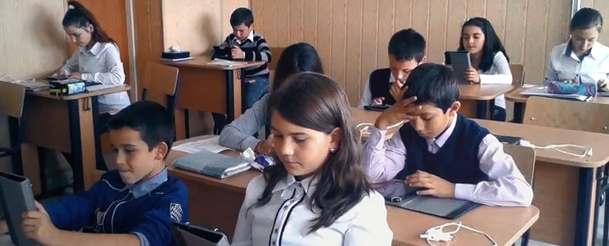

ASOCIATIA NO EGO - Charity ID: 40335102
Phone : +40765904252
Email : contact@one.ngo
Email : info@one.ngo
105600 Campina, Str. Schelelor 2, Prahova, Romania.

„Whenever the ego is absent, Love is present.”

