**OUR SUCCESS**

* We have interacted with more than 7000+ youths in Kilifi County in 2018-2019 in our attempt to make it 100% transition to higher learning institution which is currently at 16%.
* More than 50 needy girls and 20 boys we have rescued now pursuing their post primary education through Gifting Smiles Education support program.
* We have rescued 10 Teenage pregnancies and early child marriages and sent them back to school through our Gifting Smiles Girl-child program.
* Our Gifting Smiles Book donation drive annual program has made it possible to establish16 Reading clubs in public primary schools in Kilifi County and donated 2000 books including storybooks and curriculum books from known publishers and well-wishers.
* Career and Leadership guidance, Mentorship on Reproductive health established in 5 schools in Kilifi County.
* Girls holiday camp where we meet and discuss challenges they encounter and how to overcome.

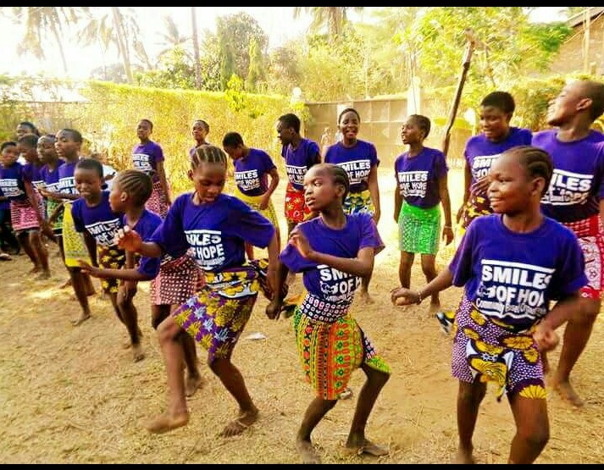

Smiles of Hope Scholars Home visit

Music and dance is one of the most effective ways of reaching out to the young people encouraging them to relate to what is acted and said and combine responsibility to combat child abuse and teenage pregnancy

***BENEFICIARY SUCCESS STORY***

Finding out that you are pregnant while in Primary School is probably one of the most terrifying things that can happen to a girl. I became a victim and after staying at home for 2 years as a house wife and being mistreated by my husband, I went back to school in June 2017 with the support from a well-wisher through Smiles of hope. I will be sitting for my Kenya Certificate of Primary Education exam in October. I count myself lucky to get the opportunity and I want to change the narrative that you cannot go back to school as a Teen mother. I want to be an advocate and champion for girls rights within Smiles of Hope.

*Dhahabu Kifalu*

*18 yrs. Old –Kaloleni-Kilifi County*

***Vivian Akinyi***

***22 yrs Old - Kibera***

# 

**CURRENT NEED**

Last year Kilifi County recorded the highest number of teenage pregnancy in Kenya, a total of 13624 school going girls. We wish to intervene and save our girls. With your support Smiles of Hope will be in a position to train girls who are victims of teenage pregnancy champion for their rights and be able to mentor fellow girls in school as we believe in peer to peer mentorship. School girls and boys camp to equip them with knowledge necessary to curb the teenage pregnancies, boys to be in a position to advocate for girls education.

**Contact Info**

Elizabeth Ziro

Smiles of hope Kenya

Kilifi County

P.O. BOX 41786-80100 Mombasa

**Mobile:** +254720176726

**Email:** smilesofhopecbo@gmail.com

**Website**: www.smilesofhopekenya.org

Smiles Of Hope Kenya

@smilesofhope_ke

OUR WORK

**Through schools and organized groups we use:-**

* **Book Drives** to collect books and send to those who cannot afford in our attempt to promote the Reading culture and improve Academic performance
* **Motivation talks** to promote academic and career guidance, hygiene and Reproductive health talks
* **Education support** to mobilize funds for education for bright needy students
* **Young Mothers Program** Rescuing girls from Early Child marriage

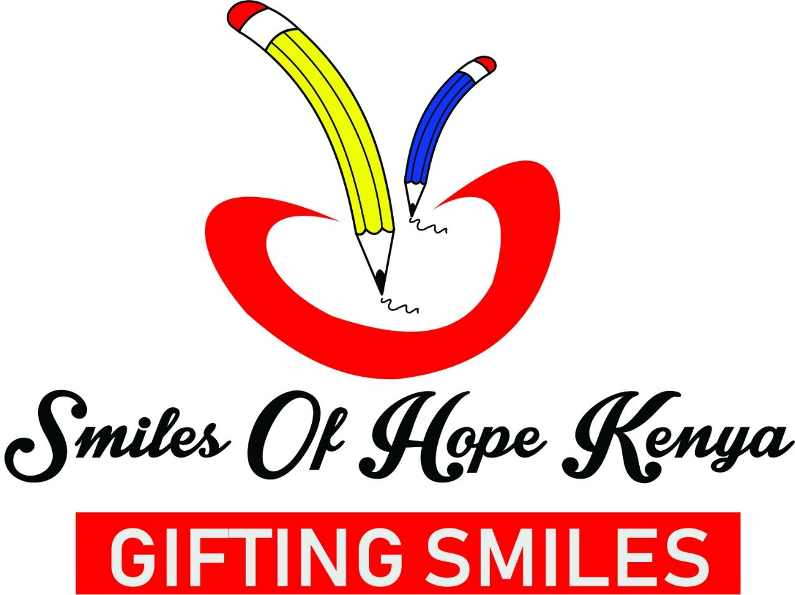

**Smiles of Hope**

Smiles of hope is a non-political, non-profit making , community based organization founded in the year 2015 under the pillars of fighting illiteracy through Books, Mentorship, Education support, combating teenage pregnancy and early child marriage in Kilifi County- Kenya. Smiles of Hope vision is to see girls succeed; by reduce teen pregnancy targeting at zero child marriages. We give girls skills by building their self-esteem to grab opportunities available, make their dreams valid and be at the fore front advocating for their rights.

**Smiles of Hope – Gifting Smiles to the Vulnerable Children**