MFDF 4YOUTH EMPOWERMENT PROGRAM (4YEP)
  - INTENSIVE SKILLS DEVELOMENT AND TRAINING FACILITATOR’S MANUAL
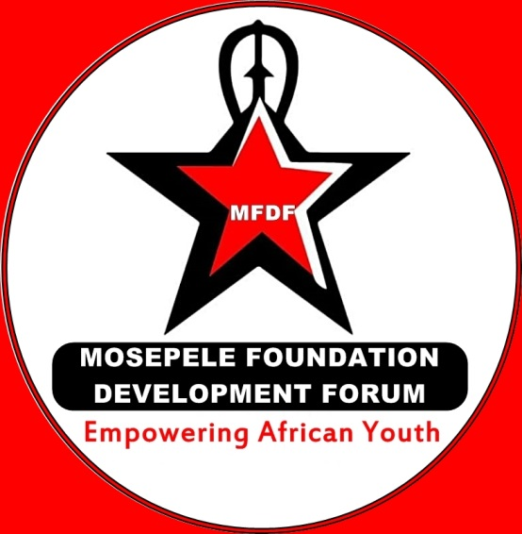

  - Manual developers: Maliehe Mosepele & Glen Schumacher

FACILITATOR’S GUIDE FOR PLANNING AND IMPLEMENTING:
4YOUTH EMPOWERMENT PROGRAM (4YEP)

1. PURPOSE OF 4YEP FACILLITATORSTRAINING MANNUAL

4YEP Facilitators Training Manual is intended for use by implementing agencies interested in establishing Intensive Skills Development and Ethical Leadership Training Programmes. The manual is primarily targeted for implementers working with young adults (Males and Females) from age of 15 to 35 years. In practice, this manual should serve as the framework for implementing and carrying out 4YEP curriculum which facilitators adapt to meet the needs of their particular sites. After the completion of the manual, participants are expected to work as 4YEP Facilitators in Training engaging in fieldwork in order to turn theory into practice and create sustainable youth development.
In this manual you will find the contents of 3 week Programme and notes about how to deliver it:
Part one: The first part of the manual gives you an overview of 4YEP Project.
Part two: The second part gives you general information about what goes into each session and how to approach it.
Part three: The third part gives you the specific details that you need to facilitate each session, including community outreach, monitoring and evaluation summaries.
Appendix: The last part provides all of the key terms, games and activities, role plays, refreshment songs and dances.

