PROJECT SUMMARY
Elderly people face several hardships in life which include chronic diseases like arthritis and disease, dental problems like tooth decay and infection, poor housing, malnutrition, stress among others. In addition to this, most of the elderly people come from poor families making it extremely hard to meet the basic necessities of life. This also puts their lives in danger. Therefore, this project will promote the well-being of elderly people.
WHAT IS THE PROBLEM?
Elderly people in rural Uganda face several challenges in life and lack the capacity to fully address or solve them. Some of them sleep in muddy and wattle houses with leaking roofs, lack what to wear, feed poorly and when they fall sick, they cannot seek better medical care. Most of them die of diseases which would otherwise have been treated.
HOW WILL THIS PROJECT SOLVE THE PROBLEM
This project will improve the quality of life among elderly people in rural Uganda by providing social care services such as nutrition, clean and safe drinking water, housing, medication, legal assistance and psych social therapy.
POTENTIAL LONG-TERM IMPACT
Special need service project will continue improving the quality of life among elderly people in rural Uganda by making it possible for such be to have access ti services like legal assistance, medical care, housing, legal assistance, clean waters and psycho-social therapy by 2023.

PHOTOS OF PROJECT BENEFICIARIES
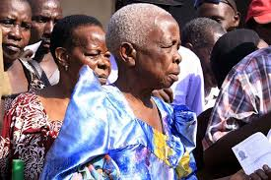

Some of elderly persons who benefits from this project in rural Uganda. They legal assistance, medication, nutrition, psycho social therapy, clean and safe drinking water, housing and clothing.
Your donation makes a difference! Thanks so much indeed.
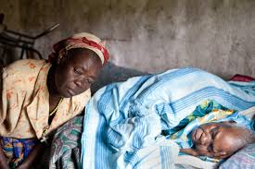
A sick elderly person being under the care of Bugema Community Child Based Organization. Your donation makes a difference by saving life.
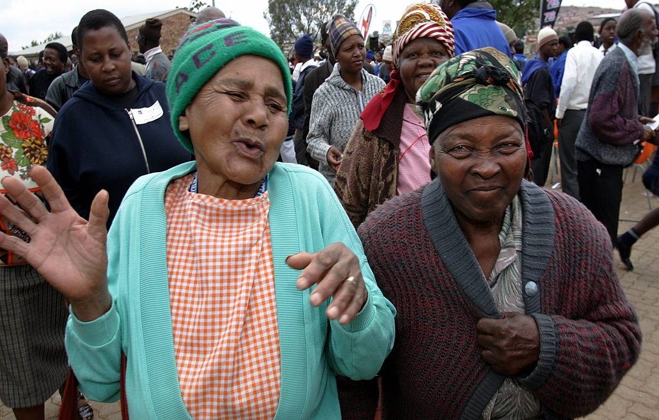

This photo shows elderly persons at Bugema Community Child Based Organization Care Centre where these people receive food, medication, counseling, clothes, eye glasses and other relief items. it is your donation that makes it happen!

Thanks so much for supporting Bugema Community Child Based Organization’s projects.

