PROPOSAL FOR FUNDING
THE COTTON TREE FOUNDATION’S
ANNUAL VACATION CAMP
July 2019

The Cotton Tree Foundation
Spanish Acres
Ariapita Road
St Ann’s

Contact: CTF General Manager
Email : manager@thecottontree.org
Tel: 623-5120

CTF Vacation Camp Assistant
Email : camp@thecottontree.org/info@thecottontree.org

Section 1: Overview of the Cotton Tree Foundation
1.1 History of the Cotton Tree Foundation
The Cotton Tree Foundation is a non-profit organization founded by Desmond Allum and a group of citizens who were concerned over the increasing number of disadvantaged people in our society. As a result, they commissioned a community survey which identified extensive poverty and high unemployment, especially among young adults of Belmont, East Dry River, St. Ann’s, Cascade and environs. Desmond Allum felt that education could change the trajectory of ‘at risk’ groupings. In 1993, The Cotton Tree Foundation (CTF) was registered as a non-profit organization with the aim of “improving life chances through the vehicle of education”.
1.2 Management
CTF is strategically managed by an seven-member Board with expertise in Law, Human Resources, Education, Child and Youth Development, Finance and General Management.
1.3 Mission Statement and Objectives
The main goal of the Foundation is to offer quality education and assistance to underserved members of our client communities. This is pursued through our Preschool, Homework Centre, Vacation Camp, Community Outreach Programme, Service Learning Programme, Parent Education Workshops, and Primary School Scholarship Programme.
1.4 Client Community
Our client communities are notably some of the most vulnerable in Trinidad & Tobago given high levels of fractured households, gang membership, crime and poverty. CTF’s community registers a huge amount of wasted potential in the form of talented children who are not given the required access to quality education. Additionally, the link between undiagnosed learning difficulties, school dropout rates and crime is well documented.
Our programmes aim to bridge this educational disconnect by providing safe learning spaces that promote good citizenship practices, positive psycho-social experiences and behavioural modification through developmental and clinical interventions, all the while providing supportive opportunities for the continued enhancement of parenting skills.
In order to achieve the widest reach within our community, Cotton Tree’s interventions are highly subsidized, or fully sponsored through grants and donations.

Section 2: Annual Vacation Camp
The Cotton Tree Foundation has successfully conducted camps every year since 2000 for children between the ages of 3 yrs. and 12 yrs. Registration has steadily increased over the years accommodating 125 campers in 2016, 132 in 2017 and 102 in 2018. The camp offers a fun-filled, safe and comfortable environment that reinforces key academic concepts specifically tailored to each child’s functional level. The camp seeks to build essential life, literacy and numeracy skills necessary for the successful functioning of children, and to provide leadership training for Volunteers and Camp Assistants.
The camp also provides a very necessary support system for parents during the first month of the lengthy July/August vacation.
2.1 Vacation Camp 2019
CTF will host its 20th Annual Vacation Camp from Tuesday July 9th to Friday July 26th, 2019. The theme of this year’s camp will focus on Scouting for Innovators in the 21st Century and has as its basis:
Innovation is not only ever-changing but also multifaceted and stands for change and the creation of something new. Through a range of activities, both academic and creative, campers will be stimulated and encouraged to explore new ways of developing concepts into creation through language, art, science, mathematics, technology and movement.
We are hopeful, that young campers will be exposed to all forms of innovation from science, art, culinary, agriculture, technology etc, to harness their imagination, expand awareness and appreciation and thus develop a sense of the infinite possibilities of what they can be when they grow up.
2.2 This Is How We Do It
The Camp is managed by a Camp Leader and Camp Coordinator. The former manages the day to day activities of the camp while the latter arranges activities and field trips in support of the camp’s theme and oversees the delivery of all aspects of the programme including providing support to teachers and volunteers. The Camp Coordinator also plays a pivotal role in managing classroom and parent/community relations.
Senior teachers are carefully selected based on their commitment and experience with general classroom teaching, specialist skills in remedial reading and mathematics and an ability to manage disruptive behaviours. Life skills coaches are also available to children to facilitate reflective opportunities in developing coping skills, effective conflict resolution, courtesy, etiquette, healthy eating and general safety awareness.
Volunteers are typically between the ages of 15 to 20 and they use this exposure at camp for both personal and professional development. Orientation and weekly support sessions are held with volunteers to ensure that they understand the guidelines for managing children and are able to cope well. The typical volunteer tends to be an individual who is interested in working with other young persons and who may wish to engage in community service for their own personal growth and/or to help with their application to universities abroad. Some of our volunteers are former students of CTF’s Homework Centre who have remained part of our close knit CTF family.
2.3. Schedule of Activities
One key benefit of attending vacation camp is halting what is typically known as the "summer learning slide” i.e.; the ability for non-stimulated children to forget up to 2.6 months of material learned in the previous school year. Vacation Camps with well-balanced academic revision can serve to mitigate this loss of knowledge by keeping children's brains active and engaged.
CTF has positioned academics as central to the structuring of daily camp activities. Morning sessions comprise carefully planned learning activities that include remedial, numeracy and literacy classes. In the afternoons, skills-development and leisure activities including sporting and field trips are scheduled.
On the final day of Camp, an Open House is held to showcase the children’s work produced during the period. Parents and sponsors are encouraged to attend this vibrant event where each class puts on a special performance and also displays craft and other items made during camp.
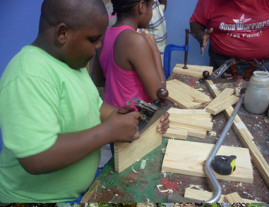
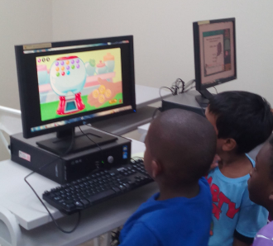
2.4 Vacation Camp Snippets

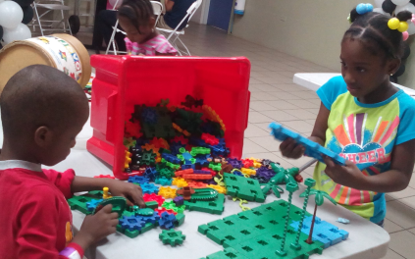

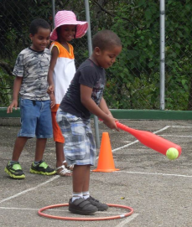
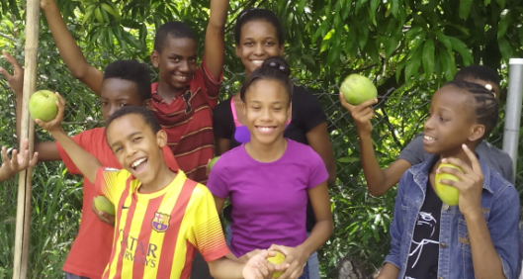
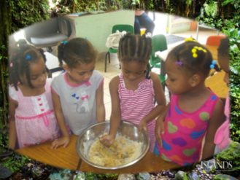

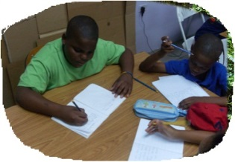
2.5 Sample Feedback from Parents
- I liked the CTF camp as a parent because they really worked very hard within such short time and a lot was being done”.

- I liked that academics were incorporated into the daily routine and that the children were exposed to information about recycling and going green.

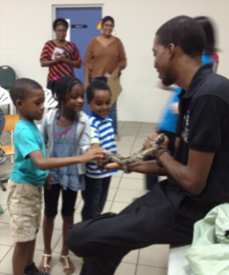
- My child enjoyed learning new things with new friends and touching the animals

- You could extend the camp to cover the month of August.

- I was glad about the amount of activities and new experiences that were available
and the fact that all the Aunties and counsellors were willing to assist with the kid’s
needs.

2.6 Requests for Funding Assistance
In order to maintain the high standards of our vacation camp, there is always a need for committed sponsors who are desirous of supporting vulnerable children through social engagements that build:
- Stronger peer relationships and academically oriented friendships
- Greater personal confidence and self esteem
- More restraint in avoiding risky behaviours
- Opportunities for greater role models.
In this regard, we are raising funds to provide such an opportunity to 120 campers and their immediate families by becoming a sponsor. We welcome your financial support at any level that you may choose. Alternatively, sponsors have the to select from one of the following pre-determined sponsorship categories:
1. Platinum Sponsor Full Sponsorship $128,000.00
2. Gold Sponsor $ 35,000.00
3. Silver Sponsor $ 20,000.00
4. Bronze Sponsor $ 10,000.00

2.7 Budget
CTF Annual Vacation Camp Budget 2019
Estimated Campers Count |  | 110
Major Expenditure Categories
Stipends - Teachers, Assistants and Staff |  | $86,692.00
Furniture, Materials and Supplies |  | $22,500.00
Field Trips, functions and transport |  | $9,000.00
Catering, cleaning and maintenance |  | $9,900.00
Total Funding Required |  | $128,092.00
Estimated cost per camper for 3 weeks camp |  | $1,164.47

---o0o---

