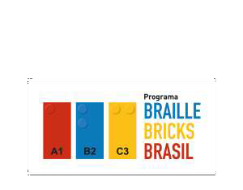



**DORINA NOWILL FOUNDATION FOR THE BLIND**

REPORT

During October, teachers, managers and other education professionals continued the training course to use the LEGO Braille Bricks feature. The course has been offered in a virtual way, so that it contributes to the social distancing process, following safety protocols against COVID-19, but this has not negatively impacted activities involving the use of LEGO Braille Bricks.

These professionals started a class of about 850 educators from the municipalities of São Paulo, São José do Rio Preto and Presidente Prudente, who participate in synchronous activities, with weekly and asynchronous web conferences, developing tasks in the Virtual Learning Environment.

There have been several feedback from these professionals who, through a lot of creativity and pedagogical sensitivity, present their experiences and work possibilities that involve literacy through braille pieces, valuing cognitive, emotional, motor, intellectual, psychological and social capacity, of children with and

The impact of the Project has highlighted some very important processes for the municipalities and is already happening in

São José do Rio Preto, as illustrated in this article.



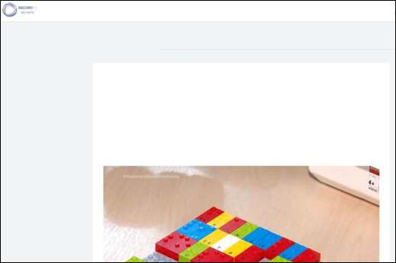

[A hora da Venenosa Agro Record Balanço Geral Esporte Record Record Entrevista SP Record Commerc](https://www.recordtvriopreto.com.br/noticia/46026/professores-participam-capacitacao-para-utilizar-ferramenta-inclusiva.html)

[ial](https://www.recordtvriopreto.com.br/noticia/46026/professores-participam-capacitacao-para-utilizar-ferramenta-inclusiva.html)

[Education](https://www.recordtvriopreto.com.br/noticia/46026/professores-participam-capacitacao-para-utilizar-ferramenta-inclusiva.html)

[**Teachers participate in training to use inclusive tool**](https://www.recordtvriopreto.com.br/noticia/46026/professores-participam-capacitacao-para-utilizar-ferramenta-inclusiva.html)

[The Rio Preto City Hall partnered with a foundation, which made Lego pieces available with the Braille language printed on the blocks. The kits have already arrived in Rio Preto and the teachers have started](https://www.recordtvriopreto.com.br/noticia/46026/professores-participam-capacitacao-para-utilizar-ferramenta-inclusiva.html)

[training to use the material in the classroom. A very cool initiative that allows inclusion of special students and interaction in the classroom.](https://www.recordtvriopreto.com.br/noticia/46026/professores-participam-capacitacao-para-utilizar-ferramenta-inclusiva.html)

**DORINA NOWILL FOUNDATION FOR THE BLIND**

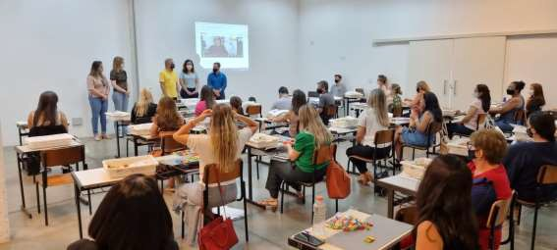 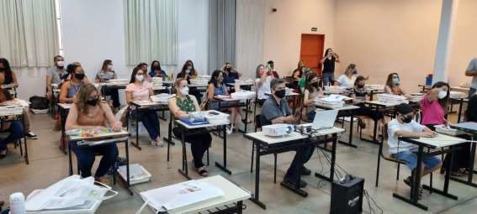

# Educators during training in São José do Rio Preto with the presence of the Municipal Mayor

**DORINA**

**NOWILL**



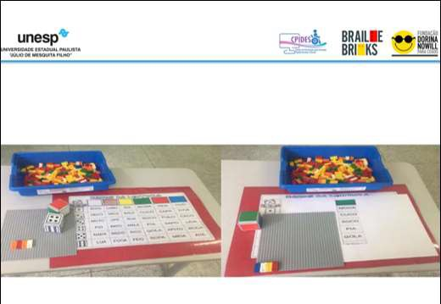

**TRAINING PROGRAM LEGO BRAILLE BRICK**

**The Intervention Plan assumes the construction of strategies**

**pedagogical for the use of Lego Braille Bricks. Some possibilities...**

# Template of slides presented during some Web conferences

**DORINA**

**NOWILL**

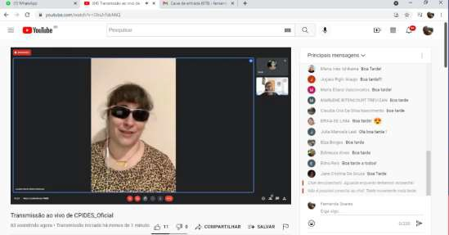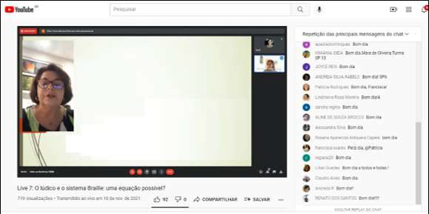

Prof. Dr. Marilda Moraes Garcia Bruno

E-mail [mgbruno@uol.com.br](mailto:mgbruno@uol.com.br)

Graduate Program in Education — PPGedu/FAED/UFGD

Study and Research Group on Inclusive Education - GEPEI

**The importance of playing**

**in early childhood education**

# Broadcast Web Conferences on YouTube

**DORINA**

**NOWILL**



# Live interaction with the students

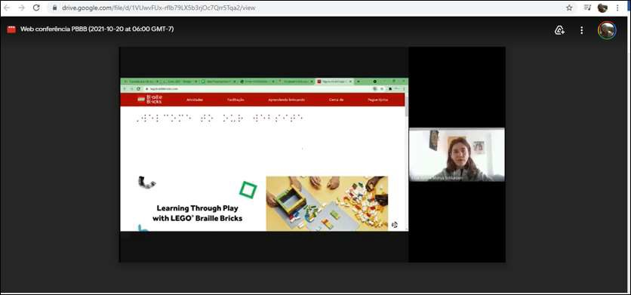

**Introducing LEGO Braille Bricks**

A fun and playful way to learn Braille

**DORINA NOWILL FOUNDATION**

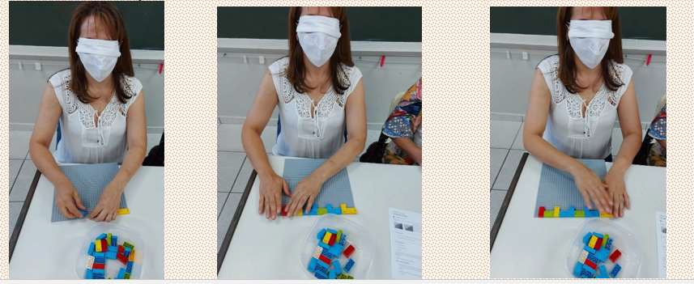

# Learning experiences in practice **DORINA**

**NOWILL**



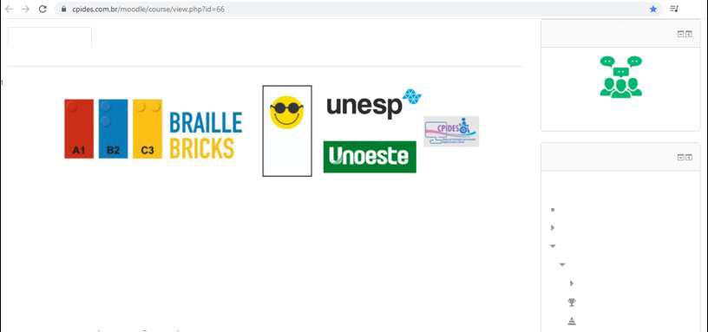

Opening Schedule Module I - Agenda 1 Module I - Agenda 2 Module II - Agenda 3

Module II - Agenda 4

Module II - Agenda 5

**tools**

Module III - Agenda 6 Module III - Agenda 7 Module III - Agenda 8 Hidden

**Program**

Talk to the Tutor

SÃO PAULO STATE UNIVERSITY JULIO DE MESQUITA FILHO

**DORINA NOWILL FOUNDATION**

**Navigation**

**FOR THE BLIND**

Dashboard

Welcome to the training course for educators **of the Braille Bricks Brazil Program**

Site homepage

Here are the main guidelines on the course you are starting. If you have any questions, contact your tutor at Talk to the Tutor tool, available in the Side Menu.

Website page

My courses

**WORKLOAD:**

PBBB1

100 hours, with 20 hours of synchronous activities (web conferences) and 80 hours of asynchronous activities.

Participants

**OBJECTIVES:**

Badges

Competencies

The training course has the following objectives

# Virtual Learning Environment (VL) home page

**DORINA**

**NOWILL**

# Following on from the project, the Dorina Nowill Foundation for the Blind is making available around 2,000 LEGO Braille Bricks kits. Of these, 1,143 kits are already in municipal public schools, where students with visual impairments between 4 and 10 years old are enrolled. The kits should benefit more than 14,000 students in the three municipalities.



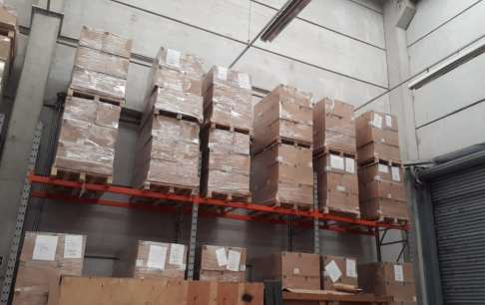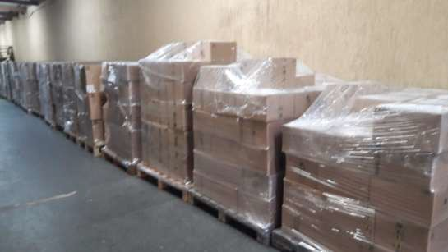*Kits in the process of organizing for shipping*

**DORINA NOWILL FOUNDATION**

# Dissemination article about the project, published in the digital magazine Família e Educação



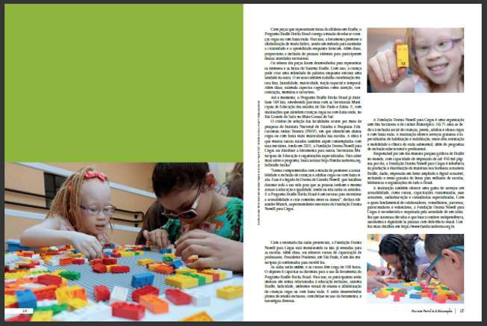

[**DORINA NOWILL FOUNDATION**](https://issuu.com/suaescolaideal/docs/revista_familia_e_educacao_3_edicao)

[**AND BRAILLE BRICKS PROGRAM BRAZIL PROMOTE**](https://issuu.com/suaescolaideal/docs/revista_familia_e_educacao_3_edicao)

[**CONCEPT OF LEARNING BY PLAYING**](https://issuu.com/suaescolaideal/docs/revista_familia_e_educacao_3_edicao)

[**The pedagogical resource aims to educate, entertain and integrate blind or low-sighted students.**](https://issuu.com/suaescolaideal/docs/revista_familia_e_educacao_3_edicao)

[**ABOUT THE DORINA NOWILL**](https://issuu.com/suaescolaideal/docs/revista_familia_e_educacao_3_edicao)

[**FOUNDATION FOR THE BLIND**](https://issuu.com/suaescolaideal/docs/revista_familia_e_educacao_3_edicao)

[**BRAILLE BRICKS PROGRAM**](https://issuu.com/suaescolaideal/docs/revista_familia_e_educacao_3_edicao)

[**BRAZIL AND TRAINING COURSE FOR TEACHERS**](https://issuu.com/suaescolaideal/docs/revista_familia_e_educacao_3_edicao)

**DORINA NOWILL FOUNDATION**

**Dorina de Gouvêa Nowill (in memoriam)** Emeritus and Lifetime President

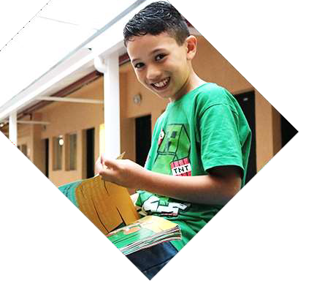

**Francisco Henrique Della Manna** President

**Alexandre dos Santos Oliveira Munck** Superintendent



**DORINA NOWILL FOUNDATION FOR THE BLIND**

**FUNDRAISING**

(11) 5087-0999 | ext. 0982

[parceria@fundacaodorina.org.br](mailto:parceria@fundacaodorina.org.br)

Rua Doutor Diogo de Faria, 558 • Vila Clementino ZIP CODE: 04037-001 • São Paulo/SP Brazil

(11) 5087-0999



**FOLLOW US ON SOCIAL MEDIA**