LIVINGSTONE YOUTH FOOTBALL ACADEMY
Sexual Health Education Through Football Coaching
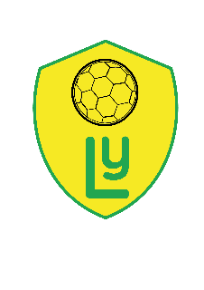

In 2018, LYFA 20 players went on a training course with Tackle Africa (https://tackleafrica.org) on teaching a HIV/AIDS prevention curriculum using the power of football. Since then our players have been running a programme that engages young people through football to provide them with the knowledge, confidence and services to realise their sexual health rights and help protect themselves and their communities from HIV. Our expert peer educators go into poor local communities around Livingstone and deliver football sessions that cover a wide range of health topics. The weekly sessions create a safe space to learn about and discuss sensitive issues in a way that they enjoy, remember and understand.
So far, we have trained 20 coaches, worked with over 300 young people and delivered 300 sessions in 8 different communities.
In November we held a football tournament at our pitch at Mulwani School which attracted over 400 players and fans. Alongside the football games, players were able to get a free sexual health screening, contraception and counselling at the pitch side. The idea of this is to create a non-judgemental environment where young people feel comfortable and safe.
We give young people the power to make decisions and to show them what might happen in their lives based on their choices.
It’s been truly remarkable what has been achieved so far, football really does have the ability to change lives.
One game saves lives.
Having run the programme for a year, we have seen first-hand the positive results that these sessions have had and want to continue and expand the programme to reach even more vulnerable communities that suffer from high rates of HIV/AIDS.
We are looking to raise funding for another 10 coaches to be trained and deliver sessions in 10 new communities. With your support we can continue to educate and empower young people in Zambia to make their own decisions and live a healthy life.

