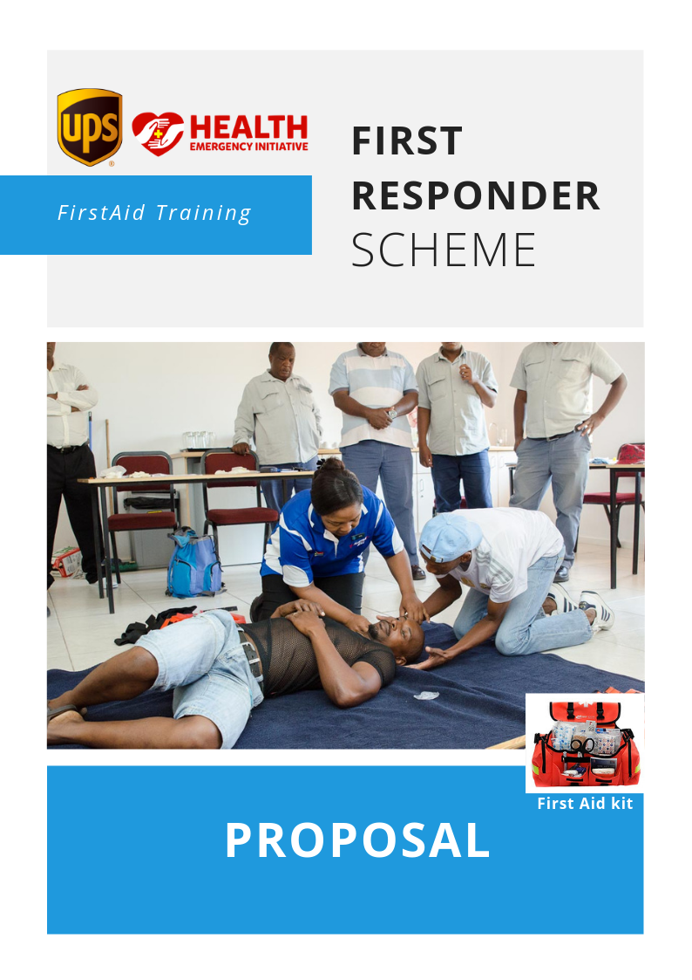

TABLE OF CONTENTS
- PROJECT SUMMARY
- WHO WE ARE & WHAT WE DO
- proBLEM STATEMENT
- OUR SOLUTION
- Project GOAL and Results
- Project Goal
- Project Objectives
- Intended Results
- Target Group
- PROJECT DESCRIPTION
- Project Activities
- PROJECT IMPLEMENTATION TIMELINE
- MONITORING & EVALUATION plan and indicators
- PROJECT BUDGET
- WHY PARTNER WITH HEI?

Project Summary

Name of Organisation: Health Emergency Initiative for Indigent Patients
Title of Project: First Responders Scheme Training
Location: Lagos State
Duration: Three Months (May - July 2019)
Proposed start date: 2nd May, 2019
Direct beneficiaries: Youths
Indirect beneficiaries: Emergency Victims
Project Cost: N4,134,000.00 (Four million, one hundred and thirty-four thousand naira only)

Name of Contact person and contact details:
Olayinka Layi-Adite – Project Officer
Office location: 2, Ayinde Giwa Street, off Ogunlana Drive, Surulere, Lagos
Tel: +234 (0)703 795 4043
Email: yinkaladeite@hei.org.ng, projects@hei.org.ng
Executive Director - Paschal Achunine

Who we are:
Health Emergency Initiative (HEI) For Indigent Patients is a not-for-profit, Non-Governmental Organization is an organization that ensures that low income individuals, vulnerable people and communities receive basic medical care as well as critical support during emergencies (inclusive of road accident).
Since its establishment in 2016, HEI has intervened to save the lives of over 370 patients and critically injured accident victims in up to 23 public hospitals
HEI has strong internal governance structures the Board of Trustees (BOT) composed of individuals with respected track record of success and commitment to integrity. The BOT access the progress of the organization, make strategic decisions and look at program and administrative issues. HEI also provides opportunity for volunteers and students on internship to learn and participate in its activities.
HEI works with several partners in the heath space and other sectors including Lagos State Ministry of Health and all the General Hospitals in the State, LUTH, FMC Ebute Metta, National Orthopaedic Igbobi, FRSC, LASAMBUS, LASEMA. Others include PwC, Greenlife Pharma, Afrigobal, Traumacare Foundation, Sherriff Deputies and host of other organizations.

What we do:
Medical Relief: HEI provides immediate medical assistance to indigent and/or vulnerable individuals in public health institutions exposed to minor but life threatening diseases like malaria, typhoid fever, jaundice, pneumonia, sepsis, one off blood and oxygen transfusion etc usually not exceeding N20,000

None Should Die Initiative: This is the flagship programme of HEI. This campaign ensures that any critically injured road accident victim taken to the selected hospitals by FRSC, LASAMBUS and other emergency Agencies are stabilized and resuscitated at no cost on the assurance that HEI would settle their bill not exceeding N20,000 within 24 hours

Project Joseph (Prison Medical Relief): This is a special intervention aimed at equipping and enhancing the capacity of Prison clinics to meet basic health challenges of the inmates. It also provides succour to prison inmates with minor infections like typhoid fever, cerebral malaria, etc referred to public health institutions not exceeding N10,000

Health and data advocacy: HEI focuses on advocacy to influence legislation and policies. HEI is putting in place a robust framework where credible data on health and emergencies can be obtained for national and transnational stakeholders.

Safety campaigns: HEI advocates for safer roads in Nigeria especially through partnerships with the FRSC through campaigns, workshops, trainings, and other initiatives.

Community health (Medical Outreach): HEI works closely with hospitals, health centres and other health facilities to improve the health of communities and consequently the health of low income families through periodic medical outreach to these communities.

- Problem Statement

It is important to note that hospitals do not manage emergencies or disasters by themselves. There are other pre-hospital factors, which have to be considered. Developed countries such as the USA, the UK, other European countries, Australia and Japan already have systems that integrate pre-hospital and inter-hospital facilities. In developing countries like Nigeria where emergency services are minimal and/or does not exist, it is imperative to equip its citizens on how to manage daily emergencies and disasters in an organized way and also provide good quality emergency medical care.

Emergency services are necessary for every economy in order to save lives and to maintain economic conditions for sustainable development. Every year, every economy experiences a number of disasters where lives are lost including children. Some of these losses are huge and the numbers of people who are affected by these disasters are in their hundreds and thousands annually. A recent report by Channels TV/BBC (7th December 2018) cited a World Health Organization (WHO) publication that road traffic accident is the biggest killer of young people especially in Africa/Nigeria

The current status of Emergency services in Nigeria reflects many attempts by both state governments and private organizations, all of which lacked first responders, paramedics or any special pre-hospital training.

Emergency medical services have become a political benchmark, rather than a health necessity. To turn attention to Emergency service irrespective of the motive and quality is a positive step in the right direction in a society that hasn't recognized emergency medicine and emergency healthcare as crucial aspects of healthcare management.
There hasn't been a substantial and coordinated effort to sensitize and mobilize the general public in emergency services, resulting in public apathy throughout the country.
A recent survey done in one of the cities with government-owned EMS showed that the majority of the public do not know what to do in cases of an emergency, the emergency numbers to call, what information to relay and actions they can take to resuscitate/sustain a victim’s life.

Also due to the absence of Good Samaritan laws, bystanders are not protected and worse still, as the study revealed, they receive harassment from the police whenever there is an attempt to assist victims. A bystander may lose his or her freedom if the victim eventually dies. To compound the issue, hospitals hold the bystander who takes the patient to the hospital liable for treatment costs. These challenges tend to pose limitations on the success of Emergency services programs in Nigeria.
The invaluable need for effective Emergency services in Nigeria continues to rise daily.

In April 2016, six medical doctors travelling for a conference lost their lives in a bus accident. Bystanders arrived at the accident scene to assist, but they were not trained as first responders. They packed the victims in a van and drove to a nearby hospital.
One of the survivors stated that many of the victims wouldn't have died if emergency medical care was available.

Without a trained first responder at the scene of any emergency or manning the resuscitation or evacuation of a victim from the accident scene to the hospital, lives would be lost.

- Our Solution

FIRST RESPONDERS SCHEME
To address the public apathy in pre-hospital emergency care and stimulate public interest, Health Emergency Initiative proposes a First Responders (FRs) Scheme to create a community/network of volunteers trained to attend to certain kinds of emergencies and provide the right care at the right time with the right skills.
This is a volunteer driven scheme that certifies volunteers to become FIRST RESPONDERS (FR’s) after they have demonstrated their willingness to help victims needing emergency care in the society.

First response is the immediate treatment or care given to someone suffering from an injury or illness until more advanced care is accessed or they recover. The provision of prompt and appropriate first aid or Cardiac Pulmonary Resuscitation can reduce the severity of an injury or illness; and in extreme cases, could mean the difference between life and death.

ROLE OF THE FIRST RESPONDER
- Stabilize a patient/victim until more highly skilled crew arrives to take over the patient; this seeks to curb the practice of snapping pictures to post on social media, and offer actual help

- Keep crowd away in a coordinated manner from the scene

- Provide psychological support to the victim prior to arrival of the emergency crew

- Inform emergency crews on phone and stay on the line providing assistance where required

- Ensure safety of victims prior to the arrival of the emergency crews

- Document, record and inform ambulance crews of the vital information given by the victim(s)

- Willing to assist the emergency agencies in large scale accidents/incidents when called upon by HEI & the emergency agencies

- Assess causalities and find out the nature and cause of their injuries

- Provide appropriate first aid treatment as trained

- If able, make notes/observation of causalities

- Provide a handover when further medical help arrives

- Project Goal and Results

Project goal:

The main goal of the scheme is to attend to emergencies in the first critical minutes/hours before the emergency agencies arrive and thus improve the chances of survival and long term recovery.

Project objectives:

- To preserve life
- To prevent illness or injury from becoming worse
- To relieve pain, where possible
- To promote recovery and protect the unconscious
Benefits to beneficiaries
- Certificate and License as a Designated/Authorised first responder
- Opportunity for self-improvement and satisfaction
- Acquire lifesaving skills and contribute to survival rates
- Network & give back positively to the community
TARGET GROUP

Youth corpers, youth Leaders in churches and mosques
Class Representatives and Student Union Leaders of all the higher institutions in Lagos State

Senior Prefects of public and private secondary schools in Lagos State

Staff of corporate organizations

Representatives of road transport union and market leaders

- Project Description
In line with HEI strategy to address health emergencies and the SDG 4 (Good Health and Well Being), HEI, in collaboration with training partners plans to train 50 interested beneficiaries per stream on crowd control management, Basic first aid/Cardiac Pulmonary Resuscitation (CPR), handling bleeding, Identification and handling head injury victims for 2-days.
We will employ international best practices to ensure that training objectives are realized and that the entire training cycle is optimized to ensure not just effective, but measurable outcomes. Training design and delivery will be structured to guarantee effective learning so that the expected development objective is consequently realized.
Beneficiary impact assessment will focus not just on the immediate outcomes of the intervention (i.e. ensuring that the required knowledge, skills and attitudes have been transferred and that learning has indeed taken place).
This developmental objective is that beneficiaries are able to respond to emergencies on time, administer first aid and ultimately save the lives of victims thereby reducing death rate.
The project will, through a mass sensitization campaign address issues on emergency care. HEI will roll out a massive social and traditional media campaign. This will be followed by a press conference where HEI, together with supporting partners will engage the media, followed by a full page column on the subject matter in 3 national dailies. The third event will be training for the target group.
- Project Activities
The following are the activities that will be carried out to achieve the objectives and attain the goal:
- Planning and preparation: This process will involve holding meetings with the project team to assign roles and responsibilities; preparing workshop materials and other logistics.
- Engage stakeholders: HEI will reach out to secondary schools, higher institutions, the ministries of Health and Education, MDs of hospitals, media, etc. This is to inform them of the initiative and secure their support.
- Conduct a mass sensitization campaign: This will involve putting out content that addresses emergency care on the major social media platforms; boosting posts, adverts, radio and TV programs, and on the websites of HEI and partners.
- Hold a press release and talk about the initiative, which will be followed by a full centre page report of the subject matter.
- Organize a 2-days training for selected beneficiaries on emergency care and crowd control in case of an emergency

- Project Implementation Timeline (May – July 2019)
X – To be completed

TASK | MAY |  |  |  | JUNE |  |  |  | JULY
 | Wk 1 | Wk 2 | Wk 3 | Wk 4 | Wk 1 | Wk 2 | Wk 3 | Wk 4 | Wk 1 | Wk 2 | Wk 3 | Wk 4
Activity 1: Planning and preparation |  |  | X | X | X | X
Activity 2: Stakeholders engagement |  |  |  |  | X | X | X
Activity 3: Mass sensitization campaign |  |  |  |  | X | X | X
Activity 4: Press release |  |  |  |  |  |  | X
Activity 5: Training |  |  |  |  |  |  |  |  | X
Monitoring and Evaluation |  |  | X | X | X | X | X | X | X | X | X | X

- Monitoring and Evaluation

HEI will monitor activities throughout the project. Regular reports will be sent to all donors.

The project will be monitored on three levels:

- Media campaign: To ensure that it is effective
- Participant selection: To ensure that there is no bias or discrimination
- The Training: Participants will be interviewed randomly to assess impact of the programme; trainers and other stakeholders will also be assessed to determine quality of sessions.

Likewise, there will be an end of project evaluation. Various indicators will be used to track performance as shown below:

Project goal: The goal of the project is to attend to emergencies in the first critical minutes before emergency agencies arrives
Activities |  | Indicators | Means of Verification
1 | Planning and preparation | - No. of planning meetings | * Meeting reports  * Attendance sheets
2 | Stakeholders engagement | -No. of stakeholders who agree to support the project | * Communication letters  * Meeting reports
3 | Mass sensitization campaign | - No. of posts, and other content on social and traditional media  - No. of responses to campaign | * Social media posts  * Newspaper adverts  * Followers’ comments, posts re-tweets and sharing
4 | Press release | - No. Of publications  - No. of responses received | * Newspaper publication  * Responses received
5 | Training | - No. of people who attended  - No. of interviews conducted  -No of beneficiaries who can administer first aid & CPR | * Attendance lists  *Training materials  * Interviews  *Questionnaires  * Report  * Press release

- Budget
First Responders Scheme Training
ITEM | NUMBER | UNIT COST | DURATION  (DAYS) | Total
Planning
Communication | 5 | 1,000 | 10 | 50,000
Logistics | 1 | 50,000 | 1 | 50000
Sub -Total |  |  |  | 100,000
Stakeholders engagement
Logistics | 1 | 50,000 | 1 | 50,000
Communication | 1 | 1,000 | 10 | 10,000
Sub -Total |  |  |  | 60,000
Mass sensitization campaign
Promotional materials (design &  print) | 1 | 100,000 | 1 | 100,000
Email marketing | 1 | 20,000 | 1 | 20,000
Social media adverts | 5 | 35,000 | 1 | 175,000
Newspaper campaign | 3 | 50,000 | 1 | 150,000
Sub -Total |  |  |  | 445,000
Press release
Media | 3 | 50,000 | 1 | 150,000
Sub -Total |  |  |  | 150,000
Training
Training cost per participant | 50 | 25,000 | 1 | 1,250,000
Hall | 1 | 100,000 | 2 | 200,000
First Aid kit | 50 | 5,000 | 1 | 250,000
Certificate of participation | 50 | 1,000 | 1 | 50,000
Writing pads/pens | 50 | 1,000 | 1 | 50,000
Banners | 4 | 30,000 | 1 | 120,000
Sub -Total |  |  |  | 1,920,000
Fringe benefits
Project Staff | 2 | 20,000 | 5 | 200,000
Volunteers | 2 | 5,000 | 2 | 20,000
Sub -Total |  |  |  | 220,000
Contractual services
Videographer | 1 | 50,000 | 2 | 100,000
Photographer | 1 | 75,000 | 2 | 150,000
Sub -Total |  |  |  | 250,000
Monitoring and Evaluation
External & internal evaluation | 1 | 300,000 | 1 | 300,000
Total |  |  |  | 3,445,000
Institutional Strengthening | 1 |  | 20% of Total | 689,000
Grand Total |  |  |  | 4,134,000

Why Partner with HEI?
Partnering with HEI gives your organization the following opportunities:

- This project will strengthen UPS brand image as the first organization helping to solve the issues of emergency response and ultimately saving lives.

- UPS will be fully recognized and acknowledged as the project funder and your corporate profile will be included in all prints materials.

- Improved brand endorsement and increased brand loyalty from target group

- Enhanced corporate visibility via media/publicity platforms

- Building new and deeper community networks

