Organizational profile

Intervention Strategy for Nutritional Health Initiative (ISNHI)



Tel: +2348052103885

E-mail: isnhi.org@gmail.com
info@isnhi.org.ng

Website: www.isnhi.org.ng

ISNHI local NGO

Contact person: O. Priscilla Godwins (Founder / Executive Directo)
Tel: +2348069450506

Address: 22, Kuffor Street, New Maitama, Kubwa, Abuja. FCT

Organizational Background
Intervention Strategy for Nutritional Health Initiative (ISNHI) was founded in June 2015 and incorporated on 18th November 2016 with registration number CAC/ IT/ No 92536. We are a conglomeration of selfless Nutritionist, Dieticians, Researchers, Disaster management experts, Community Development experts and Humanitarian workers, with an undying resolve to improve livelihood for all.

Vision statement:
ISNHI vision is geared towards a society where hunger, starvation and malnutrition is eradicated, food security enhanced and the nutritional status of citizens attain maximum standard.

Mission statement:
Our mission is to ensure a healthy, safe and improved quality life for all as we work through our activities, towards the realization of goals 1, 2, 3, 5, 6, 8, 10 and 17 of the Sustainable Development Goals.

Goal
Our goal is to reduce morbidity, mortality and vulnerability through integrated services, while collaboratively working with stakeholders at all levels in the realization of related SDGs.

Specific objectives

1. Promote optimal health and healthy living practices through proper education, enlightenment and awareness programs.
2. Incorporate nutritional care programs as a disaster management
strategy.
3. Mobilize and distribute food aids through humanitarian relief guide for disaster victim's, IDPs, Women, children, the elderly and other possible vulnerable group.
4. Encourage food supplementation, diversification, complementation,
fortification and biofortification, as well as creating awareness on healthy methods of processing and packaging local foods and their benefits.
5. Advocate for policies that seeks to promote efforts towards the
consideration of the nutritional health and general wellbeing of citizens.
6. Build collaboration with organizations, food industries and government agencies so as to promote nutritional healthy communities.
7. Collaborate with relevant organizations to develop, coordinate and implement programs that will promote the health of populace through efficient integrated nutrition services.
8. Foster proper adolescent, pregnant women, maternal and child health
care.
9. Further nutrition cause that seeks to curb malnutrition and it's risk
amongst prison inmates, rehabilitation centers, home for the elderly and in orphanages.
10. Improve the attainment of Nutrition related sustainable development
goals (SDGs).
11. Collaborate with medical professionals in relevant fields to promote optimal health status for persons living with non-communicable diseases like HIV, Cancer, HBP, Obesity, Diabetes, etc, through proper nutritional guide with the view of enhancing appropriate nutritional practices.
12. Eradicate hunger and starvation and enhance food security at all
levels.
Targeted Audience
- Pregnant Women and breastfeeding mothers.
- Children / Adolescents / Youth.
- Disaster Victims
- Orphanages.
- Prisons.
- Community Based Organizations (CBOs).
- Persons suffering from nutrition related (Non-Communicable) diseases
- Community Health Workers / TBA / VHW
- Traditional / Religious /Community Development Associations CDC, CBOs.
- Policy Makers / Local / State/National level.

Slogan
Eat Right, Live Healthy

ISNHI Networks And Collaborations
ISNHI does a lot of Networking and multi-sectoral collaboration:
- Federal Ministry of Health.
- Civil Society Scaling up Nutrition in Nigeria.
- Disaster Managers Without Borders.
- Strategy and Innovation for Development Initiatives.
- Society for Life and Human Development Initiative.
- Pink and Blue Cancer Support Initiative.
- Breastfeeding Advocacy Group.

Organizational values
ISNHI is committed to working with efficiency and long term sustainability solutions, Valuing the principle of eradicating poverty through empowerment to ensure zero hunger, food security, and eradicate extreme hunger, starvation and malnutrition. Believe in the power of committed youth individuals and organization who want to contribute to a sustainable development.

.

Structure:
Intervention Strategy for Nutritional Health is structured according to the following system

General Assembly

Board of Directors
Management Team “Executive committee”
Organizational Structure

GENERAL ASSEMBLY

Board of Directors
(B.OD)

EXECUTIVE DIRECTOR

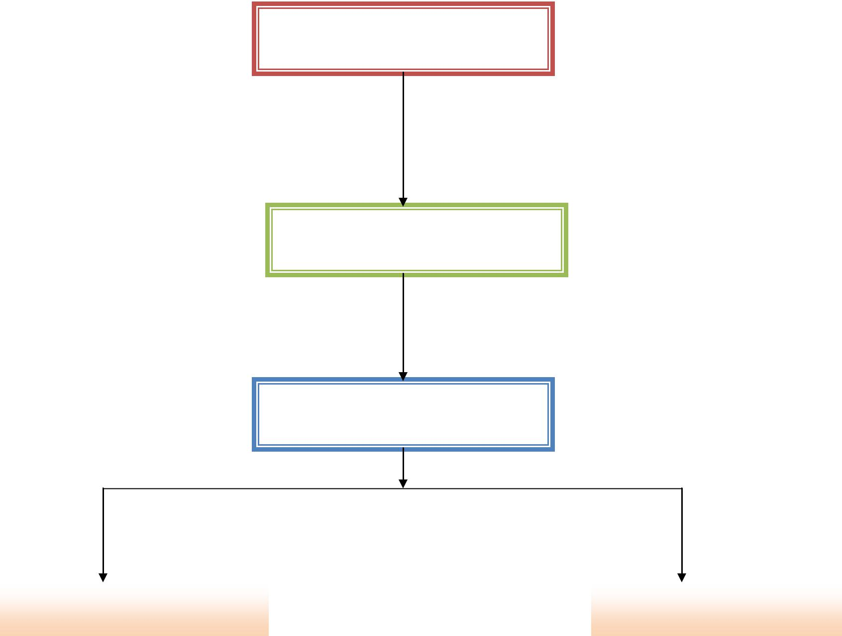 | ADMIN/FINANCE |  | PROGRAM OFFICER

