Massa/ Massar Update
Massa/Massar is a journey of discovery, of identity and of connection and compassion. While the next Massa/Massar journey is being planned, we want to share with you other journeys that are created at the Pluralistic Spiritual Center at Neve Shalom/Wahat al-Salam. Below are three recent journeys of the spirit that grew out of work on identity, connection and compassion.
Journeys: A time of Forgiveness
On March 11, 2013, the Pluralistic Spiritual Center welcomed the Sulha to a remarkable evening. Israelis and Palestinians, Jews, Muslims, Christians, Buddhists and so many others, came to the Spiritual Center which hosted Jo Berry and Pat Magee from Northern Ireland. Jo Berry's father, Anthony Berry MP, was killed by IRA operative, Pat Magee, in the IRA Brighton Bombing in 1984. In November 2000 she met Pat, the man responsible for her father’s death. Belfast-born, Pat Magee was given multiple life sentences for the Brighton Bombing. Released under the Good Friday Agreement in 1999, he has since been actively involved in peace work ever since. Said Jo: “I'm beginning to realize that no matter which side of the conflict you're on, had we all lived each others lives, we could all have done what the other did.”
Those in attendance listened to the stories from both Jo and Pat and saw in action the work required to listen, to learn, to forgive, to create something new.
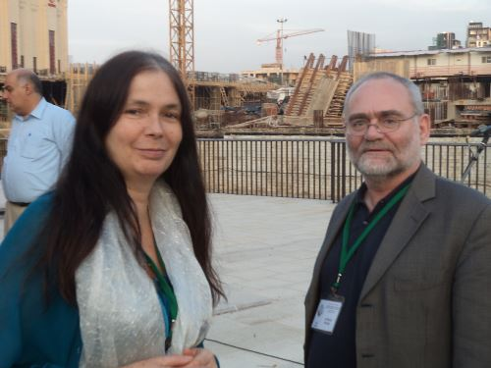

Journeys: Women’s Path to Peace
On March 20, the Spiritual Center held a special evening for a small group of seven women: Bedouin, Muslim, Jew and Christian who on March 12, set out from Jordan on a walk to awaken peace for all of us and calling for “peace in the path of women”. The group, initiated by a young woman from Jordan, is walking the ancient trade path and ended their walk on March 21st in Jerusalem (city of peace). The women join with the women of peace in Israel, at NSWAS for a festive dinner, sharing their stories and embroidering together the path to peace.
Journeys: A Living Museum
The Pluralistic Spiritual Center at NSWAS has begun the creation of an interactive and experiential living museum of peace. With over twenty activities in which groups can take part, including meetings between two worlds; history from different view points; body movement; stories from two sides; body-mind awareness; exploration of identity through the sacred texts.
As part of the Living Museum, the Spiritual Center recently hosted a group of 25 from Ramallah, brought to NSWAS by the Netherlands Representative Office to the Palestinian Authority. Guided by members of NSWAS, the Palestinian visitors were led on a tour of destroyed villages in the area, accompanied by focused dialogue and storytelling. In the future the living museum will have a number of exhibits and will include walking paths through Neve Shalom/Wahat al-Salam with plaques providing information and inspiration.

