**HUMAN-WILDLIFE CONFLICT IN THE CHIZARIRA NATIONAL PARK BUFFER COMMUNITIES:**

**STATUS REPORT AND MITIGATION STRATEGIES**

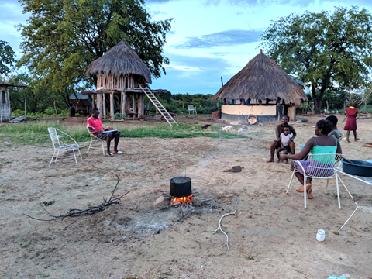

**Prepared by Dr Norman Monks (PhD) and Anele Matshisela (MSc)**

**March 2019**



