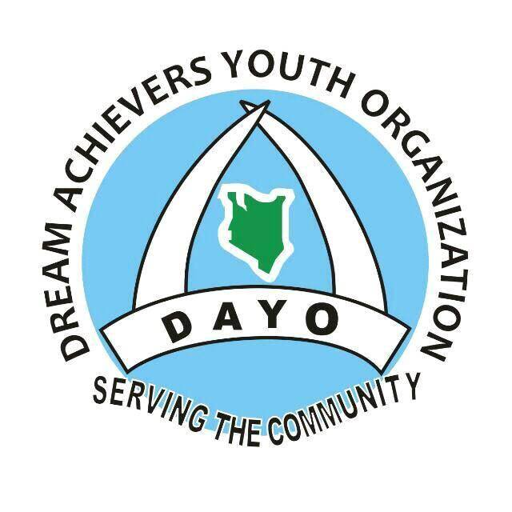
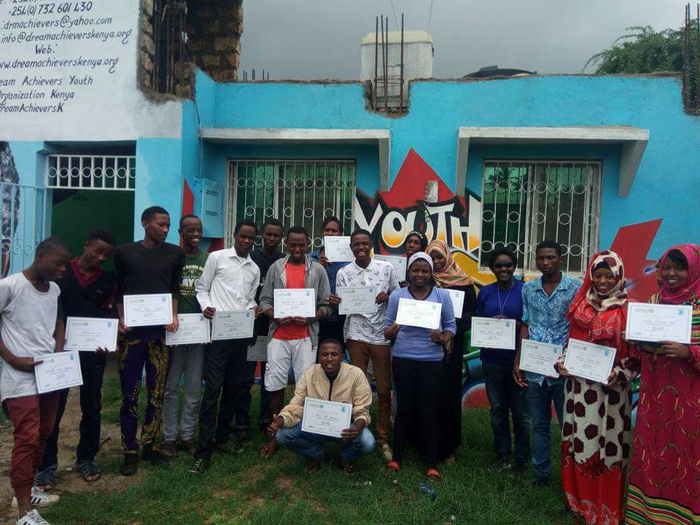
This Report Highlights Activities carried out by Dream Achievers Youth Organization (DAYO) during the financial year 2015-2016
DREAM ACHIEVERS YOUTH ORGANIZATION
ANNUAL PROGRESS REPORT
2017-2018
Dated 15/01/2019
©DAYO 2019 All Rights Reserved

Table Content
Foreword 3
About DAYO 4
Who We Are 4
Our Vision 4
Our Mission 4
Our Strategic Objectives 4
Our Approach 5
Our Principles 6
Volunteerism 6
Partnership 6
Equity 7
WHAT We Do: 8
Tusome Early Grade Literacy Activity 8
Context 8
Concept 8
Baseline Survey 9
Mobile Community Library 9
Murals 9
DAYO Performance and Targets 10
Young Men in Business (Y-Bizna) Project 10
Context 10
Concept 11
Project Components 11
Computer Maintainance and Repair Training Course 11
Men in Business Training 12
Group Formation, Vetting and Loan Disbursement 12
DAYO Performance and Targets 13
Maji Safi Afiya Bora Kwa Jamii 13
Context 13
Concept 14
Acquire Land 14
Drilling Borele 14
Building Modern Toilet/Employment Creation 14
Creating Hygiene Awareness and Preventive Messages 14
DAYO Performance and Targets 15
Right Here Right Now 15
Context 15
Concept 15
Streghthened Implementation of the ASRH Policies 16
Released Standards and Guidelines for Reduced Maternal Mortality and Morbidy 16
Inclusive National school Health Policy 16
DAYO Performance and Targets 17
DAYO’S GEOGRAPHICAL COVER 17
Donors & Sponsors 17
Collaborators 18
PARTNERS 18
Staff, Volunteers and Interns 18
STAFF 19
INTERNS AND VOLUNTEERS 19
DAYO’s Advisory Board 19
More Activities in Pictures: 20
Donations and Fundraising 20

Foreword
Dear Reader,
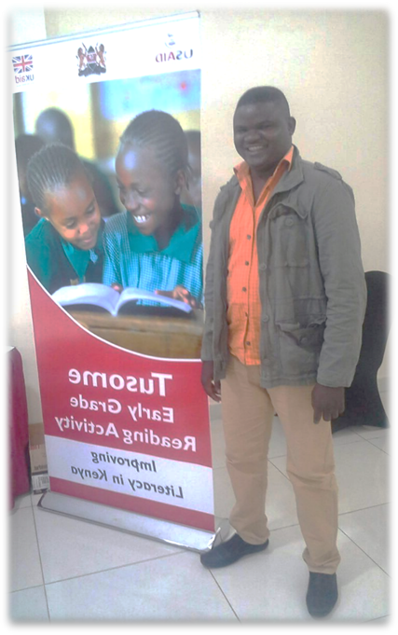
DAYO is continuing to draw towards its desire in providing hope and purposeful living for its targeted public towards continued involvement in bettering our society. This coincidentally comes at a time when the world population more so the youth is universally growing towards the 10th billion mark. We remain focused to enhancing the ability of the Youth to overcome the effects of adversity that includes poverty, unemploability, diseases, over population that is collectively blamed for some of the hardships felt today. Poverty is directly attributable to increased populations alongside weak social and governance systems and is particularly a major challenge to age-discriminated sections of the populations such as children, the youth and the elderly.
We continued to use theatre as an entry point to addressing issues of health as well as sustainable development among our target populations. The fact that seventy-five million women become pregnant unintentionally every year in developing countries alone, access to contraceptives is an issue that should be urgently addressed.
Increasing access to contraception and economic empowerment among the youth remains our core focus. We hope we will all join hands and hold forte together.
SeifJira Mali
Programs Director
Secretary, Advisory Board.

About DAYO

Who We Are
Dream Achievers Youth Organization (DAYO) was established in May 2005 under the Ministry of Gender, Children & Social Services with registration no. SS/MSA/CD/CBO/09/03 as a non-profitable and non-political community based organization by a group of young volunteers who wanted to mitigate challenges among young people through community theatre as a participatory strategy of disseminating, educating and informing the community on issues of improvement on Health, Education, Livelihood and Social justice to our children and young people.

Our Vision
Working towards a Community that is free from disease and poverty
ABOUT U
S…

Our Mission
Our mandate is to build capacity and respond to challenges faced by the Youth through prevention and reduction of the risk of disease as well as poor socio-economic situations among youth in the Coastal region.

Our Strategic Objectives
DAYO’s strategic Objectives will form the focus for concerted action in the subsequent years of organizational existence. The themes for this subsequent organization shall include:
DAYO Strategic Objectives:
DAYO strategic themes form the focus for concerted action of organizational existence. The themes for this subsequent organization include: -
a) Improving DAYO’s capacity to design and implement quality and sustainable youth programs. This shall involve on-Job Training of program staff and associates at DAYO, recruiting highly skilled staff to fill the core departments of DAYO and procuring more equipment and furniture to enhance efficiency of employees, volunteers and interns.
b) Improving the quality of knowledge on SRHR and Governance among the young people served by DAYO. This shall involve integration and strengthening employee and volunteer capacity, increasing access to information, resources and service on SRHR and governance among youth to ensure quality youth friendly services. This shall be carried through research and development of appropriate IEC materials, conducting training and sensitization for TOT’s on SRHR and Governance, development and distribution of IEC materials on SRHR and governance and carrying out assessments and activities on SRH Rights and Governance.
c) Enhance sustainability of DAYO. DAYO shall aim at Capacity building on organization internal structure and promote collaboration and partnership for strengthening integration and linkages with other organization and programs through synergy. This shall involve expanding the revenue streams by increasing income generating activities, establishing a SACCO for members of DAYO and implementing the set policies and procedures in the organization.
d) Empower youth in the community served by DAYO economically. DAYO shall promote collective bargaining of young people and ensure improved livelihood for youth. This objective shall be achieved through establishment of a resource mobilization committee, training youth on entrepreneurship skills, conducting theater production training for youth and creating linkages for youth with micro-finance institutions to expand their resource base.
ABOUT U
S…

Our Approach
Our approach relies upon strengthening and supporting the volunteers in this work. Several of our efforts aim at improving the capacity of community members to effectively mobilize resources for RH programming, advocating for national government health policy reform and financing that benefits the vulnerable and voiceless sections of society particularly women and young people. DAYO will continue to work with diverse stakeholders at all levels in order to promote the prioritization of health and successful achievement of Sustainability Development Goals.

Our Principles

Volunteerism
Volunteerism, the willingness of people to work on behalf of others without the motivation of financial gain, is a central tenet of DAYO’s programming. DAYO cannot achieve its youth development vision without the commitment, energy or capacity of volunteers. The pace in which we achieve results and the type of programming we implement can be attributed largely to the meaningful contributions of volunteers.
Our model of volunteerism is much broader than the simple service of volunteers. We recognize and foster the reciprocal nature of volunteering – that the individual who volunteers is changed by the experience and subsequently, as an organization we have a responsibility to support and foster learning and skill development. DAYO will engage youth, individual, and professional volunteers, as well as groups who are looking to volunteer together. DAYO will be a leader in volunteer programming, providing a broad range of opportunities to committed and talented individuals who can make a difference in youth development.

Partnership
Partnership is a deliberate collaboration with actors similarly motivated to youth development and/or national issues relevant to DAYO’s mission and vision. DAYO’s partners include community-based groups, local and international NGOs, local, regional and central key government ministries.
DAYO believes that partnership entails shared goals and joint responsibilities. Partnership should strengthen both partners involved, which may include sharing human and material resources. Respect and accountability is essential to a successful partnership. Other important characteristics of partnership include: effective communication, collaborative action, transparent interaction, common understanding and a determination to add upon existing value.
ABOUT U
S…
DAYO believes that partnership is necessary to achieve enduring solutions. By sharing and facilitating ownership of programs through partnerships, programs become sustainable by local actors. Partnership also facilitates results that could not be achieved by a single partner operating in isolation and reduces duplication of efforts, which promotes a more efficient use of skills and resources.

Equity
At DAYO, we strive to be an impartial and inclusive organization, rich with diversity, protecting human rights based upon understanding and mutual respect for the dignity and worth of every person. Through our partners, volunteers and staff, DAYO is committed to reducing inequality based on gender, race, nationality or ethnic origin, color, religion, sexual orientation, age or mental or physical disability. Our support for equity is grounded in an organization-wide commitment to achieving an environment that is free of discrimination and harassment. In striving to become an equity-focused organization, we will also work to eliminate, reduce or mitigate the adverse effects of any barriers to full participation in DAYO programs. DAYO will develop a working policy to promote equitable access to community and development resources through our programs. This policy will apply to our volunteers, our staff and our partners, both in terms of structures and programs.
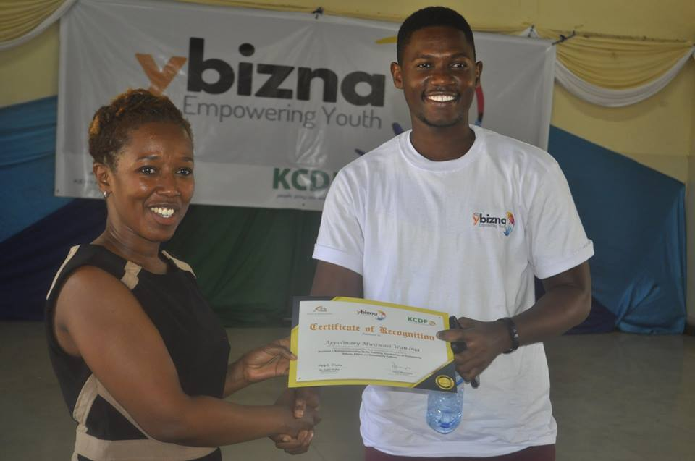

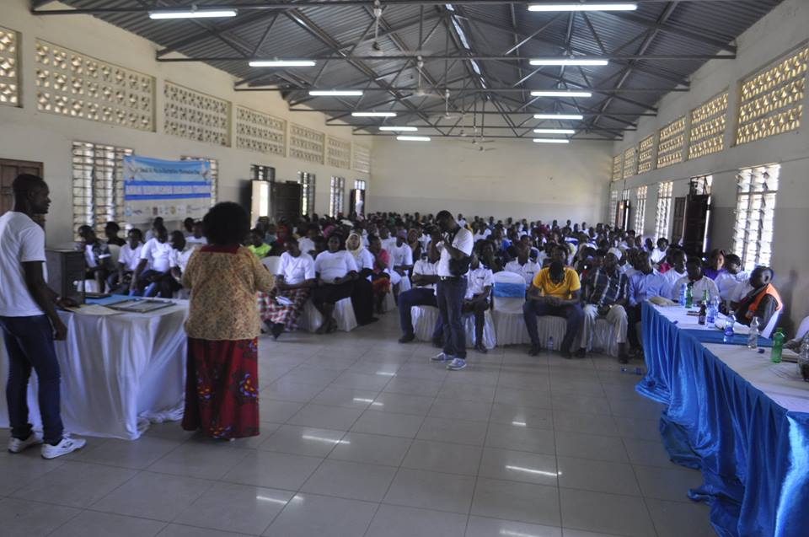

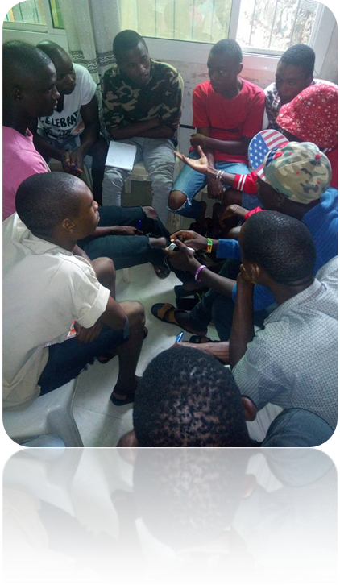
Figure 2: DAYO’s Executive Director with Jeff Koinange and Peter Kwame of Hatua Likoni during Malala's second visit to Kenya in 2016
Figure 1: DAYO's Executive Director the Governor for Mombasa County and Kuza Project staff during the launching of Imarisha Vijana Project in Mombasa 2015
WHAT We Do:
DAYO implemented four main projects in the financial year 2017 – 2018. These were:
- Tusome (Early Grade Literacy Activity
- Young Men in Business (Y – Bizna)
- Maji Safi
- Right Here Right Now

1Tusome(Early Grade Literacy Activity)

Context
We have noted that most members in our community are not embracing education and more so promoting the education of grade 1 and 2. This has greatly being contributed by negative attitudes on education, drug and substance and parental neglect, equally we have seen that there is low motivation of the teaching staff, poor infrastructure and learning equipment’s.
ACTIVITIES…
Of universal significance to early literacy educators, parents, and policymakers is that children learn to read and write at the start of their schooling; McGill-Franzen and Allington (1991) suggested children’s achievement at the end of the first grade predicts with alarming accuracy their success or failure not just in school tasks but in life experiences.
DAYO’s engagements in the Tusome Early Literacy Activity execution were planned in a manner that targeted and catered for the, School heads, teachers, schools, parents and pupils. In a bid to accomplish the set milestones DAYO had to design a work plan that outlined the milestones, providing a roadmap with set dates and a list of deliverables to each milestone, this was then followed by DAYO conducting a planning meeting with MOE/City Manager/Coaches/Head teachers the same also acted as an introductory/entry meeting to the various institutions.

Concept
The Tusome Early literacy activity is designed to support literacy development and foster a reading culture among early-grade pupils, including those visually-and hearing- impaired, across Kenya. Dream achievers Youth Organization (DAYO), a group based in Mombasa and recipients of the Youth Fund in the Tusome activity, a special fund that empowers local youth groups to work with younger children in their communities to improve reading skills, has in 2017-2018 worked with 15 schools in Mombasa County Bamburi cluster out of the possible 1,500 Alternative Provision of Basic Education and Training (APBET) institutions (low-cost private schools) across Kenya in a bid to help realize the objectives of Tusome:
- To improve teacher capacity
- Improve access to books and supplementary material
- Establish effective and efficient Monitoring and Evaluation system.
- Enhance capacity of the education sector to sustainably improve literacy outcomes.

Baseline Survey
A baseline survey was then conducted to map out the schools within the Bamburi cluster and selection of the 15 schools to be included in the program implementation out of the possible 17 schools in the cluster. Another set of meetings was then conducted with Parents association and class 1, 2, and 3 parents’ representatives from the select APBET schools within the cluster.
Activities targeted at parents included Sensitization forums on how to monitor their children’s homework and Safe keeping/ handling of reading materials. Together with these termly reading exhibitions were organized in the cluster aimed at the pupils.

Mobile Community Library
In an effort to Set up Mobile community library, a series of Internal Planning meetings were conducted followed by purchase of reading materials/tittles from list provided by Tusome. This was then to be followed by community library sessions, a reading activity that targeted pupils from the community i.e. the general populace and the pupils from the selected APBET schools.

Murals
Five Murals were then mounted in selected schools based on accessibility by the targeted general populace. This was then followed by sensitization workshops on safe keeping and handling of reading materials conducted to both teachers and parents. To ensure safe keeping of the reading materials twenty portable book shelves were constructed, and distributed to the 15 schools the selected. Apart from attending a few of the Bamburi cluster meetings, DAYO supported two cluster review meeting. This would mark the closure of the activities as planned and an annual report was to be drawn and Complete and submit for approval.

DAYO Performance and Targets
ACTIVITIES…
Name of the training/course | Training target | Achieved Number | Achieved %
Reading Material Distributed | 960 Reading material distributed by the end of project. | 960 Reading Materials | 100%
List of Storage Facilities Distributed | 20 bookshelves to be distributed by the end of the end of the project | 20 Bookshelves | 100%
Planning meeting with MOE/City Manager/Coaches/Head teachers/PA’s | 3 Meetings | 3 Meetings Held | 100%
Community Reading Sessions | 3 Reading Sessions | 3 Sessions Held | 100%
Reading Exhibition | 3 Reading Exhibition | 3 Reading Exhibition held | 100%
Bamburi Cluster Meeting | 2 Cluster Meeting to be held | 2 Meetings held | 100%
Teachers’ Training Teachers On Safe Keeping And Handling Of Reading Materials Mlaleo | 2 Teachers Training on Safe Keeping | 2 Meeting Held | 100%
Schools with Talk Walls/Murals | 5 Talking Murals to be erected | 5 Murals elected | 100%
2

Young Men in Business (Y – BIZNA) Project

Context
The project targeted Young Men from the deprived informal settlement of Kisauni, the youth targeted project concetrated on, addressing challenges affecting young men will work as a caution for addressing violence, especially electoral process associated with violence that threaten peace at the grassroots level. The Intervention mechanism will in the end generate new and tested knowledge and strategy of holistically addressing Musculinity issues and their resultant challenges that affect the community as a whole. It will also contribute in promoting Corporate-Community partnerships

Concept
Ybizna is a Positive Musculinity Focused, inclusive and participatory project that works to support young men explore, exploit and engage their capacities in bettering their livelihoods and that of their communities. The Project intervenes on the Triple Impact areas of;
- Inculcating Young Men with Community Values, Culture and Ethics resulting to Strengthened Identities that enable them to be conditioned to access available social-economic and political opportunities.
- Equipping the Young Men with Resonate Enterprise livelihood skills through a practical engagement that inspires them to create new opportunities for themselves and their peers. A Young Men Friendly loan system will be incoporated as Seed resourcing to set-up and or enhance enterprises.
- Engaging Young Men as positive role models through mentoring that results to a structured support system for Young Men at the grassroots and promoting them as community pillars especially in ensuring peace and non violence based leadership ideals.

Project Components
The Y-bizna (Young Men in business) project focused on life skills development, peace building, and youth led entrepreneurship as well as employment creation. The project sought to reduce the number of violence/crime cases and improve the living standard of the young people in informal settlements in Kisauni by training them on management of small and micro-enterprise ventures (SMEs), financial literacy and provision of business mentorship. This was in a bid to prepare them for the job market and positively engage them by equipping them with necessary skills while preventing them from engaging in maladaptive behaviors. The Y-bizna project was supported by Kenya Bankers Association (KBA) and implemented by Kenya Community Development Foundation (KCDF) through Dream Achievers Youth Organization in Mombasa.

Computer Maintenance and Repairs Training Course
The course was tailor made for the youths n Kisauni due to assessment done by DAYO and identification of the needs of the young people. The computer course was one month long and provided the basic maintenance and repairs skills. DAYO provided the computer lab which played a major role in the practical sessions which took much time of the training. The Computer Lab at DAYO became very handy for the graphical user practical experience. i.e. Re installation and installation computer hardware’s, configuring the BOS component software by adjusting time/date, bootable priority (changing bootable device sectors, set up password, report keyboard errors etc), Ethernet cable crimping .e. straight through and crossover, peer to peer networking test i.e. PING, IF configuring using the command line interface language on the terminal, programme and hardware troubleshooting processes

Men in Business Training
DAYO managed to conduct several BUSNESS training targeting young men in Kisauni Sub County. We managed to reach 133 Young men with a comprehensive package of business training.

By the end of the trainings, it was evident that the young men were able to:
- Understand how to generate, identify and select business ideas
- Acquire relevant knowledge and skills to start and successfully manage an enterprise/business venture
- Understand the preparation of a specific, comprehensive business plan tailored to each individual entrepreneur needs.
- Understand the linkages between the entrepreneur and all the resources and services needed to successfully launch and sustain an enterprise
- Understand saving as a life skill for individual livelihood and business improvement

Consequently, the Men n business training had been an entry point to Groups formation, Vetting and Loans disbursement, because from the trainings, groups were formed, business plans were written and submitted for pitching. Attached herewith, a copy of a business plan

Group Formation, Vetting and Loan Disbursement
In the desire to make the trained groups formalize their operation it was key that the beneficiaries trained to form groups to allow them to accessing start-up capital or money for business expansion.
As provided in the criteria for accessing the loans, all groups that expressed interest were subjected to a vetting process under the Lion’s den platform. This platform is a KCB platform which interrogated the viability of a business idea, explored the risks, queried the business projections and authenticity of groups.
Having met the laid down requirements for groups, i.e. formation of group, going through the vetting process (Lion’s den) and approval all eight groups qualified to receive loans. Each group was given a cheque addressed to the joint account they had opened with KCB Mtopanga branch which is the custodian of the funds.
The eight groups injected the cash in businesses; purchase of supplies, creation of work tools, marketing and as a requirement progress reports were given.

DAYO Performance and Targets
Name of the training/course | Training target | Achieved Number | Achieved %
Computer Maintenance and Repairs Training | 50 to be trained | 56 Youth Trained | 112% Youths trained
Men in Business Training | 100 trained and mentored on entrepreneurship | 133 Youths reached | 133% reached
Group Formation, Vetting and Loan Disbursement | 30 business formed | 8 Businesses formed and applied
Group Formation, Vetting and Loan Disbursement | 20 Business vetted | 8 business funded
Group Formation, Vetting and Loan Disbursement | 50 Small Businesses to receive loans (500,000) | 495,500 Disbursed | 100% Disbursed
ACTIVITIES…

3Maji Safi Afiya Bora kwa Jamii Project

Context
There has been increasing challenges by the members our community to access clean water for domestic purposes. In every five households atmost two access clean and treated piped water which can be used for domestics purposes making them free from ailments.
The local council has over time made it challenging for these communities to be able to secure piping and clean water even through reservoirs owing to beuracracy, corruptions and botlenecks in the processing of the meters and access to main pipes.
The lack of steady supply of clean water has made it difficuly for the community to lead a descent life owing to frequent water borne diseases.

Concept
DAYO implemented different projects on the four key thematic areas. Through the support from KCDF, DAYO implemented a project, “Maji Safi Afia Bora Kwa Jamii” A project that sought to provide clean well water and construction of public modern toilets for the residents of Kashani. Beyond providing clean water and toilet facilities, the project also created hygiene awareness with preventive messages on causes of diseases to the community. It created employment opportunity to the young people who were involved in the construction phase and attending to persons accessing the project services from the community.

Acquire Land
The project provided for the acquisition of land for drilling the bore hole and construction of the modern toilet. We appreciated that as much as there is a provision within the county for leasing of land for drilling the bore hole at times owing to issues related to the scarcity of land there has existed cases of grabbing and evictions which in most at times has created loss to the already made investment.

Drilling a Borehole
The bore hole is one of the easiest ways of accessing water for domestic purposes. This provided that through the project we had to drill the bore hole after which with the treatment of the water it was usable for domestic purposes.

Building Modern Toilet /Employment Creation
It will also create employment to the young people who will be involved in the construction phase and attending to persons accessing the project services from the community when it’s accomplished.

Creating Hygiene Awareness with Preventive Messages
Beyond the provision of clean water and toilet facilities, this project created hygiene awareness with preventive messages on causes of diseases to the Kashani community. We have seen that there is need for behavior change on water handling and treatment both at the point of our project but more so at the domestic level.

DAYO Performance and Targets
ACTIVITIES…
Name of the training/course | Training target | Achieved Number | Achieved %
Acquisition of land | Acquire land for drilling of the borehole and building the toilets. | Land acquired | 100%
Drilling a bore hole | Drilling one borehole | Borehole drilled and constructed. | 100%
Building modern toilet/ Employment creation | Building one modern Toilet through which create employment for at least twenty youths | Toilet built and created employment to sixteen youths. | 80%
Creating Hygiene Awareness with Preventive Messages | Disseminate at least seven hygiene awareness and preventive messages | Six messages disseminated. | 84%

4Right Here Right Now

Context
There has been an evident shriking space for the young people to actively advance their interest in programing, implementation, monitoring evaluation and learning of health projects that encampass school and community based program.
The health docket has compeleteley been underfunded by the government on service provision and such a major investment goes into infrastructural development, personel management and mildly in supplies.
The youths have continued being strongly hit with their inability to advocacate for their includes youth friendly centers and services.

Concept
The Right Here Right Now bringing together more than fourteen counties based, national and even international organizations to network has shared amongst self-varied outcomes that includes the above context.
DAYO as a member of the RHRN Platform Kenya, continued to contribute to the realization of the three Long term Outcomes directly by conducting activities geared towards attainment of the same or indirectly by supporting a lead platform member organization realize the long-term outcomes:
- Strengthened implementation of the ASRH policy for improved access to SRHR services by Youth, including LGBTIQ youth by 2020
- Released standards and guidelines for reduction of maternal mortality and morbidity by 2020
- An inclusive National School Health Policy (NSHP) which reflects the CSE needs of young people by 2020

Strengthened Implementation of the ASRH Policies
There has been a continued call for the strengthening of the implementation of the Adolescent Sexual and Reproductive Health Policy for improved access to Sexual and Reproductive Health and Rights services by Youth, by 2020.
The need of enhancing the youth voice to articulate their health needs that include advocating for sound policies and legislative frameworks has been the heartbeat of this intervention.
The program engages young people from the entire country to come and prioritize what works for them and then involve the relevant duty bearers towards seeing that their increased and improved service provision that is of quality, in a descent environment and that reflects the rights of the young people.

Released Standards and Guidelines for Reduced Maternal Mortality and Morbidity
There is an increased desire for the released standards and guidelines for reduction of maternal mortality and morbidity by 2020. This will make the access to timely maternal health services, choice on the spacing of births and in long run guarantee productivity of the gender female.

Inclusive National School Health Policy
The National School Health Policy (NSHP) needs to be inclusive and sensitive for all and should accommodate the urge of the young adults to be facilitated with information which makes them have informed choices. The same as we aspire is one which reflects the CSE needs of young people by 2020

DAYO Performance and Targets
ACTIVITIES…
Name of Performance and Target | Performance and Target | Achieved Number | Achieved %
Facilitating Youth Champions Forums | Facilitate/Host/Participate in at least nine Youth Champion Forums | Six Forums | 67%
Advocacy Training of Youth Champions/Journalists | Facilitate/Host/Participate in at least twelve Advocacy Trainings | Nine Trainings | 75%
Influencing Policy Formulation | Input/Participate/Validate four Policies | Five Policies | 125%
Influencing Public Perception through existing structures | Attends four Public Participation | Six Participations | 150%
Development of Policy Briefs | Development of two Policies Briefs | One Policy Brief | 50%

DAYO’S GEOGRAPHICAL COVER
DAYO geographically lies in Kisauni Sub-location, Kisauni Location, Kisauni Sub County and Mombasa County in Coast Region. As far as project implementation is concerned, we are targeting youth in and out of school between the ages of (9-35) years with information on issues of adolescence sexual and reproductive health education, Peace building and HIV/AIDS prevention in Mombasa, Kilifi and Kwale Counties.

Donors & Sponsors
We wish to appreciate the below mentioned existing and previous stakeholders, partners, donors, sponsors and friends who have made it possible for the implementation of our varied community interventions and projects:
- Rights Here Right Now Network and Partners
- National Aids Control Council (NACC)
- Adam Smith International (ASI)
- Africa Alive Kenya! (AAK)
- USAID Kenya
- DSW German foundation – Coast Region
- United Nation Alliance of Civilization (UNAOC)
- Kenya Community Development Foundation (KCDF)
- AIDS HealthCare Foundation (AHF)

Collaborators
- Ministry of Youth Affairs & Sports (MOYAS)
- Ministry of Public Health & Sanitation (MPHS)
- Ministry of Education (MOE)
- National Campaign against Drug Abuse
- Institute of Education in Democracy (IED)
- Provincial Administration
- Family Health Options Kenya (FHOK)
- Coast Women in Development (CWID)
- Youth Alive Kenya (YAK)
- KENERELA & Pwani
- Kwacha Afrika

PARTNERS
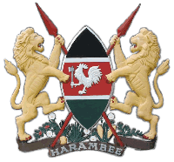
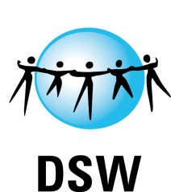


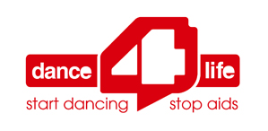

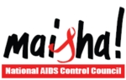

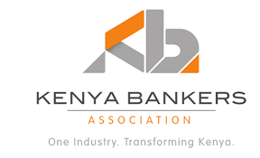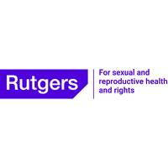

Staff, Volunteers and Interns
DAYO has a professional staff team that ensures the smooth running of its day to day activities assisted by devoted volunteers and interns through a sound structure.

STAFF
- Mr. Seif Jira Mali – Programs Director
- Mr. Enos Opiyo – Programs Coordinator
- Mr. Winnie Lozi – Monitoring and Evaluation Officer.
- Ms. Jacinta Musau – Finance and Administration Officer
- Mr. Gaetano Muganda – SRHR Officer
- Mr. George Nyale – Office Assistant IGA’s Officer

INTERNS AND VOLUNTEERS
It is also crucial to point out that DAYO continues to benefit significantly from the outstanding work of its committed volunteers and interns:

- Steve McGregor – Volunteer (Accountants For International Development (AFID)-UK)
- Fredrick Mutua – Intern (Kenya Coast Polytechnic)
- Caroline Gacheri – Intern (Outspan Medical College)

DAYO’s Advisory Board
The Dream Achievers Advisory Board comprises of six individuals drawn from different strategic positions to advice the organization of specific undertaking.

- Ali Komora - Chairperson
- Seif Jira Mali - Secretary
- Sheila Toya - Treasurer
- Mariam Bashir - Member
- Priscillah Nganga - Member

More Activities in Pictures:

With a majority of these being teenage and young mothers

