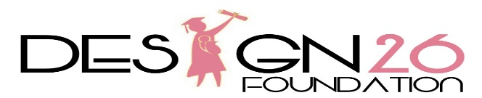

PROFILE

EXECUTIVE SUMMARY

Design26 Foundation started in March 2018, a Non-Profitable Company aiming to reduce poverty by providing free sewing skills training courses, free transportation, counselling, as well as possible job opportunities to teenage mothers and girls between the ages of 15 and 21, whom are school drop outs, faced with daily social and economic problems, by equipping them to gain much needed skills, so that they can gain confidence and independence, enabling them to become self-sustainable financially.

Our training provided is done on industrial sewing machines. The free transportation services we provide, has come about due to challenges our delegates face with daily transportation costs. We are also currently working on a child-minding service, which is another problem our delegates face daily, due to financial constraints they are unable to afford payment for both transport and day care services. After completion of our training courses offered, our delegates are able to generate and income, by either their own clothing manufacturing business or gain entry into the garment apparel manufacturing sector. Our aim to reduce the risk of becoming drugs or alcohol dependent, which in turn leads to child abuse and be solely dependent on government social grants or a second unplanned pregnancy.

In order to achieve the goal, Design26 Foundation NPC has established the Sewing Project access to help poor, vulnerable teenage girls effected by pregnancies and faced with social and economic issues. The project provides five main services:

1) Industrial Sewing skills training

2) Counselling, allowing them to become emotionally strong and independent

3) Entrepreneurial skills – guiding them as to how to start a clothing line business

4) Provide transportation to and from classes, enabling them to attend classes regularly

5) Child minding facility which will eradicate the problem of not being able to attend due to not having someone to care for their child whilst at training.

Vision:
To skill and council teenage girls to allow individuals the opportunities to become employable within today’s competitive environment positively.
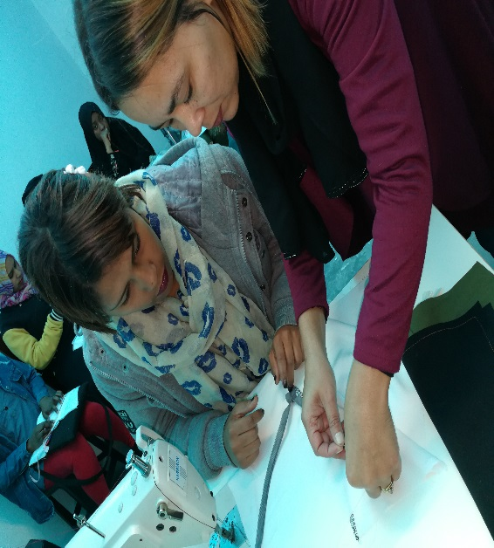

Mission:
To restore hope into the lives of teenage mothers and disadvantage young unemployed females, by making available free training skills, building self-esteem, and allowing some form of hope for a brighter future.

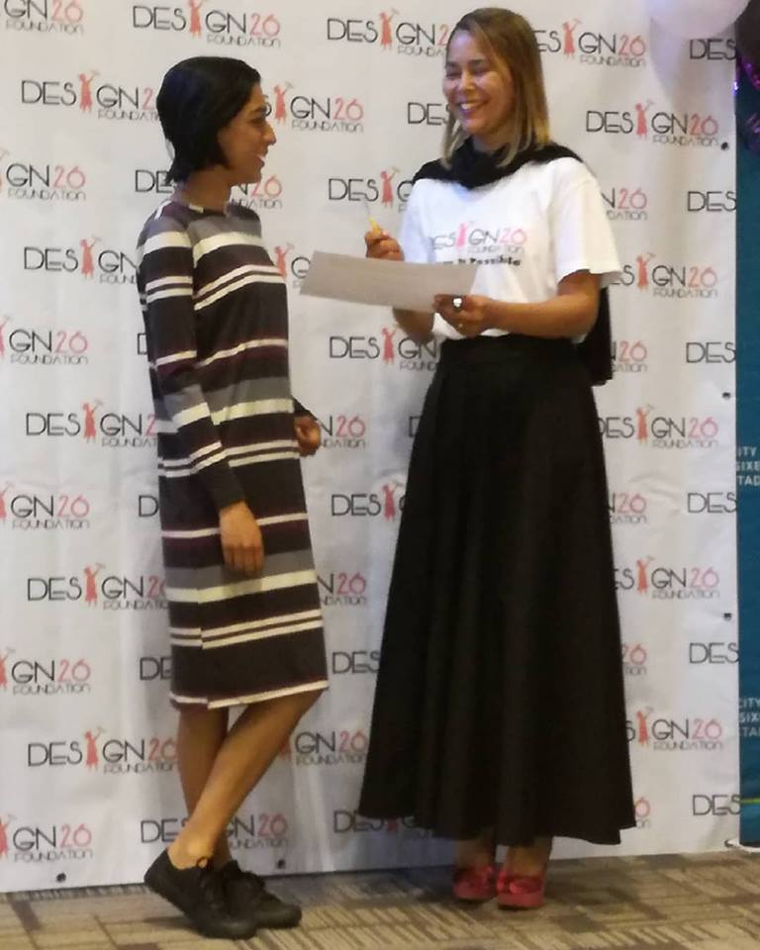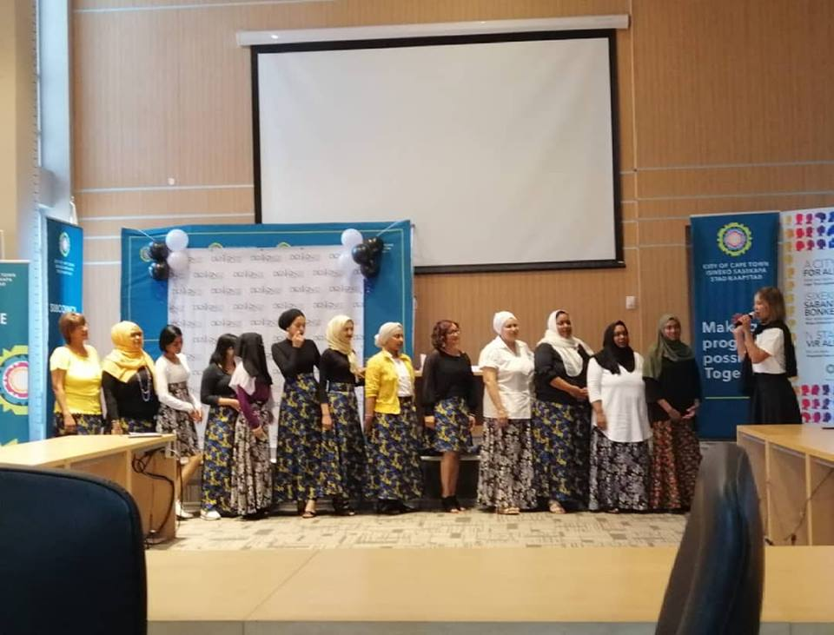

Our current needs and appeal for assistance are:

- Toyota Quantam Van, as currently we are using our own personal vehicles, thus having to make numerous trips.
- A larger premises – We have identified the perfect premises, which will enable us to have more training rooms, but due to a lack of funding, we are unable to make this a reality.
- 5 X Industrial Plain sewing machines
- 5 Industrial Overlockers
- Inventory - Fabric
- Furniture & Fittings: 5 Cutting tables/ 10 Chairs/ 2 Electrical irons/ 5 Scissors/ 5 Sewing Kits/ 10 Drawing Desks/ Machine attachments/ Pattern Paper and Pattern drafting equipment.

Current Available resources
- 5 Industrial Plain sewing machine
- 5 Industrial Overlockers
- 5 Scissors
- We currently rent a very small premises
- 1 Hatchback car
- 1 Laptop
- 1 Computer
- 1 Printer
- 1 Limited Internet Connection
- Donated Fabrics

MANAGEMENT TEAM OF DESIGN 26 FOUNDATION NPC

Design26 Foundation is a well-organised NPC with trusted board of directors who are passionate about making a difference in our community/ Currently the organisation consists of 5 Board of Directors and 1 Administrative Assistant and two Drivers all responsible for promoting the foundation, recruitment of applicants, skills training, secretarial work, compliancy and finance management, fundraising events, social media marketing and driving.

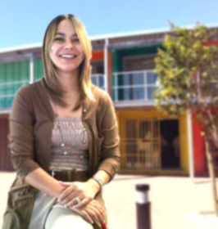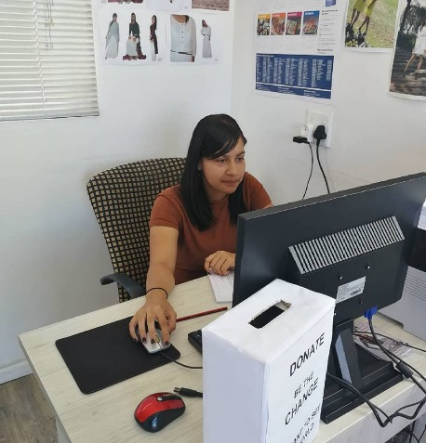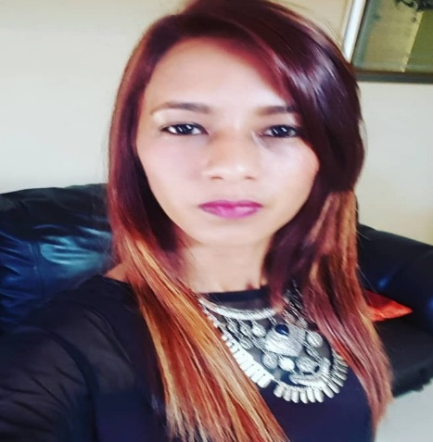
Suraya Williams –
Founding Director/
Training Facilitator/
Fundraising Co-ordinator

Aneesah Ryland – Director/Fundraising Co-ordinator

Nurunisaa Cooks –
Office Administrator

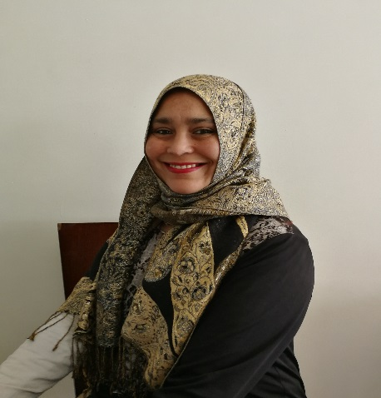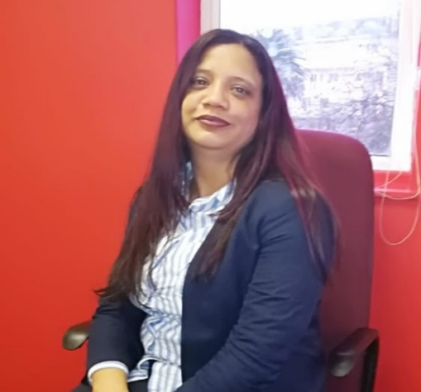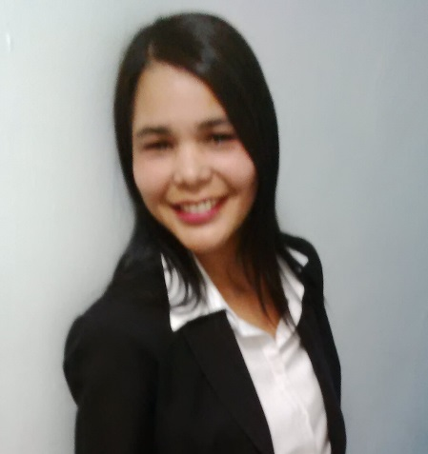
Rashieda Safedien - Director/Administrative
Secretary

Lee-Anne Steyn - Director/Fundraising
Co-ordinator

Sulayla Adhikari –
Director/Finance Manager

Organisational arrangement for the program

This sewing training project is coordinated by the head of Design26 (Pty) Ltd

Training Facilitator
Secretary
Social Worker
Driver
Marketing & Advertising Assistant
Secretary
Finance Manager
Fundraising Co-ordinators

Direct Outcome:
By Providing a six-month Skills Training Sewing Course. The Design26 Foundation endeavour to utilise these young girls by offering temporary training assistant employment, to the influx of new delegates that requires these much needed skills.

After successfully completing our training course, our delegates have the opportunity to do one of the following:

1) work within our sister company, Design26 (Pty) Ltd, and earning an income.
2) Gaining entry into the apparel clothing manufacturing market as a skilled worker
3) Become a member of the Design26 Foundation and also train the other should they show the potential to excel beyond.

Achievements
The number of students has increased due to the constant promotions on social media and local community’s interest, also word of mouth. The founder has achieved some goals to help make this project a reality, by utilising her own funds and resources.

Please visit our media platforms listed below.

https://www.iol.co.za/capeargus/news/dressmaker-to-share-her-skills-with-teen-moms-14556235

https://www.youtube.com/watch?v=BBHZukPJLy8

https://www.dailyvoice.co.za/news/sew-far-so-good-15451235

https://omny.fm/shows/early-breakfast-with-abongile-nzelenzele/design26foundation-community-upliftment-project

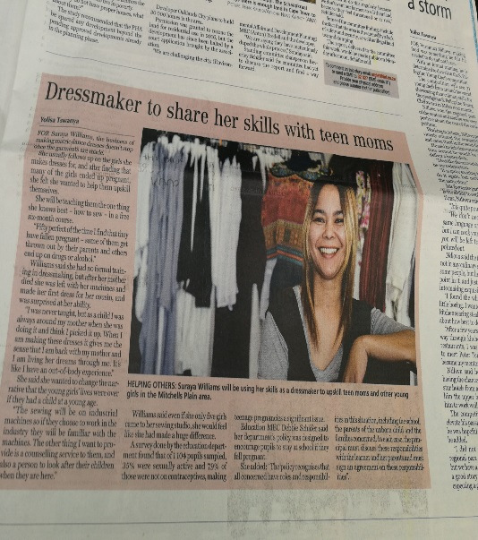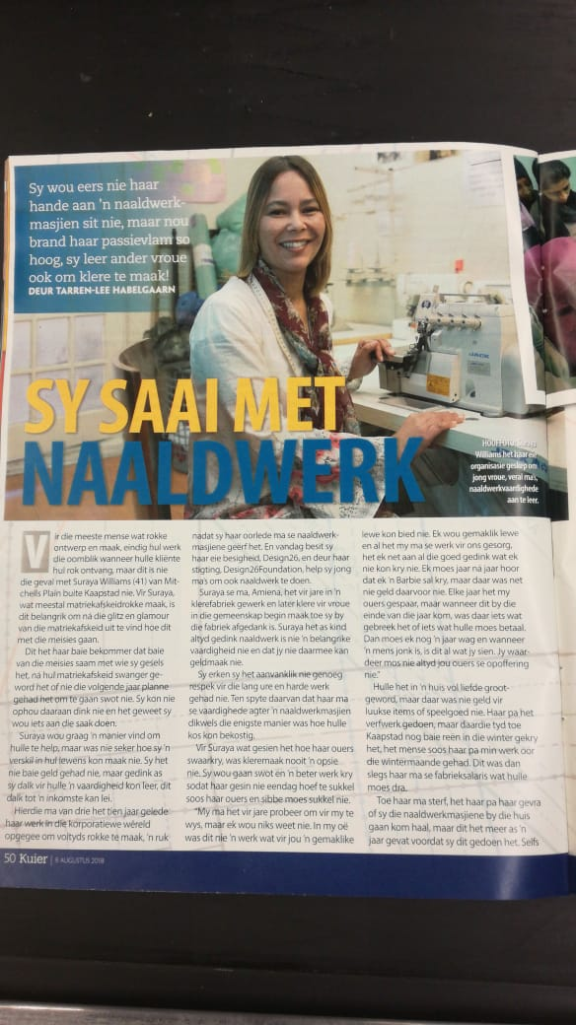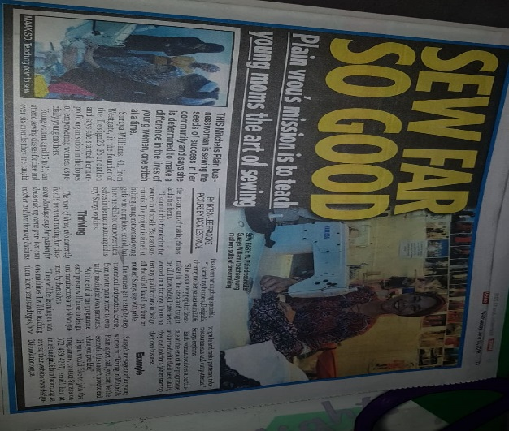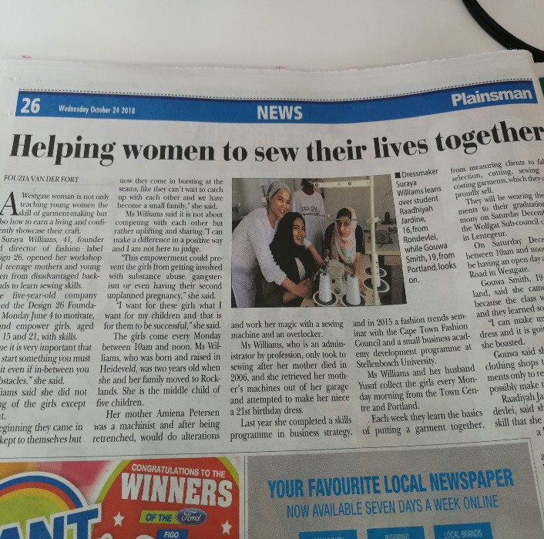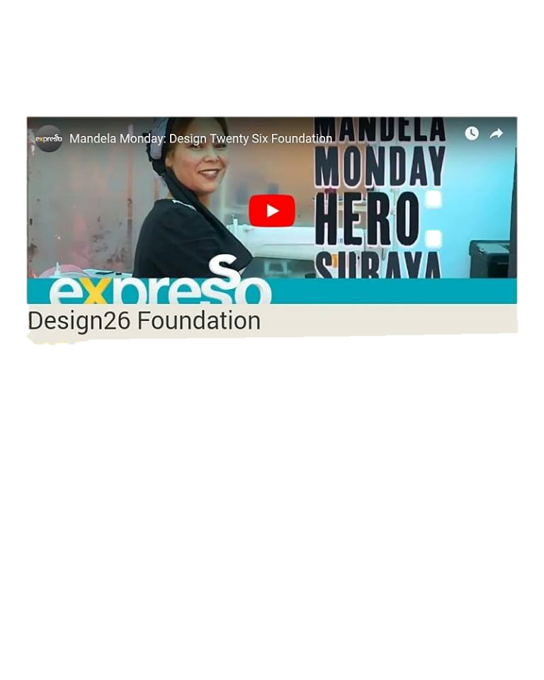

Challenges

We are faced with daily challenges whilst running these projects, namely;

Poverty issues, and slow learners,
Lack of support from the Government
Our limited training space and transportation issues.
Training materials and equipment.

Students from out of Mitchells Plain showing an interest in the program but due to limited transportation, we not able to accommodate these interested delegates.
Our organisation also makes use of one hatchback vehicle which restricts us from recruiting more applicants for the programme and high fuel usage, due to having to make numerous pick ups.
Lack of industrial sewing machines, and equipment.
Lack of funds into the program, or lack of funds to raise our own fundraising events.

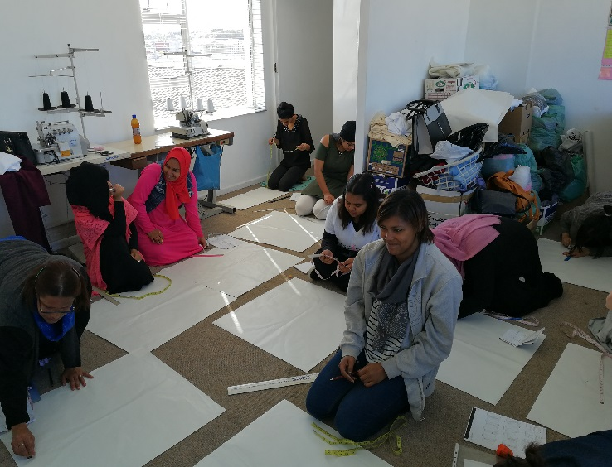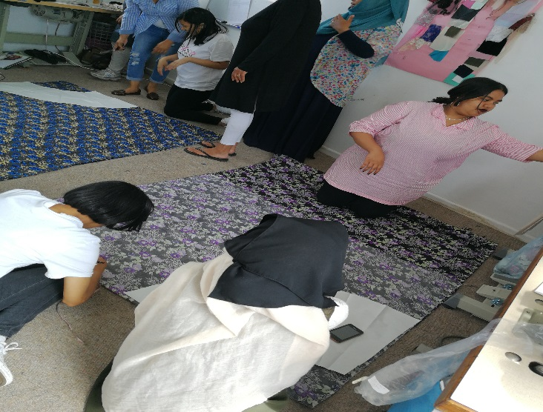

Please find our appeal for donations letter attached.

